[Title]
[Name of the Writer]
[Name of the Institution]

Company Name:
Starbucks Inc.
Shortest Maturity Bond Issued by Starbucks

Issuer Name | Symbol | Callable | Sub-Product Type | Coupon | Maturity | Moody's® | S&P | Price | Yield
STARBUCKS CORP | SBUX4568016 | Yes | Corporate Bond | 2.200 | 11/22/2020 | Baa1 | BBB+ | 100.160 | 2.058

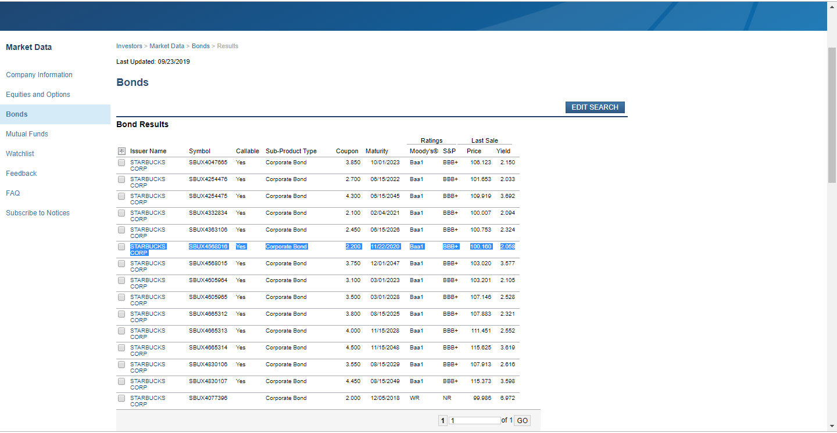
The company (Starbucks) has number of bonds. They have several bonds due to the following major reasons;
- To have sustained capital stock structure
- To have strong equity and debt capitalization
- To finance the sustainability operations and performance in the market and industry (Bonds, 2019).

Chapter # 6
Page: 206, Paragraph, 2
A forward interest rate (or forward rate) is an interest rate that we can guarantee today for a loan or investment that will occur in the future.
The sentence from chapter 6 is significant because it clarifies the views of business professionals that they have the option and they can guarantee an interest rate for a loan or investment while that would occur in future. Which is known as future interest rate (Berk, & DeMarzo, 2017).
Page: 175, Paragraph, 1
The simplest type of bond is a zero-coupon bond, which does not make coupon payments.
The sentence is significant because it assist us especially investors to be clear that every bond does not make coupon payments. The example is zero-coupon bonds (the simplest type of bond). So the investors should carefully make decisions regarding bonds (Berk, & DeMarzo, 2017).
Chapter # 8
Page: 239, Paragraph, 2
An important responsibility of corporate financial managers is determining which projects or investments a firm should undertake.
The sentence is the significant in the chapter because it states that financial managers are not required to do financial analysis while they are required to determine that which investment or project the business should undertake. By reading the sentence, we got clarified that firms do not need separate team for such decisions.
Page: 240, Paragraph, 1
A capital budget lists the projects and investments that a company plans to undertake during the coming year.
The sentence is significant especially for me because it made my view fully clear that every project and investment that a firm plans to undertake in coming year is called capital budget (Berk, & DeMarzo, 2017). While I was known and not fully clear about this term.

References
Berk, J. B., & DeMarzo, P. M. (2017). Corporate Finance: The Core, 4/e. Boston: Pearson Education. ISBN 9780134083278.
Bonds. (2019). Finra-markets.morningstar.com. Search Results Starbucks. Retrieved 24 September 2019, from http://finra-markets.morningstar.com/BondCenter/Results.jsp

