CAPSTONE PAPER
[Name of the Writer]
[Name of the Institution]

CAPSTONE PAPER
Philadelphia Museum of Art:
I visited the Philadelphia Museum of arts. It was an interesting experience. Besides enjoying the outdoor activity, it was an excellent source for learning. When I decided to visit the museum, there was an image of a typical museum that sketched a silent building full of pictures and objects. Although every museum has this typical setup, however, Philadelphia Museum of arts had its own uniqueness. Before visiting the museum, I acquired information about it so I could relate things over there easily. The main building of "Philadelphia Museum of Arts” was built in 1928. The building was categorized by several galleries where the artwork of different artists from different countries was placed. The permanent collection in the museum included American art, African art, ancient American art, East Asian art, European art, and several others (“Philadelphia Museum of Art,” n.d.). The exhibition hall directs accumulations containing more than two lacs and forty thousand items including real possessions of Asian, American and European roots. The different classes of fine art include decorative arts, painting, armor, sculpture, photographs, drawings, and prints. The Perelman Building, which opened in 2007, houses in excess of 1.5 lacs prints, illustrations, and photos, alongside thirty thousand costume and textile pieces and more than one thousand present day and contemporary design objects including glasswork, furniture, and ceramics. A few unique and special exhibitions are arranged in the museum each year, organized with different exhibition museum including touring exhibitions in the United States and overseas. In 2017, the participation figure for the place was 793,000, which positions it among the main one hundred most-visited museums of arts worldwide. The Philadelphia Museum of art is likewise one of the biggest museums due to its gallery space. Beginning in 1882, the number of the amazing collection of books, jewelry, furniture, paintings, textiles, enamels, ceramics, carved ivory, and metalwork were donated by Clara Jessup Moore. Later, number of well-known personalities donated various artworks to the museum and helped it to become one of the largest museums. The main building is additionally enhanced by a gathering of bronze griffins, which were received as the symbol of the museum during the 1970s.
Collections:
Philadelphia Museum of art acquired 240000 objects in which numbers of items are present that represent the achievement of the western world. Asian works in more than two hundred galleries spanning two thousand years. It also has a collection of pre-Columbian, Roman art, and Egyptian work. The European work from the medieval era to contemporary time and American collections of three centuries are the part of the museum. Besides historical art collection, modern work is also exhibited. It includes work of Marcel Duchamp, Pablo Picasso, Albert Gleizes and other contemporary artists. Through the huge number of artwork the most, attractive and attention taking pieces are below.
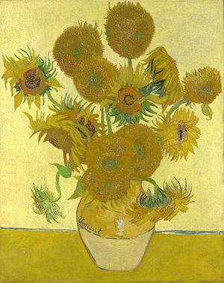
(“Philadelphia Museum of Art,” n.d.)
The name of the painting is “Vincent van Gogh”, Vase with Twelve Sunflowers was painted by the Dutch artist named "Vincent van Gogh". The painting is made up of oil paint containing a bunch of flowers. It was the part series that was executed in Paris. Various similar paintings were executed later. The painting was made in 1887 that portrait the sunflower in a vase. The first painting that was linked to this one contained flower lying on the ground. Vincent tried to portrait the summer in Paris. Later repetition through a similar medium and theme was made and the number of paintings containing different types of the flower with a different combination of color increased the collection of Vincent. By looking at the picture it can be observed that an artist portrait the summer season, therefore, he used yellow as the major color. Sunflowers are yellow in color and even the background had a bright yellow color. The table on which vase was placed was also kind of yellowish color. The whole painting executed the combination of different shades of yellow which gives the idea of sunshine and warmness of sun during the summer. The other color that is prominent in the picture is the green color to fill the leaves and stems of the sunflower.
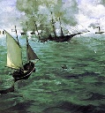
(“Philadelphia Museum of Art,” n.d.)
The title of the painting is The Battle of the Kearsarge and Alabama. The picture is drawn by Edouard Manet. The primary purpose of the picture was the description of Battle of Cherbourg which was fought between the Alabama and Kearsarge on June 19, 1864. The picture thus illustrates the battle and the phase of the American Civil War. It is currently placed in the Philadelphia Museum of Art and the medium of the picture is oil on canvas. It is located on the 1st floor, room 153 in the museum. A credit line is also given which states John G. Johnson Collection, 1917. The battle commemorated in the picture reflects the naval engagement between the Confederate raider CSS Alabama and Union cruiser USS Kearsarge. Manet did not witness the battle but was able to utilize the press description of the flight to advance his work.
It is essential to mention the painting was completed within a month of the battle and was displayed on the print shop of Alfred Cadart in Paris. Later, a French art collector acquired the painting in 1878. With drying oil used as blinders, the painting illustrates naval ships being wrecked in the battlefield. It is artistically sketched to offer a nostalgic theme of the battle on waters. Smoke clouds are also visible in the air and among several ships, only a single ship is portrayed to be safe and not completely destroyed.

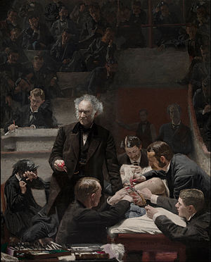
(“Philadelphia Museum of Art,” n.d.)
The name of the painting is "The Gross Clinic" painted by Thomas Eakins in 1875. The medium of the painting was oil on canvas with the dimension of (240 cm × 200 cm (8 ft × 6.5 ft)). Thomas Eakins was an American artist who portraited Dr. Samuel D. Gross. Dr. Samuel was a 70-year-old professor in black dress and giving a lecture to a group of the college student. Eakins painted himself on the right side of the painting. He was in white cuff writing something next to the tunnel railing. It was based on the time when Eakins witnessed the surgery performed by Dr. Samuel and Eakins saved that movement in a frame. The overall look of the painting was the combination of dark colors. The dresses and background were almost blackish in color. There was the use of white color in some portion to highlight certain things like clothes, paper, and surgical equipment and then there was red color indicating the blood on Dr. Samuel hands.
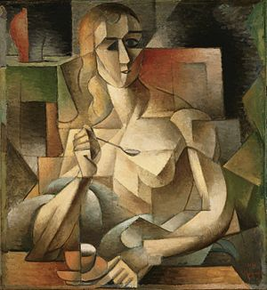
(“Philadelphia Museum of Art,” n.d.)
Le Gouter is a painting known as Femme a la Cuillere and Tea Time. It was created by the French artist Jean Metzinger in 1911. The painting was exhibited in Paris at the Salon d’Automne. The drawing is located in the Philadelphia Museum of Art in the Louise and Walter Arensberg Collection. The medium of the picture is oil on cardboard with the dimensions 75.9 cm × 70.2 cm (29.8 in × 27.6 in). The picture reflects a barely nude woman with a spoon who is seated at a table with his hand on a cup of tea. There is a vase placed on a commode in the background of the upper left quadrant. However, the painting is essentially square similar to the side of a cube. The face of the woman is divided into geometrized facets and highly stylized. It is a masterpiece where the source of the light appears to be coming from her right. The breast of the woman in the picture is composed of a sphere and triangle. The picture is structured in a peculiar and complicated manner. The unidentified aspects are composed of angular structures where the colors utilized by Metzinger are mixed, subdued with a natural allure.
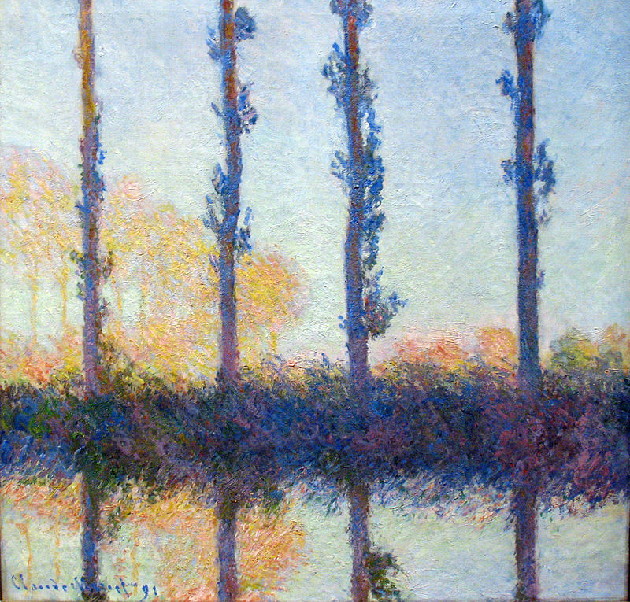
(“Philadelphia Museum of Art,” n.d.)
The name of the painting is Poplars. It was a series of painting portrait painted by Claude Monet in 1891. The painting portraits the trees, marsh along the banks of Epte River. The medium of the painting is oil on canvas. There is a total of four trees following along an S-curve. Reflection of trees also painted on the river as the painting was highlighting the summer and fall of 1891. The main reason behind the painting was the travel that Monet had to do for reaching his studio from home. He used the boat to reach on the other side of the Epte River where his floating painting studio was located. An interesting fact related to the painting was the purchasing of trees. Monet had to purchase the trees to complete his painting however, he sold them back after completing his series. The paintings highlighted the combination of both the dark and bright colors to paint trees. The front trees were painted dark while trees in the background were lighter in color. A complete reflection was painted on the surface of the river.
Besides these painting, there were many other artworks which represented a certain occasion, thought, memory, and culture. The Philadelphia Museum of arts is the place to learn a lot under one roof.

References
Philadelphia Museum of Art. (n.d.). Retrieved May 2, 2019, from https://www.philamuseum.org/

