Depression due to retinal changes in old people
[Name]
[Institution]
[Date]

Depression due to retinal changes in old people
Factors of change of an individual in an old age can be either biological, social or psychological. Biological factors include all the health and genetic related factors that could trigger changes in the body. Biological forces like changes in the overall organ system can trigger aging. Psychological forces are the emotional, cognitive and other personality factors. There are sociocultural factors that can also trigger aging. Life cycle forces include the events that combine all the biological, socio-cultural and Psychological factors and triggers aging and development in an individual (Cavanaugh & Blanchard-Fields, 2018)
However, I am afraid of retinal changes when I am sixty or above. I will probably be affected by depression due to retinal changes in my old age because this is the scariest thing I can ever imagine. The psychological effects of changes in vision have an adverse effect on the wellbeing and on the daily lives of an individual. The psychological effect of retinal change is the scary thing that I might experience in the late ages.
Psychological Effects of retinal changes in old people
The retina is the biggest part of the eye and it has all the important recipient cells including rods, cones, and the specialized vision cells. The focal point of vision is the macula which gets degenerated with aging. The individual is unable to read a book or watch television. Visual impairments change the relationship between emotions and certain personality traits. People who are having visual impairments in older ages have a very weak relationship between positive emotions and extraversion. Visual impairment also increases various vulnerabilities and those also have a negative impact on the psychological health of an individual. Like unable to move and locking oneself in a place will trigger depression in old people (Cavanaugh & Blanchard-Fields, 2018).
Visual impairment even if that is in treatable stages effect elderly and in the United States, 16 percent of the people in the age of 80 to 84 have visual impairment leading to depression. As vision and hearing problems are related to functional disabilities. The effect of visual imparity on the cognitive ability of an individual has been studied in older women which concludes that vision impairment has high odds of cognitive decline with respect to time. The treatment for vision impairment may improve the cognitive behavior of an individual and may prevent cognitive decline in elderly people (Lin et al., 2004).
The prevalence of the symptoms in old people with low vision have also been studied by Barry W. Rovner MD, MSN Yochi Shmuely‐Dulitzki DSW and Pamela M. Zisselman RN in their research paper, “Depression and Disability in Older People with Impaired Vision: A Follow‐Up Study. They have studies the relationship between visual impairment and depression with the help of Community disable scales and Geriatric Depression scale.
The participant were 31 in number and the panel study was based on two years follow up. The relationship between depression and vision imparities are studied with the help of the whole sample. The study concluded that the symptoms of depression are prevailing more in low vision of elderly persons than individuals with low vision impairments. A direct relationship between functional impairment visual impairment was seen and this triggers depression in old people. (Rovner, Zisselman, & Shmuely‐Dulitzki, 1996).
Rovner, Casten, and Tasman have done in-depth research on the relationship between depressions in old people with visual impairments. According to the visual impairment, as well as depression, is high in elderly people. They have to try to find out the associate of these two terms. The prevalence of vision impairment in the elderly is high. They are more restricted and do not interact with the border community and feel lonelier thus develop depression (Rovner, Casten, & Tasman, 2002).
Research question:
The research was conducted to identify the rate of depression in an elderly patient with vision impairment.
Sample and methodology:
51 older people were studied those having retinal changes and the outcome of their depression was studied with the help of depression scale, functional Vision Screening Questionnaire, visual acuity and Community disability scale (Rovner, Casten, & Tasman, 2002).
The dependent variable in the study is the visual impairments and the independent variable id depression that changes with the changing in the Vision function. Regression analyses are run to find out the correlation (Rovner, Casten, & Tasman, 2002).
Results:
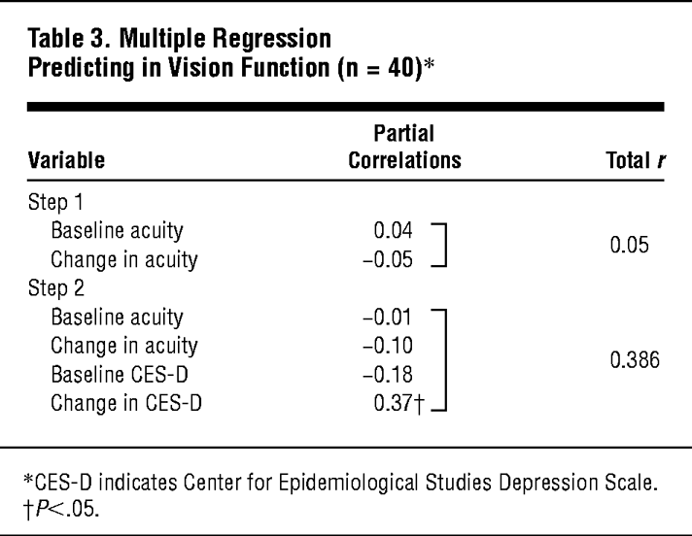
(Rovner, Casten, & Tasman, 2002).
Description of the results:
17 patients were identified with the baseline depression and those have worse visual acuity with a value of p=0.4 and the non-depressed individuals have a high rate of vision-specific. An increase in the depression symptoms declined the self-reported Vision and the change in vision security is less than 0.05. The changes in visual acuity are found out with the help of longitudinal study and the changes in vision function increases depression in patients (Rovner, Casten, & Tasman, 2002)
The scores of depression were correlated with that of vision-specific disability(r = 0.31). the independent measure of visual function, visual acuity and CDS was processed in one block and the significant p-value less than 0.001 which show that vision specific disability could lead to dispersion if the led to other physical disability (Rovner, Zisselman, & Shmuely‐Dulitzki, 1996).
Summary of the data and an explanation of the research question
Depressed persons have more vision specific disability and the correlation could be specific if other relevant disability could not be controlled. There is a non-significant relationship between depression and visual disabilities because vision changes lead to a certain factor that can boost up depression. Vision add can boost up mood and improve self-efficiency that are helpful in minimizing depression in old people (Rovner, Casten, & Tasman, 2002). The research question is asking the relationship between vision disability and depression and the result shows an indirect relation between these two.
My Curveball:
Renal changes might lead to depression in my old age but the researches show that there is an indirect relation between these two. So by controlling other factors like bodily moment depression caused by renal changes can be minimized.

References

Cavanaugh, J. C., & Blanchard-Fields, F. (2018). Adult development and aging. Cengage Learning.
Lin, M. Y., Gutierrez, P. R., Stone, K. L., Yaffe, K., Ensrud, K. E., Fink, H. A., … Mangione, C. M. (2004). Vision impairment and combined vision and hearing impairment predict cognitive and functional decline in older women. Journal of the American Geriatrics Society, 52(12), 1996–2002.
Rovner, B. W., Zisselman, P. M., & Shmuely‐Dulitzki, Y. (1996). Depression and disability in older people with impaired vision: a follow‐up study. Journal of the American Geriatrics Society, 44(2), 181–184.

