Assignment no. 4
[Name of the Writer]
[Name of the Institution]

Pre-implantation Genetic Diagnosis PGD; description and bioethical analysis
Preimplantation genetic diagnosis (PGD) is a procedure that is used before implantation for the purpose of identification of genetic defects within embryos. These embryos are mostly developed during in vitro fertilization (IVF).
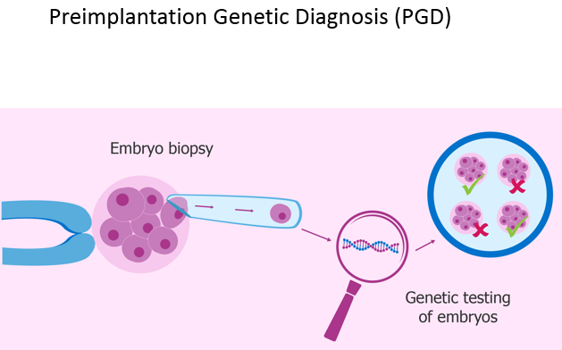
Preimplantation genetic diagnosis starts with the in vitro fertilization. Then in the next 5 days, embryos will divide into multiple cells. The process is not only costly but also offer physical discomfort as well as emotional stress.
Surrogate motherhood; description and bioethical analysis
A surrogate mother is a biological mother who is artificially fertilized with the father's sperm. "In vitro fertilization" (IVF) is used to get eggs from the mother, which is then fertilized with sperm from the father. Then the embryo is placed into the uterus of a gestational surrogate who carried the baby till birth. There is a controversy with this method as its legal process varies from state to state.
Artificial insemination; description and bioethical analysis
This is the procedure of inserting sperm directly into a woman's cervix, fallopian tubes, or uterus. Mostly uterus is used for this purpose. This procedure is used for treating infertility. There are different ethical questions that arise with this procedure such as the welfare of the child and identity of the donor to be revealed to the child.
Natural Family Planning:
Natural family planning (NFP) does not use any medicine or device but guide people about when to have sexual intercourse.
3 Primary ovulation symptoms:
- Basal body temperature
- cervix activity
- Cervical mucus
7 Secondary ovulation symptoms:
- Mittelschmerz
- Spotting
- Swollen vagina and vulva
- Increased libido
- Breast tenderness
- General bloating
- Ferning
Various protocols and methods available today:
- Creighton model (NaPro Technology)
- Couple to couple (ccl)
- Sympto-thermal method
- Billings method
- A family of the Americas (based on billings)
Some ways in which NFP is healthier than contraception:
Natural family planning (NFP) does not use any medicine or device but guide people about when to have sexual intercourse. Moreover, there is no ethical consideration involved in this method.
Bioethical evaluation of NFP:
  - as a means:
- No separation ÷ unitive/procreative dimensions
- Respectful of human nature
- marital intimacy = union of body and soul
  - as an end / goal / objective
If there is any infertility as a result of any physical or psychological condition of husband or wife then one must take advantage of the natural cycles which are intrinsic in the reproductive system.
b) as an end:
The contraceptive mentality needs to be avoided as these pregnancy/children are ethically considered as evil and these must be sidestepped by any means. Humans must accept God’s plan of creation.

