Title Page
Spring cleaning

Question: How I dress and why I dress that way?
The dressing is not only a matter of necessity but also defines the personality of a person. Fashion has changed a lot and impacted the lives of people in many ways. What men and women wore today have become non-existent today. In the twenty-first century, people and specifically girls are more cornered about dressing. Clothing and fashion are the most dominant aspects of society, culture and time. “The dress has the most direct contact with the human body and is therefore considered an integral part of the Self. Garments influence and shape the appearance with a significant impact on the construction of social identity". Although different ethnicities, religion, and cultural backgrounds influence dressing choices, but the major concern is to look attractive. Girls have become well aware of fashion due to unlimited access to global trends on the dressing. Women today enjoy liberty and are free in choosing their dressing. Women dress differently according to their age, religion, and occupation. As I am a high-school student so my focus is on dressing for a school girl. As today people are more aware of various ethnicities and cultures, they often choose dressing for representing their cultures. The society in which we like also influence our choices and decisions regarding dressing. Today women have more leisure in choosing their dresses because they are free from social constraints. The dressing is crucial for surviving in the current world when everyone is well aware of fashion and brands. Increased access to people to the internet and social media has increased the knowledge of people regarding dressing and fashion. It is thus essential for wearing nice clothes that are criteria for living in the current society.

Characteristics of dressing
I wear sweat pants and shirts on school days. I normally wear black and blue color sweat pants. In the case of shirts, I have a wider variety such as indigo, white, black, pink, blue, etc. Pink remains my favorite color, and I have many blouses of this color. I think this is because everyone says that pink is for girls as blue is for boys. Pink is a strong color that gives a sense of inner peace and contentedness. Also when I wear pink, I feel more confident energetic. I also like to wear white because it makes me look elegant and beautiful. I feel that this color is a symbol of glamor, satisfaction, and beauty. I wear white specifically on occasions when our college is organizing some event of unity. It reminds me of equality and unity. I wear a white T-shirt on occasions where I get to celebrate unity and equality. On events like parties, outing and club activities I like to wear purple. This is because wearing purple makes me look more attractive. Another reason for me to wear black is to add more charm. This color always makes me look good and is perfect for feminism. Another color that I often wear at college is green. It makes me feel good as my class fellows compliments on wearing green. “The social psychology of dress, researchers have often focused on the dress as a stimulus variable; for example, the effects of the dress on impression formation, attributions, and social perception".
At home, I wear jeans and a T-shirt or trousers with the shirt. I prefer to wear dresses that make me feel comfortable. I also like to wear a colorful vest with a jacket. I dress totally different at school because I think I must choose formal clothes. Plain denim and sneakers with a stylish blouse is a perfect choice for school. I wear crop and stripped top mostly. Crop tops are common among high-school girls, so I also follow this fashion. The cute stripped crop top is my all time favorite, and I think that this fashion never gets outdated. Black and white stripes are my preference. I adore this style because it makes me look attractive and trendy. Stripped shirts look extremely elegant with a pair of Denim. My wardrobe is full of bright color shirts because they make everything look structured and vibrant.
My choice of dresses and colors varies in seasons as in winter cap, and scarfs are added to my dressing. I wear scarfs in light and neutral tone that makes me look attractive. I have many woolen scarfs of bright colors. Jackets, parkas and long coats are also part of my winter dressing. This is not only for protecting myself from the cold weather but also for looking trendy and fashionable. I prefer to wear black, white and purple color coats at school. While at home I wear puffers to the hoodie. The black jacket is the perfect choice for high school because it gives a formal look. I think jackets of loud colors are not appropriate for school. I don’t have woolen coats or jackets because I feel like a fuzzy blanket covered around me. During snow days I wear Teddy coat for protecting myself from the harsh weather. Fuzzy jackets in snow season are easy to carry and allow me to feel comfortable. I feel long coats also allow me to make a trek in the class. When I go out to a walk or for hangout I wear a parka. That looks amazing when you are walking in the street. I normally wear a parka with tights or denim. I have a violent color puffer that wears at home during winters.
Long-boots is in addition to my winter wardrobe because it is the perfect time for boots. I have two pair of boots in black and camel color. That are neutral and goes will all dresses and jackets. While in summer I wear sandals and heels at school. Sneakers are my all time favorite, so I wear it irrespective of the season. At home, I wear sandals in summer because they make you feel good.

Why do I dress in this way?
For me, the dress is an important part of human personality. I dress in a way that allows me to build relevance with my gender. Being a girl, I choose a dressing that adds to my feminine looks. I believe that a girl must dress differently from a boy. So, I follow dressing that adds to my feminine appearance. Although some people follow fashion more or less but I always consider it an important aspect. The dressing has its relevance with brand, origins and other similar aspects. I believe that one needs to fit in the society by following the trend and right kind of dressing. The reason for dressing in such a way is to feel more confident, positive, powerful and stylish. Right clothes are empowering because they affect confidence level, self-esteem and also helps in propelling at school and other places. The choice of dressing is reflected in wardrobe size, color, and type of dressing. The brand choices are also resulting of one's preferences associated with clothing. Another thing that affects my decision to dressing is age. As I a teenager and heading to my twenties, so I try to choose something that looks amazing. I believe that girls at high-school must not choose boring or dull colors. A right dress will be the one with a bright color and attractive style.
Reasons for dressing
Whenever I go out, I am conscious about my dressing and give thought to how people will see me. I, therefore, buy more clothes than I actually need. This indicates that girls spend unnecessarily on clothing because their biggest concern is to look attractive. I always see other girls at school and observe their dressing. To compete and look appropriate it is important to invest in clothing. My wardrobe is overstuffed because I keep adding clothes to it every season. I give away clothes that are old and are no trendier. I follow the trend for dressing that makes me look fashionable and stylish. I don’t take tips from anyone about dressing but follow blogs and fashion pages online that reveals what’s in trend. I go for shopping at least twice in a month and buy things that I find attractive. I follow models on social media that gives me an idea about what's in trend as if they are wearing baggy, boot cut, slim fit or low-rise.
In choosing the right dress, I always wonder how I must represent myself at school and in the crowd. I also thought if dressing would make me feel positive and affect my self-esteem or not. During purchasing dresses, the factors that influence my decision include; prices, style, and comfort. I prefer to buy a dress that is affordable but stylish. I never compromise style for the money. Other factors that influence my decision include, “intelligence, confidence, trustworthiness, responsibility, authority, and organization”. For me, dressing is an intelligent choice that means spending money for gaining maximum utility. The outcomes are thus satisfaction, confidence, happiness, and positivity. According to me, dressing is an essential part of human life so one must make a clear choice after considering the cost and benefit analysis. Although I spend more on clothing but it is linked to self-respect, high confidence, and satisfaction.
I pay much attention to understand the color wheel that means picking the right colors. Finding some attractive and glossy colors adds more enthusiasm and glamor to personality. So, picking the right colors is as important as choosing the right dress. Matching up colors with the outfits is also an important part of the dressing. As far as I think about dressing, I prefer something that is comfortable, functional and flattering.
There are several factors that influence a girl's choice of dressing. There is a unique relationship between women with clothes. They care more about their looks and appearances compared to males. It thus reveals that women pay more attention to their dressing because it makes them look good. Girls feel pressurized to dress appropriately because people in society are habitual of judging them accordingly. It is also right that women are always judged on what they wear.
Impact of dressing
The dressing has a significant impact on the level of confidence. As when I wear a good dress, and I have the feeling that I am looking good, I act more confidently. When one looks good, it definitely adds to confidence and credence. I believe, “it is an external signal emitting meanings of an image of the Self to others, but can also be internal, enhancing the self-image and confidence of someone to play a role”. Self-confidence is important for deriving lots of energy so I think that by stylish dressing one can perform better in every aspect of life.
Social status remains one of the prominent factors that influence dressing sense. One would dress in a way that will allow him/ her to cling to society. We make assumptions that wearing an outdated dress will create our negative impression. So society causes unnecessary pressure on choosing the right dressing. If you are wearing something that is outdated or not according to society’s expectations it makes you feel awkward.
Summary of findings
Social. Economic and environmental factors influence the way of dressing. The environmental factors include weather conditions such as winter and summer. The place also influences one's decision of dressing as at school. I prefer to wear formal while at home I wear casual. Changes in weather influence one's choices of dressing as in winter I add jackets, coats, and scarfs to my wardrobe. In summer I prefer to wear sandals instead of boots. The impact of environmental factors depicts that dressing is not only for looking good, but it is also for gaining protection against the harsh weather.
The finding reveals that I dress in this way to look trendy and fashionable. Another reason for dressing in this way is to look attractive and glamorous. This is because when I wear a good dress, I manage to sustain attention. This is also the dominant reason for investing in dressing. By dressing in this way, I manage to compete with other girls. This gives me the satisfaction that I do not lack in style or fashion. Without right dressing, I would fail to compete with other girls who are following the right trend and right dressing. Dressing in this manner adds to my self-confidence. When I know that I am following the latest fashion, I feel better. This permits me to feel a lot of energy in everything that I do. The sense of satisfaction is also associated with trendy and fashionable dressing. An aesthetically pleasing attire definitely boosts confidence. Confidence is linked to self-perception and people's behavior. So when I am wearing a good dress, I get the feeling that people find me attractive and glamorous. Evidence also states that “clothes don't just affect your confidence levels, they can affect your success, as clothing significantly influences how others perceive you and how they respond to you”. The better you dress the high will be satisfaction and pleasure.
The findings also depict that fashion is a dominant factor that influences my dressing. The reason for me to dress in such a way is to follow the latest fashion and trend. This indicates that girls care about fashion. Dressing speaks about one's personality and is important for creating a positive impression among the people. It is thus important to dress appropriately at school and other places, so it could help me in building a positive impression. It also suggests that without appropriate dressing one would create a negative impression among others.
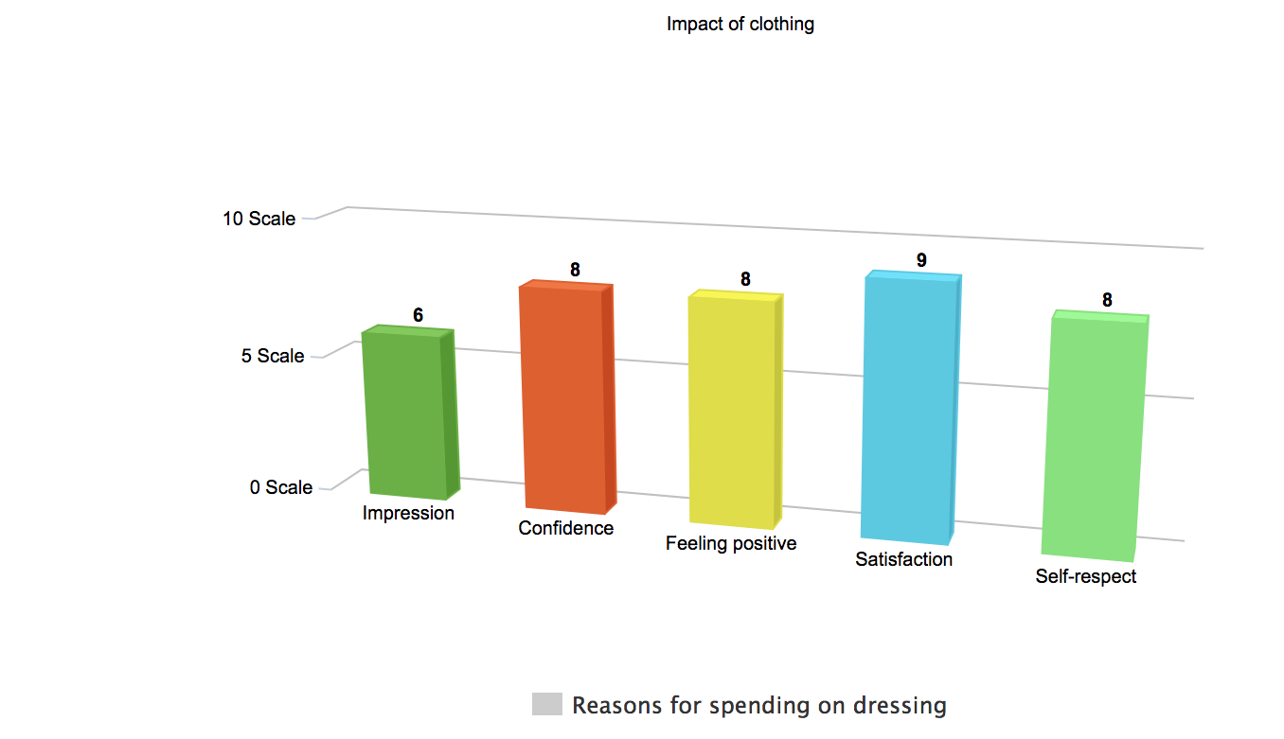
Celebrity also influences the decision of dressing. This is because following celebrities on social media provides a better sense of fashion and dressing. I try to buy what celebrities are wearing to stay trendy. What celebrity wear influence my personality and thoughts, so I also follow their dressing. This is also linked to positive feelings because it allows an individual to overcome insecurity and self-consciousness. Knowing fashion and celebrity helps in picking the right clothes that add to positive feelings. With confidence and comfort, one felt happier and satisfied depicting that dressing has a strong correlation with emotions.
The dressing is also linked with social status. People invest more in dressing to compete with others and to show that they are enjoying better social status. The inappropriate dressing makes one feel that they lack in social status. Without proper dressing, one cannot fit in the society. To avoid social criticism, it is important to choose the right dress. The way of dressing depends on adjusting to society. This indicates that without appropriate dressing one cannot adjust to society as everyone is following a certain trend and fashion, so it becomes a need to follow it. People in order to make themselves part of society adapt to the same dressing style.
The dressing is linked to an impression that means that it is important for building a positive image among people. It is thus influenced by the way people look at dressing. I invest in dressing for building a positive and attractive impression among viewers. Clothing reflects self-image as it not only affects how people perceive you but is also important for maintaining self-identity. The dressing has a strong correlation with self-respect. When I dress according to fashion and trend, I attain the feeling of self-respect. Better dressing means high self-respect. With appropriate dressing, I feel a better sense of self-esteem. This is also linked to high spirits and passion. The thoughts that I am not dressing according to trend or fashion will undermine self-esteem. So, by picking the right kind of dressing one would be able to feel a sense of satisfaction and respect.
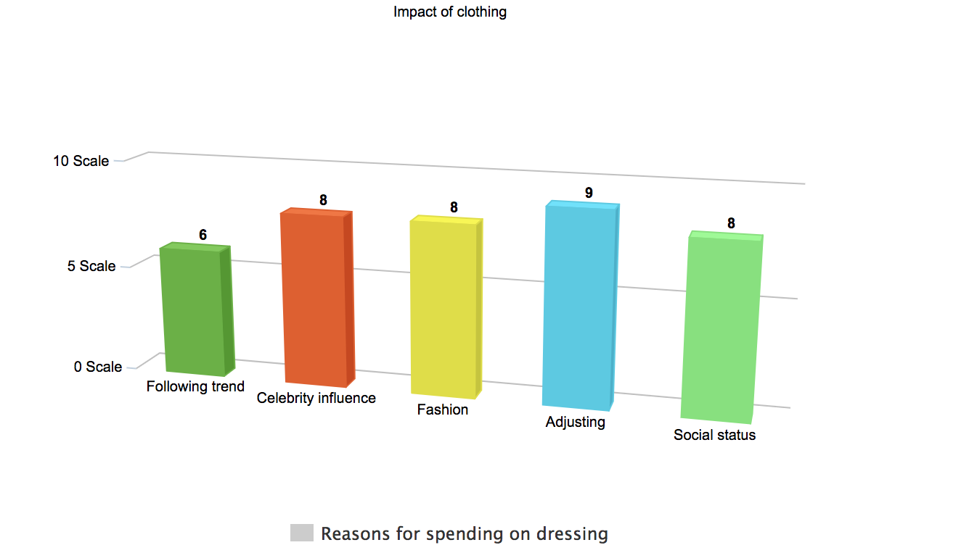

Feelings about dressing
The visuals indicate that dressing is not only linked to positive feelings, but it also has negative implications. When it comes to dressing it is important for me to make the right choice. I dress like this so I can assure you that I am wearing the right thing. I revealed that I spend more on clothing that is unnecessary. Having more clothes than needed reflects a waste of money. As I keep on adding more stuff in my wardrobe, it also reveals waste of money. Girls are spending more on the dressing. Stressors also influence dressing. I dress like this for overcoming stress caused by the feeling of dressing appropriately. A person who doesn't dress reasonably or is not following trend will be more likely to experience stress. So, by investing in dressing one can get rid of stress. Considering things like “if I am looking good in the outfit” exhibits stress level associated with clothing.
My feelings associated with dressing depicts that it causes worry. I think much about dressing and stresses on looking good. The worrying nature reveals that women fear about their looks and appearances. The findings also indicate that dressing is for competing with other girls. I feel that appropriate dressing is important at school to integrate with others. As everyone is dressing well, so it becomes essential to wear good clothes. The inappropriate dressing makes one look awkward. The reason for dressing like this is to ensure that I am following the same trend as others. Too much thinking about dressing causes stress and worry because it generates feelings of intimidation and discomfort. Unnecessary thinking also generates confusion when one thinks what we want to wear and what best suits us.
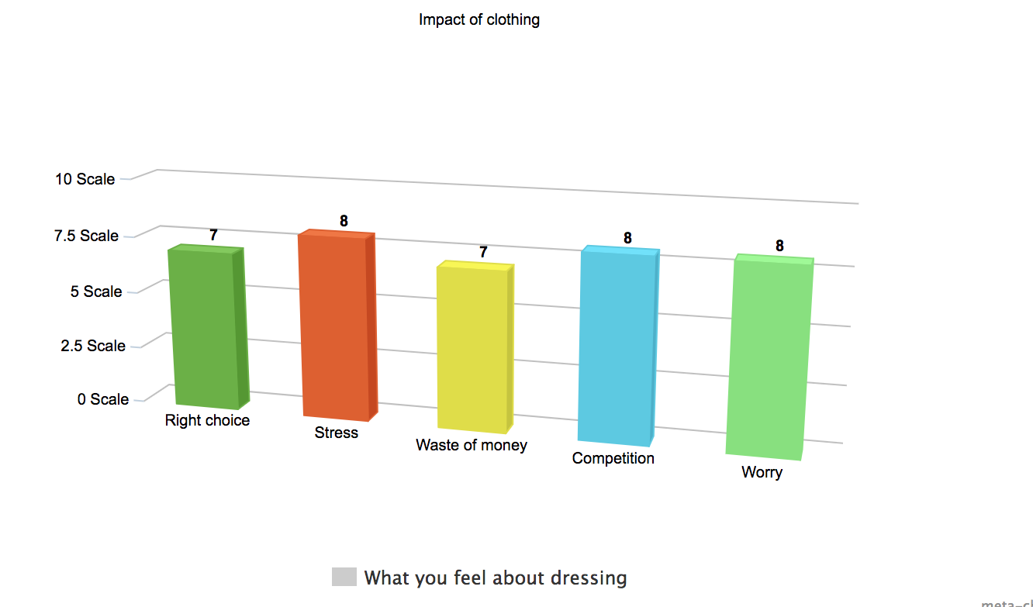

References
Arvanitidou, Zoi, and Maria Gasouka. "Construction of Gender through Fashion and Dressing ." Mediterranean Journal of Social Sciences 4, no. 11 (2013).
Ferguson, Jill L. How Clothing Choices Affect and Reflect Your Self-Image. 2017. https://www.huffpost.com/entry/how-clothing-choices-affect-and-reflect-your-self-image_n_9163992 (accessed 03 06, 2019).
Fletcher, Ben C. What Your Clothes Might Be Saying About You. 2013. https://www.psychologytoday.com/us/blog/do-something-different/201304/what-your-clothes-might-be-saying-about-you (accessed 03 06, 2019).
Johnson, Kim, and Sharron J LennonNancy Rudd. "Dress, body, and self: research in the social psychology of dress." Fashion and Textiles 1, no. 20 (2014).

Arvanitidou, Zoi, and Maria Gasouka. "Construction of Gender through Fashion and Dressing ." Mediterranean Journal of Social Sciences 4, no. 11 (2013).
Johnson, Kim, and Sharron J LennonNancy Rudd. "Dress, body, and self: research in the social psychology of dress." Fashion and Textiles 1, no. 20 (2014).
Fletcher, Ben C. What Your Clothes Might Be Saying About You. 2013. https://www.psychologytoday.com/us/blog/do-something-different/201304/what-your-clothes-might-be-saying-about-you (accessed 03 06, 2019).
Arvanitidou, Zoi, and Maria Gasouka. "Construction of Gender through Fashion and Dressing ." Mediterranean Journal of Social Sciences 4, no. 11 (2013).
Ferguson, Jill L. How Clothing Choices Affect and Reflect Your Self-Image. 2017. https://www.huffpost.com/entry/how-clothing-choices-affect-and-reflect-your-self-image_n_9163992 (accessed 03 06, 2019).

