Name
Name of Professor
Class
Date
Gender Wage Gap
"It was heartbreaking. I was disappointed and angry and thought that maybe someday I could figure out why it had happened". Said by Kerri Sleeman, now serves as the regional field manager for AAUW. Before she took this position in 2014, Kerri Sleeman worked for a company that "designed, built, and installed laser welding assembly systems" (Owens). After five years of serving in that company, the company experienced bankruptcy, so that every worker in the company received pay checks through the bankruptcy court. When looking at the list of claims, Sleeman found out that the men she supervised were receiving larger final paychecks then hers. It was the most devastating experience for her. When she inquired her former supervisor, he simply remarked that her salaries "weren't negotiable when she was hired." And her male juniors are receiving higher salary as they are "the sole breadwinners for their wives and children." Like many other people in the society supervisor also believed that her as she was married, it was fair and justified to pay her less than her male juniors. Even after giving five years to the company and working for extra hours, her extra contributions were meaningless because of her gender standing her way of getting her due right of equal or rightful wage. She like many other women was thinking the worst thing is that she couldn’t do anything to differently to get her due right. In society where men are considered as breadwinners, females always face this discrimination. Like many other women, in the end, she couldn't do anything to get back the money which was more than $10,000. Not only she, but her family also suffered the loss. According to her "Pay inequity is a family issue and it affects everybody” (“Bankruptcy Court Revealed ‘Heartbreaking’ Pay Inequity”)
Sadly, this is one of the many cases that still happen in this time even in America that is the largest economy in the world. The problem of the Gender wage gap is not simple at all; it has multiple causes and its effects are also numerous on the lives of the females. Even though the causes are complicated, it could be narrow down and concluded as the social prejudice towards women such as what can and what should a woman do, and how much they should be paid. The gender wage gap problem is not personal, although there are many different opinions about wheatear the gap is real or not, the effect of it on trade and men's social behavior are apparent.
Creating understanding of the gender wage gap issue is really important. This gender wage gap is the difference between the salaries of the men and female employees not on the basis on competency but the gender biasness. Gender wage gap has different ways of calculation, it is usually calculated on the basis of median of annual pay of full-time workers, and it can also be calculated based on weekly or hourly earnings of both female workers and the individual situation within a specific job field base on the different database(“The Simple Truth about the Gender Pay Gap”).
In the fig 1, data table representing the “Median Annual Earnings and Earnings Ratio for Full-time, Year-round workers” for Ages 16 and Older is given with respect to each state of America. By checking the number of earning ratio by state and gender, we can see that the problems of Gender wage gap are real. The highest earnings ratio of women and men are 91%, and the lowest ratio is 66%, and if we consider the wage difference for both genders in each state, it clearly shows that difference in wages exist. The lowest wage ratio state is Louisiana where men are earning 1.5 times what women are earing(“By the Numbers”).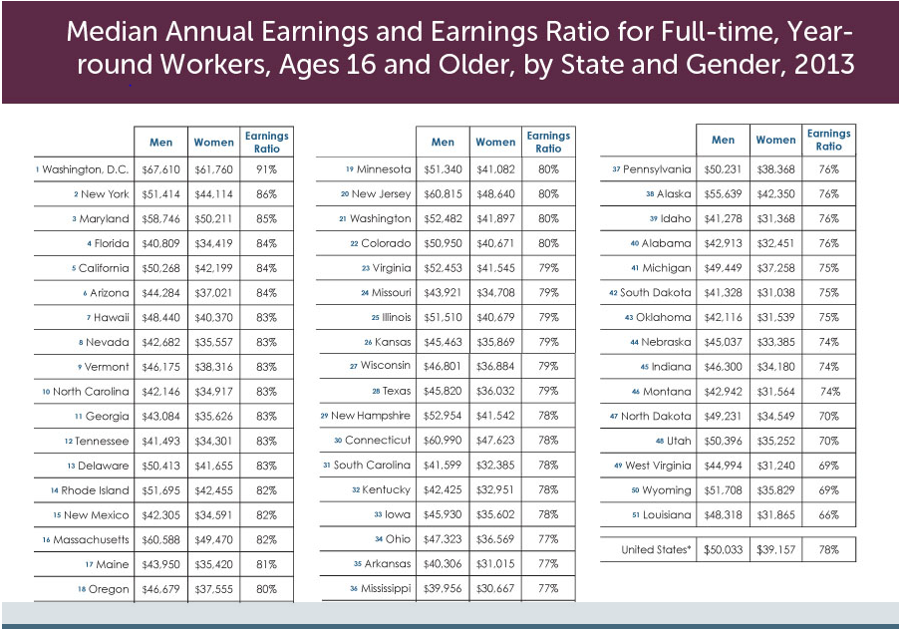
Fig.1: Median Annual Earnings and Earnings Ratio for Full-time, Year-round workers.
According to another report "Women had median weekly earnings of $794, or 80.0 percent of the $993 median for men"(USUAL WEEKLY EARNINGS OF WAGE AND SALARY WORKERS FOURTH QUARTER 2018). The data on "women's-to-men's earnings ratio" is definitely points to the deep underlying factors. It is not possible that such difference exists on the basis of nothing.

Even though the causes of Gender wage gap are complicated and it is difficult to comprehend them completely, the main reason could be narrow down to the social prejudices against women, or in another word, gender biasness. The existing of gender bias is rooted in people's mind; there is some common opinion of what and how should a woman do.
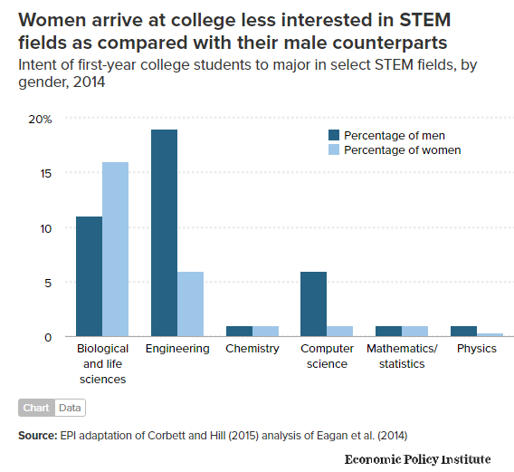
According to the study done by a senior economist, factors which contribute to the gender wage gap are "particularly occupational differences between women and men --- are themselves affected by gender bias." By collecting and analyzing the education levels, interest levels in various types of jobs, and various working environment; one of the biggest reason for women’s lower appears to be their choice of profession. "Female-dominated professions" are usually not the high-paid occupations in comparison to professions
Fig 2: Stats show that women are less interested in STEM fields

dominated by men. “Women arrive at college are usually less interested in STEM fields as compared with their male counterparts,". when women enter college, they usually have different ideas about the direction of their future professions in comparison to men (see fig.2). Due to their choice of career many high-pay job opportunities get close to women.
Although some women select the lower wage job, others other women want to pursue the high-pay job (for example, STEM careers). Based on the fact that these job fields are mostly dominated by men, the occupational opportunities for women in these occupations is limited. They get hired on such jobs with huge difficulty.
Social norms are different for the men but when the topic comes to women and their career choices people often have the option of a housewife. As what Gould quoted, there are "more than twice as many women engage in housework daily [compared with men], and women spend twice as much time caring for other household members." Because of the gender bias idea of housekeeping works, women are less likely to pursue or handle a job that required a huge workload, which usually happen to be the high-pay occupations (“‘Women’s Work’ and the Gender Pay Gap”).
The gender wage gap has effects on economic growth of the country and human rights of its citizens. As the wage gap grows, the situation of employee turnover in some job field become predictable. The wage gap has an inverse relationship with the market competitiveness, which is "the growth of the gender wage gap increases the concentrated sectors." As part of the result, they got, in a more competitive company, which was proven the best form of economic, has a smaller number of the gender wage gap. These results of the can be verified easily proves that inverse relationship between the gender wage gap and economic growth exists. So we can conclude that gender inequality is hurting "not only the individual but also the economic growth as a whole"(Wolszczak‐Derlacz).
While the wage gap indicated that men get higher payment than women even though they didn’t perform better, it could also result in some bad consequence. Often men despite of their poor performance believes that they deserve the high wages and never give any regard to others better performance “Men have internalized their normatively higher social position and are unwilling to forego the privilege of high reward that accompanies that position when that privilege is openly threatened”. It is obvious that the gender wage gap does not only hurt the women but the social behavior of man also. The family status of women is often considered lower than the man because of their payment are being seen as the amount of contribution toward the family((PDF) The Gender Wage Gap: An Explanation of Men’s Elevated Wage Entitlement).
There exists a serious connection between the domestic violence and lower wages of the females. It is observed that women who are victims of the domestic violence miss opportunities of seeking better jobs and promotions, due to their health situations. Domestic violence in the form of physical abuse, often results in women seeking leaves from their offices that eventually makes them look incompetent in the eyes of their employers. This results in women losing their bonuses and chances of increments. Such victim women also risk losing their jobs due to lack of performance and absentees Thus both wages and domestic abuse are highly interrelated. It is also essential for females to recover properly before joining their offices, but this “safe time” often results in them getting fired from jobs.
Many females also complain of getting late from job due to the domestic issues like fighting and bullying. Incase issues starts before office time; it results in getting absents(Roepe et al.).
While the average earning of women has increased in the past few years, the social and family status of women gets to rise, too. Many studies support that "the policies that serve to narrow the male-female wage gap also reduce violence(Aizer). It is fact that families where both partners share equal responsibility in terms income, issues of the domestic abuse also reduce.
The view of the existed of significant wage gap is not universal, Diana Furchtgott-Roth, an economist that has been nominated by President Donald Trump to serves as the Assistant Secretary of Transportation for Research and Technology. He claims that the gender wage gap is not real, "Men and women generally have equal pay for equal work now if they have the same jobs, responsibilities, and skills"(Researcher).So we can definitely conclude that difference in narratives exist regarding the difference in wages among the men and women.
However, the two-sided opinions exist that some people think that there might be some individual cases experiencing gender based wage inequality in the workspace, but these should not be taken as universal. As such incidents don’t represent the whole picture. The vast majority of employers don't harbor prejudice against women", said by June O'Neill, who served as the director of the Congressional Budget Office.
The disagreement on the importance and existed of the gender wage gap problem led to the debate on the necessary on the Equal Rights Amendment. According to the debated under the topic of Gender Pay Gap, Idella Moore, the Executive Officer, and Phyllis Schlafly, the president of Eagle Forum each present their view towards the sex discrimination and the Equal Rights Amendment. Idella Moore, the side which value the problem think the Equal Rights Amendment (ERA) are still needed because, including the gender wage gap, the problem of sex discrimination is still happening all around the world.
At the same time opinion exists that that equal Rights Amendment is a lost cause because it was brought up several times but every time it got turned down, which indicated the country doesn't need it anymore. According to Debate.org survey, women make less than men for the same work and About 72% of people disagree on the topic; they think the people on the other side "heavily misrepresented" the problem of gender wage gap, most of the people argue with the authenticity of the actual data and hold a skeptical attitude(Do You Believe in the Wage Gap and Why?).
As it was mention, the data and study prove the existence of the gender wage gap and show clearly how female workers are getting less pay than male workers within the same occupations. Even though the reality is proven, the debate is still intense. The cases of the gender wage gap are related to many different factors, and the biggest one is gender bias, which affect the major and job choice for young women. The sense of what and how should a woman be, creates a barrier between men and women, which could lead to a harmful effect on trade and economic growth. Also, the cultural norm about what kind of role women should be playing in the family is almost inflexible, which limits the opportunity of various jobs for women. Also the high-pay jobs require a huge workload, the effect becomes a drop-dead halt and intensify the gender wage gap.
The gender wage gap, deeply affects the man’s social behavior and results in creating unstable society because it gives the idea that men don't need to perform well to compete with women. Which according to economic theory, creates an inefficiency economic environment. Also, when women are earning less than men, it is considered as lower contribution toward the family and society. The social and family status of women gets hurt, and it also results in the rise of domestic violence toward women.
Until today, the debate around the importance of the gender wage gap is still going. It would be helpful if society could realize the causes and understand the effects of the problem. Once the topic gets fully understand not only by individuals but the society as a whole, we can hope to get towards the society that strongly believes in equal work ethics and wages for both men and women, not on the basis of gender but on the basis of competency.

Work Cited
Aizer, Anna. “The Gender Wage Gap and Domestic Violence.” The American Economic Review, vol. 100, no. 4, Sept. 2010, pp. 1847–59. PubMed Central, doi:10.1257/aer.100.4.1847.
“Bankruptcy Court Revealed ‘Heartbreaking’ Pay Inequity.” AAUW: Empowering Women Since 1881, https://www.aauw.org/2013/05/09/heartbreaking-pay-inequity/. Accessed 6 Mar. 2019.
“By the Numbers: A Look at the Gender Pay Gap.” AAUW: Empowering Women Since 1881, https://www.aauw.org/2014/09/18/gender-pay-gap/. Accessed 6 Mar. 2019.
Do You Believe in the Wage Gap and Why? https://www.debate.org/opinions/do-you-believe-in-the-wage-gap-and-why. Accessed 6 Mar. 2019.
(PDF) The Gender Wage Gap: An Explanation of Men’s Elevated Wage Entitlement. https://www.researchgate.net/publication/225158326_The_Gender_Wage_Gap_An_Explanation_of_Men’s_Elevated_Wage_Entitlement. Accessed 6 Mar. 2019.
Researcher, C. Q. Social Problems: Selections From CQ Researcher. Pine Forge Press, 2009.
Roepe, Lisa Rabasca, et al. “The Hidden Impact Of Domestic Violence On The Gender Wage Gap.” Fast Company, 30 Aug. 2016, https://www.fastcompany.com/3063253/the-surprising-impact-of-violence-against-women-on-the-gender-wage-gap.
“The Simple Truth about the Gender Pay Gap.” AAUW: Empowering Women Since 1881, https://www.aauw.org/research/the-simple-truth-about-the-gender-pay-gap/. Accessed 6 Mar. 2019.
USUAL WEEKLY EARNINGS OF WAGE AND SALARY WORKERS FOURTH QUARTER 2018. p. 15.
Wolszczak‐Derlacz, Joanna. “Mind the Gender Wage Gap – the Impact of Trade and Competition on Sectoral Wage Differences.” The World Economy, vol. 36, no. 4, 2013, pp. 437–64. Wiley Online Library, doi:10.1111/twec.12026.
“‘Women’s Work’ and the Gender Pay Gap: How Discrimination, Societal Norms, and Other Forces Affect Women’s Occupational Choices—and Their Pay.” Economic Policy Institute, https://www.epi.org/publication/womens-work-and-the-gender-pay-gap-how-discrimination-societal-norms-and-other-forces-affect-womens-occupational-choices-and-their-pay/. Accessed 6 Mar. 2019.

