[Name of the Writer]
[Name of Instructor]
[Subject]
[Date]
Writing Assignment #1: State Analysis

Part 1: State output, employment, and cost of living

Gross State Product (GSP)

GSP

Gross state domestic product is the aggregate value of all the goods and services produced during the given financial year within the g’
eographical boundaries of any particular state. GSP is also known as state income or SDP, and it is always measured in monetary terms. It helps in telling the economic growth in that particular state.

List of the current level of real annual GSP (in chained dollars) incorporating all the industries

Below is the list provided for all the industries that are contributing to the real annual GSP of Maryland state of United States of America (Bureau of Economic Analysis).

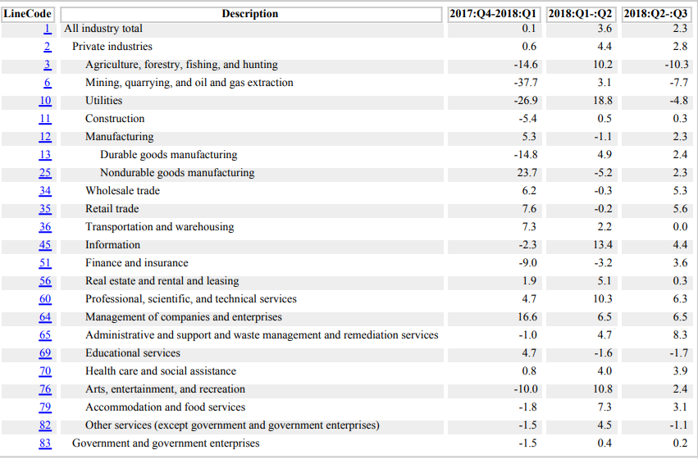

Calculation of 1-year percentage change in GSP from 2017 to 2018 (in chained dollars)

One year percentage in per capita is calculated for 2016-2017 for the state of Maryland (Bureau of Economic Analysis).

GeoFips | GeoName | 2016-2017
24000 | Maryland | 1.7

Discussion

Almost all the industries are in the increasing trend indicating a prosperous economy of Maryland. The Retail trade, information, professional, scientific and technical services, companies’ management, Administration, waste management and remediation services are the industries that are contributing the most the annual GSP of Maryland. There is a 1.7 percent increase in the GST per capita of Maryland for 2017-2018. Industrial growth in Maryland is far better than that of Colorado as the industries there are far better in GST contribution. The reason for this growth is that the workforce has rapidly increased over the past few years due to which production has grown and is keep on increasing (Shin et al., 2015).

Employment

Current labor force

The current labor force of the state of Maryland is 3194248(B) for Dec 2018 period.

Labor force participation rate

Below is the list of labor force participation rate for the whole decade 2008-2018. In 2008, the labor force participation rate was 4.3%. Labor force participation rate jumped to 7 percent following 2008 but again declined in the years after 2015, and it was now 3.9% in 2018.
2008 | 4.3
2009 | 7.0
2010 | 7.7
2011 | 7.3
2012 | 7.0
2013 | 6.6
2014 | 5.8
2015 | 5.1
2016 | 4.4
2017 | 4.2
2018 | 3.9

Employment

The number of people employed in the state of Maryland is 3075662(B).

Unemployment

The total number of people who are unemployed in Maryland State is 118586(B).

Unemployment rate

The unemployment rate is 3.7(B) for the state of Maryland of U.S.A.

One year percent change in the unemployment rate and the labor force participation rate

Unemployment rate for 2017-2018 is the difference of 0.3 percent. That means that unemployment has reduced up to 0.3 percent in Maryland. Labor force participation rate for 2017-2018 is declined from 4.2 percent in 2017 to 3.9 percent in Maryland (Historical Unemployment: Bureau of Labor Statistics).
Discussion

Looking at the given condition of employment in Maryland, the current force is rapidly increasing in the last decade. Today, the labor force in Maryland is more than it was in 2008. Due to the increase in the current workforce, employment has also increased as more and more people are getting employed by the organizations due to their skills. Unemployment is continuously declining with a 0.3 percent difference in each year in Maryland. Maryland has far better conditions of employment as compared to other states.
Cost of living

Cost of living

Cost of living is generally interpreted as the cost or expense of maintaining a certain standard in the economy. It also indicates the economic conditions of that state, whether they are good for the living or not. The changes in the cost of living are measured with the help of the value of the living index. This measure is also used to compare the standard of living in different geographical areas.
State comparison in the cost of living

I live in Denver and want to migrate in Baltimore, Maryland as there I am getting a $52,191comparable salary.
Discussion
I have noticed my expenses and price difference between the two cities. I have found that my grocery expenses will be 9, 10, and 15% more in case of groceries, housing, and utilities respectively. While transportation will be 2% and health care 13% less in Baltimore. I have found Denver is more suitable and less expensive as a significant part of salary consist of groceries and utilities which is higher in Baltimore. Baltimore is relatively cheaper with higher income to offer (Sharfstein et al., 2018).

Part 2: State summary

Maryland is a state of the United States of America that is going on a speedy economic growth currently. It has improved so much in the last ten years and is still performing well as compared to other states. Almost all the industries are in the increasing trend indicating a prosperous economy of Maryland. The Retail trade, information, professional, scientific and technical services, companies' management, Administration, waste management and remediation services are the industries that are contributing the most the annual GSP of Maryland. There is a 1.7 percent increase in the GST per capita of Maryland for 2017-2018. Industrial growth in Maryland is far better than that of Colorado as the industries there are far better in GST contribution. The reason for this growth is that the workforce has rapidly increased over the past few years due to which production has grown and is keep on growing (Shin et al., 2015). Looking at the given condition of employment in Maryland, the current force is rapidly increasing in the last decade. Today, the labor force in Maryland is more than it was in 2008. Due to the increase in the current workforce, employment has also increased as more and more people are getting employed by the organizations due to their skills. Unemployment is continuously declining with a 0.3 percent difference in each year in Maryland. Maryland has far better conditions of employment as compared to other states. There is a massive difference in the prices of the cities in Maryland and Colorado. The grocery expenses are 9, 10, and 15% more in case of groceries, housing, and utilities respectively in Maryland. While transportation is 2% and health care 13% less in Baltimore, Maryland. Denver is more suitable and less expensive as a significant part of salary consist of groceries and utilities which is higher in Baltimore. Baltimore is although expensive in some cases, but the high salary compensates for this (Sharfstein et al., 2018).

Works Cited
Bureau of Economic Analysis (BEA): Regional data, GDP and personal income…http://www.bea.gov/iTable/iTable.cfm?reqid=70&step=1&isuri=1&acrdn=1#reqid=70&step=1&isuri=1

"Cost Of Living: How Far Will My Salary Go In Another City? - CNNMoney." CNNMoney. N. p., 2019. Web. 6 Mar. 2019.
Historical Unemployment: Bureau of Labor Statistics (BLS): http://www.bls.gov/lau/home.htm
Mazaroff, Stanley, and Todd Horn. Maryland Employment Law. LexisNexis, 2018.
Sharfstein, Joshua M., Elizabeth A. Stuart, and Joseph Antos. "Global budgets in Maryland: assessing results to date." Jama319.24 (2018): 2475-2476.
Shin, Hyeon-Shic, et al. Measuring the economic contribution of the freight industry to the Maryland economy. No. MD-15-SHA/MSU/3-5. Maryland. State Highway Administration, 2015.

