Business Plan Assessment

1. Executive Summary:
The report consists of a detailed marketing plan that can help the Empire achieve its strategic objectives. The strategic objectives are based on the vision and mission of Empire and are directed towards the expansion of the company. To achieve the national and international objectives based on the increase in sales, reputation and brand recognition of Empire a detailed marketing plan is made which initially analyses the company and its business environment and recommend strategies to pave its way towards success in the local and international market. Moreover, it also focuses on the communication strategies to be used to communicate the goals and objectives to stakeholders of the company. To expand the business in an international market, gap analysis is conducted to identify the gap between available and required resources to examine the capabilities of the company.
A detailed environmental analysis is done to identify the strengths, weakness, opportunities and threats and a detailed macro analysis helps to identify the external factors that can impact the business of the company. Risk analysis highlights the threats that a company can face and based on all these observations strategies are designed using the Ansoff model to increase business sales and profitability both nationally and internationally. To implement the strategies successfully and to achieve goals different strategies such as communication, employee support and performance review methods have been designed which will make this plan effective. The drive of this report is to create a range of products of good quality in new colors, textures and experiment with new designs in our articles for the comfort of our new clients as well as for the good look of their homes.
Current Objectives
Local Objectives:
- By the next 3 years, Empire will have an increase in sales by $20 million per year in Australia.
- The Empire loyal customer list will be heightening from 10,000 to 15,000 clients for the next year.
- Empire will be recognized for 1 in 3 people by 2022 all over the territory.
The expansion of business across the border has provided the corporation to enhance its business in various regions. China in this regard is a big market and it is also supported by well and sustainable business environment. The increase in clients and achievement of objective before 2022 is mandatory for Empire. It will effectively achieve the said requirements.
International Objectives:
- In the next 3 years, Empire has to reach $2 million per year in China.
- At the first quarter of the year, the Empire loyalty customers must reach the 5,000 clients in China.
- By the next 18 months, Empire is determined to be one of the most significant home-wares brands being recognized at least for 1 in 50 people in China.
Other than the local business international environment is quite competitive which reflect that Empire should attract customer who buy large quantities of product offered by it. Quality enhancement and reliability will boost the business for more than 5000 customers in the market of China.
Targets and Sales Growth
There are certain targets and objectives set by company for Sales growth to increase to 16% per annum – otherwise growth becomes uncontrollable. The share of market to remain at 11% - maintain share in growing market. Industry expected to continue growing at 13.75. The expenditure to acquire new business increase to 16% to accommodate new online distribution channel and as Empire is not currently in China, hence their targets for sales growth are less. They are not familiar with the market conditions and market growth can’t be predicted. However, in the next three years they want to be at $2 million sales per year. Once Empire is able to build brand recognition and customers in China, they can expect to grow.
The analysis of Gap in the relation with the human capabilities and resources illustrate that the company will have to find out the real and potential workforce for excellent delivery of services. Through a proper, sustainable and internationally trained staff the core objectives can easily be achieved by the Empire. Technology and use of robotic instruments are the key factors in contemporary business in China.
Same like the potential and increase output from the trained workforce, the company will ensure the comfortable and stable environment for clients of diverse background. There are multiple choices and options for the clients and these can meet through the collaborative efforts by higher management, senior staff and trained field workers that are posted in various warehouses. Hard work or the troublesome position for the establishment of business requires the recognition of brand in new settled areas like China.
After the initial step there would only place for good relationship because the recognition of brand is itself a great success in the business. In order to do an effective strategic planning, the organisation needs a strong base or foundation on which it can build objectives, goals and business strategies. Capability gap analysis is important because it helps an organisation in assessing that foundation and the important factors that have to be addressed before any strategy is implemented. Moreover, gap analysis gives a direction for the further future actions. The loyalty and positive feedback over certain products will enhance the market position of Empire.
Further the demographic environment is strives for the professionalism in serving and appeasing the clients. The company will have wonderful chance of ensuring the competitive edge over all other brands use in the place like China. Business is expected to continue growing and the expenditure to acquire new business increase to 20% to accommodate new online distribution channel and as Empire is not currently in China, hence their targets for sales growth are less. They are not familiar with the market conditions and market growth can’t be predicted in the establishment of new business.
Business profile
Description of business: Family based business comprises of the group of stores in Australia. More than two decades the company incorporates beautiful showcasing and homewares. With quality based items supplied to the clients that are available across the Australia and associated regions it has enhanced the collection of items. In the next three years the management want to be at $2 million sales per year. Once the Empire is able to build brand recognition and customers in China it will have worth of earning in international market. The past experience of expanding business in Australia is successful and it encourages the management to come up with new business plan for the region of Asia. Strategic partnership with other stakeholders in China would be considered if the company finds better position during the negotiation.
Business name: Empire Homewares
Type of industry: The operations of the business and items provided by the corporation include the stool, sofa, side table, bookcase, bedside, bed and other miscellaneous items used in the house. Various types of furniture are also designed within the reasonable prices.
Business structure: The structure of the business is based on collaboration with the designers and related companies that are operating in the same way.
ABN: Registered Australian Business Number: 48009133082
ACN: Registered Australian Company Number: 009133082
GST: The Company is registered for GST and regularly pays the required tax on its products and services. Since the two decades it is performing its functions under the specified rules issued by tax authorities.
Business commencement date: Start of the business was done two decades ago in February 2000. The formal operations started shortly after the commencement.
Number of years in operation (if applicable): we have more than 18 years of experience in operating at various regions of the Australia.
Business location: The location of the business premises is stretched at various regions and cities in Australia. The main address is West Perth WA 6872 Australia.
Buy/lease: The purchased of the premises or those which are currently leasing will include the new places at Chinese markets. Like the places Claremont WA 6010 and the Prince Street Busselton are the central stores which will be expanded in a due course of time.

Operating Strategy

Location and premises
According to the new marketing plan for the international expansion of Empire warehouse and the establishment of this brand in China by setting strategies and priorities as well as developing skills to evaluate, plan and execute the entry into this new market. Empire is a chain of home-ware stores with a total of 16 stores in Brisbane. The growing and locally expansion of this brand has been done with such a good success all over the territory that has been put in consideration the possible international expansion of this brand, being China the first market to be explored. China could be a good market to start with, due it is considered the Australia’s largest trading partner because of the standards and business aspect that China has kept during its business history with Australia, also the huge sales market and cost saving potential this country offers.
Table 1 – Premises
Description of premises | Description of location: The state of China is considered as the premises where the location will be decided in Beijing and the material that is present in the premises of Brisbane will be transferred.
 | Parking: An extensive and large part of the area near to stores would be preferred for easy movements of clients and those who are regular visitors.
 | Future Growth or Development Plans: Other items that are used in the houses and demanded by our customers will be included in the future. Innovative designs of furniture are under process for their development and possession.
Owned (Bought) Premises | Date of purchase (21-02-2000)
 | It was a Single story
 | Premises of the stores are near to home
Future Growth or Development Plans:
The business requires further expansion and incorporation of clients from various parts of the world. It will also include the expansion of premises

Home-based business | Part of house being used: The services are based on home based working where the company had started work from home and it expanded to the various stores, which are located in different parts of Australia.
 | Future Growth or Development plans: Since the plan for expansion is already decided and location is allocated in China, it would be better to expand it more and more as the clients are increasing every day.

Owner Profile
Business owners: Elissa Coleman
Experience:
- The managing director of the organization was a Perth designer. His designed were lauded and appreciated by many. He has a degree in art and design from the University of Curtin. Before opening the branch of his own business he moves to various places for searching some job and to earn money. In the fashion magazine he work for a short time and laid the foundation of his own store Paddington Street.
- His experience and training at the fashion magazine offered him a great area of learning and to explore the hidden talent that was deepen into him. Fashion designing was like the food for his thought and he really wanted to be an artist.
- He had interaction with various agencies and manufacturers who helped him out through their experience of styling and business.

Business performance at a glance
The overview of the contemporary position of business is positive and people like the products and services provided by Empire. There are multiple choices and options for the clients and these can meet through the collaborative efforts by higher management, senior staff and trained field workers that are posted in various warehouses.
Hard work or the troublesome position for the establishment of business requires the recognition of brand in new settled areas. With every day it is expanding. Designing has a very close relationship with the summer and the owner is always waiting for the season to come up with something distinguish.
Children things, homewares and stocks of collections are central to the interests of owner. From the trained workforce, the company will ensure the comfortable and stable environment for clients of diverse background. There are multiple choices and options for the clients and these can meet through the collaborative efforts by higher management, senior staff and trained field workers that are posted in various warehouses.

Social media
Provide social media information below:

Table 2 - Social Media
Social media site | Address
E.g. Website | https://empirehomewares.com.au/
Social Media | Great Perth Social #3 - Empire Homewares
Instagram | @EMPIREHOMEWARES

Performance Objectives
Provide/develop minimum three (3) performance objectives and measures and discuss how you consulted with key stakeholders (e.g. internal/external personnel) to be part of creating these SMART goals (Pg. 22, 26 & 130 LG).
Discuss above you table the importance of identifying SMART Objectives and why stakeholders need to be consulted.

Table 3 - Performance
Performance Objectives | Measure(KPI’s) | Stakeholder Consulted
Increase in Sales | 15% by Dec 2019 | Sales Department, Sales Staff, Manager/Department Head
Designing of new items | More than 10% | Training and Designers
Expansion | 3-4 cities by 2020 | Administration and Senior Management

Risk Assessment
Above your table discuss the importance of what risks you have identified that stand out for the business to be aware of.
Table 1 - Risk Analysis
 | RISK | Likelihood | Impact | Strategy/ Recommendation
1 | Limited marketing budget  (Local & International) (R) |  | M | More efficient marketing strategies to keep customer acquisitions low ( referring, rewards, word of mouth)
2 | Long term repayment plans (R) |  | H | After pay, interest-free short payment plans
3 | Stores that are employee-run, overheads (R) |  | M | Staff according to demand, clear set KPIs, commission, performance appraisal, lighting sensors, solar roof panels
4 | Trade laws (R) |  | H | Research, check government portals, networking
5 | Failure of Marketing objectives (R) |  | H | Contingency plan

The pursuance of risk analysis for Empire Homes will incorporate an effective strategy like limited marketing and a reasonable budget to explore its product in the local and international market. These also include referring and word of mouth, where the customer will be engaged for trust building and long term feasibility of the products and parts of furniture. Further, the interest free plans enlarge the payment and acquire the attention of common member associated with Empire. The modernization of the various stores will be done according to the plans and system that it will not affect or influence the business.
Every type of risk will be analysed in a proper way to save the company from collateral damage. It is essential to follow the trade laws to remain active on the list of government recognized institutions and receive a positive response from the executive. The training of employees and other workers is again important to ensure the safety measures from various dimensions. A business person has to keep all the things in its mind because there are certain chances of failures of marketing objectives. It usually happens in the local as well as the international business arena. To tackle such types of the situation there is a need for a contingency plan that can play a role as an emergency responder for the effectiveness and sustainability of the Empire products and services.
9. Environmental Analysis
Internal Environment
Strengths | Weaknesses
- Quality, range and accessibility of products above competition (L).  - Highly qualified staff (L)  - Store Facilities/Bright clean and functional (L)  - Location/easy access  - Transactions – (choice)  - Loyal customer base  - Assortment of unique and stylish home-wares  - Superior after sales service  - Brand recognition  - Steady sales | - Limited marketing budget (L & Int) (R)  - Long term repayment plans (R)  - KPI’s not clear (R)  - Limited region area Brisbane only  - Lack of training – not consistent (R)  - Performance appraisal not being conducted  - Rewards program out dated  - Low memberships(R)  - On-line ordering and payment option  - Stores that are employee run, overheads(R)
External Environment
Opportunities | Threats
- More sales opportunities outside Brisbane region/nationally  - Growth in a growing market  - International opportunity – research mode of entry and how this approach can be adopted  - Build relationships – nationally and internationally  - Increase in migration – building activity – show home  - Increase sustainable practices  - Increase in demand for Australian Product – status | - Recession leading customers to spend less with non-essential home utensils (R)  - Competition – threat of substitutes(R)  - Entering a market overseas(R)  - Government restrictions/Trade agreements (Int) (R)  - Economy – slump – less disposable income for luxury items (R)

The environment analysis reveals the strengths, weakness, opportunities and threats of Empire. Empire can use its strengths and opportunities to cover its threats and to fight the threats it can have. Environmental analysis shows a lot of strengths such as quality of its products, brand recognition, loyal customers, qualified stuff etc. that can be used to deal with the weakness such as lack of training, low memberships, and overheads. Different business opportunities are available for the company to enter the international business as growth and sales opportunities. However, there is a lot of competition and entering a new market overseas can be threat for the company.
PESTLE Analysis
Political | Economic
- Political changes (elections) (R)  - Labor laws - changes(R)  - Taxes  - Trade laws(R) | - Large increase in interstate migration which affects the building activity and home ware needs  - Exchange rate  - Economy state (stable, slump, recession, boom ) (R)  - Employment status
Social | Technological
- A house-proud lifestyle  - Cultural differences(R)  - Customer fluctuation  - Current trends  - Migration patterns(R) | - Younger people (20-50 year old) are tech-savvy  - Accessibility through online platforms  - Needs to be user friendly  - Multiple platforms (R)
Environmental | Legal
- Expectation by government sustainable practices  - Natural disaster(R)  - Current sustainability laws  - Change of climates | - Current legislation (local and international) (R)  - Labor laws- legislation(R)  - Marketing ethics  - Qualifications  - Healthy and safety laws
Environmental Obligations
As we know the Pestle analysis is the macro environment analysis which shows the Political, legal, economic, social, and technological and the environmental analysis. Different factors are being identified in the analysis, some of them can be the risky factors such as Trade and Labour laws and elections that may affect the business performance and impose some restrictions to the company. Economic conditions of the country impact the buying power of the people and hence can impact business sales. When the company enters international business cultural differences and migration patterns can affect the business activities. New laws can also be a risky factor for the company.

10. Risk Analysis
 | RISK | Level  H, M, L | Strategy Recommendation
1 | Limited marketing budget  (Local & International) (R) | M | More efficient marketing strategies to keep customer acquisitions low ( referring, rewards, word of mouth)
2 | Long term repayment plans (R) | H | After pay, interest free short payment plans
3 | Stores that are employee run, overheads (R) | M | Staff according to demand, clear set KPIs, commission, performance appraisal, lighting sensors, solar roof panels
4 | Competition – threat of substitutes (R) | M | Brand recognition, unique, stylish, avoid discounts, point rewards, provide limited editions for some products, guarantee
5 | Entering a market overseas (R) | H | Thorough Ground work /homework, building relationships, market research, trading laws and legislation, suppliers, negotiations, contracts, training, mode of entry(partnerships, joint venture, alliance)
6 | Trade laws (R) | H | Research, check government portals, networking
7 | Natural disaster (R) | M | Research the area/region, have contingency plans, insurance
8 | Multiple platforms (R) | L | Constant control checks and reviewing, updating, ensure we have appropriately qualified expertise, cross trained staff
9 | Failure of Marketing objectives (R) | H | Contingency plan
10 | Changing Demographic for pandemic reasons (R) | H | Insurance

Empire has to conduct the risk analysis so that they can eliminate any risks that can occur and become a threat to their business success in the international environment. These events are analysed and mitigated to see how risky they are to the company in the new market and make us, be ready to face any situation and get the success of the project or the business we are investing in.
11. Cause and Effect
Fish Bone Diagram
Product

Threats of substitutes
Failure of Marketing Objectives
Promotion
Place
Online promotion failure and
Limited Marketing budget
Lack of 24hours support
Competitors prices
Price

In the planning of business there is always need of analysing the cause and effect. It is because every promotion has some background of the product or it is the place where effective strategy work. Same is the case with Empire Corporation where the plan will include the threat and related support for completion of the products that is issued and manufactured by parallel companies in Australia. Further the availability of service at 24 hours will give enough space to the business for boosting and expansion. The online industry has also provided more opportunities to company where it can effectively approach the other regions of the world.
12a. Marketing Opportunities
An opportunity for the marketing is open for Empire which can serve through the managerial management of supplying and purchasing the products. The guarantee, price, promotion and other aspect will be addressed in an effective way. Reasonable price and the use of broachers can adjust the values and it will attract the client.
Marketing Mix | Local | International | Responsible
Product | - Unique home-wares specialized in bathroom and bedroom fittings, mirrors and decorative items.  - 3 years guarantee on every item sold  - High quality of stylish products with limited editions.  - Lighting fixtures | - High quality of stylish products with limited editions  - Adjust cultural value designs – adaptation.  - Furniture  - Unique products | - Sales Manager  - Marketing Manager  - Designer
Place | - Currently 15 stores within Brisbane area and growing to 100 Australia wide.  - Purchase online through website.  - Warehouses out of city for builder developers to visit.  - 24 hour online availability  - Easy to get to (location) | - Purchase online through website  - All invoices should include website address  - Store location would be on wealthy-suburb area (Guangdong).  - Public transportation close to the Display store so customers will have an easy access.  - Have a pilot store in place | - Logistics Officer
Promotion | - In-store promotions  - Online promotions through email, website and social media ( Facebook page and Instagram) ‘Find us at www.empire.com’  - Company’s web page will also carry the advertising visuals on the home page and will use the PR copy in article marketing on popular article content sites.  - Rewards program and VIP launch events for our loyal customers.  - Expos  - Company logos on vehicles | - Small Brochures  - Online promotions through email, website and social media ( Facebook page and Instagram) ‘Find us at www.empire.com’  - Keywords will also be secured via pay-per-click traffic directing  - Loyalty programs for retail and wholesale trades.  - Billboards on bus stations. | - Marketing department (name staff)  - Web site designer  - SEO
Price | - Sophisticated people who are house proud.  - Reasonable and affordable prices compared with the purchased quality of the products.  - Economies of scale within the building operators  - End of season specials/discounts  - Bundle packaging | - All invoices should include payment options.  - Prices will be equal of the product’s quality  - Adjust pricing in comparison with a medium to a high income of the Chinese population.  - Reasonable and affordable prices compared with the purchased quality of the products.  - Currency from Australian Dollars to Renminbi.  - Taxation changes when expanding premises to China.  - Transportation costs and distribution | - Marketing Manager  - Sales Manager  - CEO  - Finance

Cultural analysis is done to evaluate the business culture and measure consumer preferences. The marketing team of the Empire will conduct cultural analysis to identify the need and motivations of the customers for its products. The cultural analysis also includes the identification of buying behaviours of the people of China and how these cultural values are related to the products of the company. Moreover, broad cultural values about the family, home improvement and decoration should also be identified so that the products may not conflict with the cultural values of the people of China. The promotional methods must be decided according to the culture and preferences of the people of the country. Colours, themes, images and the sales personnel most relevant to the culture should be adopted.
The method of distribution acceptable in certain culture should be employed. The difference in the host country must be kept in mind before taking any decision. Based on the business culture and consumer preferences of a country, market structure will be chosen by Empire. The business structure not only depends on the buyer's references but also on the buyers and the entry and exit barriers in the market. The market structure defines how well Empire will carry its business in the international market and how it will price and supply its good. The four types of the market structure include perfect competition, monopoly, oligopoly, and monopolistic competition.
12b. Product Adaptation/Standardization
Since Empire is an Australian brand exploring the Chinese sector; the product adaptation will help to the business to entry with a greater facility to this new market area. Having in consideration, China is a country with a completely different culture than Australia, by doing the adaptation in the Empire’s product; it will allow the brand to meet local culture and regulatory requirements necessaries to attract a new type of customers. No doubt, the Product adaptation is a strategy Empire has to follow at the moment to export its products to China or any other country to reach the success in sales.

 | Local
Product | - Unique home-wares specialized in bathroom and bedroom fittings, mirrors and decorative items.  - 3 years guarantee on every item sold  - High quality of stylish products with limited editions.  - Lighting fixtures
Place | - Currently 15 stores within Brisbane area and growing to 100 Australia wide.  - Purchase online through website.  - Warehouses out of city for builder developers to visit.  - 24 hour online availability  - Easy to get to (location)
Promotion | - In-store promotions  - Online promotions through email, website and social media ( Facebook page and Instagram) ‘Find us at www.empire.com’  - Company’s web page will also carry the advertising visuals on the home page and will use the PR copy in article marketing on popular article content sites.  - Rewards program and VIP launch events for our loyal customers.  - Expos  - Company logos on vehicles
Price | - Sophisticated people who are house proud.  - Reasonable and affordable prices compared with the purchased quality of the products.  - Economies of scale within the building operators  - End of season specials/discounts  - Bundle packaging

 | International
Product | - High quality of stylish products with limited editions  - Adjust cultural value designs – adaptation.  - Furniture  - Unique products
Place | - Purchase online through website  - All invoices should include website address  - Store location would be on wealthy-suburb area (Guangdong).  - Public transportation close to the Display store so customers will have an easy access.  - Have a pilot store in place
Promotion | - Small Brochures  - Online promotions through email, website and social media ( Facebook page and Instagram) ‘Find us at www.empire.com’  - Keywords will also be secured via pay-per-click traffic directing  - Loyalty programs for retail and wholesale trades.  - Billboards on bus stations.
Price | - All invoices should include payment options.  - Prices will be equal of the product’s quality  - Adjust pricing in comparison with a medium to a high income of the Chinese population.  - Reasonable and affordable prices compared with the purchased quality of the products.  - Currency from Australian Dollars to Renminbi.  - Taxation changes when expanding premises to China.  - Transportation costs and distribution

13. Product Market Growth Analysis – Ansoff’s Matrix
The matrix aims to provide the support, market growth and the senior management a framework that helps them in devising policies and the future plans for sustainability and production. The phenomenon was generated as a concept by Ansoff Matrix to enlarge the services and corresponding set of missions.
 |  | PRODUCT GROWTH
 |  | Existing | New
MARKET GROWTH | Existing | Market penetration  Market and Advertising programs  Addition of sale resources  Expansion of the list of products to be sold in China | Product development  Create a development plan in China  New pricing and packaging on products  New channels such as agents or intermediaries
 | New | Market Development  Production of new products in China  Offer low and competitive pricing  Daily products inclusion | Diversification strategies  New products in China  New designs in products and variants  Develop related products or services

As we know customers are the ones who have the power to determine how successful the business becomes. By having a clear understanding of customer preferences, the business get the right direction at the moment to sell products or offer a service, guarantee customer’s satisfying and hence to attract much more of them. It is so important to understand what customers like, what they do not and what they really want, because it will definitely bring a chain of benefits such as improve the image of the business, referrals and great sales, which are very important when a business is penetrating a new market area for the growing and recognition of this.
14. Feasibility of strategies
Local

Strategies | Feasibility | Justification
Market and Advertising programs  Addition of sale resources  Expansion of the list of products to be sold in China | Company can invest in the online and web advertisements by different channels by assigning role and responsibilities to new personnel | Marketing and advertising will help targeting the new markets that are not yet targeted. Adding the new sales sources will increase the sales of existing products in existing market.
Create a development plan in China  New pricing and packaging on products  New channels such as agents or intermediaries | Product Development Plan is China is less costly and has labour with the set of skills required | New Pricing and packaging will attract new customers  New Channels can make the sales process easy and assist in the sales of products
International

Strategies | Feasibility | Justification
New products in China  New designs in products and variants  Develop related products or services | New personnel and skilled labour can create new innovative designs  Same related products can be made easily due to the experience in area of home wares | These strategies will help one business or product stand if another fails  Related products
Production of new products in China  Offer low and competitive pricing  Daily products inclusion | Skilled labour is available in China for production of new products  Cheap cost of production can help in achieving low price | Customers want a whole range of products and demand a larger selection to choose from

The strategies are developed to achieve the local and international business objectives of Empire. To increase sales and brand recognition in local market company will focus on advertising and promotion. It has allocated certain budget for that and hired new personnel that will focus on web advertising and content marketing. For the local market new product development plan can be developed. China is less costly and has labour that is more skilled. Empire will be able to produce large range of products and sell in local and international market. For the international market, new products can be developed by the skilled and creative labour in China. Empire's experience in the area will also be helpful. In addition, company can adopt the diversification strategy in the same related business to excel. Cheap cost of production will also help in achieving low price.
15. Marketing Objectives
 | Objective | Resource Increase | Resource Increase
1 | In the next 3 years, Empire have to reach $2 million per year in China | - Financial capital  - Marketing tactics  - Advertisements  - Remove unprofitable products  - New additions/products  - More productivity | - Marketing Consultant  (specific in analytics)  - Project manager  - Advertising experts
2 | At the first quarter of the year, the Empire loyalty customers must reach the 5,000 clients in China | - Promote the business on social media  - Feedback  - Expansion of the network  - Be on demand | - Advertising experts  - Marketing consultant
3 | By the next 18 months, Empire is determined to be one of the most significant home-wares brand being recognised at least for 1 in 50 people in China | - Great customer service  - Create a social media presence  - Provide values  - The use of blogs  - Use the same logo in all marketing materials | - Graphical design  - Website designer  - Marketing consultant

To achieve the marketing objectives Empire has to adopt strategies to enhance its resources and organisational expertise. To achieve the objective of $2 million in China, the capital, marketing and advertisements has to be increased by hiring the marketing consultants, project manager and advertising experts. To increase the number of loyalty customers in China, business has to be promoted on social media by hiring the experts. Customer’s feedbacks must be obtained. To increase the business awareness good business practices must be adopted by hiring experts.
16a. International Marketing Approaches
International Marketing is referred to as the purchase and sale of products and services in a market which acts as a platform for other markets. By advertising the products and services on same platform companies from different countries try to draw customer attention. It is very famous saying ‘think global, act local’. Empire has to adapt the customized approach in order to match the products and services with the local market and choices or preferences of people. The cultural differences are important to consider before meaning any international marketing strategies.
16b. Marketing Trends
The strategic objectives of Empire include both national and international objectives. The marketing phenomena keeps on changing as the consumers keep on demanding new and stylish products. To increase sales Empire has to use the modern advertising tactics such as web based and content marketing. To enhance business reputation and recognition Empire has to focus on user generated content to interact and engage with customers using the multichannel marketing and branding techniques. Experiential and influencer marketing are also the modern marketing trends that Empire has to use to achieve its strategic objectives.
17. Modes of entry (Marketing Opportunities)
Mode of Entry (Ranking) | Strengths | Weakness
Joint venture | Access to core competency and management skills of the partners | Dependence on local partners
Direct exporting | Higher Profits  High knowledge of customers  Better understanding of market | More time and energy required  Handling logistics alone
Franchising | Low failure rate | Large initial investment
Strategic alliance | Access to Partner’s Resources  Help access global markets | Dependence on partners  Clash of corporate cultures
Indirect exporting | Risk-free Business  Less involvement in the export process | Less profits  Less control on foreign sales  Less knowledge of customers

Based on the strategic objectives of Empire, it is good for them to go for the Joint Venture as it will not only help them in having access to the skills and knowledge of their partners moreover they can get customer knowledge which will help them in gaining customer loyalty. They can be recognized as a good business in local market of China with help if their partners.
18. Implementation
Through the various tactics and steps the process of implementation will follow a formal process. It is because of the nature and expansion of business over the required span of time. The definition, communication, monitoring, evaluation and the documentation of performance will ensure the proper implementation of plan.
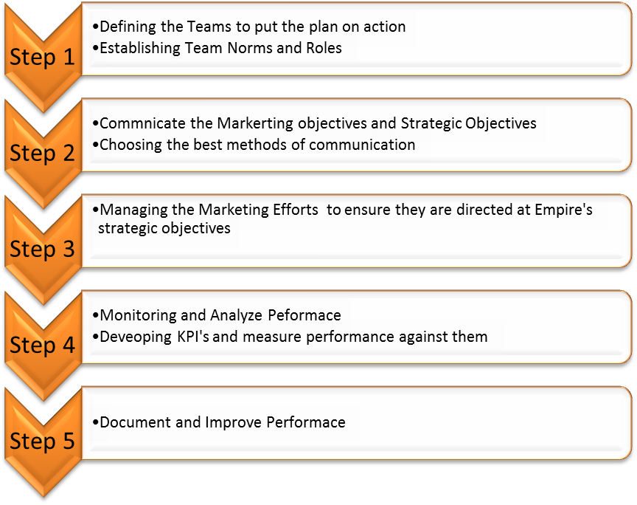
18.1 Implementation of tactics
In order to achieve the marketing objectives and to implement the marketing plan of Empire. The first task is to develop a team and define the roles and responsibilities of each team member, after that we should communicate the plan; one of the members will play the role of ‘Resource Investigator’ from Belbin’s nine roles. To judge the progress of marketing plan, the sober one will take the role of Monitor Evaluator and the cooperative diplomat designate will be responsible to resolve any conflicts arising in the team.
The Specialist will give ideas and the implementer will turn ideas into actions. The Marketing Manager will be taking the role of managing the whole team. To keep the track of progress it is important to monitor the activities and their contribution towards the goals and objectives. The performance will be measured against the Key Performance Indicators. For example, the customer retention and loyalty rate must increase and the brand awareness can be measured by the number of visitors on web site and increase in followers.

Implementation Table
Strategy/Objective | Tactic | Scheduling | Cost | Accountability
Increase sales 15 mil to 20 mil in the next three years | 24hr online chat/service  Reward program  Specially event VIP customers  Online Payments | Effective immediately  By Mid Feb 2019 | TBA | Store Managers  Assistant Store Manager
Increase the loyal customers from 10000 to 15000 clients, and 5000 clients in China | Improvements in the Customer Service  Meet customers’ demands and expectations  Exchange and Refund Policies  Ensure the right and timely delivery | Effective immediately  By End Feb 2019 | TBA | Customer Service department  Sales Manager  Marketing Team  Logistics officer
Brand Recognition locally and internationally | Web and Social Media Branding  Content Marketing  Influencers Branding | Effective immediately  By End Feb 2019 | TBA | Marketing manager  Marketing Team  SEO and web designer

It is important to get the reviews of the on-going tactics that if they are contributing to the marketing and strategic objectives of Empire or not. All the tactics mentioned above are directed at the objectives of Empire however, evaluation is important to see the purpose they are fulfilling. They can be adjusted if they are getting out of budget allocated by the management to specific task. Remaining in the budget constraint the tactics have to be fulfilled to achieve the objectives.

19. Communication Strategy
The communication strategy implies various elements like the sense of responsibility, promotion, place and the product identification in a professional way. There are two major aspects that are important by one or the other way. Marketing at the local level and at the international regions requires a comprehensive plan of action which will work under the proper communication.
Marketing Mix (Local) | Responsibility
Product | -Sales Manager  - Marketing Manager  - Designer
Place | - Logistics Officer
Promotion | - Marketing department (name staff)  - Web site designer  - SEO
Price | - Marketing Manager  - Sales Manager  - CEO  - Finance

Marketing Mix (International) | Responsibility
Product | -Sales Manager  - Marketing Manager  - Designer
Place | - Logistics Officer
Promotion | - Marketing department (name staff)  - Web site designer  - SEO
Price | - Marketing Manager  - Sales Manager  - CEO  - Finance

It is important to communicate the marketing objectives to all the personnel in the organisation who can play their part in achieving those objectives. The communication strategy that can be used to communicate timely performance in all the departments is meetings at different intervals and emails.
All the departments and personnel responsible must communicate the performance based on KPI’s and what to do and what to avoid to remain on track. Choosing the best communication method is essential to suit the culture and needs of the personnel and the stakeholders of the company. The communication audience has to be given importance before choosing any method.
19.1 Communication Messages
The market trends and customer demands keeps on changing. Moreover, the organisational requirements also change over time. Monitoring has to be done to keep the marketing plan in accordance with the market demands and organisational goals. They must be directed at the strategic success of Empire.
19. 2 Communication strategies
Stakeholder | Method
CEO | Face to face meetings  Speech
Management | Emails  Meetings
Employees | Emails  Meetings
Suppliers | Video Conferencing
Customers | Social Media pages  Web site content and blogs  News

Choosing the best communication method is essential to suit the culture and needs of the personnel and the stakeholders of the company. The communication audience has to be given importance before choosing any method.
19.3 Feedback
Feedback from all the stakeholders is important to keep the marketing plan on track of success and towards the marketing objectives of Empire. For instance, in case of lack of financial resources, the feedback from finance manager can help in shaping the promotional activities. It can also be supportive for the evaluation and productivity of Empire.
20. Integration of marketing activities
Marketing activities are engaged in the professional way where the various elements of business integrate with each other. The work done on the social media must be aligned with the physical and professional way through the following of ethics and legal codes.
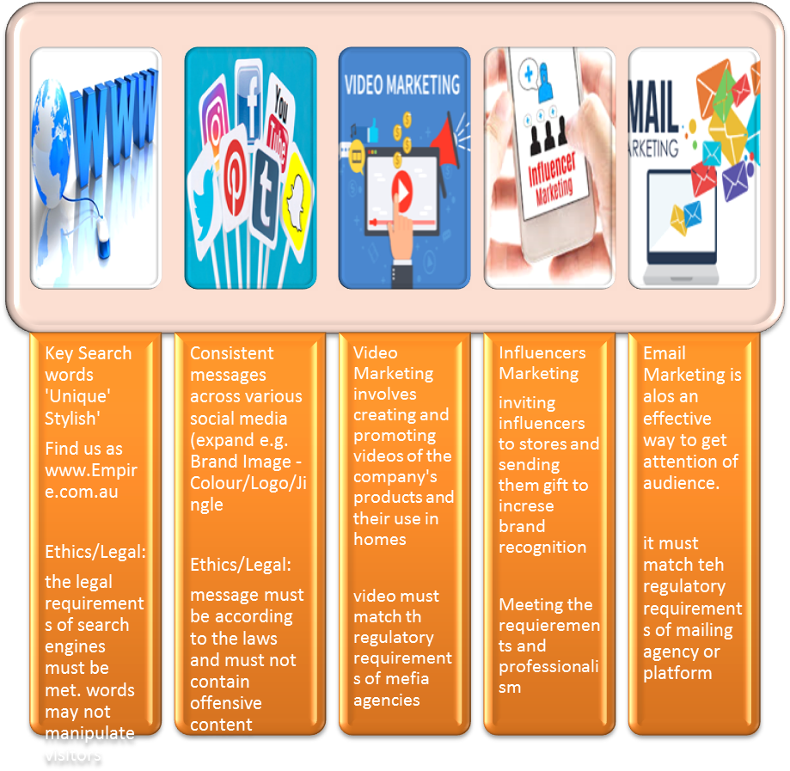
Ethical Marketing Practices
The ethical marketing is the primary purpose of Empire which is central at the local and international business. Following the rules, specific laws and the code of conduct will be part of plan. These practices will ensure the healthy environment and international standards of commercial activities. Other than the region of Australia it will work for the stability and choices of effective marketing in those regions.
21. Feedback and Performance
As a Marketing Manager, my emphasis would be on efficient and productive relationship that could enhance personal and professional capacities in staff members. I would listen to all their queries and concerns, and would provide them with best possible solution.
Further, I would show my involvement in all the works that they would undertake to bring more professionalism in their overall work. Also, I would like staff members to take ownership of their work. In order to complete any task, it is essential for all the team members to work together in a group. I would keep in my mind the potential and capabilities of my employees, and would motivate them to work more effectively for organisational goals.
Mentoring, coaching and feedback improves the productivity among the employees, provides guidance to the new employees, and assist them to grow professionally. Not only the employees it also benefit the mentor. Both the employee and mentor gets the chance to share knowledge and experiences. Throughout the marketing process, a vital part will be to give the team continuous feedback in order for them to develop on both a professional and personal level.
Feedback; both constructive and positive is very important so that employees feel they are valued in the work place and that they know what is expected of them in terms of performance.
It is important for Empire to attach rewards and recognition to the achievement of goals and highlight when team members do an outstanding job by for example have “Team member of the month” sent out in the company newsletter. Having weekly competitions in-store is also a great way to encourage and empower employees. Moreover, having effective communication and giving them chance to learn, grow and prosper will be very helpful.
GROW Model and Coaching
In the corporate coaching, the concept was generated during the last three to four decades was based on the setting of goal and problem solving in the business and other areas. The basic approach for the Empire Corporation is to include the potential for more resources and lifestyles that are well suited to the business. The life coaching conversation are significant for the business and exploration of other resources.
22. Employee Support Plans
Maxine's Support Plan
Support Plan
Name: Roberta Porteous
Position: Advertising and Public Relations (PR) Officer
Date: 7th Jan 2019
Strengths  Ready to Learn new Skills  Good understanding Skills  Keen to gain knowledge | Weaknesses  Lack of Teamwork  Lack of confidence to take decisions  Ready to improve herself
Support plan solution: GROW KPI’s

To empower Roberta in her role Empire will offer to cross-train her with the SEO Ashley to learn more about web design and web marketing. It is important for her to work in team and work confidently with Ashley to improve her skills and abilities and her knowledge to become successful. She is interested to increase her knowledge and seeks advice and suggestions from me as an experienced person. Empire will provide her opportunities to polish her skills and gain knowledge to succeed in her field. Adapting a team based approach and a friendly behavior despite the bossy one will empower her to improve.
Her mentor will keep a check of her improvement status weekly by evaluating the work assigned to her. The mentor will also get the feedback from Ashley about her performance. She will have to maintain a friendly working relationship and appropriate manner with everyone in the company. She will have to be informative, helpful and accurate. Moreover, the coaching and mentoring will be unbiased and will be aimed at providing her with real world experience.
Support Plan 2 – Ashley Lally
Ashley's Support Plan
Support Plan
Name: Ashley Lally
Position: SEO and Web designer
Date:
Strengths | Weaknesses
Very competent in his field  Knowledgeable and intellectual abilities | Unethical behaviour  Non-team player  Unprofessional behaviour
Support plan solution: GROW KPI’s
To assist Ashley in becoming more of a team player Empire will cross-train him with the PR Officer Roberta and send him out on a field day to one of the Empire stores to work together with the store manager and assistants for a day to see how they work as a team and how the stores are run as visiting stores is included in his job role.
He has to comply with the rules and regulations and can’t take decision without the approval of the supervisor. He will be required to share the knowledge with the team member and Roberta Porteous. He has to keep the ethical and legal considerations in mind before taking any step. He is expected to show the right attitude towards the company and his responsibilities and is required to show the citizenship behavior. Ashely will be responsible and accountable for all of his actions. In case he fails to meet job requirements and comply with the policies, supervisor has right to take corrective action against him.
23. Marketing Performance Review
Following are the three performance indicators that company will be following:
Metrics: As a marketing manager, the use of numeric data would enable our company to focus on the relationship between our marketing strategies and long-term organisational objectives. For this purpose, Marketing metrics have various factors of measuring net sales, bills, and product, and surveys of brand to evaluate brand awareness. Through effective use of metrics, the company would enhance competitive intelligence.
Customer Satisfaction: For sustainability, customer satisfaction is most important element, and it can be achieved through better quality. To evaluate customer satisfaction, customers will be asked to leave feedback about the company, and in which ways, the company can become better in the future.
Competitor Analysis: For an organisational success, it is essential to keep a close eye on the strategies and marketing plans of competitors. To measure our overall performance, we would employ all the tools to get an insight about our competitor’s as the long-term objective of the company will be to gain a competitive edge and achieve sustainability.
24. Conclusion
The purpose of the report was to create a detailed marketing so that the company Empire can achieve its strategic objectives locally and internationally. The local objectives of the company are to increase its sales, reputation and recognition as an established brand and increase loyalty of its customers. Moreover, Empire wants to build its brand in an international market i.e. China. The strategic objectives in international market also involve the increase in sales, brand recognition and loyal customer base.
The report comprises of the set of strategies related to the marketing objectives as well as the communication and implementation of the marketing plan for the company. Empire is a company known for its stylish home-ware products with 16 stores in Brisbane. It wants to enter Chinese Market. Company has the capabilities and need to enhance its resources in order to meet the business requirements. To fill in the gap between the current and required resources which are obtained by doing the gap analysis. Environment analysis reveals the strengths, weaknesses, opportunities and threats of the company.
A detailed macro analysis identifies the factors that can impact the business positively and negatively. A detailed risk analysis has also been done to identify the threats to business. After the detailed analysis strategies are being developed to meet the strategic objectives of the company. To meet the strategic objectives Ansoff’s Matrix has been employed to develop the strategies that can be helpful to increase the sales locally and internationally. Moreover, the communication strategy has been made to communicate the plan and its objectives to all the stakeholders of the company.
Strategies have also been developed to get the constant feedback and have a check of performance. The employee support plan will also help in employee management and evaluate their performance. Performance review methods have been identified do that it remains inclined with the strategic objectives and goals. The plan overall will help Empire to manage its marketing activities which will lead to the achievement of local and international business objectives.

References
http://www.diva-portal.org/smash/get/diva2:421070/FULLTEXT01.pdf
https://ebrary.net/21432/management/international_marketing_communication
https://myventurepad.com/business-opportunities-international-markets/
https://www.fm-magazine.com/news/2015/jan/201511686.html
https://www.languageconnect.net/blog/travel-and-tourism/3-steps-to-formulating-a-global-communications-strategy/
https://www.mastercardbiz.com/2013/05/24/going-global-adapting-your-products-to-meet-the-needs-of-the-marketplace/
https://www.youtube.com/watch?v=Flw-l6AMdt8
https://www.theurbanlist.com/perth/a-list/best-homewares-shops-perth

http://www.diva-portal.org/smash/get/diva2:421070/FULLTEXT01.pdf
https://ebrary.net/21432/management/international_marketing_communication
https://www.languageconnect.net/blog/travel-and-tourism/3-steps-to-formulating-a-global-communications-strategy/
https://www.mastercardbiz.com/2013/05/24/going-global-adapting-your-products-to-meet-the-needs-of-the-marketplace/
https://www.youtube.com/watch?v=Flw-l6AMdt8
https://myventurepad.com/business-opportunities-international-markets/
https://www.theurbanlist.com/perth/a-list/best-homewares-shops-perth
https://www.theurbanlist.com/perth/a-list/best-homewares-shops-perth
https://www.mastercardbiz.com/2013/05/24/going-global-adapting-your-products-to-meet-the-needs-of-the-marketplace/
http://www.diva-portal.org/smash/get/diva2:421070/FULLTEXT01.pdf
http://www.diva-portal.org/smash/get/diva2:421070/FULLTEXT01.pdf
http://www.diva-portal.org/smash/get/diva2:421070/FULLTEXT01.pdf
https://ebrary.net/21432/management/international_marketing_communication
https://ebrary.net/21432/management/international_marketing_communication
https://ebrary.net/21432/management/international_marketing_communication
https://ebrary.net/21432/management/international_marketing_communication
https://myventurepad.com/business-opportunities-international-markets/
https://myventurepad.com/business-opportunities-international-markets/
https://myventurepad.com/business-opportunities-international-markets/
https://www.fm-magazine.com/news/2015/jan/201511686.html
https://www.fm-magazine.com/news/2015/jan/201511686.html
https://www.fm-magazine.com/news/2015/jan/201511686.html
https://www.mastercardbiz.com/2013/05/24/going-global-adapting-your-products-to-meet-the-needs-of-the-marketplace/
https://www.mastercardbiz.com/2013/05/24/going-global-adapting-your-products-to-meet-the-needs-of-the-marketplace/
https://www.mastercardbiz.com/2013/05/24/going-global-adapting-your-products-to-meet-the-needs-of-the-marketplace/
https://www.mastercardbiz.com/2013/05/24/going-global-adapting-your-products-to-meet-the-needs-of-the-marketplace/
https://www.mastercardbiz.com/2013/05/24/going-global-adapting-your-products-to-meet-the-needs-of-the-marketplace/

