Student Name
Teacher’s Name
Course Title
Date
Introduction
A marketing research process starts with identification of needs of customers in a particular area. After identifying the need, research is designed according to these needs. Data is collected from recipients and is analysed using multiple techniques. The outcomes of these data are then implemented to solve the initial problem. Problems may include decline in sales of a product in some particular area or simply introducing a new product in a market. Different situations will require little modifications in marketing research processes and modifying the process effectively will describe its success or failure. An example for existing product can be a scenario where sale of a particular product has declined over time. Company wants to see reasons of this decline and conducts a research. It is possible that the product no longer suits the needs of customers and some changes have to be made to make the product attractive for customers (R.Hyman and Sierra p.1).
Application
We assume that it is a new product which will be introduced in a certain market. Firstly, the company will identify what particular needs this product will satisfy. People may say that they want it as a tea time snack. Company will now analyze how this research will be carried out. One way of carrying out this research is to distribute questionnaires among people regarding the product features like taste, flavors and packaging. Once the relevant data has been gathered, company will have to ascertain the features which are to be included in this product. The top two flavors selected by the people will be offered initially. Similarly, people have identified that they need product in three packings namely small, medium and large so the company will provide them accordingly. After a period of time, company will assess the sale of its product and see if desired targets have been met or not.

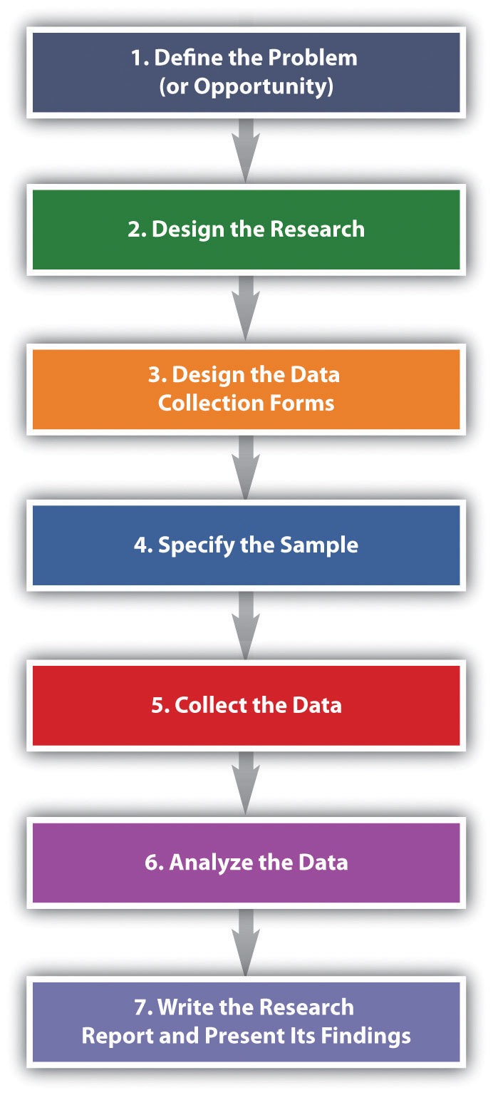

Works Cited
R.Hyman, Michael and Jeremy J. Sierra. "Marketing Research Process: Six Stages." Business Outlook (2015): 1-11.

