Week 2 Blog: Writing Process
[Author’s Name]
[Institutional Affiliation(s)]

Week 2 Blog: Writing Process
Part A
Survival techniques are very essential to cope up with any distressing situations in real life or on a vacation (Khamsi, 2005). The video “How to Escape Quicksand” facilitates viewers in learning various survival techniques that may help an individual if he or she gets stuck in the quicksand. The video also highlighted the composition of quicksand and how the viscosity of quicksand is enhanced when it is distributed after a certain pressure is applied to it. The information presented in a video was very well organized and the demonstration of the technique by using animated characters further helped in learning how to apply the quicksand escaping technique in real life.
Part B
Since my childhood, mac and cheese has been my favorite dish. I not only love to eat the dish but also love cooking it as well. It is very easy to cook Mac and cheese. The first step is to gather all the ingredients. As the name suggests, to make mac and cheese, the most important ingredient is pasta of any shape. I prefer elbow-shaped macaroni as it is easy to boil and takes less time to cook as compared to other pasta types. The second important ingredient is cheese. I like to use parmesan and mozzarella cheese. Also sometimes, I use American cheese as well. The other ingredients include fresh cream, milk, spices, salt, and onions. Bacon or vegetables are optional and depends upon an individual’s choice.
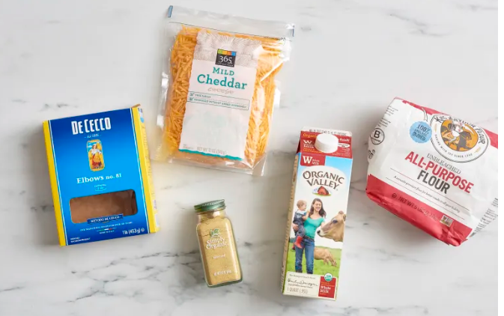
Fig:1 Picture of the ingredients used to make mac and Cheese. URL (https://www.thekitchn.com/how-to-make-the-best-macaroni-and-cheese-on-the-stove-82588).
To start cooking, take a pan filled with enough water so that pasta can be boiled. Put the pot filled with pasta and water on the stove on light heat to boil. Then take a separate bowl and pour half a cup of milk and flour in it. After that, whisk the mixture until no visible lumps are seen. Then on a second stove, put a pan and fill it with milk and let it boil for some time. After the milk gets warm, pour the whisked mixture in it and start whisking again. Now turn the heat to low and start adding a handful of cheese. Stir until all the cheese is melted. Now add spices and any boiled vegetable or bacon, etc. Then remove the pan from the heat put the pasta into the mixture. Mix it well and serve the yummy and cheesy pasta to your guests.
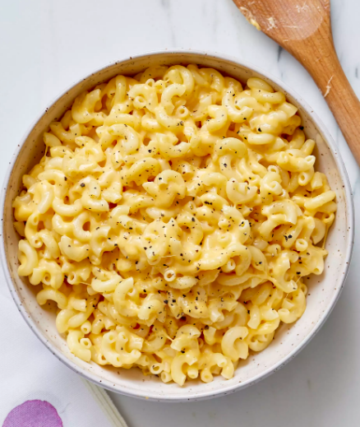
Fig:2 Picture of Mac and Cheese. URL: (https://www.thekitchn.com/how-to-make-the-best-macaroni-and-cheese-on-the-stove-82588).

References
Khamsi, R. (2005). Quicksand can't suck you under.

