India Geographic Research Report
Ray
[Institutional Affiliation(s)]

Author Note

Geographic Analysis of the USA

(Checkpoint 2)

India Geographic Research Report
Introduction
What are Demographics?
Demographics is the analysis and study of a region’s populations which is based mainly on factors like gender, race, and age, etc. This study is socio-economic details that are presented statistically that include different details and information. Demographics or demographic information is used by different entities such as governments and organizations etc. for different purposes such as analyzing the characteristics of people or population for research, development (policy development) and decision making.
India: An Introduction
India is one of the top countries in terms of its population and economic condition such as GDP etc. India can be found as a highly well-performing company in some aspects. India is located in Southern Asia bordered with the Arabian Sea and the Bay of Bengal. The close countries of India are Bangladesh, Bhutan, Burma, China, Nepal, and Pakistan. The geology of the country is diverse as it is plain in the south, flat to rolling plain, having deserts, and the Himalayas. While the government in India is a republic where the prime minister performs as the government head. The economy of India is a market economy (Singh, 2009). This is so because the economy is shaped by the free price system of products and services. Furthermore, the country is a member of the Asia Pacific Trade Agreement, and SAARC.
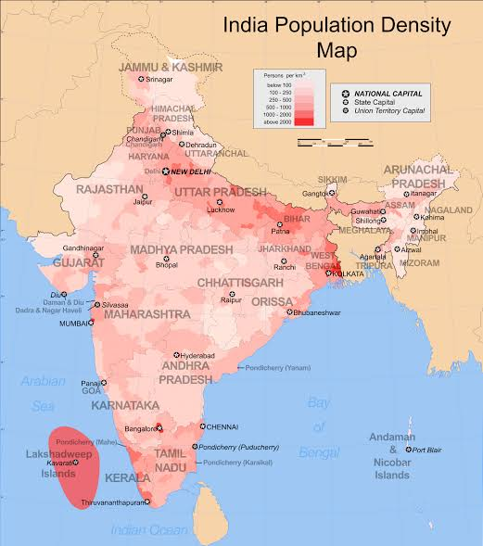
Available at: https://encrypted-tbn0.gstatic.com/images?q=tbn%3AANd9GcRhdvPHIXjVHOAGJQxVT-q9_ZolgscEaW2pGHgWn2u33_opJyQd
- Demographics
  - Political Demographics
    - Population
As India is the second-largest country of the world on the basis of its population or number of people. The country’s population estimates for 1.37 billion as per the data of the United Nations. In addition to this, India is on the seventh number in the world based on its area while (as mentioned) is the second-largest or most populous country of the world that has higher/more than 1.3 billion residents as per the results and statistics of recent reports in 2019.
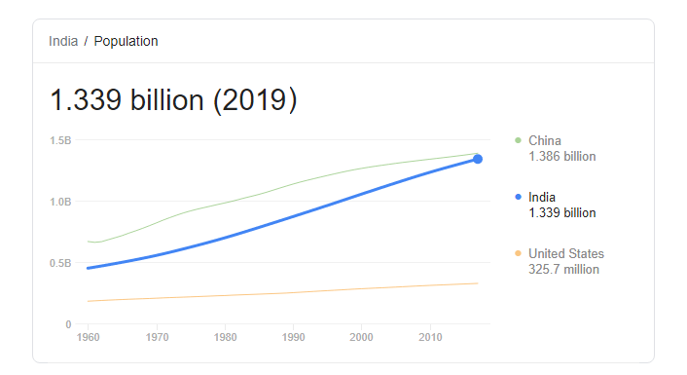
    - Political Parties and System
The political system of India can be found enough fine and stable up to an extent. Two parties that work as leading parties in India while other small scale or level of parties also exist. The two main parties in India are Bharatiya Janata Party (BJP) and Indian National Congress also known as Congress and INC (Singh, 2009). BJP is the leading right-wing party of the country while INC is the leading center-left leaning party.
  - Economic Demographics
    - GDP and Economic Growth
India is a well-performing country and nation when one looks at its GDP rate and growth. The GDP of India has accounted for 7 percent in the last financial year (2018-2019). During the second and third quarters of 2019, the economy of the country has been seen to grow by 4.8 percent as compared to the very last quarter and year(s) (Singh, 2009).
The GDP of the country also shows the growth of 6 percent as per the results of the FICCI survey. The country is also expected to be growing economically in the coming quarters as the economy grows finely in the last periods such as 8.2 percent from April 2018 to June 2019.
    - Available Workforce
As India has a huge number of citizens or as India is the second-largest country in the world, the country has a huge amount of available workforce. According to the report findings of the World Bank, India has a total amount of workforce of 503.8 million which can be increased in the coming years. The country had been found added 6.6 million people to the workforce each year (Joseph, 2017).
  - Cultural Demographics
    - Languages
There are many languages that Indians speak in their daily lives. Currently, there are 14 regional official languages that are spoken in India while these languages have increased to 18 as per the inclusion of Sindh, Konkani, Meitei, and Nepal. But the mostly spoken language in the country is Hindi. Hindi is also the official language of India (Taubenbock, 2019). In the current times, Hindi is being spoken by more than 150 million people in India.
    - Diverse Ethnic Groups
In the current time, the country has almost 2100 ethnic groups as well as every major is represented where accepted and followed. There are four families of languages (Indo-European, Dravidian, Austroasiatic and Sino-Tibetan languages) as well as two language separates (Nihali and Burushaski) (Taubenbock, 2019).
- Major Events Influencing Demographics
There are several events that influence demographics but the most common and highly crucial and major ones are as follows.
  - Political Events
Political Events influence demographics in many ways but the aspects of political events that puts such influences mainly include;
- Type and stability of political bodies and government.
- Press freedom, corruption level, and rule of law, etc. in India.
- The trends and regulation and de-regulation and legislation in the country.
- Changes in the political system and events like elections in each region.
  - Cultural Events
The Cultural Events that have influences on the Demographics in or of India are listed below.
- Growth of the population of the country and the age profile of the people and communities.
- The health, educational level, and social mobility of the population of the country.
- The patterns such as employment and job market etc. (Julie Davanzo, 2011).
- Public opinion, cultural attitudes, lifestyle, and changes in the socio-culture and its aspects.
  - Economical Events
The economic events in/of India also have a huge influence on the demographics of the country. The economic events that put the influences are;
- Stages of business cycles in the country.
- Existing and projected economic, interest, and inflation rate, etc.
- Labor costs, unemployment rate, and supply of the labor force.
- Disposable income level and income distribution
- Changes in technologies and other economic aspects (Julie Davanzo, 2011).
- The influences of globalization and possible changes in the economic environment.
- India in 2050: Future Demographics
According to (PTI, 2019), India would be having 1.73 billion population by 2050. Beyond this, India has projected to surpass the strongly competing country “China” as the most populous country of the world near to 2027-28 as per the present situation and projection. The country is also projected to be adding around 273 million individuals/people from 2019 to 2050 where the population of Nigeria would be around 200 million (Union Budget, 2019). In short, India is projecting to become the world's most populous country by 2050 and overtake China as it will lead to generating an Indian economy of 85 trillion Dollars.
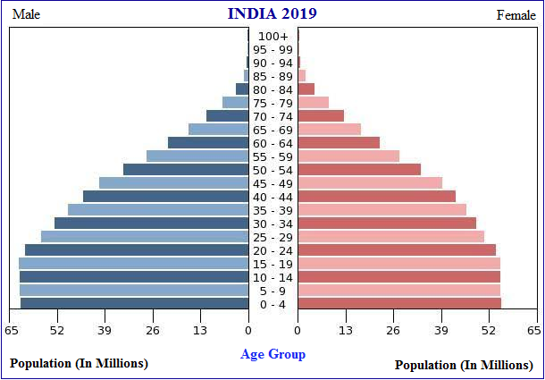
Available at: https://encrypted-tbn0.gstatic.com/images?q=tbn%3AANd9GcQLsfkh5Sn6EzO8vrL0Kh_gKPplR8k1Rs7PTcak2c6bfkQOlIi3
- Conclusion
After an in-depth analysis and geographical research about India, it has been found to conclude that India is one of the growing countries of the world. The country is so because it is the second-largest country of the world by population while 7th largest by area. Furthermore, India is also a diverse region that is a benefit as well while the economic growth, GDP, and labor force have found efficient enough. Apart from this, the political system is also fine as the country is led by a well-organized political system while the future of the country and nation can be reflected as successful and healthy in almost every aspect.

References
Joseph Chamie, B. M. (2017). India is unprepared for the near future when it will be the world's most populous country. Quartz India. Retrieved from https://qz.com/india/1051533/india-is-unprepared-for-a-near-future-when-it-will-be-the-worlds-most-populous-country/
Julie Davanzo, H. D. (2011). Demographic Trends, Policy Influences, and Economic Effects in China and India Through 2025. RAND Corporation. Retrieved from https://www.rand.org/content/dam/rand/pubs/working_papers/2011/RAND_WR849.pdf
PTI. (2019). India likely to add 273 Million People between 2019 and 2050: UN Report. The Economic Times. Retrieved from https://economictimes.indiatimes.com/news/politics-and-nation/india-likely-to-add-273-million-people-between-2019-and-2050-un-report/articleshow/69830509.cms?from=mdr
Review, W. P. (2019). India. Retrieved from http://worldpopulationreview.com/countries/india-population/ Review, W. P. (2019)
Singh, S. (2009). Geography in India: Some Reﬂections. Trans. Inst. Indian Geographers, 31(2).
Union Budget. (2019). India's Demography at 2040: Planning Public Good Provision for the 21st Century. Government of India. Retrieved from https://www.indiabudget.gov.in/economicsurvey/doc/vol1chapter/echap07_vol1.pdf
Taubenbock, H., Wegmann, M., Roth, A., Mehl, H., & Dech, S. (2019). Urbanization in India–Spatiotemporal Analysis using Remote Sensing Data. Computers, environment and urban systems, 33(3), 179-188.

