Anatomy and Physiology
[Writer]
[Institution]
Anatomy and Physiology
Post 1:
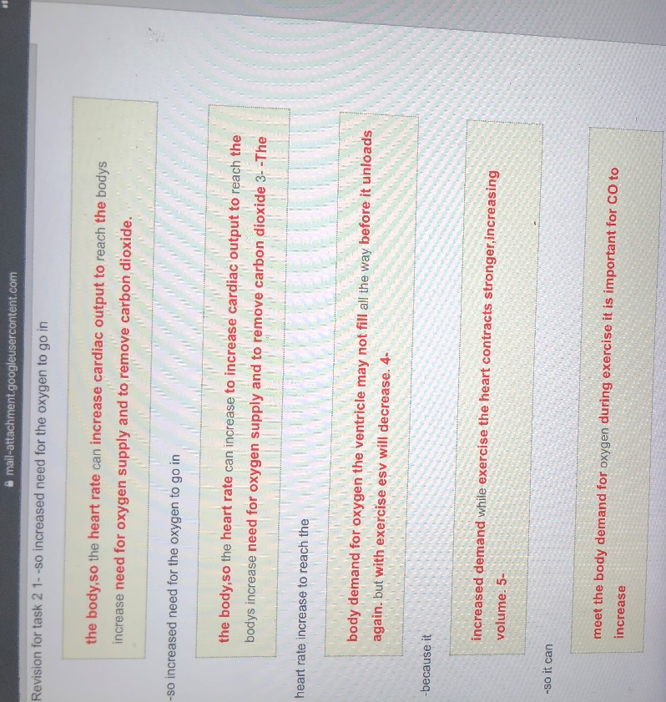
The physiology of heart during exercise conducts substantial regulatory actions to maintain the normal cardiac and transport functions within the body. In the course of exercise, the cardiac output increases significantly to provide sufficient oxygen to all body cells and remove excess carbon dioxide. When the heart rate increases, the cardiac contractions increase with its increasing cardiac output. The blood flow also increases due to enhanced cell metabolism. Blood cells contain hemoglobin that carries oxygen to all body cells and discharges carbon dioxide and sends it back to the lungs. Excessive metabolic activities require an increased need for oxygen and nutrients supplied to the cells. So, as the blood flow increase, it carries oxygen with it and on its way back it removed carbon dioxide. This change in the oxygen intake and an increase in cardiac output results in significant changes in the structure of the left ventricle of the heart. The increased heart contraction during exercise induces an increase in the volume of stroke and decrease in the end-systolic volume in the ventricles (Kudomi et al., 2019). These regulatory changes in the cardiac and circulatory system help meet the demand for providing enough oxygen to the cells and increasing the amount of carbon monoxide during vigorous activities like exercise.

Post 2:
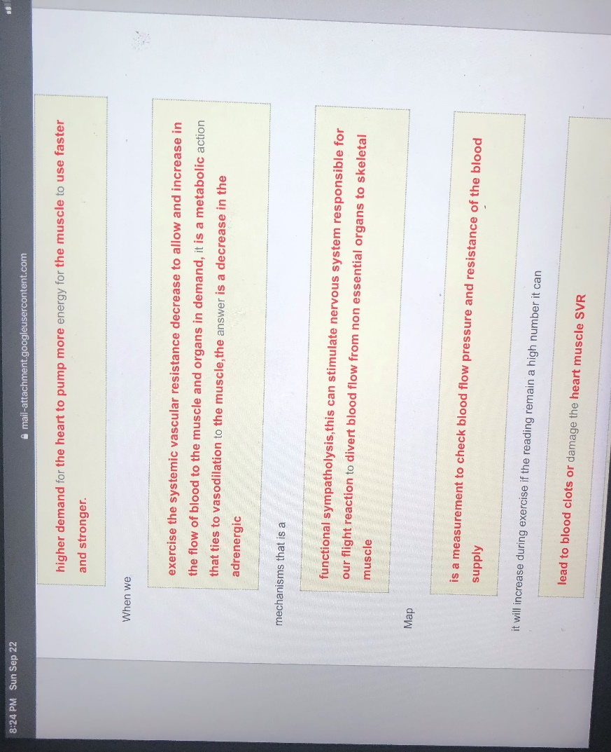
During the workout, there is a higher demand for the heart to pump faster in order to provide energy to all the muscles. Cardiac muscles go through the process of sympathetic vasoconstriction and the decrease in systemic vascular resistance increases the cardiac output and stroke volume. Vasodilation in cardiac muscles is induced by metabolic factors. Vasodilation in arterioles influences a decrease in the peripheral resistance for the blood flow. The decrease in the parasympathetic activity of the sinus node increases the heart rate and sympathetic activity. The process of adrenergic functional sympatholytic decreases and it eventually stimulates the nervous system. The sympathetic nerve mediates ventricular myocardium and maximizes the blood flow towards skeletal muscles (Fisher & Secher, 2019). The systolic and diastolic rate can measure blood flow pressure. If it consistently remains high, it can cause blood to clot and damage cardiac muscles.
Post 3:
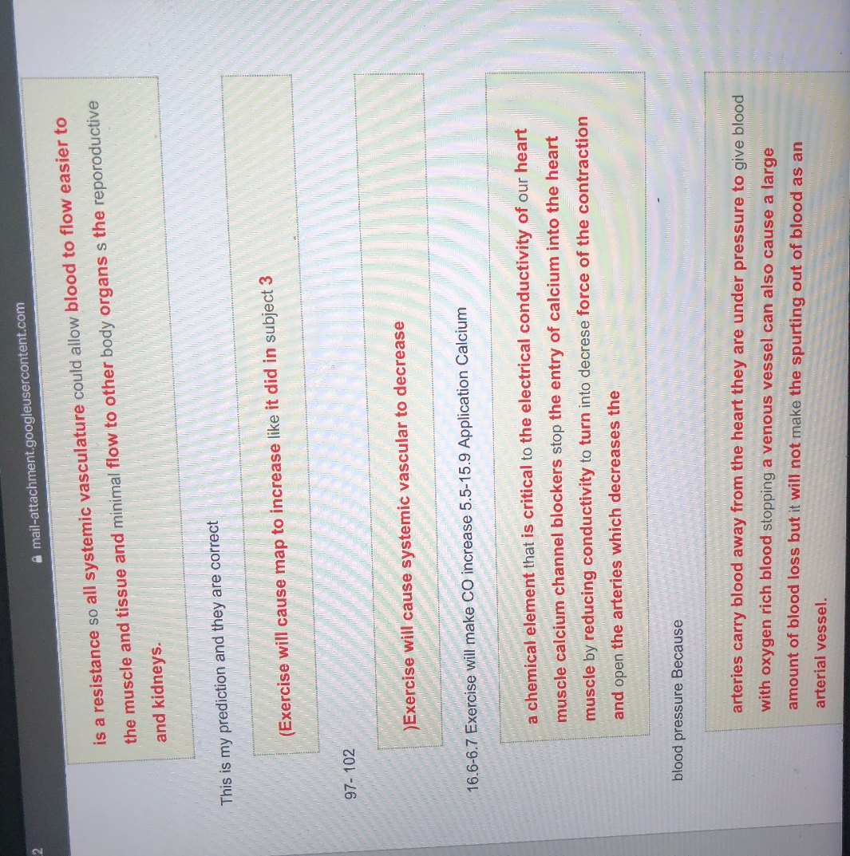
Under the condition of extreme exercise, resistance in the systemic vasculature allows the flow of blood towards skeletal muscles and tissues and minimized flow towards parts of the body that do not require an immediate intense supply of oxygen. Vasodilation in skeletal and cardiac muscles induce vasoconstriction in kidneys and gastrointestinal organs as sympathetic activity of neurons supply them blood. The absorption level of oxygen in hemoglobin is decreased as the level of carbon monoxide increases in the blood. Calcium is a vital chemical element for maintaining the electrical conductivity of cardiac muscles. The calcium channels blockers inhibit the entry of calcium into cardiac cells and blood vessels. It results in the prevention of vasoconstriction and thus electrical conductivity. This mechanism reduces the force of contraction as the arteries open up and lower the blood pressure. Arteries transfer the blood from the heart and reducing the pressure carry the oxygen-rich blood to the venous vessel. If the venous vessel is stopped, a large quantity of blood can be lost but it will not cause the spurting out of blood in the arterial vessel (Gordan, Gwathmey, & Xie, 2015).
Post 4:
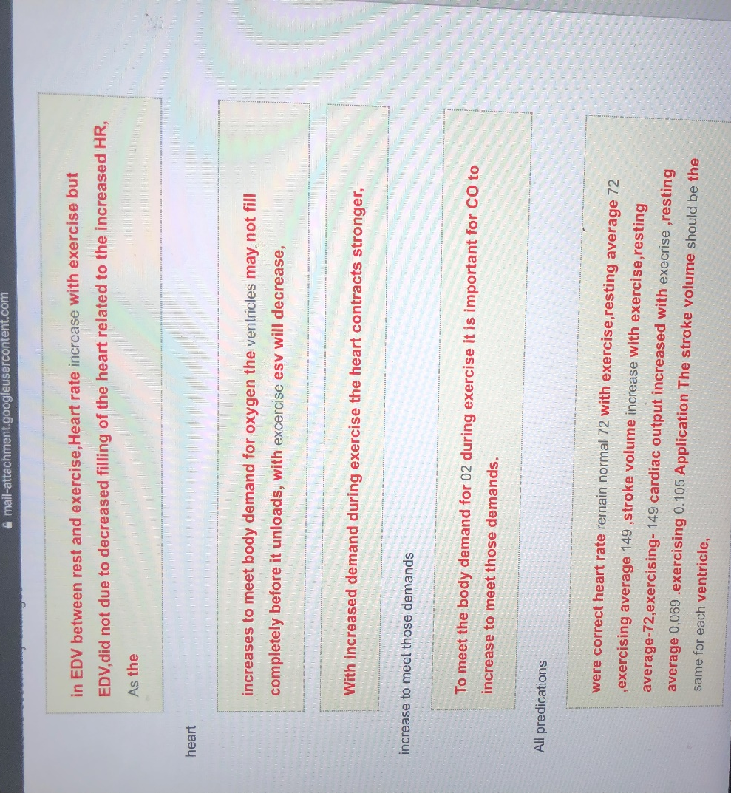
In the intervals of rest and exercise, the heart rate increases with the progression of exercise but not the end-diastolic volume. It happens as the ventricles empty themselves and the heart rate increases. The cardiac output increases so that the need for oxygen demand can be met. It might occur that the ventricles do not completely fill up before unloading the blood. The rigorous exercise helps to decrease the diastolic volume (Fisher & Secher, 2019). As during exercise, the cells run short of oxygen, the heart contracts with strength. As the blood contains hemoglobin for the exchange of gases. It is imperative that during exercise carbon monoxide is increased for the absorption of carbon monoxide for meeting the body demand for oxygen. The average heart rate of an individual is 72 while resting and 149 during exercise as the stroke volume increases.
Post 5:
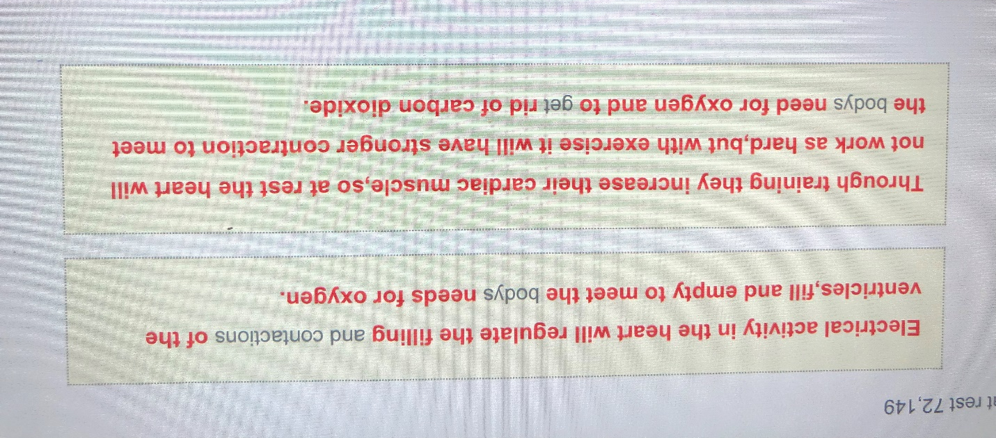
The electrical conductivity regulates the filling in and contraction of the heart ventricles. During exercise, the vasoconstriction helps in filling and emptying the blood from ventricles in order to meet the needs of the oxygen. The conductivity mechanism increases the cardiac output at rest but at the time of exercise, heart pace increases and the contractions become stronger so that by the increased blood flow, oxygen can be made available to all cells and carbon dioxide be discharged out (Tse, Lai, Yeo, Tse, & Wong, 2016).

References
Fisher, J. P., & Secher, N. H. (2019). Regulation of Heart Rate and Blood Pressure During Exercise in Humans. In Muscle and Exercise Physiology (pp. 541–560). Elsevier.
Gordan, R., Gwathmey, J. K., & Xie, L.-H. (2015). Autonomic and endocrine control of cardiovascular function. World Journal of Cardiology, 7(4), 204.
Kudomi, N., Kalliokoski, K., Oikonen, V., Han, C., Kemppainen, J., Sipilä, H. T., … Heinonen, I. H. (2019). Myocardial blood flow and metabolic rate of oxygen measurement in the right and left ventricles at rest and during exercise using 15O-labeled compounds and PET. Frontiers in Physiology, 10, 741.
Tse, G., Lai, E. T. H., Yeo, J. M., Tse, V., & Wong, S. H. (2016). Mechanisms of electrical activation and conduction in the gastrointestinal system: Lessons from cardiac electrophysiology. Frontiers in Physiology, 7, 182.

