Cultural Food report
Name of the Writer
Name of the University

Cultural Food report
Introduction
It has been seen that food, culture, and society have a close connection. Food is not only an important part of nutrition but also have some cultural and symbolic meanings attached to what one has in his/her plate. Traditional cuisine is passed on to the next generation as food is a part of the culture and operates as an expression of cultural identity. Even immigrants bring their traditional dishes with them and continue to make food that depicts their cultural connection as a symbol of pride in their ethnicity. Food provides an important link with the cultural heritage. Food and way of eating food are quite different as it has been witnessed that in some of the cultures, eating with hands is common but in some, it is considered rude.
Like every country and culture, Mexican culture has its certain dishes. Researches show that Mexican food is known for its flavor, spices, colorful ingredients, and varied flavors. It is interesting to note that lively seasoning makes Mexican food unique as not all the Mexican recipes are spicy (Dreby, et, al,2019). In Mexican fare, subtle and intriguing spice combinations could be found. Beans and corn are the one of the main ingredient of Mexican food. Studies show that Mexican food has a great variety because of the regional, climatic, ethnic and geographic differences.
Mexican food has great variety and fulfills the nutritional requirements that are essential for optimal health. Mexican food maintains nutritional adequacy as balance is maintained between required and consumed nutrients. Nutritional adequacy is linked with intake of sufficient essential nutrients. According to Juan A. Rivera and his colleagues, it could be said that Mexicans are facing the burden of malnutrition as there are two groups that are facing severe issues regarding malnutrition. Low-income youngsters are facing deficiency of micronutrients and pregnant women are having iron deficiency (Wilk, et, al,2019). According to the scholars, the key risk factor for this malnutrition in both youngsters and pregnant women is because of inadequate dietary intake of essential nutrients.
According to historical research, some famous dishes of Mexican people include Salsa, Enchilada, Tomatillo, and Portuguese. These meals are all derived from strong cultural association taking into account that these dishes are derived from cultural derivations. It would not be wrong to say that flavors from the world have influenced the Mexican dishes, in the same way; Mexican traditional favorite dishes affect the countries menus.
The food history and food habits of Mexicans are one of the longest and diverse ones. One connection between a person’s heritage and culture and food is undeniable. This is one of the basis for the Quotation "You Are What You Eat". Plenty of researchers have worked hard on researching the correlation between these two things. The Mexican cuisine has a vast history behind it and each and every dish in their cuisine has its own story to tell. Furthermore, the dishes are also used as another method of highlighting the difficult times that have plagued the people of Mexico. The Mexican cuisine and the Mexican people have had a long and prosperous relationship and this led to the building of tremendous personality of the culture and its tastes. The origin of this cuisine can be traced back to the times of the Mayan civilization, who had a long-held belief that the human body can be enriched through the richness of the food.
Taking a look at different researches done on traditional dietary habits of Mexicans, it won’t be wrong to say that around 94% Mexicans eat lunch on daily basis, 78% Mexican take breakfast and only 64% takes dinner. Researches show that the history of Mexican food is the oldest. Most of the researchers claim that Mayan Indian’s food has more similarity with Mexican food. In 1952, with Spanish invasion, Mexican food was affected most. Traditionally, Mexicans eat more salty food and as per the researches Mexicans have a domestic diet that includes stew, soup, and rice.
Mexico has made potential efforts to ensure food security taking into account the lack of food security for people. Food security is defined as a position when, "All people, at all times have both economic and physical access to the safe nutritious and sufficient food that can help to address the food and dietary preferences of people, ensuring healthy and active life". There are some specific guidelines for food-based dietary guidelines taking into account the context of obesity and overweight in the Mexican Population (Lucero, et, al,2019). The development processes that are for guidance regarding food are led by the committee of experts who are the representative of National Institute of Public Health, Medical Sciences and the National Institute of Medical and Nutrition Services adhering to a common goal of designing food schedules and plans that are meant for designing the food choice and options of food security.
Reviews on dishes
While I was researching Mexican food, I thought of making a Mexican dish. Though I was cooking it for the first time when I tried Mexican food. I made Vegetarian Tacos and Enchiladas. I took help from the online recipe video. I asked my brother and one of my friends to taste food. My brother said that he really liked both Mexican dishes. He also pointed out that spices are being used in an accurate portion. Also, he pointed out that not only both dishes were delicious but also were well-garnished.
My friend also tasted the food I made and he was totally surprised about my cooking skills. He appreciated me a lot and advised me to have proper cooking classes. He liked the number of spices that I used and was happy with the selection of vegetables that I used in vegetarian tacos. He even asked for the recipe. My friend’s empty plate indicated how delicious my food was.
It was a great experience making Mexican dishes as for me trying new things makes me excited. I love trying new flavors and ingredients. Tacos and enchiladas are one of the best and most well-known Mexican cuisine out there. For most people in order to get the real authentic experience of Mexican cuisine tacos and enchiladas are one of the first recipes that they are requested to try. I am humbled that this assignment allowed me to taste such exquisite dishes for the first time. Furthermore, it is also not just about tasting the dish but seeing that the effort I put in making such a remarkable dish come to fruition. After making these two cuisines I even got it tasted by my other family members and found that their experience was similar to mine.

Enchiladas

Vegetarian Taco
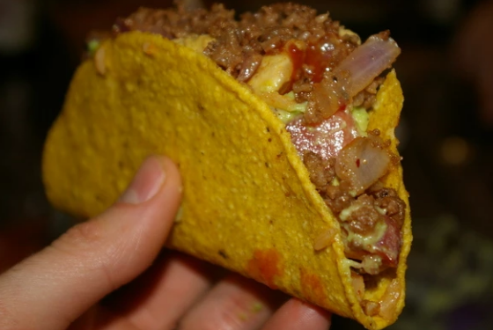

References
Dreby, J., Tuñón-Pablos, E., & Lacy, G. (2019). Social class and children’s food practices in Mexican migrant households. Childhood, 0907568219832640.
Lucero, Y., McKenzie, C., O'Donnell, B., Stanford, L., & Guzman, I. (2019). Southern New Mexico Dietary Practices and Carotenoid Content in Traditional Mexican Meals. Journal of the Academy of Nutrition and Dietetics, 119(9), A48.
Wilk, R. (2019). Postface: Is there Mexican Food? Taste and the Politics of Cultural Identity. Taste, Politics, and Identities in Mexican Food, 207.

