Finance paper
Name of the Writer
Name of the University

Finance paper
Introduction
Coca Cola is the world’s largest brand of beverages and other assortments. This company was formed in 1892 and has a market capitalization of one hundred and seventy billion dollar. Coca Cola is known as the leader of the most valued brands all around the world. Its manufacturing involves carbonated soft drinks, tea, beverages energy sports drinks and coffee. Coca Cola has worldwide operations and currently has presence in over two hundred countries all around the world. Furthermore, it owns licenses and is able to market products over a range of five hundred and all these are non-alcoholic in nature. Moreover, these brands are worth around twenty billion dollars and even more. At an average they are able to serve around twenty four million customers on a weekly basis and out of those only fifty percent of people drank Coca Cola in the last month. The major part of its revenues come from the CSD brands that are the core of the company’s operation. This is why there is high reliance on part of the company on the basis of these brands as their performance has a profound effect on the health and wealth of the company. The mission statement of Coca Cola Company is to provide a sense of refreshment to the world and be the inspiration for happy and cheerful moments all around the world. This way they want to make value for their brands and also be able to make a difference in the world. During the last decade, the beverage market bot domestically in the United States of America and internationally has seen a major shift. A major shift in the preferences of the customers had been witnessed. This has led to a sharp decline in the demand of the beverages and its related products in the domestic and the international market. These growing concerns are mostly related to the effects of carbonates drinks on health and becoming a cause of obesity. This also affected the revenue of Coca Cola as it declined at a massive rate without any growth. This works is focused on analyzing the movement of Coca Cola’s share and bond price. Then an analysis of the financial statements and finally calculation and analysis of ratios would be done.
Charts
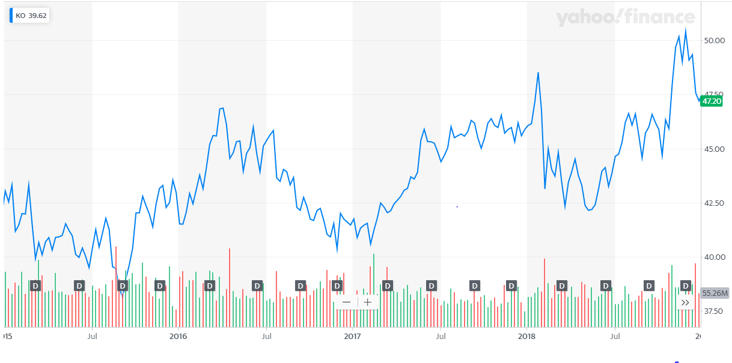
These changes witnessed within the share prices of the Coca Cola Stock is due to a combination of several reasons. These include a combination of micro, macro and firm specific factors.
Micro factors
The company’s share price has seen a significant movement in the recent years. Primarily, micro factors have played a huge role in making pushing the movement of the share price of the Coca cola stock over the selected period of time (2015-2018). During these time the major micro economic factor that came into play were the consumers themselves and their changing preferences. Consumers have always preferred stronger and notable brands during times when economy is prospering. However, when there is a downfall in the economy their preference changes towards those of the alternatives and cheaper brands (Nielsen, 2018). This is due to less accessibility to disposable income and this has been one of the factors that has affected the company’s share price during this time. Furthermore, there is greater awareness regarding factors that cause health issues in people such as obesity, diabetes and many others. This is also one of the reasons why people have started avoiding carbonated drinks as much as possible as healthy living has become a major trend. This affected the share price of the company as more and more consumers are moving away from their beverage products, their revenue is staying in a flat line rather than exhibiting any form of growth.
Macro factors
In the context of the macro environment, Coca Cola has had to witness certain factors that have influenced its share price in a variable way. Primarily, its products have had to go under increased scrutiny by the FDA. If their products did not meet the required regulations than they could not put their products out for sale as well. Furthermore, due to coca cola’s distribution network being very vast spanning over different countries. There are a plethora of aspects that needed to be considered when promoting products both internationally and domestically. This also had a profound effect on the share price of the company. As there is a growing trend towards healthy living and food, Coca Cola is far behind in moving in that direction (Nielsen, 2018). This comes in the social factors where the preference within the society is changing with different countries. Coca Cola has not aligned itself with this social diaspora and it has left it staggering in the wind. However, the rise in its share price is also due to the fact that it has used technology very much to its advantage. This is true for both manufacturing and marketing as it has introduced top of the line machinery within its plants. Additionally, it also has used media technology including print, and social media to attract an increasing number of consumers towards its products.
Firm specific factors
However there are certain firm specific factors that have also played its part in maneuvering the movement of the share price of Coca Cola over the years. Coca Cola’s brand itself was the most important factor for increasing the share price of the company whenever it fell down. This is because it is one of the most adored and precious brands in the whole world. Furthermore, due to its strong distribution network and innovative products it has kept investor confidence within its operations. However, due to its less than affordable products people tend to move to its cheaper alternatives. Moreover, the focus of its products is higher towards the younger generation, which means that it left out almost all other demographics. This has also severely impacted its already falling share price. It has access to large domestic and international market that has allowed it to explore new markets. This has proven to keep its share price on a positive note when it needed the most. However, its competitors are chasing up to Coca Cola such as Pepsi and other domestic brands. All these firm specific factors have helped in making the share price of the company move in a zig zag motion. However, if an overall look is given it can be seen that the company is still witnessing growth every year.
Securities Grading
Stock Price
Year | At the start of the year | At the end of the year
2015 | 43.03 | 42.96
2016 | 41.51 | 41.46
2017 | 41.74 | 45.88
2018 | 46.07 | 47.57
Stock Rating
According to Standard and Poor’s rating mechanism, Coca Cola’s global ratings has been downgraded from AA- TO A+. Fitch ratings also has downgraded the rating of Coca Cola from A+ to A.
Bond Price
Year | At the start of the year | At the end of the year
2015 | 100 | 106
2016 | 106 | 99.50
2017 | 99.50 | 97
2018 | 97 | 105.80
Bond Rating
According to Fitch Ratings the current rating for the bonds issued by Coca Cola is A. This bond is at a coupon rate of 2.125% and will mature on 06 Sept 2029.
Three Major Financial Statements
Income Statement
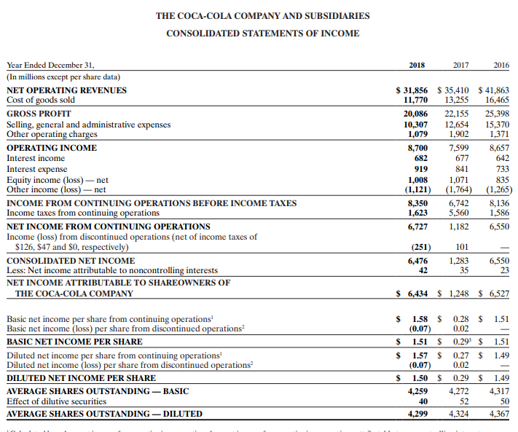
(Annual Report, 2018)
Balance Sheet
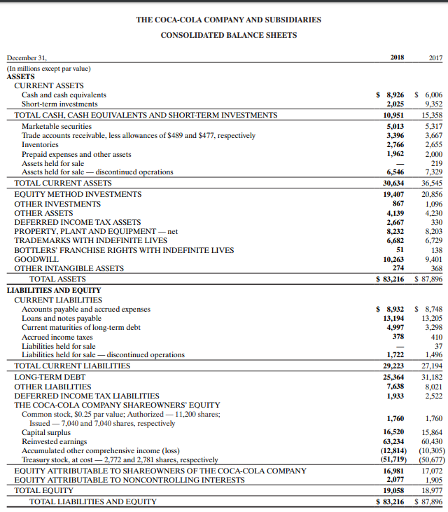
(Annual Report, 2018)
Statement of Cash Flows
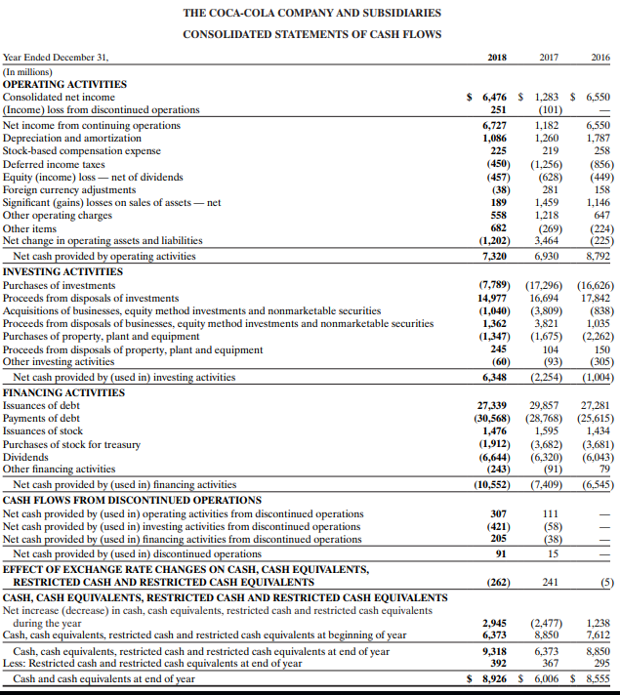
(Annual Report, 2018)
Calculation and Analysis of Ratios
Debt to Equity Ratio
=Total Liabilities /Shareholders Equity
= 0.72
The importance of Debt to Equity ratio stems from the fact that it is a tool of comparison between the total liabilities of the company and the shareholder equity of the company. This is an important tool for calculating the amount of leverage a company has. Considering the debt to equity ratio of Coca Cola calculated above it seems that the company’s stock is at a much lower risk. This means investing into the stock of Coca Cola will have less amount of risk attached to it and there is a chance of higher gains in comparison to the level of risk present.
Current Ratio
=Current Assets/Current Liabilities
=1.70
The current ratio on the other hand focuses more on the level of current assets in comparison to the level of liabilities within a company. This ratio provides a picture of the company’s liquidity position in the short term but assessing the relationship in between current assets and current liabilities. Looking at the current ratio of Coca Cola Company it can be summarized that the company is in good hands as its value id just barely above ONE. This means that the company has a higher number of assets in relation to the number of liabilities which gives it a stronger liquidity position.
Quick Ratio
= (Current Assets-Inventories)/Current Liabilities
= 1.15
If a company wants a more conservative view of its liquidity then the quick ratio comes in handy in comparison to the quick ratio. The only difference between this and current ratio is that in this ratio inventories are subtracted from the current assets in order to get an even clearer picture of the company’s liquidity position. Coca Cola Company’s quick ratio is above one just like its current ratio meaning that its level of asset are far more enough to cover its liabilities. This also means that the company has a higher liquidity position in the short term as well.
Return on Equity
=Net Income/Shareholders Equity
= 6.31%
This is a profitability ratio and is the measure of the firm’s ability to generate profit from the investments done by its shareholders within the company. So this is a true measurement of the level of profit generated form one dollar of the equity of common stockholders. Coca Cola has a nominal return on equity but still is a good enough number compared to its performance in recent years. From an investors point of view the stock of Coca Cola is still worth investing in as there is around a 6.31% return on each dollar that an investor decides to investment within this company.
Net Profit Margin
=Net Profit/Net Sales
= 3.08%
Net profit margin is an indication of how much profit a company generates in comparison to the revenue it has collected from its operations. This ratio also helps in analyzing if the management of the company is able to generate profit that is enough form its sales. Furthermore, the level of their costs both operating and overhead are either being minimized or even contained. In Coca Cola’s perspective it has a considerably healthy net profit margin (Öztürk and Karabulut, 2018). This means it has been able to create a positive return in terms of profit not only for the company itself but for the shareholders of the company as well. Lastly, it also shows that the company’s management is also working to the utmost of its abilities in order to increase its level of profit.

References
Annual Report. (2018). Retrieved 25 November 2019, from https://www.coca-colacompany.com/content/dam/journey/us/en/private/fileassets/pdf/2019/annual-shareholders-meeting/2018-Annual-Report-on-Form-10-K.pdf
Nielsen, B., Asmussen, C., & Goerzen, A. (2018). Toward a Synthesis of Micro and Macro Factors that Influence Foreign Direct Investment Location Choice. In The Routledge Companion to the Geography of International Business (pp. 190-212). Routledge.
Öztürk, H., & Karabulut, T. A. (2018). The Relationship between Earnings-to-Price, Current Ratio, Profit Margin and Return: An Empirical Analysis on Istanbul Stock Exchange. Accounting and Finance Research, 7(1), 109-115.

