Executing Your Strategy
[Name of the Writer]
[Name of the Institution]

Strategic Management
Executing Your Strategy
A strategy is a plan of action. Execution is doing it. You start with developing a strategy and then you execute it. For example a strategy is to build a web site to sell books to teachers. That is the plan. Actually building the web site and marketing it to teachers is the execution.

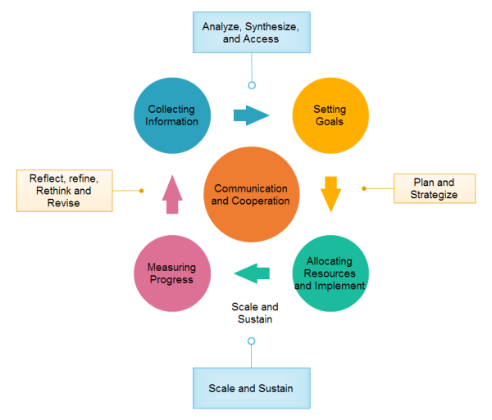

It depends whether you define strategy as a synonym for goal or as a synonym for execution. Most executives (but not all of them), substitute the word “strategy” for the word “goal.” They make pronouncements like “our strategy is to innovate,” or “our strategy is to internationalize,” or “our strategy is to be an industry leader.” Execution, then, is simply the resources and effort to attain that goal. This is the reason that there is a common complaint that, “we had a great strategy, but couldn’t execute it.” As Prof. Roger Martin points out in a HBR article, this is a model where there are “thinkers” (the executives) and “doers” (everyone else). As you might surmise, executives (and their consultants, too) like to use this strategy=goal definition because it makes it easy to blame poor results on poor execution.
Often overlooked, is that the organization has too many goals, too many projects, and too many commitments. Naturally, resources are limited and the perceived problems with execution are really a failure by executives to make tough decisions about where to focus those scarce resources. Those tough decisions are rooted in their inability or unwillingness to take a hard look at their organization’s fit with its competitive environment.
Many goals are completely illogical. They don’t take into account the reality of existing commitments, they are overly-optimistic, and they assume that resources will appear through the magic of visionary leadership. Below the executive level in the organization, managers often use the word strategy as the resources and effort to achieve the goal assigned to them by their executives. In other words, a strategy is a plan of coordinating resources towards achieving a goal. The execution of those plans can also suffer from lack of resources and coordination.
The takeaway is that the concept of strategy is watered-down and disintegrated in common usage. Most organizations have mediocre strategy. On the other hand, some organizations have a more integrated view of strategy, and they craft strategy that is could be termed clever, powerful, or effective. It’s simply foolish to aspire to some goal if you can’t find the resources or leadership to achieve that goal.
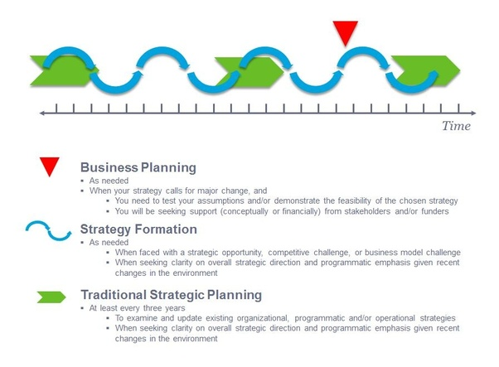
A business plan is a good example of strategic planning. Even a concept plan to create a business opportunity or a project plan to implement a task is also a good example. At its core, is the systematic game plan, which highlights all the strategic and tactical initiatives of completing the journey. It has all these key elements:
- 1) Executive Summary;
- 2) Unique Selling Proposition/Unfair Advantage;
- 3) Organizational Background (including vision and mission statements);
- 4) Market Analysis;
- 5) Competition Analysis;
- 6) Vulnerability Audit;
- 7) Marketing Plan/Product Launch;
- 8) Manpower Plan;
- 9) Financial Analysis (with a detailed 12-month statement);
- 10) Sensitivity Analysis;
- 11) Contingency Plan;
- 12) Game Plan (with a detailed 1-year plan, including all the strategic and tactical initiatives in tandem with predefined corporate objectives);
- Your game plan encapsulates all your long-range goals and objectives which are systematically translated into specific, prioritized and executable tasks which you need to accomplish daily, weekly, monthly, quarterly, and annually.
- For implementation and execution, it contains the following critical elements:
- - specific objectives for each predefined task;
- - metrics to measure your progress;
- - accountability, as some tasks may need to be shared;
- - resources you need to get the work done respectively;
- [I call them the 7 Ms.': Money; Men; Methods; Machines; Materials; Metrics; and Mojo
- - timetable for completion of each predefined task;
- Moreover, your game plan also provides a clear snapshot all potential obstacles and/or roadblocks that may pop up, and also a slew of possible strategies to deal with them (Bryson, 2018). They serve as your contingency plan. Furthermore, the business - and game - plan is not etched in stone (Mintzberg, 2000). You have to stay laser-focused on your strategic goals and objects, but remain steadfastly flexible in your tactical execution. There is no correct format. There is also no correct way of making a strategic plan.
1. What is a strategic plan?
It should cover:
- - Production:
- + Cost: The cost of materials, the labor cost and overhead and some other cost, as well as provision for unexpected cost, might even include provision for risk management.
- + Time: The time it took to purchase or manufacture yourself the materials, as well as the time it took, for the manufacture process.
- + Scope: What will change to the cost and time, if, say, your goal is, 1000 bags a month? What if it changed to 10,000 bags a month?

2. Marketing:
- + How are you going to reach your customer? Understand, online and offline campaign are fundamentally different.
- + What is your cost of acquisition for those channels? Say, you tried 3 channels: Facebook ads, google AdWords and lastly, fliers. You should be able to determine the effectiveness of these 3 channels:
- * Reached: How many people could you potentially reach? This should vary from channel to channel.
- * Effectiveness: The percent of people, who respond positively to your ads.
- * Cost: And finally, based on reached and effectiveness, we could calculate the cost of leads, which is how much it cost you, to tell someone who might be interested in the product about your product.

3. Sales:
- Alright, now, people are lining up to buy the thing, it's good alright, right?
- Wrong. You need someone to sell them, or you might outsource it somewhere.
- + First, determine how you are going to sell, will it be tele sales (god, these people are annoying, but if done right, it's extremely effective), or perhaps those sale people will just stay indoors, waiting for customer?
- + Again, the effectiveness, determine the percentage of leads those sales people can turn into buying customer.
- + Finally, calculate the cost of customer acquisition.

4. Pricing:
- Now, you have:
- - The cost per unit
- - The cost per leads
- - The cost per customer
Based on this, you could calculate the total cost that a single bag must cover. Then add a little more, for profit. In a nut shell, a business plan is a road map, to show you how to go to where you want to go from where you are.

References
Bryson, J. M. (2018). Strategic planning for public and nonprofit organizations: A guide to strengthening and sustaining organizational achievement. John Wiley & Sons.
Mintzberg, H. (2000). The rise and fall of strategic planning. Pearson Education.
Steiner, G. A. (2010). Strategic planning. Simon and Schuster.

