Ehsan Faraz
Instructor Name
Course Number
14 January 2019

Title: Fashion Icon: Marie Antoinette
The 18th century introduced new fashion directions to the world. Among the fashion icons of the century, Marie Antoinette was seen as a role model in style, especially by the bourgeoisie women of the French court, in times when women’s roles were restricted. Through her attire, she was able to influence major changes in 18th-century fashion for which her name remains revered, despite the political criticism she received. The essay will examine her 1785 portrait by Adolf Ulrik Wertmüller and attempt to analyze the portrayal of her attire it in terms of its fashion statement and interpret the cultural phenomena associated with the depiction.
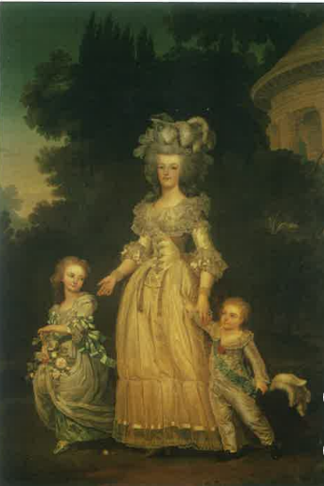
Although Marie Antoinette’s persona was that of an impolite and sour nature, the image captured by Wertmuller intended to counter that. The 1785 image depicts her as a fine motherly figure, which outlines the loving and caring aspects of her nature. A maternal concern is visible to indicate a more positive and appealing persona of her to the French public. The attire is simple and modest, and shows her two elder children, being taken for a walk in a garden. The portrayal opposed her mainstream image and helped calm the controversy surrounded her character in France and lent credence to the claim that she was a fine queen and a mother.
At the time, the women of the French court had adopted wide skirts and tight corsets, which Marie Antoinette inherited and took more steps further. Her attire would be wider than usual and would accentuate and emphasize her breasts. However, the time period in which Wertmuller captured her was when Antoinette, thirty at the time, wanted to change her public image and subsequently announced her intent to dress in a more modest manner (Weber). Although the dress is still corseted but has a more modest outlook, consistent with the change she desired.
In addition, the image portrays Marie in a garden which surrounded her palace. It was an environment she would usually spend considerable time in. The mother’s role remains a highlight in the picture as part of a conscious strategy to reverse the image of a foreign woman who would indulge in all of life’s luxuries that wealth could buy, to one that depicts her as the mother of all France. A rose on the ground along with tiny spots of red on the dress indicates that she may have pricked herself while picking a rose, and dropped it on the ground, possibly as a present for her child.
The other contrasting picture within the same image is that Marie Antoinette still lives a royal lifestyle stereotypical to that of a Queen. Although conservative in fashion, the multiple layers of fashionable and expensive clothing that both the Queen and her children are dressed in is indicative of such. The hat her son holds, and the flowers held by her daughter make it evident that they belong to the wealthy class and carry the same poise and attitude. Along with that, their facial expressions exhibit a sense of confidence, not showing too much emotion but a hint of contentment. They are noticeably aware of the great influence and power they hold in France. The daughter looking towards her younger son is indicative that the Queen taught her daughter common customs in accordance with the gender norms prevailing at that time.
In conclusion, the 1785 portrayal of Marie Antoinette by Wertmuller accurately depicts the idea of beauty common in French bourgeoisie society at the times and tries to counter the negative image of the Queen with that of a caring mother. Women at the time would strive to morph their style, fashion, and appearance to Marie Antoinette, as she represented the height of fashion in 18 century France. Her clothes, her hair, and accessories were nearly perfect to go along with her social class and family history. The change in fashion was a message to all of France that Marie Antoinette was more than a rich woman given to indulgence. She was, in fact, the Queen and mother of France.

Works Cited
Weber, Caroline. Queen of Fashion: What Marie Antoinette Wore to the Revolution. 1st. New York, NY: Picador, 2007.

