Intercultural Relationships
Name
[Institutional Affiliation(s)]

Author Note

Intercultural Relationships
Cultural factors
Culture has a large impact on the development of ethical relationships between people belonging to either the same culture or different cultures. Language, religion, experiences, communication patterns, and education are the cultural factors that affect the ideas of people and the development of their ethical relationships. The ethical relationships refer to the promotion of trust and healthy communication among people. A better building of ethical relationships takes place between the people of the same culture. They follow the same religion, speak the same language, and share common experiences and communication patterns. However, people belonging to different cultures have difficulty accepting the values and norms of others. If they learn the culture of others and let them express their ideas, ethical relationships will be developed and will be healthy. To develop healthy ethical relationships in culture and between cultures, it is necessary that the people show a willingness to adopt the standards and values of other cultures (Kalyani, 2018).
Developing, maintaining, or ending relationships in members of different cultural groups
Building and maintaining relationships is an important community goal that helps in facing and solving the problems of people who connect from diverse cultures. To deal with people belonging to different cultures, a person needs to develop caring and sturdy relationships that are based on understanding, trust, and shared goals (Oetzel, 2017). For building relationships with another culture, people need to make their minds to establish relationships with people belonging to other cultures. They need to examine the biases in their minds about the people of other cultures. The histories and cultures of other groups should be read and examined. The language patterns and different communication styles of the other cultural groups should be examined and respected. The people should ask about the cultures and customs of each other as it helps in building healthy relationships (Gunkel, Schlaegel, & Taras, 2016).
Influence of differing norms and cultural values on conflict styles
It mostly happens when people we interact with are outside of the base of our culture, values, and origins. We consider that they must be a threat to our way of life because they don’t think or behave as we do. The differing norms and values make people shocked and surprised at the out group. They believe that it is a lack of education and a lack of understanding that the other group is not following the same cultural values as them (Okech, Pimpleton-Gray, Vannatta, & Champe, 2016). Due to different cultural values and norms, people tend to develop arrogance, racism, ignorance, and misunderstanding about the people belonging to other groups, and it gives rise to more conflicts among the people and their cultures. When people of different cultures or intercultural communities live in close proximity where peace, harmony, respect is expected, there is a tendency to work harder at listening. When one doesn't understand what something means or what an experience is like, there is a chance of conflict because the non-listener jumps to conclusions, judges, and reacts or retaliates based on false assumptions (Scott & Wildman, 2015).

Illustration of different conflict styles of people from different cultures
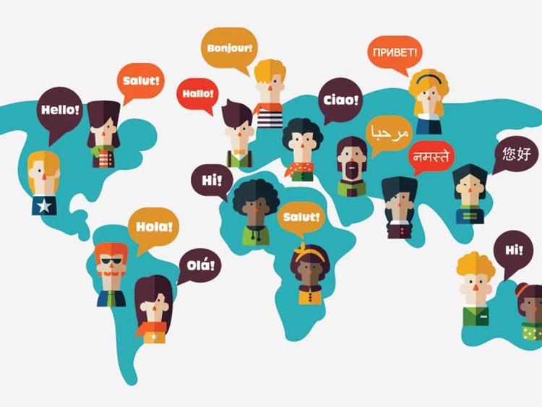

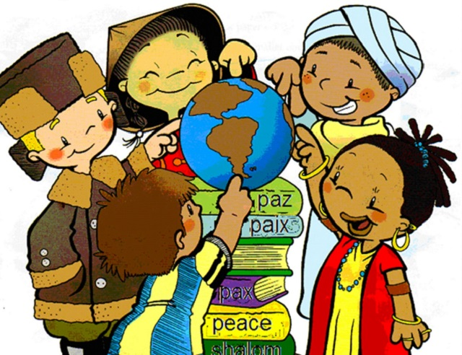

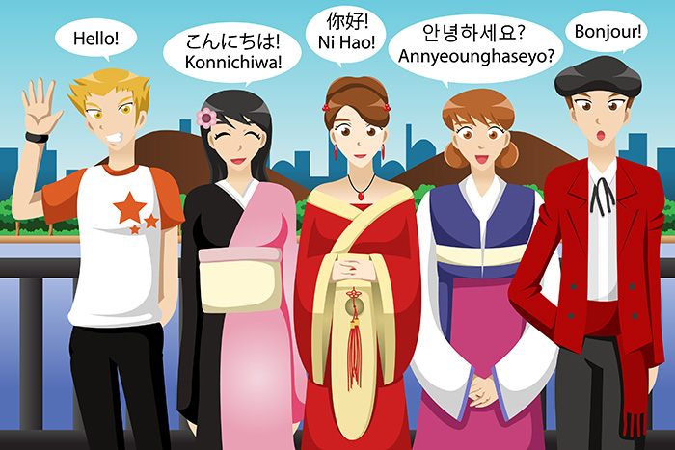

The above illustrations show the intercultural conflicts among people from different cultures and societies. The development of ethical relationships becomes difficult when conflicts between the cultural values of people arise. They face difficulty in understanding the language and communication patterns, their religions are different from each other, their customs and rituals vary, and the education they are receiving in their cultures is very much opposed to others. If people are not willing to accept and respect the cultures and norms of others, there is a huge chance of misunderstanding and conflicts among them. The true acceptance and respect for the cultural values and norms of others are essential to creating a peaceful environment among the different cultures.

Graph
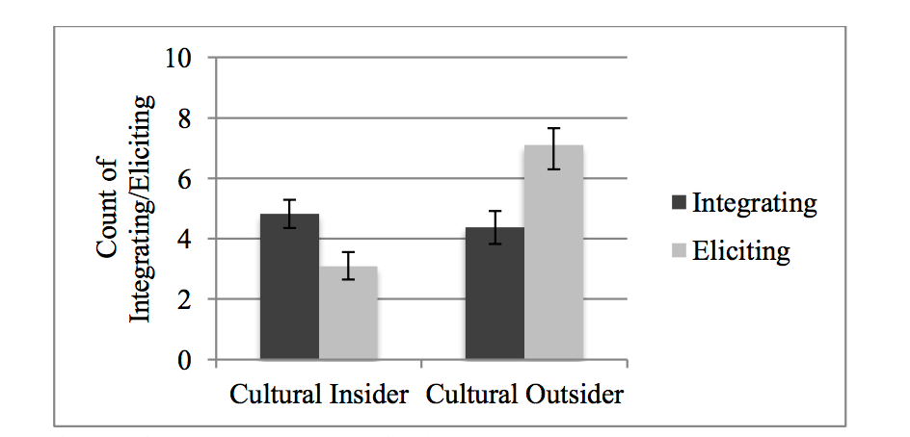
The above graph shows that cultural conflicts are high, especially when people from different cultures interact and communicate. The people in the same culture but with slight differences such as the dialects of the language and a few norms and customs do not face the cultural differences to a large extent. However, people who belong to different cultures have a more ratio of developing conflicts with each other. These conflicts can be on the basis of language, religion, communication patterns, customs, rituals, and education. There are many ways to resolve these conflicts so that peace and harmony can be created among people, and they accept and respect the cultures of each other.

End Notes
Gunkel, M., Schlaegel, C., & Taras, V. (2016). Cultural values, emotional intelligence, and conflict handling styles: A global study. Journal of World Business, 51(4), 568–585. https://doi.org/10.1016/j.jwb.2016.02.001
Kalyani, A. (2018). What Ways Can Culture Affect Ethical Standards & Shape Business Behavior? Retrieved November 1, 2019, from Bizfluent website: https://bizfluent.com/12083818/what-ways-can-culture-affect-ethical-standards-shape-business-behavior
Oetzel, J. G. (2017). Effective Intercultural Workgroup Communication Theory. In The International Encyclopedia of Intercultural Communication (pp. 1–5). https://doi.org/10.1002/9781118783665.ieicc0025
Okech, J. E. A., Pimpleton-Gray, A. M., Vannatta, R., & Champe, J. (2016). Intercultural Conflict in Groups. The Journal for Specialists in Group Work, 41(4), 350–369. https://doi.org/10.1080/01933922.2016.1232769
Scott, C. P. R., & Wildman, J. L. (2015). Culture, Communication, and Conflict: A Review of the Global Virtual Team Literature. In J. L. Wildman & R. L. Griffith (Eds.), Leading Global Teams: Translating Multidisciplinary Science to Practice (pp. 13–32). https://doi.org/10.1007/978-1-4939-2050-1_2

