System analysis and design
Student’s Name
Institution

Abstract

Introduction
The goal of this paper is to provide detailed needs of system development for an organization. It analyses the operations of an organization, problems faced in the management and recommend the right system design which can be used to solve the problem. The analysis of the operations of the organization established that the organization required an automated system where clients can order products through an online platform and track the delivery process as well. The XYZ Company mostly deals with organic vegetable, which requires immediate delivery of products to customers. With Online Library system, which can be used in tracking and monitoring products from suppliers, warehouse to the delivery process would be profitable to the company and therefore, the design and development of CMR system would change the way XYZ operates and improves its efficiency as well.
In most cases, system is designed and developed to solve a problem in an organization. The problem could be related to management, operations, financial or any other issues within an organization (Russell & Russell, 2015). The system analysis and designed involve various processes and at every stage or phase a specific objective or goal is achieved. In order to develop a workable system for an organization the following stages are involved to ensure that the needs and wants of an organization are met.
The Case Study
Background of the system
The Online Library system is designed to improve the working relations between customers and the company. It ensures that customers can easily reach the company, get updates on the new products and also order, track and receive products without any delay. It encompasses several users’ platforms to allow clients to use the system efficiently. The system would be helpful in reducing the overhead, time taken before delivery and improve the efficiency of the company hence profitability. Fox (2017) pointed out that Online Library system was popular during 1997, due to lack of efficient management system. However, much has not changed and several companies still use it for efficient management. It includes several components essential for running of a company. The proposed ONLINE LIBRARY system would be used to link all departments of the organization to ensure that the data are centralized for efficient management. Delivery of products is a critical component of efficient business management and with proposed ONLINE LIBRARY system, items or products ordered by clients would be delivered on time. The analysis of the data gathered indicates that XYZ Company has faced challenges related to tracking, delivery which is being done manually, and it takes time to sort out orders to send to customers. With Online Library system, customers and members can easily order the products online and receive at different part of the country without facing much difficulty. The Online Library system is designed to solve the backlog of people streaming to the library to read books.
With e-library system, it would be easier to engage lead customers, build scalable sales, sort and delivery products faster to customers. The system intends to change the way company does its business and improve efficiency as well. The XYZ e-library system would bring together all the departmental operations to ensure that a specific objective of the company is achieved. The installation of the system would also help the company to improve the performance of the company. The company would be able to collect relevant information related to customers. It would allow the company to get relevant information which can be used to develop a platform and relevant products for customers to meet their needs. The
Features
The proposed e-library system intends to have several features to support the operations of the company. It shall have users’ interfaces for customers where customers can be able to login and make an order of any products. This will allow the company to make quick delivery of products to customers (Ramakrishnan, 2014). The fact that the system is integrated with all departments makes it easier for the management of the company to be efficient. It intends to have contact management, social media management, reports and dashboards, mobile apps, email tracking, and tasks and deals. However, to make the operation of the company very efficient, different channels and points would be included such as websites, live chart, direct email, social media aspect. These will allow the company to be able to operate efficiency and build a good reputation in the market. According to Adair (2014), technology plays an important role in reaching out to customers.
Business Justification
With the expansion of XYZ Company, there is need to have a system which customers can use to reach the company. The YXZ Company sells and rent books and most of its products are magazine, books, Newsletters and research materials. This requires efficient delivery of product to the market and to customers. Again, the company is expanding to other regions and therefore, it would be important to have a system that can be used to track operations from all branches.
System requirement
The development of system for efficient operations of the company requires the understanding of the operations of the company. It will be important to understand the profile of the employees, products being sold, customers profile and model of operation of the company.

Users Diagram
The user case diagram of the e-library indicates the functionality of the system and the main purpose for the development of the system. The users diagram provides a clear description of how the system would be installed and operates as well. 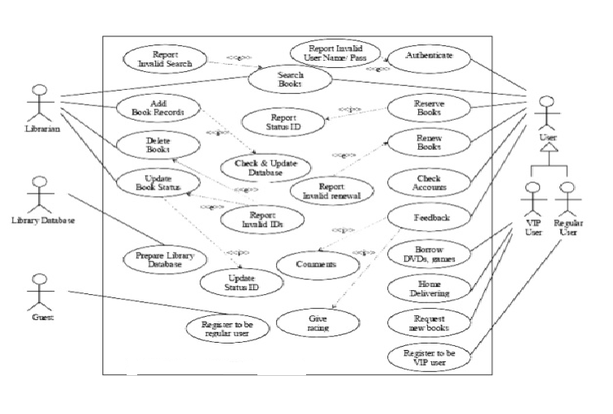
Figure 1: Library management system
Class Diagram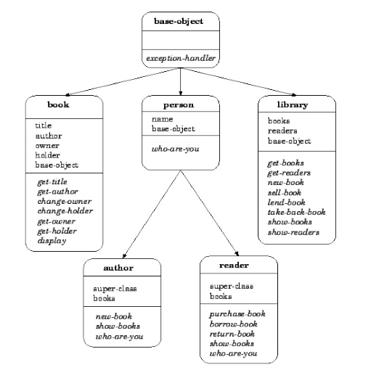

The UML xml file
“<!--Navbar-->
<nav class="navbar navbar-expand-lg navbar-dark primary-color">

<!-- Navbar brand -->
<a class="navbar-brand" href="#">Navbar</a>

<!-- Collapse button -->
<button class="navbar-toggler" type="button" data-toggle="collapse" data-target="#basicExampleNav"
aria-controls="basicExampleNav" aria-expanded="false" aria-label="Toggle navigation">
<span class="navbar-toggler-icon"></span>
</button>
<!-- Collapsible content -->
<div class="collapse navbar-collapse" id="basicExampleNav">

<!-- Links -->
<ul class="navbar-nav mr-auto">
<li class="nav-item active">
<a class="nav-link" href="#">Home
<span class="sr-only">(current)</span>
</a>
</li>
<li class="nav-item">
<a class="nav-link" href="#">Features</a>
</li>
<li class="nav-item">
<a class="nav-link" href="#">Pricing</a>
</li>

<!-- Dropdown -->
<li class="nav-item dropdown">
<a class="nav-link dropdown-toggle" id="navbarDropdownMenuLink" data-toggle="dropdown"
aria-haspopup="true" aria-expanded="false">Dropdown</a>
<div class="dropdown-menu dropdown-primary" aria-labelledby="navbarDropdownMenuLink">
<a class="dropdown-item" href="#">Action</a>
<a class="dropdown-item" href="#">Another action</a>
<a class="dropdown-item" href="#">Something else here</a>
</div>
</li>

</ul>
<!-- Links -->

<form class="form-inline">
<div class="md-form my-0">
<input class="form-control mr-sm-2" type="text" placeholder="Search" aria-label="Search">
</div>
</form>
</div>
<!-- Collapsible content -->

</nav>
<!--/.Navbar—“

Objective Diagram
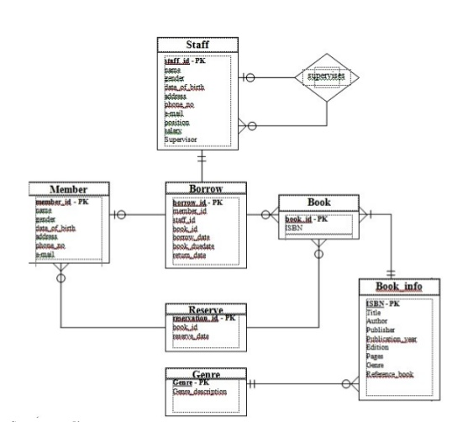

Sequence Diagram

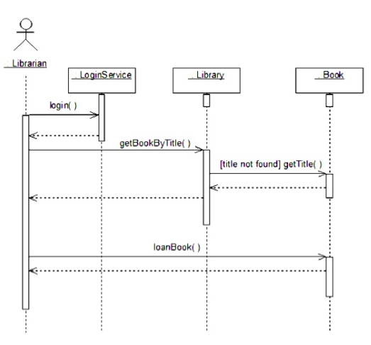

State chart diagram 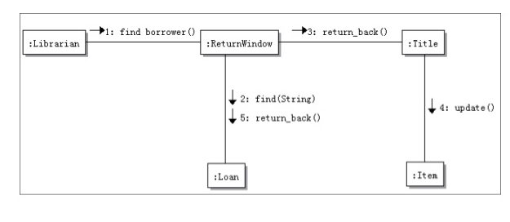

Active Diagram
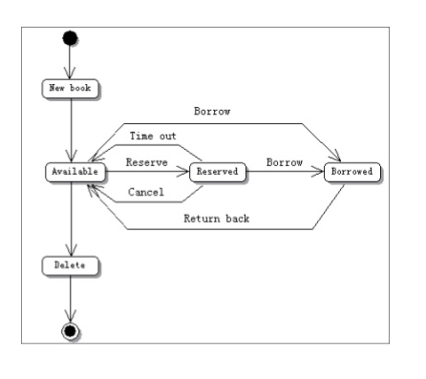

Component Diagram
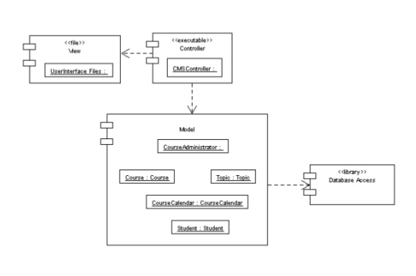

Deployment diagram
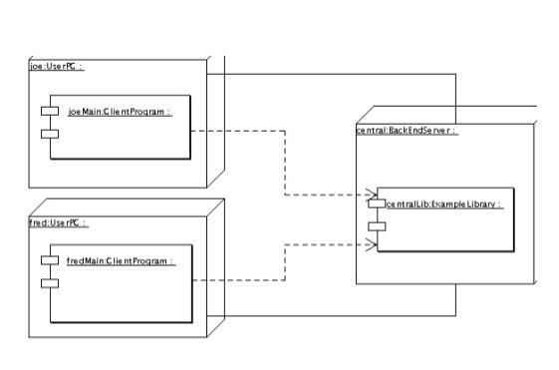
Proposed service
Online Library: this service improves the site by providing students with e-library services including books, past papers and other learning materials options and ease of doing business with the company, with additional features such as e-library account, payment type and category.
Library Membership is more of maintenance or backend feature its assist students and other users depending with their preferred service and cluster them on the mode of business requirements; the service has sub groups of specialization, categories and membership duration.
Products: It provides users with a good option for products type such as for hire or purchase .Accessories for onetime and single buyers and lastly advertising for on sale, new arrivals and wish list.

Cost Analysis
In order to design and develop e-library system for the XYZ Company certain amount need to be factor to cover the collection of data, design and development of system and installation process of the system.
No/S | Description | Quantity | Unit price | Amount
1. | Designing and building a website | 1 | @$10,000 | $10,000
2. | Building e-library management system. | 1 | @$200,000 | $25,000
3. | Voice integrated system | 1 | @$50,000 | $50,000
4. | Email integrated platform | 1 | @$5,000 | $5,000
 | Total |  |  | $90,000

Gantt chart

Conclusion
The e-library project for the XYZ Company intends to establish a good system where clients and members can borrow and purchase books and other reading materials through its online platform. The e-library establishes a platform where books can be order and therefore, it ensures that the operations of the company are efficient. In this project, the online library addition to the system of the company added several advantages to both financial and operation of the company. The XYZ Company having a well developed website but does not have an online platform library. This was deterring learning in the XYZ Company making it difficult for the XYZ Company to provide efficient online classes to students. Using the diagrams, the links, relationship and connection of the library with other sectors of the website has been properly illustrated. The website interface has been improved as well, making the website users’ friendly. This makes it easier for students to borrow, read, and purchase learning materials through the online platform of the university.

References
Adair, B. (2014). CRM Features and Functionality List. https://www.selecthub.com/customer-relationship-management/crm-features-functionality-list/ , 2-34.
Dalcher, D. (2012). The nature of project management. International Journal of Managing Projects in Business , 2-15.
Fox, T. L. (2017). Systems Analysis, Design and Development Case Study: Sarah's Short Cakes Sales Order System. International Journal of Information System , 3-35.
fullerton, m. (2014). Integrated Marketing Communication Project. International Journal of communictaion , 2-15.
Ojiako, U. (2012). Facilitating the Development of Project Managers as . Reflecting on your management of the project , 2-15.
Ramakrishnan, S. (2014). System Analysis and Design. Journal of Information Technology & Software Engineering , 3-35.
Russell, J., & Russell, B. (2015). A Systems Analysis and Design Case Study for a Business Modeling Learning Experience for a Capstone CIS/IS Systems Development Class. Information Systems Education Journal (13), 2-35.
Soderlund, J. (2008). Project Management : Managers And Teams. Relating, reflecting and routinizing: Developing project , 2-15.
Sutcliffe, A. G., & Faraday, P. (2015). Designing Effective Multimedia Presentations. International Journal of communication , 2-31.

