Writer’s Name
Instructor Name
Art 101
10 December 2019

Rapture and Second Coming of Christ
It is a Christian concept for the return of Christ to Earth for the second time from heaven. It is believed that the ascent of Christ will happen for the second time from heaven. It is a part of canonical gospels and almost all of the eschatologists have believed that Christ will come back from heaven. Various claimants have predicted different dates for the second coming of Christ. It is also projected that the second coming of Christ and the nature of ascent varies among Christians (Schroeder). Rapture is an eschatological belief or various Christians predominantly in American evangelicalism. They have proposed that Christ is alive and will rise among clouds to meet Lord (Carroll). Rapture term was derived from Latin Vulgate 1 Thessalonians 4:17. The transformed Christians has been observed not practicing rapture term and also they do not agree with the views of pre-tribulations. Above all, the views of the pre-tribulation concept are more understanding, evaluated and accepted by most of the Christians because they are more explained according to the Christine doctrine. Also, the concepts are evidence-based with Thessalonians, Roman, and Danial.
The transformed Christians use this term to describe the phenomenon that Christ's gathering in heaven and his second coming. They also repudiated the views of premillennial dispensation (Four Views of End Times Prophecy). This community from Christians also rejects the opinions that a large section of humanity would be gone behind after events 1 Thessalonians 4:1 for an extended period (Vagramenko). It has shown that various classes among Christians have different views regarding Rapture and the second coming of Christ and the most widely accepted views are of premillennial dispensation. There are numerous theories on the occurrence of Millennium regarding second coming (Dulin). This article will analyze common beliefs and four different views concerning end-time prophecy and will evaluate predictions and claims by various Christians in this regard.
Rapture
The term Rapture was frequently used by conservative Christians. It is a mystical union with God or life hereafter. Amillennialists have believed that the promises of God would not be fulfilled specifically 1000 year reign of Christ (Four Views of End Times Prophecy). Christ will return before His accurate reign on the earth for 1000 years is another sign that exists among Christians (Scholtz). Among these are the post-tribulationists, mid-tribulationists, and pre-tribulationists. Post-tribulationists are those having belief that Rapture will not occur till the finale of the 7-year trial, just preceding to the commencement of the millennial kingdom (Vagramenko). Mid-tribulationists believe that Rapture will occur in three to one-half years in tribulations.
There are different viewpoints about the return of Christ and the time of the rapture. It was believed that the return of Christ will occur followed by the 1000 year Messianic kingdom. The widely accepted view is the view of pre-tribulation (Four Views of End Times Prophecy). Though these views are often debated among pre-tribulation and evangelicalism (Four Views of End Times Prophecy). Various views also exist regarding Thessalonians explained in 1 about aerial gathering. The majority of the Christians do not subscribe to pre-tribulation opinions. Rapture was a word derived from Latin Vulgate 1 Thessalonians 4:17. Most of the reformed Christians has been observed not using rapture term and also they do not agree with the views of pre-tribulations. Instead, they use this term to describe the phenomenon that Christ's gathering in heaven and his second coming. They also denied the views of premillennial dispensation (Four Views of End Times Prophecy). This group also rejects the opinions that a large section of humanity would be port behind after events 1 Thessalonians 4:1 for an extended period (Vagramenko). It has shown that various classes among Christians have different views regarding Rapture and the second coming of Christ and the most widely accepted views are of premillennial dispensation.
Amillennial
It is suggested that there will be seven years of tribulation. History has also demonstrated that God discloses His predictions (Four Views of End Times Prophecy). For example, the building of temple numerous times, the city of Tyre destruction and so many (Four Views of End Times Prophecy). It is also suggested there would be verbatim 1000 year empire of Christ as Isaiah 65:20:25 (Carroll). People will age, grow and live for many years and it would the same as before the flood. as the day of the Lord would be as long as 1000 years means one day would be literal 1000 years (Four Views of End Times Prophecy). Studies have also suggested that the life of earth and heaven would be destroyed and will be recreated after the event.
Post-Tribulation
According to the concept and views of the followers of post-tribulations, it is believed that life would be ended as evil has recognized therefore he will come for humans to distract them. All the things will be ended and destroyed (Four Views of End Times Prophecy). Saints would be those who are true followers of tribulation and rapture of Church (Four Views of End Times Prophecy). Many of the reasons that rapture would not occur are described in the pre-tribulation period as it is believed that if a rapture has to occur before Christ then they would have resuscitated and to resuscitate again.
Mid- Tribulation
They have believed that divining of goats, millennial kingdom growth and resuscitation of tribulation are true. They claim that in the second half period of tribulation, the worst plagues would occur. They believe that Antichrist will initiate war with the believers soon after the tribulation in the second half period. Also, in case all of the believers have to be raptured, no saints would be left to wage war (Four Views of End Times Prophecy). The views represent that God would remove Christians and evil would be free and it would open a way for deception and Christ will return, people, will grow. According to the revelation, it also shows characteristics of tribulation and it’s pleading.
Pre-Tribulation
There are various views regarding rapture and tribulation. They believe in the present church, not the end time. There are three major classes of people including Church, Gentiles, and Jews. There is no specific distinction among them according to the views (Four Views of End Times Prophecy). However, in chapter 7 revelation that states all tribes are mentioned specifically from people of Israel (Four Views of End Times Prophecy). This concept generates the way for the gospel of great kingdom and will produce it. They will grow, expand their generation and will be destroyed (Carroll). They also believe that Christ has sacrificed his life for the sins of people. It is believed that the last gentile would become Christian and God will start his plans with Israel therefore they believe the views of the fullness of gentiles (Four Views of End Times Prophecy). They also suggest that the day of rapture is not known (Four Views of End Times Prophecy). No time and no warning has been mentioned to people to know how and when rapture will happen. It can happen at any time though it was mentioned in Danial 9:27 that covenant of antichrist followed by second coming and Israel would break the covenant in three and half years. It is believed that if the post-tribulation views are correct then people would have seven years indication before the rapture, however, if the views of mid-tribulation are correct then it means people would have three and half years notification. As explained in 5:9, 1 Thessalonians, people of Christians would not face the wrath from their God (Carroll). All of the concepts and viewers believed this notion.
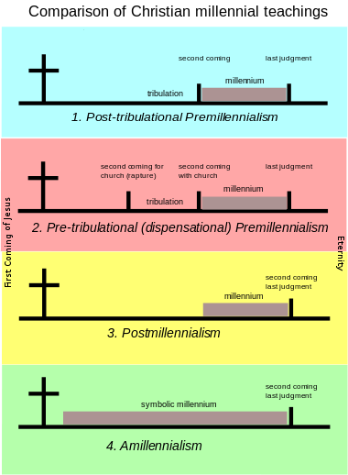
Paul informed the Thessalonians, "And now ye know what withholdeth that he might be revealed in his time. For the mystery of iniquity doth already work: only he who now letteth will let (hinder) until he is taken out of the way" (2 Thessalonians 2:6-7). This shows that God would remove Christians and evil would be free and it would open a way for deception (Four Views of End Times Prophecy). Until Christ returns, people will grow and operate their relations. This revelation shows characteristics of tribulation and it's plead.
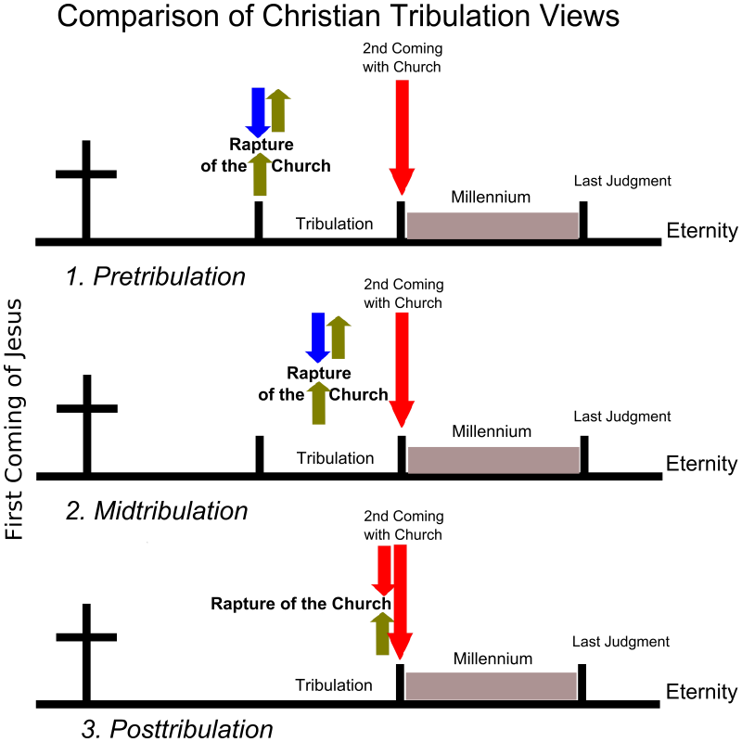
I believe that the views of pre-tribulation are more realistic as compared to other concepts and views. It is believed that most of the ideas and concepts people may disagree with however, divergence on end-time prophecy is a sign. It is difficult to split the Word of God and to understand the main theme (Four Views of End Times Prophecy). The truths explained in the article from different concepts have been evaluated by various researchers (Vagramenko). For instance, if the views of mid-tribulation are correct then it means people would have three and half year notification before the event. As explained in 5:9, 1 Thessalonians, people of Christians would not face the wrath from their God (Carroll). All of the concepts and viewers believed this notion. Therefore, I am of the view that the pre-tribulation concept is more understanding and agreeable because they are more explained according to the Christine doctrine. Also, the concepts are evidence-based with Thessalonians, Roman, and Danial.

Works Cited
Carroll, Timothy. “Theology as an Ethnographic Object: An Anthropology of Eastern Christian Rapture.” Religions, vol. 8, no. 7, 2017, p. 114.
Dulin, John. “Reversing Rapture: Evangelicals’ Practice of Jewish Rituals and Processes of Protestant Inclusion.” Anthropological Quarterly, 2015, pp. 601–34.
Four Views of End Times Prophecy. https://www.matthewmcgee.org/rapture.html. Accessed 10 Dec. 2019.
Scholtz, Jacob J. “One Messiah, Two Advents, Three Forerunners: The Chiastic Structure of Matthew 11: 2-17: 13.” In Die Skriflig, vol. 50, no. 1, 2016, pp. 1–10.
Schroeder, William Dale. Of Raptures and Raptures: Locating Ideology with LiDAR Imagery. 2018.
Vagramenko, Tatiana. Chronotopes of Conversion and the Production of Christian Fundamentalism in the Post-Soviet Arctic. Berghahn Journals, 2018.

