Data analytics for business
Student’s Name
Institution
Date

Introduction
PLE is private owned designer and producer of traditional lawn mowers, which are used by homeowners. Within the last 10 years, the company has added several key products strategic for its growth. It has added a medium sized diesel power lawn and tractor to improve the service delivery to its customers. PLE has experience several challenges in the market related to defects and retention of employees. The HR department had to make decision on management of employees to improve performance of the company. This report therefore, presents the analysis of the defect after delivery of products, employee retention.
Defects after the delivery of products
In order to determine the impact created by quality of problem and defects, regression analysis was implemented on the Number of Defects, which were received from suppliers with time before taking the initiative in August 2011. It was discovered that the initiative which was taken in August 2011 indicates that the trend of defects receive was rising up, and therefore, it indicates an in increased amount of defects which were received within the period. The analysis of data indicates that R Square is 0.69, and this means that 69% of the increase realized on defects received is likely related to the time. This therefore, means that quality problem being released by the company increase over a period of time. It is therefore, translates that if there is no immediate initiative taken to correct the quality problems which was being experienced by the company, then the number of Defects, which the company is experiencing will continue to grow. Therefore, the Trend Line Equation above is showing that the number of company’s defects is closely related to the time. It is therefore, established that the number of Defects = 795.37 + 11.98, which is obtained to be the defects. The time is 1.209. It is therefore, evident that defects are affected by time and which means that the company must work on the modality to maximized time in order to improve performance of the company. The problems related to defects can be resolved through engineering
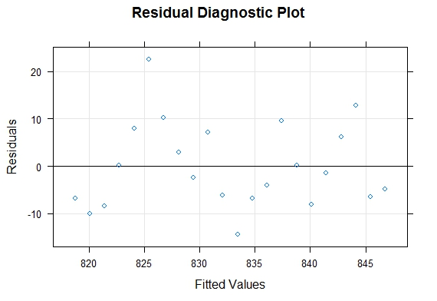
Employee retention
The review of PLE employee retention indicates that number of years, gender, and number of years of education, number of years at PLE, College graduates and college GPA are some of the factors which are significant for employee retention. The analysis of data using ANOVA to determine the relationships between variables indicates that gender is related to the number of years at PLE. It is established that the years at PLE is related to gender. Based on the data analyzed indicates that male gender has several years of service at PLE compared to female. The average mean of male is 0.725 and the average mean of female gender is 0.525. Based on the box plot of the year below, it is therefore, evident that female gender has several years of experience at the company compare to male.
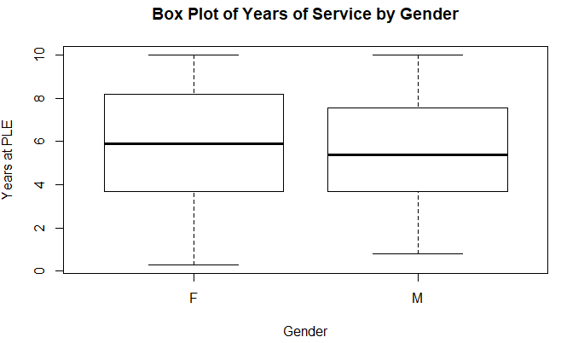
Graph 1: Box plot of the year of service gender
The analysis of two variables, the Years at PLE and the age of employees established that, there is no significant differences. The p- value is 3.9124, which is higher that the significance value of 0.05. This means that the value is not statistically significant and therefore, it shows weak evidence against the hypothesis. It means that the null hypothesis is rejected and the alternative cannot be accepted as well. This means that employees’ retention is not related to college GPA, year of education and age of an employee. This means that the company focuses on other factors when it comes to making decision on the retention of employees.
ANOVAs: Single Factor
SUMMARY
Groups | Count | Sum | Average | Variance
Column 1 | 40 | 221.5 | 5.5375 | 8.069070513
Column 2 | 40 | 628 | 15.7 | 2.625641026
Column 3 | 40 | 117.37 | 2.93425 | 0.207332756
Column 4 | 40 | 1006 | 25.15 | 12.69487179
Column 5 | 40 | 13 | 0.325 | 0.225
ANOVA
Source of Variation | SS | df | MS | F | P-value | F crit
Between Groups | 17017.27589 | 4 | 4254.318972 | 892.9422293 | 3.9E-124 | 2.417962542
Within Groups | 929.0547275 | 195 | 4.764383218
Total | 17946.33062 | 199

Comparing male employees and college graduates shows a unique result. It indicates there are several male employees who are graduates at the company. The result shows that 65% of male employees are graduates compared to female employees who make only 35% of the graduates. This can illustrate why many male employees are likely to be on retention compared to female employees. In the analysis the variables were established as illustrated below to help in determining the relationship between employees art PLE and college graduates. It is therefore, established that there is relationship between college graduate and employees at PLE. It means that there are high chances of graduate employees being retained at the company compared to employees who are not graduates.
Correlation between Age and College graduate
However, the analysis further conducted in relation to the GPA and graduates shows a unique trend. “Is college GPA correlated with years of education? How about age? Is it correlated with years of education?” In this case, it is established that the variable is 0.7, and therefore, it means that there is a correlation between age and college graduates. Though the correlation is low, the multicollinearity is not an issue. The analysis was conducted using linear regression to determine the relation between the variables and as indicated on the table below, it is evident that there is no relationship between age and college graduates. This could mean that the HR resource manager can use other factors rather than age and college graduates to determine which employees to retain.

Residuals:
Min 1Q Median 3Q Max
-5.3299 -1.6122 -0.2433 1.8893 4.6312

Coefficients:
Estimate Std. Error t value Pr (>|t|)
(Intercept) -2.73711 4.50415 -0.608 0.5472
Employee-Retention$YrsEducation -0.06705 0.35516 -0.189 0.8513
EmployeeRetention$College.GPA 0.67998 1.18355 0.575 0.5692
EmployeeRetention$Age 0.29154 0.13504 2.159 0.0376 *
Significance Codes: 0 ‘***’ 0.001 ‘**’ 0.01 ‘*’ 0.05 ‘.’ 0.1 ‘’ 1

Residual standard error: 2.726 on 36 degrees of freedom
Multiple R-squared: 0.1502, Adjusted R-squared: 0.07939
F-statistic: 2.121 on 3 and 36 DF, p-value: 0.1146

However, the result indicates that age is statistically significant factor or variable when it comes to making decision of employees at PLE Company. According to Kaul (2019)employees age is essential because most companies would want to have dynamic and age employees who can adapt to organizational changes and spearhead the growth of the company. The plot of the residual diagnostic plot against the fitted value is indicated on the graph shown below.
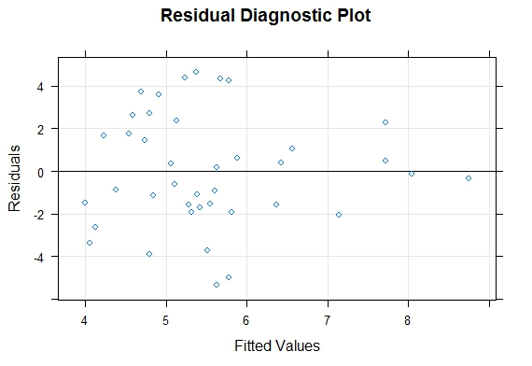
The study also indicates that college graduate and employees age are also significant to the
Residuals:
Min 1Q Median 3Q Max
-4.9927 -1.6430 -0.1952 2.0328 4.8078

Coefficients:
Estimate Std. Error t value Pr(>|t|)
(Intercept) -2.0149 3.0425 -0.662 0.5118
Employee-Retention Age 0.3003 0.1198 2.506 0.0166 *
---
Significance codes: 0 ‘***’ 0.001 ‘**’ 0.01 ‘*’ 0.05 ‘.’ 0.1 ‘ ’ 1

Residual standard error: 2.666 on 38 degrees of freedom
Multiple R-squared: 0.1419, Adjusted R-squared: 0.1193
F-statistic: 6.282 on 1 and 38 DF, p-value: 0.01659

Bibliography
Kaul, V. K. (2019). Business Organization and Management Text and Cases. https://www.researchgate.net/publication/334194938_Business_Organization_and_Management_Text_and_Cases , 2-35.

