Title page
Environmental issues

Lab 4
4.1 Introduction to biomes
- Do certain zones appear along coasts?
Yes certain zones appear along the coast as shown in the image.
- Are they in the interior of a continent?
Zones are in the interior of the continent such as consider moist tropical ‘A’ zone.
- Are they located north or south of the equator?
Zones are located both on the north and south.

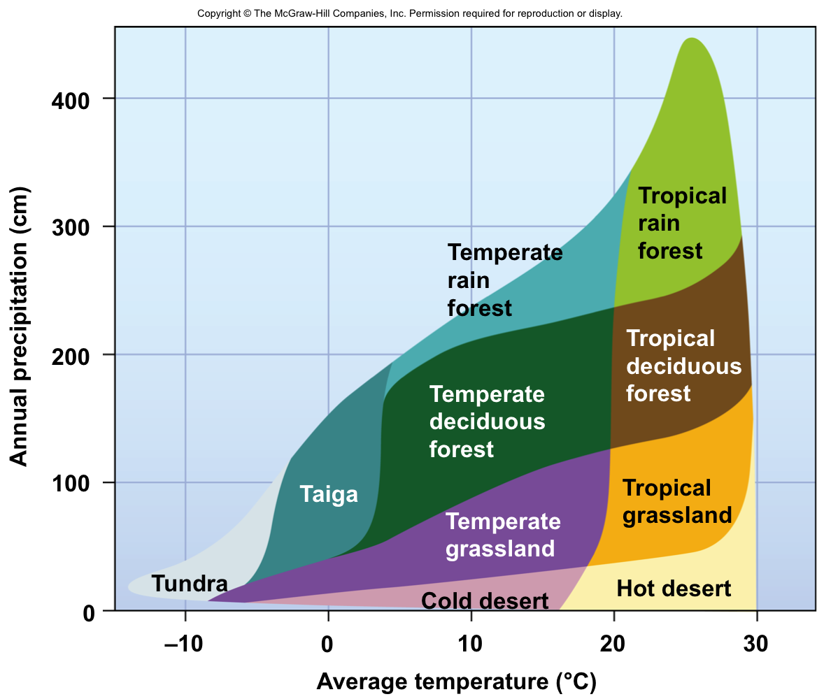
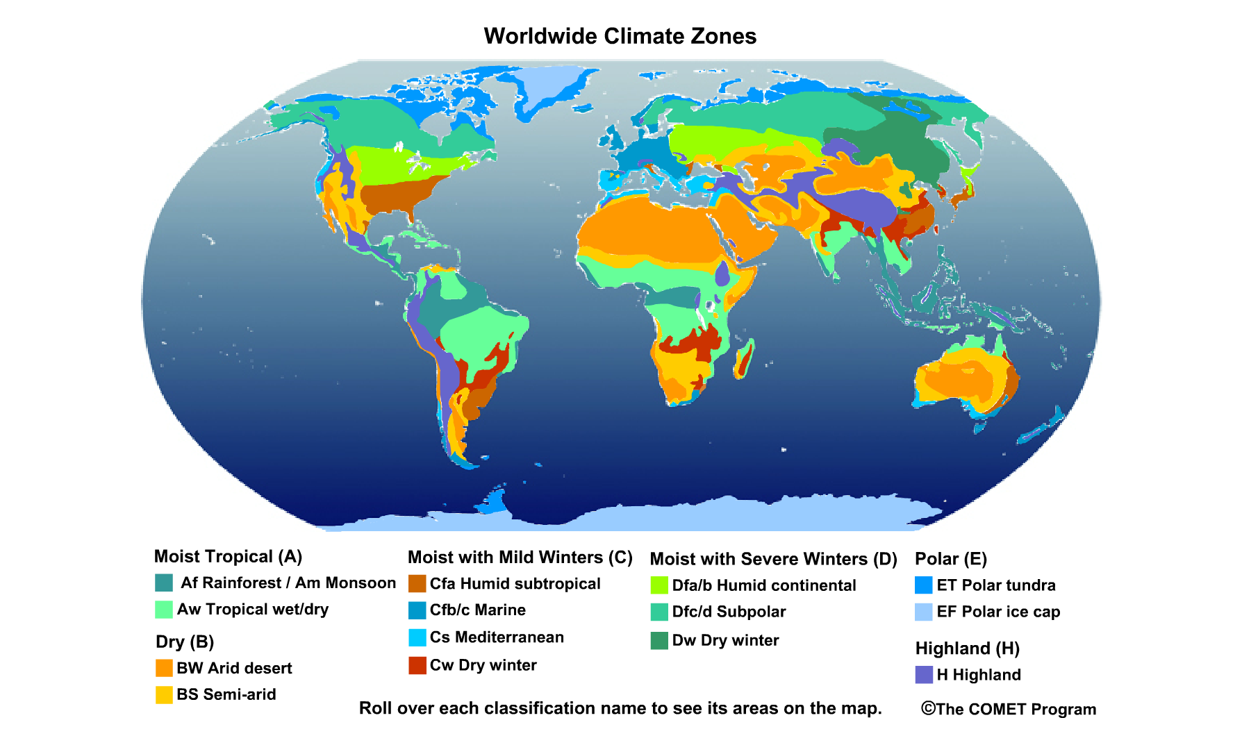

Use the map and legend to answer the questions below:

- In what general latitude bands, or sections of the map, are the deserts located?
Temperate rain forest, temperate deciduous forest and temperate grassland are located at ‘X’ 10 degrees latitude band. Deserts in hot desert zone are located at ‘Y’ latitude.

- Where are the moist tropical climates located? Do they seem to have a particular region within which they occur?

Moist tropical climates are located between hot and cold deserts.

- Where do you find the severe winter (extremely cold) climates?
Severe winter extreme cold is at O degrees.

- What climate zone do you live in? Where else does it occur?
I live in cold climate zone it occurs in
Once you have located the biome in which you live, find it on the Whittaker Classification diagram:
- What is the range of annual temperatures you can expect in this area?
Annual temperatures are between -5 degrees to 30 degrees.
- What is the range of annual precipitation that can be expected?
Annual precipitation expected is 400 cm for deserts in hot desert area
- Look to see what would happen if the average temperature in this area increased by 5˚C, and precipitation decreased by 25 cm per year? Compare the vegetation in the current biome to that of the new biome, and describe any shifts you might expect.
If the average temperature is increased by 5˚C and precipitation by 25 cm per year vegetation conditions will be affected adversely. This rise in temperature will undermine the agricultural activities which also reflects climate change. New biome suggests more adverse living conditions due to high temperature and precipitation.

  - Biomes and climatology
Explore biomes and geography
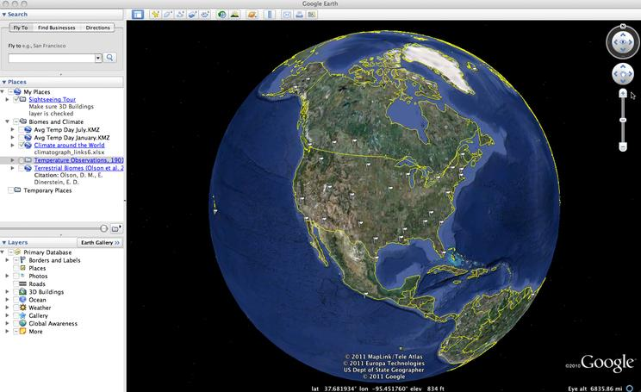
- How do the biomes change as you go from west to east across the United States? Use your knowledge of regional climate forces to explain this pattern.
Biomes change as I go from west to east across the US. This suggests that in east ocean currents play prominent role in adding moisture so the climate is not very dry. Temperate deciduous desert is on the east where precipitation changes from 28 inches. This causes frost in winter and even summer. Temperature goes to below zero. While in west temperature is high and there is more sun than frost.

Explore climate and geography
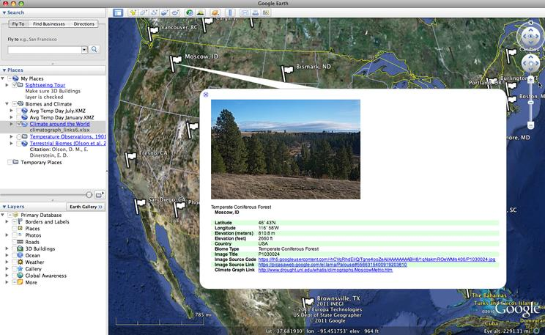

2. Look for two cities around the world that share a biome type and compare their climographs. Do they have similar temperatures and receive similar patterns of precipitation?
Two cities around the world that have similar biome are Philadelphia, US and Beijing, China. This is because both cities fall in the temperate desert zone. Temperate forest zone covers north America and also northeast Asia. Due to these similarities biomes are same. Biomes represent low rainfalls and temperature contrasts strongly between winter and summer.
3. Describe the animals and vegetation that you see in the images of the climate zones.
Animals in temperate climate zone are classified as 40 degrees to 70 degrees. There are no extreme temperature zones. Mountain regions will include animals like mammals, songbirds and meadowlarks. Sparrows, ground squirrels and badgers are also present. Vegetation conditions are good which means more crop production.
4. How does climate and life vary around Earth's surface? Give specific examples from this Google Earth project.
Climate and life vary around earth’s surface due to two central reasons. First is that sun generate different energy or radiation at different points on its surface. This means that every zone will receive different energy level from sun. Second reason is the variation in the circulation of oceans and atmosphere. Heat and moisture will change across different arcs. Change in climate affect lives of people such as in hotter places people will adapt to the climate by wearing light dresses. Similarly in cold places people would wear warn clothes.
5. Imagine you are a modern-day explorer and have been charged with describing how climate and biomes change as you travel north to south across a continent.
As I traveled from north to south I realized biomes changes massively. In the North I learned about Tundra that is the coldest region. There is frost and temperature goes below zero. This means survival in extreme cold is difficult. When I traveled the south region I experienced warmth of places. This region is wet and humid which means survival is possible. The temperature is increasing in this region which is due to global warming and high ecological footprint. Extreme changes in climate exhibits future challenges for the society.

Discussion week
If I had the option of saving two ecosystems, I would save forests and wetlands. This is because of the fact that forests are a greater source of generating oxygen and absorbing CO2. This would require taking a large-scale action in order to restrict deforestation. Cutting trees is damaging the environment because it affects the capacity of absorbing carbon dioxide, and releasing oxygen. Forests remove carbon dioxide at a massive level that has a significant impact on environment sustainability and protection. By investing in forests and wetlands it is possible to fight against climate change. Forests have always been climate saviors because there are hundred of trees that absorb carbon dioxide generated by human activities (TED, 2016). I think reforestation programs at a large-scale could play a significant role in mitigating climate change risks. Carbon sequestration is linked with forestation that offers social, economic and environmental benefits (Canadell & Raupach, 2008). Countering carbon emissions is also possible by developing wetlands. Environmentalists have found that wetlands absorb huge amounts of carbon dioxide that is deteriorating for the environment. These are also prominent sources of carbon sequestration and can protect the environment in the long run. Researchers have also found that wetlands are important for removing pollution. I think forests and wetlands could protect future human populations and allow countries in attaining its global agenda of climate protection. There is a need for building more forests and wetlands across the world. I believe that it is not possible to stop the generation of carbon dioxide because consumption of electricity is increasing at a rapid pace, which is increasing the threats by environment degradation. Goals of forestation could include spreading awareness to the population about protecting forests and refraining from activities such as cutting trees.
DDT lab
DDT in algae = 0.0003 mg in the chosen lake
DDT consumed by shrimp = 10g algae x 0.0003 = 3ppm
Total amount of fish eaten = amount eaten per day x number of days in individual’s life
If a person eats 1 fish per day then total amount of fist eaten in 60 years of life is
= 1 x 21,900
Total fish = 21,900
If a person eats 2 fish per day then total amount of fist eaten in 60 years of life is
= 2 x 21,900
Total fish = 43,800 fish
DDT is Dichlorodiphenyltrichloroethane that is the danger caused by upsetting the natural balances due to extensive use of farm area. Researchers and scientists have found that DDT is linked to deteriorating human health. Exposure to DDT could result in various diseases in humans of different ages. Calculated DDT at the lake is 3ppm, which indicates that it will threaten the health of human beings in the nearby areas. Pregnant women in these areas will be more likely to give birth to immature babies. The insecticide could also increase the risks of death. The overall estimate of 3ppm DDT indicates that the death risks are increased by 15 percent. DDT will also have indirect effects, such as, influencing the bird reproduction and crop production. Insecticides could damage crop fields at a large scale that means infected food intake by humans will lead to other diseases. Overall generation of crop will be affected as it is linked to human consumption. DDT is also identified as a cause of respiratory diseases such as asthma. It indicates that the babies born in the neighborhoods might develop respiratory problems including asthma.
Response to Jason
After reading the “Open Letter to Greta”, I agree with the viewpoints of Jason D. Hill because he provides criticism to the solutions presented by Greta. I agree that the solutions mentioned by Greta are unrealistic because no one will be willing to act in the way he wants. According to Greta, rational adults must act fairly and consciously by considering the repercussions of their actions. Throughout the discussion, Greta has blamed humans for damaging the environment and the world. Most of the points addressed by Greta are based on his personal experiences which make her less convincing towards the world. The strongest argument made by Hill is that survival without technology and civilization is not possible. I strongly agree with him because it took centuries to build technology and refine human ways of living. However, Greta is suggesting to go back to the stone age when people had no electricity or technology. I don’t accept this as a realistic solution because Greta has not considered the desires of the current population. I am living in the age where the youth is more inclined to learn and explore new things. For them living without smartphones, computers and gadgets is not possible. It has also been observed that the demand for technology has been growing massively since the twenty-first century. I agree with Hill that technology has caused more good to the society by making lives easier and convenient.
I also agree with Hill that Greta’s generation is less efficient compared to the older population. Younger generations are contributing massively to carbon emissions and global warming because they are addicted to social networking and gadgets which means excessive use of electricity. I strongly agree with Hill’s argument that suggestions presented by Greta are based on illogical facts. She has suggested that humans must live primeval conditions which is impossible. Hill has rightly pointed out that living in jungles would increase the risks of getting bitten by dangerous animals or insects which means a shorter life span. I agree with the statement, “we would have to adapt ourselves to nature rather than adapt nature to meet our needs, like all members of civilized civilizations do”. I agree that the system suggested by Greta is illogical and will cause more deaths and miseries. Surviving in such a system means more starvation, poor pluming systems, ineffective irrigation systems and more diseases. Living in jungles, means people will be attacked by animals and everyone would live in fear. I also believe that no one will be willing to adapt to the nature by choosing the same old ways of living. Society continues to progress because it is a natural phenomenon.
Critical analysis of Hill has made me realize that there could be more effective solutions for mitigating the risks of climate change rather than relying on the personal views of Greta. I totally agree with Hill that society has advanced in every aspect of life due to development in technology and civilization. The concepts discussed by Greta are vague and based on a false analysis. I accept the argument that human activities such as using excessive water and other natural resources are constantly threatening the environment. However, the solutions offered by Greta cannot be attained. I think Hill has provided better ways of dealing with some of these challenges such as companies switching to environment sustainable methods of production. I disagree with Greta’s views because she had rejected the very idea that human population progresses with time. The methods discussed by her are unrealistic and unacceptable by even her own generation.

References
Young, E. (2001). DDT finally linked to human health problems. Retrieved 01 30, 2020, from https://www.newscientist.com/article/dn1012-ddt-finally-linked-to-human-health-problems/
AMADEO, K. (2019). Climate Change Facts and Effect on the Economy . Retrieved 10 12, 2019, from https://www.thebalance.com/economic-impact-of-climate-change-3305682
Canadell, J. G., & Raupach, M. R. (2008). Managing Forests for Climate Change Mitigation. Science , 13, 1456-1457.
TED. (2016). Architecture that's buillt to heal. Retrieved 10 11, 2019, from https://www.ted.com/talks/michael_murphy_architecture_that_s_built_to_heal?language=en

