Week 6 Assignment
[Name of the Writer]
[Name of the Institution]

Week 6 Assignment
Maslow’s Hierarchy of Needs Theory
For having better understanding of what actually motivates human beings in their lives, Maslow has proposed that the needs of human beings should be organized in a hierarchy. This Maslow’s hierarchy ranges from the very basic needs of humans like food and water to the highest level of needs fulfilment like Self Actualization. According to the theory of Maslow, when the need of lowest level met then the next need on the hierarchy become the focusing one for human beings.
According to Maslow’s theory, these categories of needs are five in numbers.
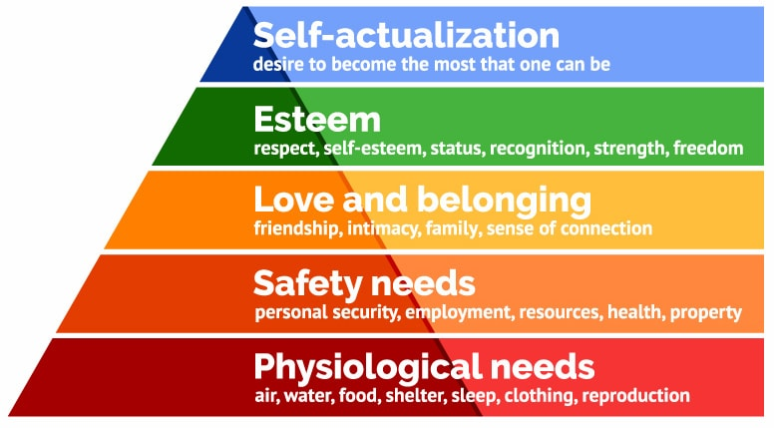
- Psychological
Psychological needs of human beings refers to the basic needs like drinking water and eating food. Based on the theory of Maslow, these needs require efforts of humans to meet their basic needs of their bodies which is to maintain the body consistent at different level through meeting their basic needs.
Psychological needs are the most important and essential out of all other needs. If a person has lack of more than one need in the hierarchy, then he/she would prefer to meet the psychological need firstly (McLeod, 2007). For instance, if a person is very hungry then he or she would definitely focus on food instead of fulfilling any other need. Another example of basic or psychological need would be adequate level of sleep.
- Safety Needs
The next need of human beings which occur, once the psychological needs are met is safety or safe environment. The need of safety exist in human from the very early stage of life like childhood till old age. Like even if the need for safety of a child does not meet then he/she feel fear and anxiety. As well as the need for safety might be highly apparent in emergency situation for the adults who live in a developed nation.
- Love and Belongings
In the Maslow’s hierarchy, the next need which occur for a person is he/she should be loved and accepted. This need (love and belonging) comprises both, relationship with friends and family as well as romantic needs of human beings. Beyond that, it also comprises the need that we belong to a social group. Mainly, this needs covers both, loving others as well as loved by others. It is more important for humans because having strong social connections put positive impact on people and their physical health while having no social can impact the person negatively (McLeod, 2007).
- Esteem
The esteem need of human beings includes the desire to feel good about ourselves. Based on the Maslow’s theory, the esteem need covers two major components where the first component is to feel good and self-confident about oneself. While another component includes feeling valued and important by others in the society or community. Which means that our accomplishment and contribution have been highly recognized by all others. People feel valued and thinks that their accomplishments have been valued and recognized when the esteem needs of people are met (McLeod, 2007). But when the esteem needs of people or human beings are not met then they would experience the feelings of inferiority in the society or community around them.
- Self-Actualization
Self-Actualization is on the top in the needs hierarchy of Maslow. Self-actualization means the feeling of being fulfilled, or the feeling that live and spend our life up to our extreme potential. The need of self-actualization looks varied for every person and it is the unique feature of this. Like the need of self-actualization maybe to help other people around him/her while it may be different for others, such as another person’s self-actualization may involve achievement in a creative field (Bolles, 1967). In short, self-actualization means that we feel that we do what we feel or what we need to. Additionally, based on the Maslow’s view, achievement of self-actualization is relatively rare.
History of Maslow’s Hierarchy of Needs
Maslow’s Hierarchy of Needs theory is proposed in the 1943 paper by Abraham Maslow. The Maslow’s Hierarchy of Needs has been used to study that how human beings essentially participate in the behavioral motivation. In this theory, Maslow presented the terms “psychological, safety, love & belonging, esteem and self-actualization” for describing the patterns through human beings usually move forward (McLeod, 2007).
Maslow’s Hierarchy of Needs has fully expressed in his book “Personality and Motivation” in 1954. This hierarchy got popularity in many studies and researches like sociology, management, psychology and many other studies or fields. As well as the theory has been revised several times afterward. Where the original theory states that the lower level needs should be met and satisfied before proceeding to fulfill the next one.
Relation of Maslow’s Hierarchy of Needs with Motivation at Work
There is no doubt, while stating that everyone at work place wants to lead someone or group as well as to be highly valued by others and my accomplishments should be valued and appreciated by others at workplace. So for meeting these concerns, every single person or staff member put huge and his/her best efforts to gain these needs. In this way they are motivated to work hard and put more efforts to meet the lower needs and go higher ones (Hall, & Nougaim, 1968). Beyond that, it creates the desire or drive which motivates people at work place to satisfy their needs like gain supervision at workplace, lead or come to the top. In other way and words, people at workplace would always think of moving to higher level than the existing one which would lead to their motivation.
Comparison of Maslow’s Hierarchy of Needs Theory with other Theories
Theory | Hierarchy of Needs Theory  (Maslow) | Two-Factor Theory (Herzberg) | ERG Theory (Alderfer) | Manifest Needs Theory (McClelland)
Comparison | Focuses on meeting lower needs to move forward | More than a single need can operate at a time | Motivators and Hygiene factors motivate people to work more and hard | Need for achievement, affiliation and power motivate human beings

References
Bolles, R. C. (1967). Theory of motivation (p. viii). New York: Harper & Row.
Hall, D. T., & Nougaim, K. E. (1968). An examination of Maslow's need hierarchy in an organizational setting. Organizational behavior and human performance, 3(1), 12-35.
McLeod, S. (2007). Maslow's hierarchy of Needs. Simply psychology, 1.

