Strategic Management and Strategic Competitiveness
Your name
Affiliation

General Motors, founded in 1908 is the world largest auto maker and has been global industry sales leader for more than seventy five years. General motors designs, manufactures, markets and distributes trucks and cars and their parts in more than thirty three countries around the world. The net volume of sales was ten million vehicles in the year 2016. When e commerce was introduced, many organizations shifted their mode of work completely by using internet, which helped them a lot in their economic success. Besides the enormous success of General motors they had to suffer a great loss due increasing demand of globalization to bring change in the technology. They had to get out of their comfort zone and shift themselves towards the modern use of technology.
- Impact of Globalization and Technology on General Motors
Globalization is the exchange of goods and ideas between businesses or organizations through different means. It can effect enormously, if one firm is using modern means of production or selling, obviously they are gathering more attention of the customers than the other firms. The first major technology that changed the form of work globally was the system of e-commerce. It got spread so quickly and it was highly appreciated by the users. Because it helped people in buying, in social connections and in different transactions. General Motors also had to face the big change of the technology. Their competitors like Swedish auto maker Volvo, Toyota or Chrysler etc. made the great use of e commerce technology. Due to lack of modern technology General Motors had to evacuate five factories in North America with the loss of approximately fourteen thousand employees. When General Motors realized the great loss they are having they decided to shift to the online technology. Their online website provided detailed analysis of a vehicle, comparison of their product with the product of their competitors, dealer inventory, a personal message center and many more. Usage of new technology raised the economic statistics of GM massively. They sold more than twenty lac vehicles and recovered their economic status with time.
The second globalization factor that impacted GM was emergence of new market lines outside the US and UK. The new markets used the idea of manufacturing small vehicles and got huge economic benefits through this idea. As for GM, the balance of their economy was very important at this point. Hence they decided to get a partnership with Suzuki, Opel, Holden, Isuzu and many more. The benefit for Suzuki was they were getting the usage of new technologies from GM like the idea of hybrid cars and GM was establishing their roots internationally. According to recent stats, these companies together now sell more than thirteen million vehicles annually across the world (Conlon & Perkins, 2018).
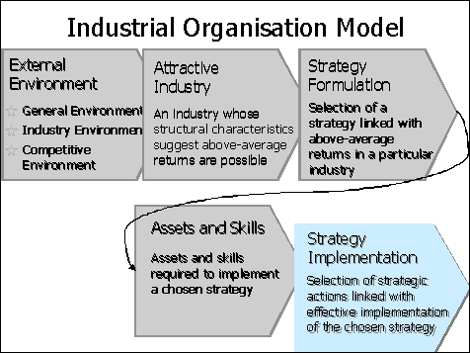
- Industrial organization model and the resource based model
Factors or environment effecting the organization from the outside are called external environment. The first major factor that influences GM is competition. GM competition is with Ford Company, it is trying to take over the GM industry by using different strategies like low pricing etc. Besides all the struggles of Ford Company GM is top leading Company due to its quality and strategy management. There are some other factors also that have been effecting the external environment like social, at what extent the consumer and sellers can communicate effectively. Legal is another factor which includes the amendments of employee rights. Economy and technology can also effect the external environment. Change taxation polices or interest rates by government, or the introduction of new inventions in the market, forces the company to change their policies.
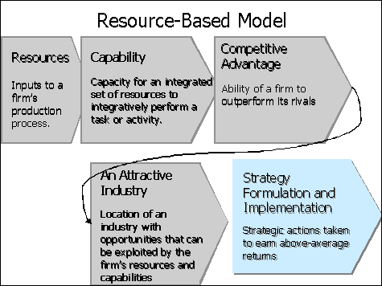
The attractive industry for GM is Ford. It was found in 1920. Their luxury, sports and day to day use cars have given a serious competition to GM. The strategy which GM formulated was to provide the vehicles which are enrich with qualities and latest technologies. Their main focus is on the design of the vehicle that should be highly appreciated by the customers. To implement these strategies GM is using highly advance technology in their factories. They innovate or change themselves with the change of the technology (Behmer, Betancourt, Metros, Stevens, & Park, 2018).
GM has a great number of resources through which they are capable of producing quality products. They have a joint venture with local Chinese automotive companies. The economy benefit from these companies is a great resource for GM. They use 3D modeling design for implementation or designing of their vehicles. They are going to use the generative design software which will be using the technology of cloud computing and artificial intelligent algorithms. By using such resources GM will be capable of generating high performance vehicles, they will be capable of producing customized cars that is the weight and accessories could be decided by the customer. The competitors of a company are a great source to learn, by their progress GM can think of strategies how to overcome their competitor’s features and quality. The attractive industry for GM was Chinese local market, Chinese are also making a rapid progress in the use of technology hence this industry is perfect for GM in producing highly technological cars.
By using both these models GM can easily analyze their industrial and resource needs. The idea of joint venture with Chinese market benefitted a lot. In the year 2017 they manufactured quality vehicles more than four thousand and five hundred units in number, which was a great benefit to for the GM economically (McLean, 2018) and they managed to earn more economy than the average.
- Vision and Mission statement
The Vision statement of GM is that they want to become the world leader in vehicles and related services. They want to become the worlds most valued, successful and innovative automotive company. Their mission is to gain the trust and loyalty of their customers for life by providing them the best quality services by continuous improvement and their efficient team work and innovative skills. These both statements help the GM Company to stay focused towards their goals. The vision and mission statements and performance results of the company show the overall image, if they won’t follow their statements they won’t be able to maintain their brand image. Basically both these statements are the major part of the strategic planning of any company. They strategy is the core element in the success of any organization. If GM won’t follow their strategic planning they won’t be able to become world’s most famous automotive company.

4. Impacts of Stakeholders
Stakeholders are those parties which contribute or invest their money in the economy of the company, they get the interest on the profit earned by the company. Stakeholders can have a great influence on the company’s progress and success. Stakeholders can be divided into four groups that is users, influencers, providers and governance.
- Users are those stakeholders which use the end product of the company. In case GM their end vehicles are used by their customers, the feedback of the customer surely has a great impact on General Motors Company. The good feedback of the customer will lead the company towards a better future and bad review of the product will lead the company in loss of the economy and also the loss of the brand name.
- Governance are the internal stakeholders of the company. Their direct influence is in the manufacturing of the product. The top three internal stakeholders of the GM are Mary Barra, Mark Reuss and Dan Amman. Their role is the most important in the success of the company. If their management goes wrong the end product or the out output gets entirely wrong. Their impacts control the economy and stability of the company.
- Influencers are the stakeholders that can help in making generating a good image of the product publically. As GM sells the vehicles their public advertisements of the products is very important. Media can grab a lot of customers for the company easily which will help in the rapid increase of the economy and attaining the loyalty of the customers.
- Providers are the people which help in the economy by investing their money. The major providers of GM are Honda, GMC, Chevrolet or different other companies. Honda will invest approximately two billion dollars in coming twelve years. Which will greatly help the GM Company in the manufacturing of the products by using new and innovative technologies.
Stakeholders have great influence on the success of the company. The internal stakeholders can make the product or they can damage the product. It’s all in their hands that how they manage and use the resources of the company for generating an innovative product and fulfilling the vision and mission of the company. The external stakeholders can massively help in the capital of the company. The joint venture of GM and Chinese markets increased the economy of GM on a very large scale. Every stakeholder has its own influence on the company which cannot be neglected.

References
Behmer, D. P., Betancourt, M., Metros, C. S., Stevens, C., & Park, J. (2018). Vehicle rear lower bumper cover.
Conlon, R., & Perkins, J. (2018). Wheels and deals: The automotive industry in twentieth-century Australia. Routledge.
McLean, M. (2018). Understanding your economy: Using analysis to guide local strategic planning. Routledge.

