From:

To:

Dear Sir:

RE: SALESFORCE.COM STOCK PERFORMANCE

As an investor, I purchase stock for the purpose of financial flexibility, to make money, take tax advantage and portfolio diversification. For the last years, I have been an investor at Salesforce.com with a strong belief that investing in Salesforce.com’s stocks would allow me to achieve my investment core goals. Salesforce.com has been performing in the stock market for last year until recently, when the prices of the stock started to dwindle, and this is one of my greatest worries. Salesforce.com is growth stock, and for the last year, the company stock has increased in value but has not yielded a lot to the investors (Patterson, 2015). Though it has been one of the biggest gainers in the stock market, the trend has changed, and it does not produce the biggest gains as expected and cannot be compared with the last two years. The graph1 below can illustrate my point well. From 2015, the stock price has been performing well and increased to the highest in the market. However, from 2018, September, the prices started to decrease until now, 2019 December.
Graph 1: salesforce.com, inc. Price and Consensus
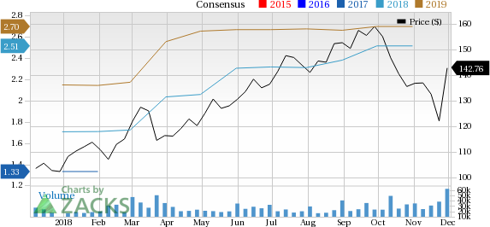

The analysis of the Salesforce.com’ financial performance indicates that Salesforce.com’s EBITDA, for FY 2018 is $2.245 Billion, which is 24.3% increase from the last financial year 2017. The EBITDA, for the first and second quarters of 2019, is $0.732B, an increase of 32.85%, and therefore, it indicates the best performance of the company (salesforce.com, inc, 2017). The EPS is $1.43, a 191.84% increase from 2018, but the EPS for the quarter ending July 2019 is $0.11, which is a decline of 71.79% in the last financial year. The current ratio for FY 2019 is 0.97; the return on equity is 7.11 and return on investment is 20.14. The analysis of the stock performance also indicates that the ROIC of the company is 15% and RONIC is 26% (Romanoff, 2019). Based on the ratios established, it is evident that Salesforce.com performs fairly well in the market and therefore, any investor would like to invest in the stock market. However, return on equity, current ratio and ROIC must improve so that it can attract investors to invest in the market. A lower ROIC might make investors like myself to get worried about the future of the company.

The best and most profitable products for Salesforce.com are the iCloud system. The analysis of the performance of products and services offered by the company indicates that iCloud is the most profitable, followed by service cloud and commerce cloud system. It means that the clouding systems are highly sold compared to other products. It is also noted that Salesforce.com offers a variety of products such as Commerce Cloud, Marketing Cloud, Sales Cloud, Internet of The Thing (IoT) Service Cloud, App Cloud, Data Cloud (including Jigsaw), Analytics Cloud and Community Cloud. The management of Salesforce.com should increase investment in the cloud computing system and CRM system. These two products have been high in terms of growth, and increasing investment would allow the company to increase performance and, therefore, higher profitability. However, the investment should be reduced on some of the products, such as the analytics cloud. In the last one year, the analytic cloud has not registered income as an aspect that therefore, the reduction of investment would be a good move by the company though there is less competition in the field, much research needed to be done to get the right market segment before investing further to improve the growth. The reduced investment would allow the company to invest in moving products and service and this is likely to increase the performance of the company.
Conclusion
Salesforce.com performs well in the market. It has a good financial standing based on its ROE, current ratio, EBITDA, and ROIC and therefore, it is profitable compared to some of its competitors in the market. Salesforce.com is a great moat because of its ability to remain competitive in the market and keeping low value. It has remained competitive despite the market challenges. Salesforce.com has kept its stock price high at $165.07 and only fluctuates with less than 5% despite the economic factors which have been influencing the performance of stock prices. This could mean that Salesforce.com is strong in the market, and therefore, it can stand a strong challenge from market competitors and other factors. The economical look of the company is, therefore, very favorable, and it is expected to increase its performance in the nest years.
Recommendation
It is recommended for the management of Salesforce.com to investment more in products and services which move faster and reduce investment in slow-moving products. This would help the company to have products competition fair in the market. It is also recommended for the company to improve its marketing strategy by focusing much on its market segments to improve the general sales of the company. The management should be worried about the company’s ROE due to stock share fluctuation. The increase in sales would like to address the fluctuating rate due to increase profitability. However, environmental factors would not be solved immediately, and therefore, it is recommended for the company to takes measures to address economic down by investing in other markets as well. This would allow the company to remain profitable despite the economic crisis in one region.

References
Patterson, R. (2015). Learn Salesforce Basics. https://resources.docs.salesforce.com/198/0/en-
us/sfdc/pdf/basics.pdf , 2-15.
Romanoff, D. (2019). Salesforce.com Inc.
https://www.morningstar.com/stocks/xnys/crm/analysis , 2-15.
salesforce.com, inc. (2017). salesforce.com, inc.
.https://www.sec.gov/Archives/edgar/data/1108524/000110852416000053/crm-2016131x10k.htm , 1-34.

