Curation project
Student’s Name
Institution
Course Code
Date

Introduction
My research was on to extent did soldiers engage with their wives and family members during the civil war. The focus of the study was effective for leaders wrote by soldiers to their wives. During the civil war, the soldiers were writing letters back home to their wives to inform them of their condition and as a form of encouragement. The focus of the research is to discover to what extent did the letters from the soldier impact their performance on the battlefield. Did the soldier got encouraged because of the letters shared? The choice of the format was based on the information be gathered, I wanted to include soldiers who participated, and a sample of some of the letters (Sweet 2015). The use of a column where the image is on one side, and the description on the other side could work well. The format could allow me to have a proper arrangement of the images. The format provides a place for an image, brief description and therefore, it makes the presentation neat and easy to understand.
In order to develop this project, canva software was used to create images of letters and some of the soldiers who participated during the civil war. Canva is a design software or an application, which is used to create images. It provides access to photographs, graphics, vector images, and fonts. It can be used by the designer and no designer as well. In the process, I discovered that the importance of letters which was being exchanged and the impact, which the letters caused to the soldiers (Herbert 2014). The use of canvas allows me to create the biography of the Mexican leaders who were caught up in the middle of the war. Therefore, my main objective was to highlight the example by creating biographies of soldiers and also have some pieces of the letters which was exchanged between soldiers and their wives back at home (Leong-Salobir 2015, 23). The “Recipe book for women in the colonies” is a historical event that gave me an idea of the project. The recipe book for women in the colonies provides details on how women used to survive within the colonies in many camps. According to Steinitz (2018,11), the tale of women can be linked to other several stories about the war which occurred in the early days. Therefore, the concept gave an idea to construct a project which reflects the war in Texas.
However, I learned a lot of things during the creative process. First, I learned how to bring together different images and combine biographies using canvas. The use of canvas improved my knowledge and skills on how it can be used in the field of anthropology and especially to looking into historical aspects of events that occurred during the early days. It helped discover how Mexicans citizens who migrated to were caught in the middle of the war (Wier and Stuart 1998, 24). It also helped in collecting the images and details of various historical leaders, and through the creative, I got the opportunity to learn several things besides history and canva usability.
Creative Portion
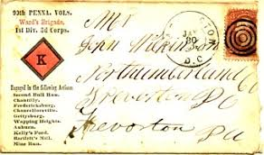
Collection of Gettysburg NMP)

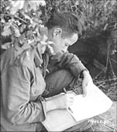

A soldier writes home from France in 1944
Courtesy 2nd Infantry Div.

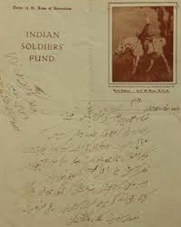

A Letter by an Indian Soldier to his wife

Bibliography
Herbert, Amanda E. Female Alliances: Gender, Identity, and Friendship in Early Modern
Britain. New York: Pearson, 2014.
Leong-Salobir, Cecilia Y. "Spreading the word: using cookbooks and colonial memoirs to
examine the foodways of British Colonials in Asia, 1850-1900." In C. Helstosky (Ed.), The Routledge History of Food, 2015: 2-15.
Steinitz, Mara. "Destabilizing Domesticity: The Construction and Collective Memory of Jewish-
American Womanhood from 1900 to 1950." History Honors Projects 23, no. 4 (2018): 2-35.
Sweet, John H. "American Civil War Soldier Letters Home."
https://www.americancivilwar.com/kids_zone/soldiers_letters_civil_war.html, 2015: 2-15.
Wier, Patricia, and R Stuart. "Sources of Information about American Cookery in the British
Colonies & Early Republic." Applewood Books reprint edition, 1998: 2-18.

