Every company that produces grooming products behind their hair strives to get as much interest in the product range as possible. Everyone has the best shampoo that makes your hair look like damaged, fallen, thin hair. Advertising is its job, and now we are expecting that we will soon have the same hair as a blonde on a TV screen or a billboard. However, we are not always told what it really is.
What are the criteria you need to consider choosing the best shampoo? The right decision depends on the health of your scalp, shine curls, filament smoothness. Unfortunately, it is certainly difficult to say that hair products for a particular company are right for you. Before making a purchase, you need to determine the Hair Type and examine their condition. It is impossible to wash your head continuously with the same remedy as the condition of the hair and scalp varies depending on the processes in the body. Once you have determined what is currently needed for your hair, you need to evaluate your financial ability.
And you can create and use a full line hair shampoo that nourishes your hair lamp thanks to a formula developed by a large number of professionals and takes into account all the factors that affect your hair condition. This formula is very clearly and correctly combined with a chemical composition (unfortunately without chemistry anywhere) that conveys the property of all the components for their purpose. Thus, the cost of such development and publications is not cheap, because the company "Y" has worked hard to make a miracle called "Your best hair shampoo". But again, everything is very personal!

Palmolive "Intensive Strengthening"
This shampoo is suitable for normal hair. It contains an extract of orange and green apple. The shampoo formula is able to penetrate deeply into the structure of the hair, nourishing and tinting it, intensively strengthening the entire length and giving shine. Hair becomes healthier, stronger and more obedient, easy to comb, styling.

After the first application, the hair becomes remarkably soft. The pleasant scent of ripe apple gives a good mood, covering you with the warmth and lightness of summer.
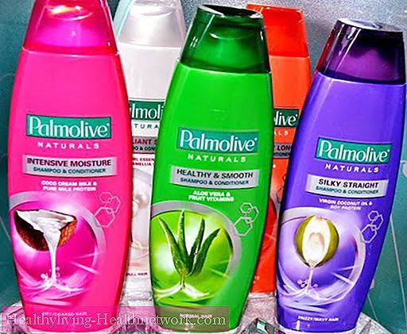

This product is suitable for daily use.
Application does not damage or dry hair. Many point out that the need to wash your hair every day disappears after using the Intensive Recovery Palmolive Shampoo, which is very convenient and useful.
Against Hair Loss
Beautiful, luxurious and healthy hair is the decoration of any girl. Today, their health is difficult to maintain. Dangerous environmental factors, chemical effects of paints and curls, hot air in hair dryers and irons all contribute to loss and fragility.

If your hair started to break, then Palmolive Shampoo for hair restoration will help. The shea butter and keratin in this product can strengthen, prevent brittleness and loss. Over time, the hair becomes strong, thick and shiny again. By the way, this product is able to restore the most damaged hair with Perm, which is more than a dry hay hair.
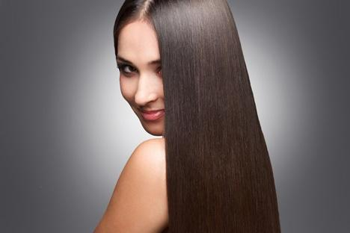
"Palmolive " is a shampoo that preserves the natural beauty of women's hair, restores damaged areas. The soft composition of this cosmetic product cleanses, moisturizes and radiates. The "Palmolive " parts of the shampoo components nourish the hair. The beneficial substances that make up its composition penetrate every hair and improve its health.
High demand is the company's tool " Palmolive " line shampoo . The Professional Color-care-therapy series is created to treat colored hair. " Palmolive " is a shampoo that retains color. The paint is not washed, it makes it even more tired, shines. The components that make up this grooming product heal damaged hair.
Named shampoo is the ideal application for daily use, and a positive reversal is evident from the first use. For a complete restoration of the hair, this shampoo must be used for at least three months, and at this time must not be exposed to adverse effects.

Shampoo "Palmolive": reviews
Mostly, they write about regenerating shampoos that, after applying Palmolive, the hair becomes healthier, stronger, and begins to grow faster.
Note separately the price of the products. The price for each type of shampoo is different but always affordable. The products are sold in different quantities, and women who first purchase this company shampoo can take a small bottle for testing.
But the reviews available in Palmolive Shampoo are not just enthusiastic. For some customers, not one product from the entire product range was suitable. They find that the head after using this tool is very itchy and the hair is heavy and sticky.

Although most of the consumers went to the frantic comments. Women especially like the selection. Owners of different types of hair, good or problematic, were well able to retrieve Palmolive shampoo, which was pleased with its perfect operation.

