Week 5 Project
Mark Wrublewski
HUM1002 History of Art from Middle Ages to Modern Times SU01
11/25/2019

Late Nineteenth Century: Impressionism or Post Impressionism
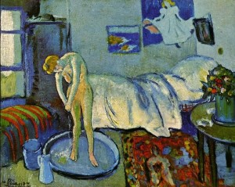
The Blue Room”
Identifying information
Name of the artist: Pablo Picasso
Title of the work: A blue room (A tub)
Date of the work: 1942
Medium/materials used to create the work: oil /canvas
Now the main task is to figure out who the Spanish painter painted. For Pablo Picasso, 1901 was very important in his search for his own style in painting. The 18-year-old artist lived in Paris, was very poor and worked day and night. So there is nothing surprising in the fact that he sometimes painted on old canvases, no.
Perhaps that is why art critics were not very surprised, although, of course, they were delighted when, using the latest technology, they discovered a portrait of a man in a bow tie under one of Picasso’s early paintings, “The Blue Room”. (Kleiner, 2016).
Now experts from the Phillips Collection gallery in Washington will, as detectives, determine the identity of the mysterious stranger. “Picasso couldn’t buy new canvases every time he had an idea and grabbed a brush,” said Susan Berends Frank, curator of Phillips, to AP reporters. “Sometimes he worked on cardboard because the canvases were much more expensive.” (Gershman, 1962).
Specialists have long suspected that there could be something else under the Blue Room, which has been in the Phillips Collection since 1927, because the individual strokes do not really correspond to the image of a woman taking a bath in Picasso's studio.
Early Twentieth Century: Fauvism, Expressionism, or Futurism

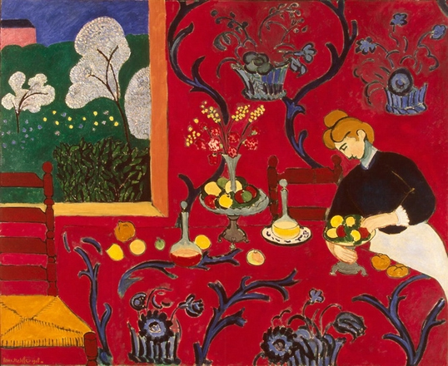
Henri Matisse "Buffet, or Red Room, or Harmony in Red", 1908
Identifying information
Name of the artist: Henri Matisse
Title of the work: Buffet, or Red Room, or Harmony in Red
Date of the work:1908
Medium/materials used to create the work: oil on canvas
Fauvism as a new art movement did not exist for long but managed to prove itself quite vividly in the canvases of painters. This style of image performance mixed in itself several components and gave rise to rich avant-garde paintings. To understand Fauvism, just look at the "Red Room" Matisse. The view of the Seine flowing into the Chatou is a favorite motive of Vlaminok. A self-taught student who carefully studied Van Gogh, he inherits from him the color intensity on which the intense expression of his works is based. The surface of the river, cut by the noses of longboats, is covered with ripples of white strokes: wide and convex, spreading their energy throughout the landscape. The forms of ship's hulls, dams, and structures on the shore are outlined by sharp twisting movements of the brush.
Fauvism set itself the task of showing enthusiastic joy from the contemplation of life. And Matisse in the "Red Room" was able to realize this idea as well as possible. The picture is decorative, energetic, optimistic. The sharp color changes, elements of ancient art and primitivism are perfectly combined and create a concentrated picture of the original talent of the French master. The interior blooms with an amazing palette and fruits with drinks on the table are calling to enjoy the gifts of life. (Denvir, 1975).

Cubism: Analytic or Synthetic
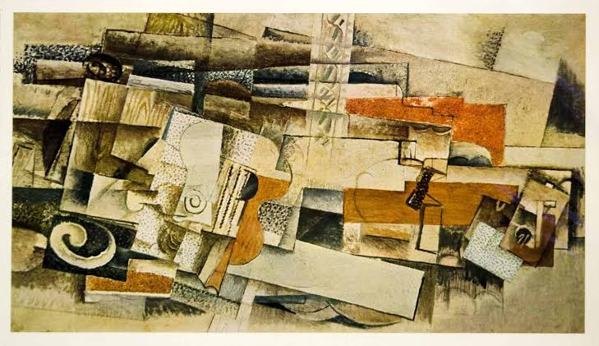

Name of the artist: Georges Braque
Title of the work: Man and Guitar
Date of the work:1914
Medium/materials used to create the work: drawing
The multidisciplinary art creator Georges Braque has distinguished himself in history as a decorator, sculptor and graphic artist. He mastered the ideas of impressionism, was immersed in Fauvism for a long time, together with the great Picasso he formed the direction of cubism, and after that he turned to free experimentation with color and forms, continuing to paint still life and landscapes. The “Musician” of Braque is the quintessence of an individual style, a complex and, without a doubt, interesting work (Yu, 1997). The prospect of constructing a composition surprises with the created volume effect in flat forms. The wealth of broken figures, color contrasts and stripes masterly draw the viewer the appearance of a man playing a guitar.
Post-World War II Art: Abstract Expressionism, Minimalism, or Pop Art
Ingre's Violin, 1924 by Man Ray
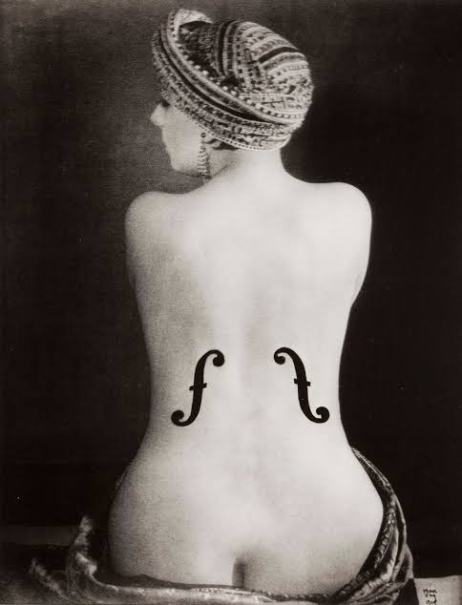
Name of the artist: Man Ray
Title of the work: “Violin of Ingres”
Date of the work:1924
Medium/materials used to create the work: Photograph

“Violin of Ingres” is a work that has become a landmark for Man Ray. Kiki, seated in a turban, is filmed from behind, ephs (resonant holes in the violin case) are superimposed on her bare back. image Ingru became his exemplary nude and a symbol of his love of the instrument. A Dadaist game of “French classics,” like Duchamp and the great Leonardo da Vinci, who painted the playful tendrils of Gioconde. It seems that Ray, like all surrealists, was obsessed with female nudity. The exhibition presents many examples of a completely traditional interpretation of the body along with surreal interpretations of the topic. Kiki, the famous model from Montparnasse, whom the artist met in 1921, having just moved to Paris; his talented student, an American photographer and journalist Lee Miller, the photographer lived and worked with her from 1929 to 1932; another great love is the young dancer Edie Fidelin and, finally, Juliet Brauner, who later became his wife and remained with him until his death.
Post-World War I Art: Dada or Surrealism
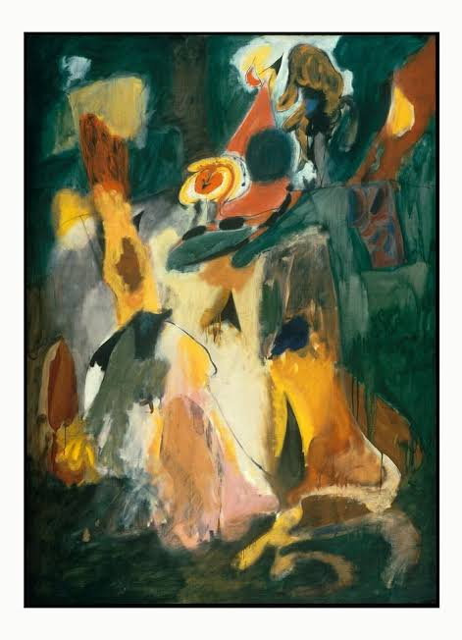
Identifying information:
Name of the artist: Arshile Gorky
Title of the work: "Waterfall”
Date of the work:1943
Medium/materials used to create the work: Oil on canvas
An American artist of Armenian descent is Arshil Gorky, one of the founders of "abstract surrealism. Developing the principles of surrealism towards greater pointlessness, Gorky found himself between the conservative official-national painting of American art and abstract expressionism. Although Gorky was considered an American artist, he considered himself an Armenian. He loved his people, his homeland. And at every opportunity, Vartush wrote to his beloved sister, sharing with her sad memories of the house and the past. (Brodskai︠a︡, 2012).
"Waterfall" transfers the movement of water from the upper right corner of the composition to the center and leaving our imagination to think up a further flow path. But take a closer look: in the very center of the image, you can notice two figures who are standing, hugging. On the left is a woman, and on the right is a man wrapping his arms around her. Gorki applied the painting technique “dripping” here: with a turpentine-soaked rag he erased, although not completely, dried paint from the canvas (traces of the rubbing are visible in the lower right part of the picture). This marked a significant change in the artist's style in comparison with his previous manner.
His work is not without contradictions. He loved his homeland, called himself an Armenian, although he was considered an American painter. Gorki equally respected the national creativity of his people and the traditions of the art of the past, but at the same time he fought for the creation of a new direction in painting. In his works one can find features of both modernism and classicism, since he was not limited to the framework of one direction.

References
Brodskai︠a︡, N. V. (2012). Surrealism. New York: Parkstone International. Retrieved from
https://search-ebscohost-com.southuniversity.libproxy.edmc.edu/login.aspx?direct=true&db=nlebk&AN=455960&site=eds-live
Denvir, B. (1975). Fauvism and expressionism. Thames and Hudson.
Gershman, H. S. (1962). Futurism and the Origins of Surrealism. Italica, 39(2), 114-123.
Kleiner, F. S. (2016). Gardner's art through the ages: The western perspective (Vol. 11). Cengage
Learning.https://digitalbookshelf.southuniversity.edu/#/books/9781337250665/cfi/6/18!/4/2@0:0
Yu, L. (1997). An investigation of the relationship between popular music and analytic Cubist
paintings in prewar Paris.

