Art as Revolution
Mark Wrublewski
HUM1002 History of Art from Middle Ages
11/20/2019

Hogarth, Breakfast Scene, 1795
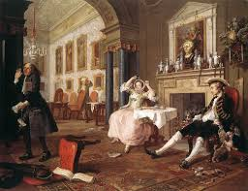

This painting is from William Hogarth . We see young people who are completely not interested in each other. The costume of the freshly baked husband and his hat indicate that he spent the night outside the house, unlike the young wife, who, apparently, had just stood up. The owner who has fallen into apathy does not notice that a ladies' cap sticks out of his pocket, with which the dog is keenly interested. all three characters participate. This composition depicts morning in a young house. The overturned chairs that the sleepy servant lazily raises, playing cards lying on the floor, musical instruments and a notebook of notes - all speak of yesterday's holiday, which ended with a fair orgy. (Marriage a-la-mode, by William Hogarth ,1697-1764).
The pretty countess casually stretches, is about to yawn, and expresses complete indifference to her husband, who tumbled into the rooms without removing his hat and collapsing heavily into a chair. The manager with a bundle of bills in his hand leaves, raising his hands to the sky. Everything that happens in the picture - the relationship between the actors, each physiognomy, each gesture - is depicted extremely clearly and clearly. Hogarth reaches extreme expressiveness. The relationship between the figures and the space, the drawing of the figures, and the dynamic pictorial surface create integral artistic works.
David, Death of Marat, 1793
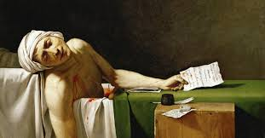
The Death of Marat created by Jacques-Louis David (1793). This Painting is of the classicism era. The picture of the French painter Jacques Louis David "Death of Marat." The size of the painting is 162 x 128 cm, oil on canvas. Jean Paul Marat, one of the most fanatical, cruel and bloodthirsty leaders of the French Revolution, was a close friend of David. Marat was stabbed deadly in his own bathtub, and the vivid image created by the artist serves as a reminder of this murder. The heroic realism of David reaches its highest expression in the film "The Death of Marat." It was written based on a direct impression of the situation in which the artist saw for the last time a friend of the people. Historical authenticity is combined here with the emotional richness of the image.
David sought to maintain the authenticity of what was happening. Marat was killed right in the bathroom, from which he did not actually get out due to the severe form of skin disease. A wooden box replaced the revolutionary table, and the sheets that wrap the Jacobin, really were in patches. However, the hero himself is depicted with a lesser degree of certainty - David turned him into a kind of athlete, the hero of Antiquity, and this asceticism in the setting gives the whole plot a special gloomy solemnity. In the hands of the murdered Marat is a note that could not be read by the hero. It belongs to Charlotte Korda and has the appearance of a certain statement, which says that she (Korda) is deeply unhappy and has the right to defend Marat. (Beaumont, 2018).
Talking about the event, David limited himself to only the most necessary details: a limp body drooping, a bleeding wound, a murder weapon and a letter that the killer used to let him into the house. David created a work likened to a majestic and strict monument. Patient Marat was killed in the bath, which he took as prescribed by the doctor, while he was reading the treacherous letter of the killer , Charlotte Corde. A bathtub and a drapery of fabric hanging in large folds are perceived as an antique sarcophagus, a block on which an inkwell stands, is a tombstone with the inscription: "Maratu - David." The traits of the slain are of a portrait character, although they are altered by the expression of sorrow and suffering. The dark background, harsh light and a clear stable black and white modeling used by the French painter in this picture, reinforce a sense of detachment from all that is accidental. The artist monumentalizes a figurative solution, emphasizing his laconicism and heroism, his dramatic expressiveness.
Delacroix, Liberty Leading the People, 1830
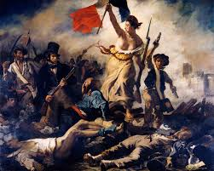

The composition of the image is very dynamic. In the center of the picture is simple clothes, it moves in the foreground and to the right. Because of the powder smoke, the area is not visible, nor is this group. The pressure of the crowd that fills the depth of the image forms all the increasing internal pressure that must inevitably break through. And now, in front of the crowd, a beautiful woman with a tri-colored Republican banner and a pistol with a bayonet on her left stepped wide from the cloud of smoke to the top of the barricade. On the head is a red Phrygian cap of Jacobins, his clothes fluttering to reveal his chest, his face profile reminiscent of Venus de Milo's classic features. who is determined and courageous towards the fighters? (Delacroix, 1830).
When working on the image in Delacroix's worldview, two opposing principles collapsed - inspiration inspired by reality and, on the other hand, distrust of reality that has long been rooted in his mind. Confidence that life can be beautiful in itself, that human images and purely pictorial means can convey the image of the image completely. This distrust dictated the symbolic symbol of freedom and some other allegorical refinements.
Goya, Third of May 1808, 1814-15
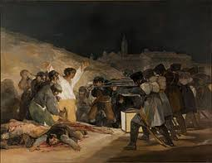
The painting was created in memory of the events associated with the Madrid uprising against the French occupation forces. In fact, this work is the right half of the diptych. The left half is directly the events themselves, which took place on May 2, 1808. The revolutionary painting is undoubtedly a significant part of 19th-century Spanish art. Nevertheless, the avant-garde canvas was coldly accepted by contemporaries and critics, since the author rejected all the rules and principles of the then prevailing trends of painting. "The Third of May 1808" does not contain brave deeds, noble deeds and heroes. Instead, Goya portrays a grim and bloody execution. (Malache, Bruyns & Dorlodot, 2017).
In contrast, for example, from the " death of Marat " , the authorship of Jacques-Louis David , or the "last day of Pompey" Bryullov , in this work there is only an aimless death. The date of the first demonstration of the painting to the public is not known for certain. Along with May Day, it was stored in the Prado Museum, and was not even included in the catalog from 1872. Nevertheless, with the advent of contemporary artists and fresh artistic trends, the work was recognized as an innovative masterpiece. The symbol of the atrocities of war puts work on a level with such canvases as “Guernica” and “The Massacre in Korea”, by Pablo Picasso . Goya clearly indicates through the "crucified" protest that the rebels are martyrs, and also shows that the rebellion was useless and meaningless.
Courbet, The Stone Breakers, 1849
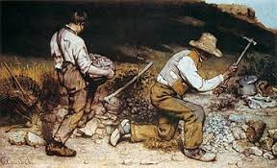
In this picture of Gustave Courbet, we see two men at work making debris from larger boulders. The structure of the picture is simple: in scorching sun the low work happens, the background is dark and dark. Only the top right shows a ray of sunshine and blue sky. The escape lines of two tools and the old point there.
Otherwise, the workers are firmly on the ground, almost grown together with him. The color of the clothes (despite a little red and blue) do not stand out from the workplace. The exploited labor assimilates man into the environment, including language and culture. The tattered, old-fashioned clothes, wooden shoes and worn-out shoes mark the social status of the workers. The straw hat of the older man is like a privilege, like a luxury - but he hides his face. It is in the shade. Both workers show no face - the workers like a crowd of people, each one anonymous and replaceable.
While the left figure is almost horizontally removed, the right makes a power-consuming turn. Painterly well composed, if you also notice to the right-hand worker that he only does this work in the studio. No stonecutter holds his pimple, his mallet! At that time, the painters often painted the outdoors in the open air and in the studio in front of the model in the studio, hence such details.

References
BEAUMONT, H. S. (2018). Art as Revolutionary Propaganda in David’s The Death of Marat.
War, Literature & the Arts: An International Journal of the Humanities, 30, 22–28. Retrieved from https://search-ebscohost-com.southuniversity.libproxy.edmc.edu/login.aspx?direct=true&db=lkh&AN=131832413&site=eds-live
Delacroix, E. (1830). Liberty leading the people. American Library Color Slide Company.
Malache, M.-J., Bruyns, E., & Dorlodot, S. de. (2017). Francisco Goya : A True Artistic
Visionary. [Place of publication not identified]: 50Minutes.com. Retrieved from https://search-ebscohost-com.southuniversity.libproxy.edmc.edu/login.aspx?direct=true&db=nlebk&AN=1642327&site=eds-live
Marriage a-la-mode, by William Hogarth (1697-1764), detail. (2014). Bridgeman Images:
DeAgostini Library. Retrieved from https://search-ebscohost-com.southuniversity.libproxy.edmc.edu/login.aspx?direct=true&db=edscrc&AN=edscrc.15657522&site=eds-live
Romanticism and Realism in Nineteenth-Century Europe. Retrieve from : https://myclasses.southuniversity.edu/d2l/le/content/54185/viewContent/2179903/View

