Question 1: The Painting of Modern Life
Monet, Rouen Cathedral: The Portal (In Sun), 1894
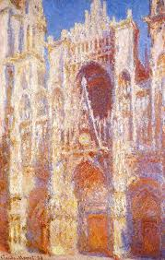

This painting is representative of Impressionism. “Monet is good at experimenting and expressing techniques of light and shadow. His most important style is to change the way the shadows and outlines are drawn”( Kalitina, Brodskai︠a︡, & Monet, 2010). cathedrals, depending on time of day, year and lighting. This cycle was written by the artist in the 1890s. The cathedral allows it to show the connection between constant, solid, building and changing, light-play structures that change our perception. Monet focused on the individual fragments of the Gothic church and selected portals, St Martin's tower and Albana tower. He was only interested in playing light on the rock.
Manet, Bar at the Folies-Bergère, 1881-82
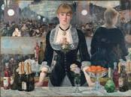
This is a good example of impressionism. The artist of modern life has…sought after the fugitive, fleeting beauty of present-day life…Often weird, violent and excessive, the acrid, or heady bouquet of the wine of life." (Ardis, 2002). This is the work of Manet in 1882. It’s been nearly 20 years since the “Lunch on the Prairie” and “Olympia”. Shortly after completing this work, Manet died. For 20 years, Manet has experienced a lot of struggles and struggles in his life. In his last work, he still maintains a consistently bold style – the theme of the bar girl. However, this time, Manet is 51 years old. In addition to being bold and innovative, he wants to bring us a deeper message.

To explore the work of Manet, we must first understand the structure. First of all, everything behind the girl is a reflection of a mirror; her back on the right is her own reflection in the mirror, as for the rightmost moustache? He is the person in front of the girl, me, or you. So what about the crowd behind her? They are not behind the girl, but in the audience behind the moustache, that is, us. They are enjoying a wonderful performance in the painting. When we watched the picture in the art gallery, we saw ourselves and the people behind us. Why is Manet going so far and out of the mirror? He can arrange everyone to be behind the girl, there is no need to make such a mystery (Ardis, 2002). With this concept, we can first explore the protagonist of the whole painting - the bar. Look at this bar, flowers, fruits, champagne, and delicacies, all with the bar girl, the whole display is only for one purpose: to attract customers who are drunk. Manet arranged the items neatly in a long box, so carefully and deliberately treated, and later came to a conclusion: Manet's entire painting is mimicking a department store's window. If we look at other paintings with the same title, we can see the ulterior motives of Manet's composition.
Seurat, A Sunday Afternoon on the Island of La Grande Jatte, c. 1884-86
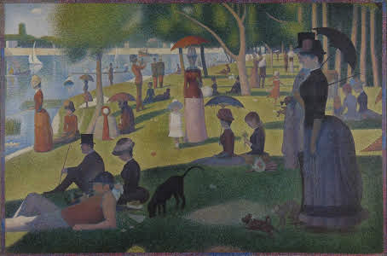
One Sunday afternoon on the island of La Grand Jatte is the most famous and greatest painting that Georges Seurat has ever created and one that probably expresses the painting technique at the highest level, a sort of manifesto of the so-called "pointillism". La Grand Jette is a peripheral park of Paris on an island on the Seine, a meeting place for middle-class relaxation in the 19th century.
A Sunday afternoon on the island of La Grand Jatte is one of those rare cases in the history of art in which a single work of art is able to be unique, to be absolutely able to get attention as if it were a poster for its transcendence, both narrative and technical, and is instinctively recognizable by all. Executed in 1884, a Sunday afternoon on the island of La Grand Jatte expresses all that is magical in the world of Seurat: it is beautiful and disturbing, illuminated by the sun and shaded, silent and noisy, all at the same time (Bromwell, 2018).The imposing size of the painting (about 2 by 3 meters), was rare at that time and therefore indicates a precise choice of the artist to want to "wrap" the viewer completely making him participate and present.

Question 2:
I always in search of pop art and it is something that you do not need to go to only art gallery. Pop art has replaced abstract expressionism, relying on a new image created by the media then. Thanks to pop art, such new directions as kinetic and situational art, as well as op art, have appeared. In fact, pop art summed up and brought to a logical conclusion the traditional types of fine art. Thanks to this, the way was opened for completely new types of artistic practices. For example, pop art prepared the way for postmodernism and conceptualism. And already in the 80s of the XX century, as a result, a new type of art arose - neo-pop art.( Porter& Grant, 2017).
This direction in the visual arts conveyed the taste and mood of the time. Sexuality, youth, fleetingness, daydreaming and even some naivety in pop art paintings are considered a reflection of a real American dream. In different countries, they talked about it only decades after the first appearance of pop art in America. By the way, in our time, pop art is again in fashion, both in painting and in other forms of art. And it’s good that there are plenty of modern masters working in this direction.

References
Ardis, A. L. (2002). Modernism and Cultural Conflict, 1880–1922. Cambridge, U.K.: Cambridge
University Press. Retrieved from https://search-ebscohost-com.southuniversity.libproxy.edmc.edu/login.aspx?direct=true&db=nlebk&AN=120259&site=eds-live
Bromwell, T. (2018). True to Life: British Realist Painting in the 1920s and 1930s, Scottish
National Gallery of Modern Art, July 1-October 29, 2017. Visual Culture in Britain, 19(1), 132–134. https://doi-org.southuniversity.libproxy.edmc.edu/10.1080/14714787.2018.1450330
Kalitina, N. N., Brodskai︠a︡, N. V., & Monet, C. (2010). Claude Monet (Vol. 2nd ed). [New
York]: Parkstone International. Retrieved from https://search-ebscohost-com.southuniversity.libproxy.edmc.edu/login.aspx?direct=true&db=nlebk&AN=416840&site=eds-live
Porter, J., & Grant, S. M. (2017). 149 Paintings You Really Need to See in North America : (So
You Can Ignore the Others). Toronto: Dundurn. Retrieved from https://search-ebscohost-com.southuniversity.libproxy.edmc.edu/login.aspx?direct=true&db=nlebk&AN=1609526&site=eds-live

Reply to Mark Graham
Thankyou for posting your discussion and it is really very nice effort. Cross's early work is almost extinct. These are just a few portraits and landscapes, painted in a realistic manner, and painted with a rather gloomy palette. After a trip to the south of France, where he met with Claude Monet, the artist’s style of writing began to change significantly: Cross tried to completely abandon the dark brown colors that are so characteristic of realist paintings in favor of brighter, more open and saturated colors of impressionism.

Reply to Jennifer Rice
This is nice post by you. The most interesting thing from your post is when you say ,” Realism art because it’s considered to be the beginning of the modern art movement, incorporating both modern art and real life” and I am totally agreeing with your point of view. Socialist realism is reflected in all spheres of cultural activity, including applied art and architecture. Only in the twentieth century, realistic art began to acquire diverse forms and vibrant national features.

