Name
Instructor
Course Code
Date

Assignment: Hydrosphere Hazard
Discussion on Tsunami
Tsunamis are waves which are not caused by the normal blowing of the wind and are usually caused by earthquakes, or massive forceful displacement of water by a meteorite or a landslide. They can be theoretically caused by abnormal tides which cannot happen here on Earth. Tsunamis are also different from storm surges brought in by harsh storms. The shaking alone will not cause devastating waves, however, in an earthquake, one section of the earth moves, disturbing the water and kicking it up or dragging it down billions of liters at a time.
Tsunami Poster Idea
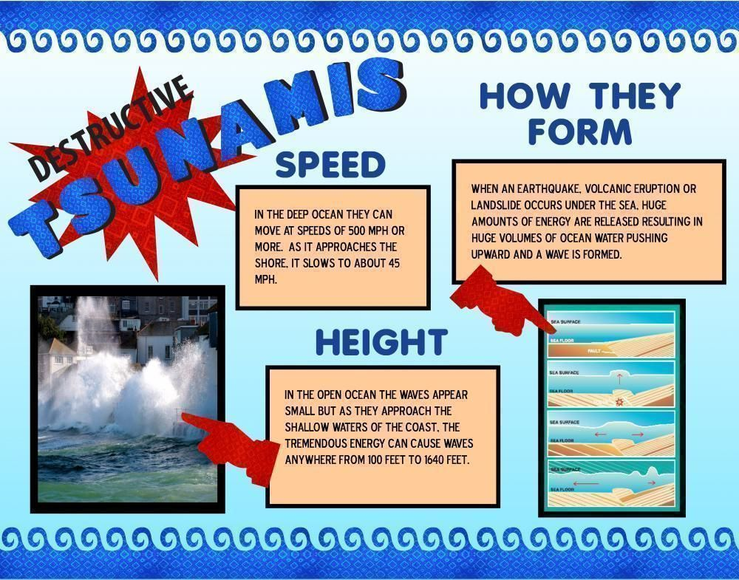

Case Study of 2011 Tsunami
The 2011 tsunami that hit the coastal strip of Japan was actually a series of waves which struck in sequence. So, one wave would sweep in and begin sweeping out, and another would follow. In fact, reports predominantly indicate that the second wave was actually the largest in many locations. Following 30 minutes of the earthquake, the water had begun pulling back from the shore (Mori et al.). It varied with location, but in northern Miyagi Prefecture, following one hour of the earthquake, the first wave came.
The 2011 tsunami was not a singular event at all, however, there were multiple tsunamis and the repercussions lasted for days throughout oceans, and aftershocks continued to compound the dynamics of the tsunami. The speed of the tsunami on land looked really fast at times, and the speed of the wave was not sustained either. At Sendai, the water reached over 6 miles inland at 10 mph and it took less than 40 minutes to go that distance (Mori et al.). Had the speed of the wave been more the 10 mph, the time taken by waves to cover 6 miles would have been reduced. As far as time to recede was concerned, the complexity of multiple events coupled with localized topology would play a pivotal role in the receding rate.
One cannot fail to mention the global economic impact of 2011 tsunami. Japan is the third-largest economy in the world- and tsunami shut down all business-related activities for weeks. Multiple auto factories and steel production units were shut down. The 2011 tsunami caused not only uncertainty in economic spheres and had a negative impact on financial markets and oil prices worldwide (at least in the short term). Besides, the 2011 tsunami not only hit Japan, rather it brought along serious repercussions for global climate/weather (Mori et al.). Tsunami waves traveled radially outward from the point of origin and tsunami warnings had already been issued for other areas that might be affected. Albeit, the 2011 tsunami localized to one area, however, it brought along serious economic implications that affected the rest of the world.
Of the coastal villages that were directly impacted by the tsunami, over one third will never be rebuilt as they were completely wiped out - literally in terms of infrastructure and survival. Some regions will eventually reclaim the land that was once a village or small town, but when, it is unclear so far. Yet immediately to the north in Miyagi and Miayto-Jima, hundreds of acres of coastal homes and small businesses buildings have not returned to their shape yet. The land on which the residents of Miyagi and Miayto-Jima stood remains vacant and probably will remain vacant for another 10 to 15 years, if not longer. The agricultural impact varied from region to region because the height of the tsunami varied along the coast.

Works Cited
Mori, Nobuhito, et al. “Survey of 2011 Tohoku Earthquake Tsunami Inundation and Run-Up.” Geophysical Research Letters, vol. 38, no. 7, 2011.

