Individual Database Project
[Name of the Writer]
[Name of the Institution]

Step 1: I Launched the AWS workspace and then home screen appeared as follows:

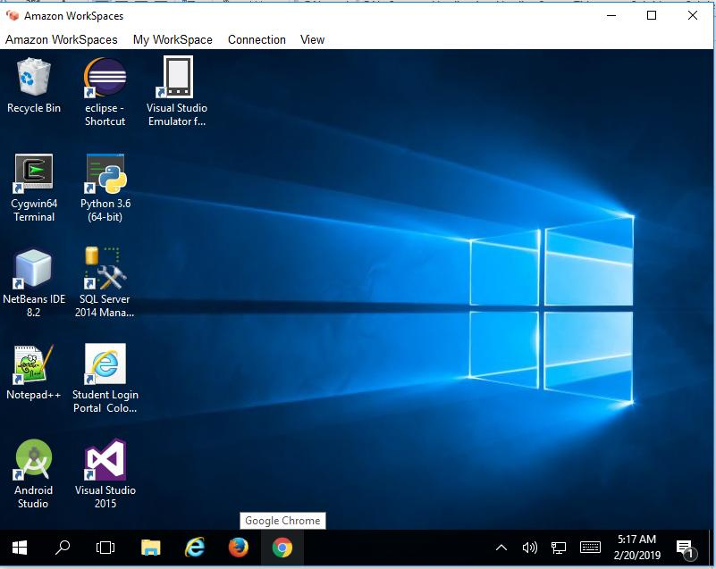

Step 2: I opened Microsoft SQL 2014 Management Studio and the following screen I just clicked connect.

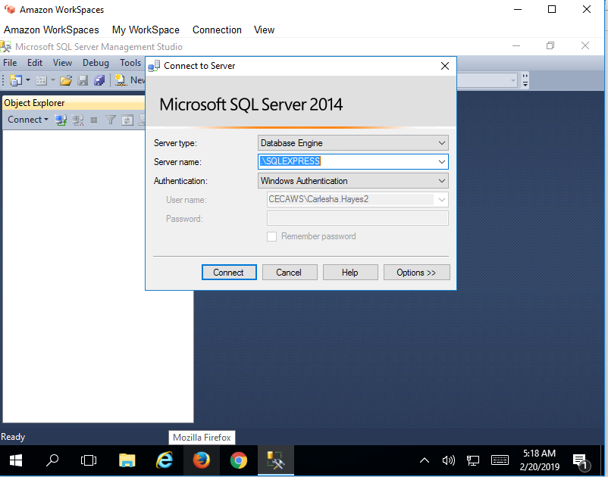

Step 3: After successfully connecting the database following screen appeared and I right-clicked on the “Database” Folder to create new database.

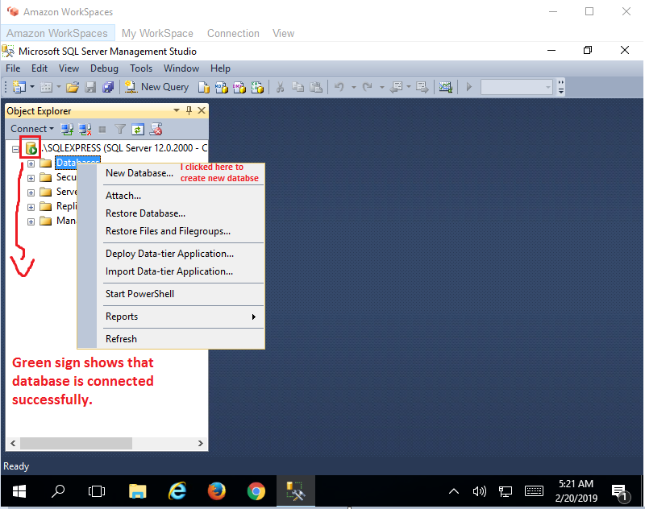

Step 4: Following screen appeared:

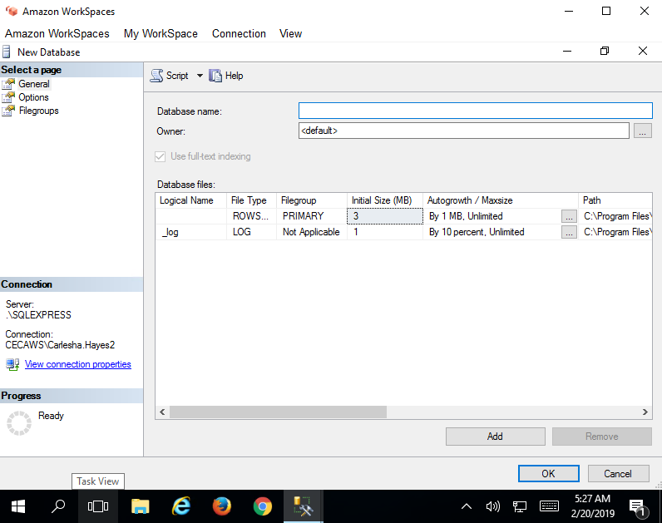

Step 5: I put a suitable name for my database as “Sample_Database” but received an error because I put a name on the “Owner” field rather than keeping it to “Default”.

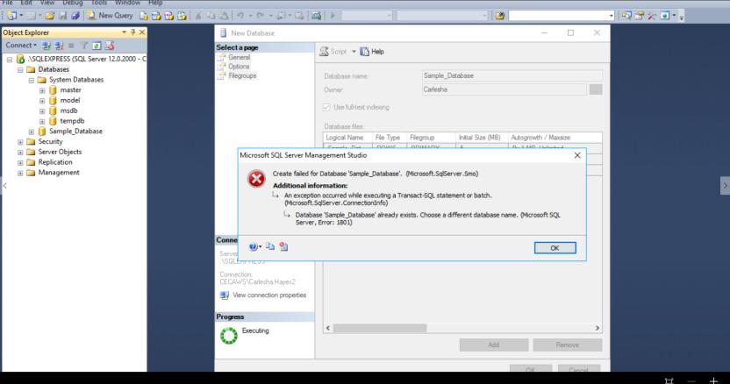

Step 6: After getting the above error I watched the video on YouTube and followed the exact steps performed in the video and then I was able to create a new database named “mydatabase”.

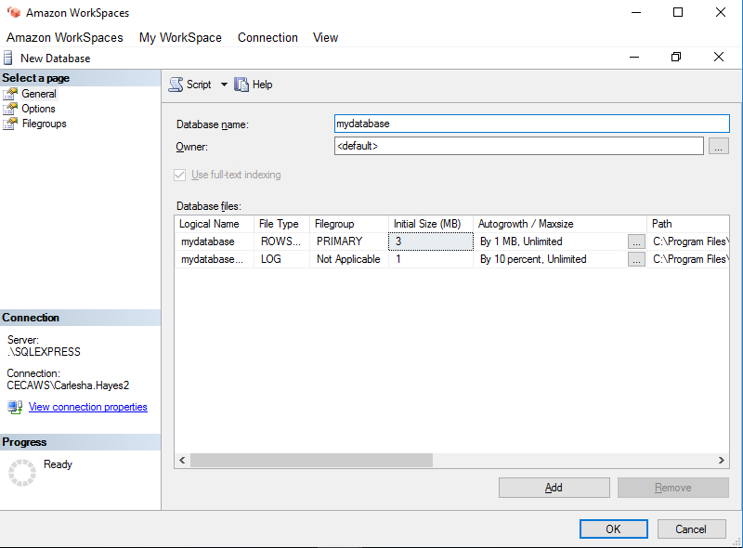

Step 7: After the creation of the new database named “mydatabase” following screen appeared and under the breakdown of “Databases” you can view name of the new database.
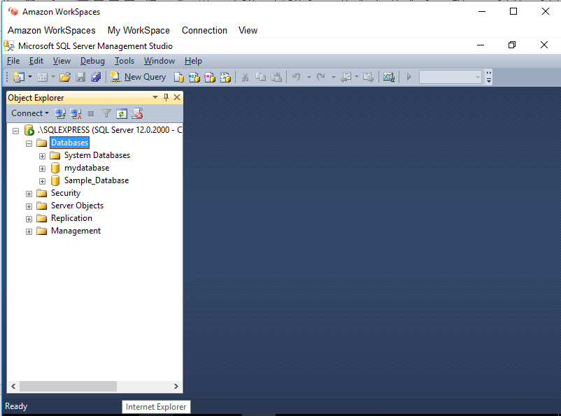

Step 8: I expanded databases and the on the Tables I right-clicked to add a new table to the database.

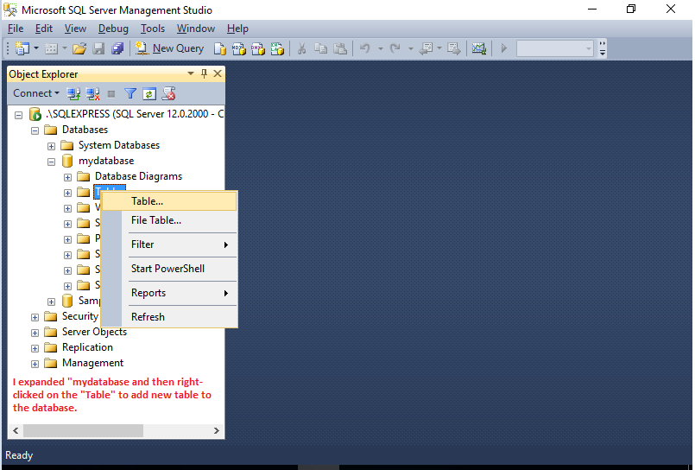

Step 9: Following interface appeared and allowed me to add Columns to my table. I added my first column as “Customer_Id” and set it as the primary key of the table.

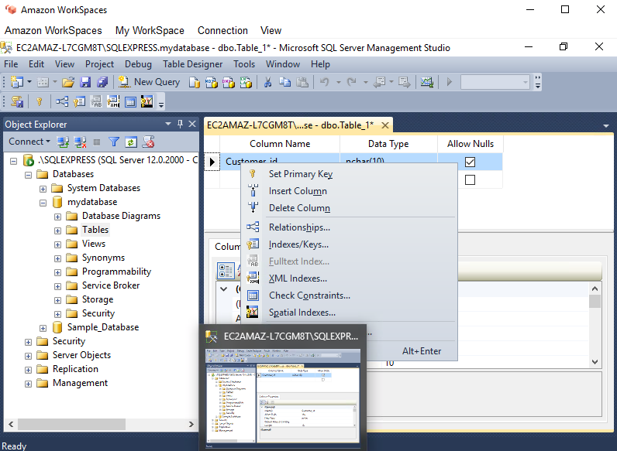

Step 10: I added more columns and assigned the suitable Data-type along with a suitable length. Secondly, I unchecked “Allow Nulls” order to avoid null entries.
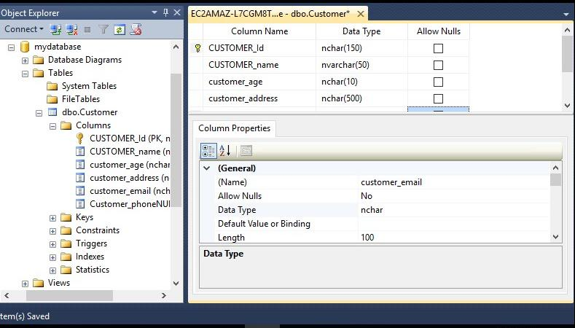

Step 11: After adding more columns I saved the table as “Customer”.
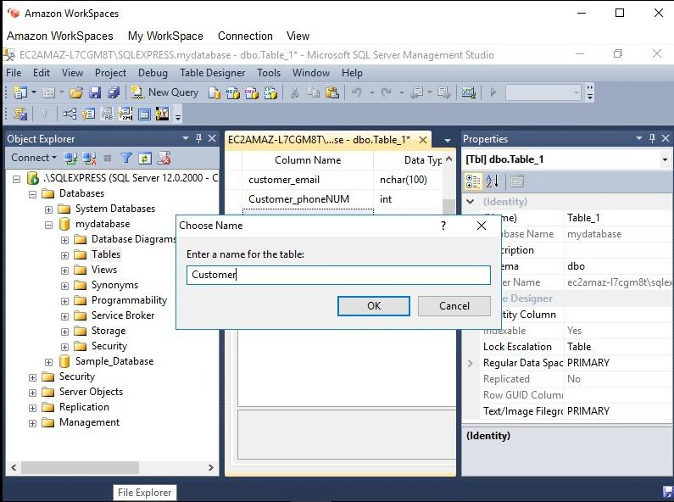

Step 12: Now on this last snapshot you can clearly view that table named “Customer” is successfully added to the database “mydatabase”.

