Benefits Booklet



Snowball Collection

(SC Clothing Company

Snowball Collection

(SC clothing company)

Page 8

Page 1

# 

Who we are

A clothing brand that delivers clothes made up of pure wool and cotton. Our mission is to make our client look, feel and dress perfect by offering them uniquely designed dresses. We promise to clothe the world with the most appealing and attractive clothes. We have a specialization in producing casual clothes that will take our customers into another level of comfort.



Contact Us

Street 32, City Parker town, New Jersey the USA

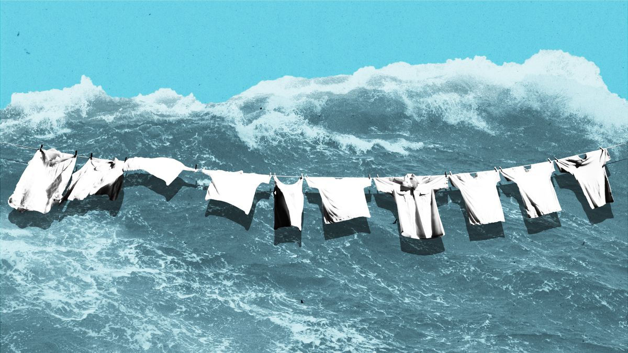

Table of contents

Who we are……………………………………..2

Protection program…………………………….4

Disability benefits……………………………….4

Criteria for disability……………………………5

Life insurance……………………………………6

Retirement programs……………………………7

Mandated Benefits………………………………8

**Protection programs:**

The very important discretionary protect programs offered by our company includes retirement program, life, insurance program, and disability insurance.

**Disability insurance**

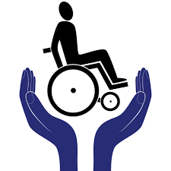

This protection program replaces the regular income for employees with disability insurance and

It is provided to employees who are unable to work anymore because of the accident or some sickness most of the employs remain disabled for more than 90 days and they get disability Insurance for that period.

The company provides disability insurance in two forms:

Short-term disability Insurance: that is for a limited time and it is usually provided to employees for six months and till now twenty percent of our employees have got this insurance.

The send from is Long-term disability insurance and it provides benefits to employees who are being affected by accident and sickness for more than six months. We provide a very suitable work environment for our workers but five percent of them got injured while driving on the way to office or home and are currently getting long-term disability insurance.

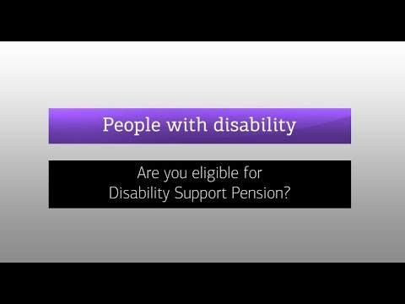

**Criteria for disability:**

Short term plans are mostly offered to those who are facing disability that is not letting him or her perform his or her regular job at the workplace. For example, the short term condition likes recovery from injuries, hospitalization for the treatment of short term illness, pregnancy and recovery period after childbirth makes the employee unable to perform his or her regular duty for short span of time and thus they are considered as disabled for short term. Short term disability plans have other features as well and those include Preexisting conditions like mental or physical disability ad for which medical diagnosis or treatment is being received for a certain time period. But disability insurance programs have certain eligibility periods.

The coverage of the insurance program starts on a certain date after the employee is hired. The employee will have to go through pre-eligibility and the elimination period to be able to get the insurance. The company has also designed an exclusive provision list that includes the types of health conditions that are not eligible for the coverage and the company has removed inflicted injuries from the list.

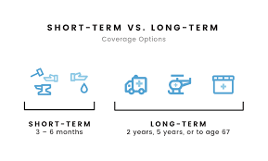

Long- term disability insurance plan is offered to an individual who cannot perform the specific task that he or she was trained for the employee is unable to enroll in any employment for a lifetime. The employee will either get half or full compensation of his or her monthly income. The full benefit provided by the company is equal to the company has divided the long term disability into four types, the permanent total, temporary total, and armament partial disability. Both types of disability program offer compensation based on the disability benefits decided by law.

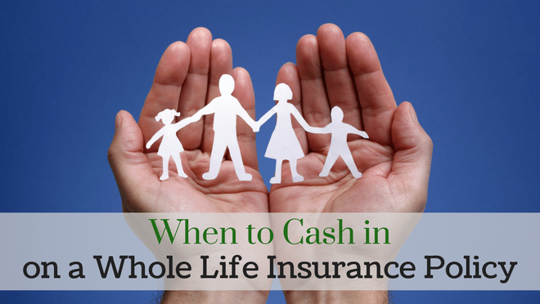

**Life Insurance:**

The company has designed life insurance for an employee in such a way that the family members will get the company upon the death of the employee. Our company has divided life insurance into three types, term life insurance, whole life insurance, and Universal Life Insurance.

Term life insurance is provided to employee’s beneficiaries for a maximum five years and after the expiration of the insurance, no family member is eligible to get any compensation. Whole life insurance is designed with an option of cash saving plan and the company provide compensation with an option to save cash for future use. Universal life insurance has both the features of term life insurance and whole life insurance.

**Retirement programs:**

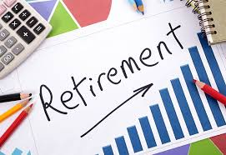

Retirement programs of the company provide income to its employees and to the beneficiaries of its employees for some or full period after their retirement periods. The company has designed three types of pension or retirement plans. The defined benefit plans include month sum that is equal to the preretirement pay multiply by the number of years the employee has worked in the company. The company has set eligibility right for this benefit and it is that if the employee is retired after specific years of working in the company most probability when his or age limits reach sixty. The Annual benefits designed by the company are also dependent on the experience, age and the final average salary of the employee.

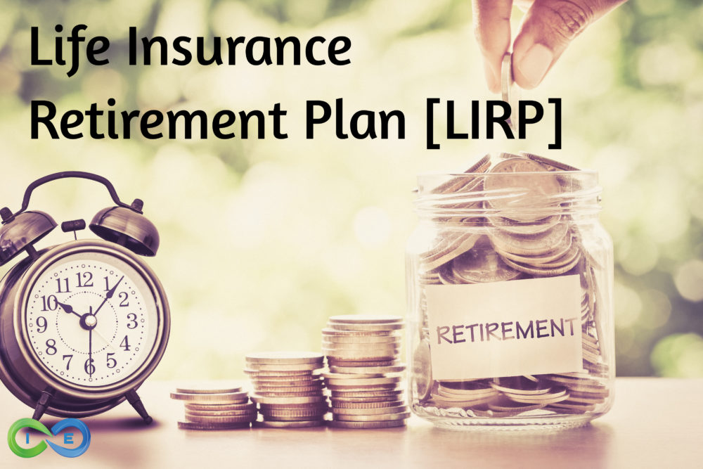

The company has also given the option to the employee to run multiple accounts on their name and this comes under the distribution plan. The company deducts some amounts from the salary of the employee and use that amount in the contribution plan. The company has developed a hybrid plan for retired employees and has combined the traditionally defined contribution plan and benefit plans. Company has designed Cash-balance plan and it is structured in a way that each employee will get benefits based upon the hypothetical account balance.

The Defined Benefit plan and the Contribution plan of the company have certain characteristics. The Defined Benefit plan is due at a normal age of retirement and the payment is done on annual bases.

For this benefit plan, the employers are responsible to pay a sufficient amount and will be getting benefits regardless of any investment returns on trust. While the Defined Contribution plan is an amount that is contributed to the employees account regularly.

**Paid Time Off:**

The company also has an option of the discretionary benefit of paid time off. The main types of paid time off are in public holidays, sick leave, vacation, funeral leave, personnel and military leave, cleanups and traveling time, rest period in offices and volunteerism hours outside the office.

Mandated Benefits

There are a set of legally required benefits given by the company to its employees

**Social Security Programs:**

The social security program designed by the company includes Medicare and an old age, survival and Disability Insurance. Medicare includes Hospital and Medical insurance. The original plan of Medicare is a fee-for-service plan and the care can be received from any healthcare specialist.

Hospitalization includes both inside and outside health cares.

**Family and Medical leave:**

This program gives job protection to the employees in case of an emergency. The position of the employee is saved by the company until he or she is back to work. Health benefits are also been given to the employee who is having a mental health issue and affected by substance abuse. Various treatment like delivering of prescribed drugs and outpatient care are covered by the mental health and Substance Abuse Plan. This Company is also focusing on Consumer-driven Health and enables the employees to make smarter choices about medical health care.

Employees have the option to open health reimbursement accounts and the eligible medical care cost is delivered to the employees on that account by the company.

Page 7

Page 2

Page 3

Page 6

Page 5

Page 4