Supply Demand Curve
Student’s Name
Institution

Introduction
The demand and supply are affected by market variables which include quantity and price. When the quantity of a product is high in the market the price is affected and this could mean the supply is high in the market and the demand is low. These factors influenced the performance of every product in the market.
Q1: Price and Quantity Curves
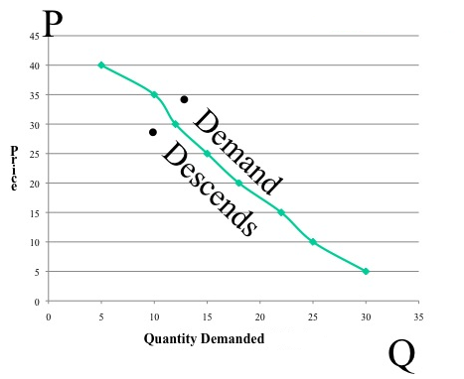
Q2: Supply Curve
If there decrease in the firm of firms in the market supply quantity would be low and therefore, the price of the product would increase. However, a decrease of the current price, would attract buyers and therefore, the supply would be low since many firms would not be willing to sell their product. An increase in productivity would increase supply and therefore, the price would decrease in the market (Brækkan, 2014). However, the decrease of expected future prices of product is likely to reduce the productivity and therefore, the supply quantity would low. An increase of input prices is expected to increase the cost of production and therefore, the prices are expected to increase.

Q4. Demand Curve : Watermelon Demand Curve

An increase in income and the goods increase the demand of the goods in the market and therefore, the demand graph will turn right and sloppy. A decrease of price of the goods will increase the demand of the product. The decrease of price occurs when the supply is high in the market. A decrease in population would cause a decrease in demand of a product. An increase of the taste of food is likely to increase the demand of the food.
The situation whereby demand is high and price is lower could happen when the supply is high in the market. Watermelon is produced during summer and people consumer a lot of watermelon during summer as well. Therefore, the demand and supply of watermelon is high during summer and therefore, the demand would be high and the prices of watermelon would be lower in the market due to high supply.

References
Brækkan, E. H. (2014). Why do Prices Change? An Analysis of Supply and Demand Shifts and Price
Impacts in the Farmed Salmon Market. https://www.researchgate.net/publication/282149761_Why_do_Prices_Change_An_Analysis_of_Supply_and_Demand_Shifts_and_Price_Impacts_in_the_Farmed_Salmon_Market , 2-35.

