Introduction to Information Systems and Technology
[Name of the Writer]
[Name of the Institution]

The Hershey Company
Executive Summary
Hershey Company is one of the companies in Pennsylvania that deals in the production and supply of chocolates and other confectionary items. The company was founded in 1960 and it was one of the few companies at that time that was a major supplier of different candy and sweets. Today, Nestle, Mondelez, Mars and Lindt & Sprengel are the major competitors of this company (Weaver et al. 2019). Taking into account the data published on different resources, it is highlighted that the company uses a well-developed information system comprising SAP, PI, ERP, and AIM software. The company manages its data and information by both informal and formal styles. (Weaver et al. 2019). The overall information system is guided and managed by Rick Bentz and his few fellows but he is the central person to take decisions (Weaver et al. 2019). This management team is responsible for taking major information system decisions such as allocation of recourses, transfer of data and analyzing input and output keys.

Background of the Organization
Hershey Company was founded in the late 19 century in Pennsylvania by Miltin S Hershey. By that time, Hershey is famous for the production of some beloved and iconic brands such as chocolates and sugary confections (Gressel et al. 2019). Hershey Company also called Hershey Chocolate Co., Hershey Chocolate Corporation and Hershey Food Corporation is known as the best manufacturer of different food products. Some major food products are sugar-based confectionary and chocolates (Gressel et al. 2019). Some major candy bars of America are produced in this company such as Hershey’s Milk Chocolate, specifically designed in brown and silver wrapper. The origin of the company can be traced back to the 1880s when for the first time, the caramel company was set in Lancaster. After having a view of the chocolate-making process and machinery at the World's Columbian Exposition of 1893, the owner Hershey decided to start chocolate business as well. Later on, the company was sold to one of the competitors but the company became so strong that Jersey, the real owner stated to work in a new factory which became one of the largest platforms for the production of chocolate (Gressel et al. 2019). The business was extended in 1960, the manufacturer of Reese’s Peanut Butter Cup and PATST business was bought by the owner. This amalgamation resulted in the foundation of Hershey Food corporation in 1968. The company grew to expand and it reached the realms of the United States and North America. It is important to know that the company is providing and serving many philanthropist functions as well as providing educational opportunities for helpless people (Gressel et al. 2019).
It is found that the number of employees who are serving full time in the company is 14,930. However, the total revenue of the company is increasing over the course of time. The total revenue of the company for the quarter ending on June 30, 2019, was $1.767B. The annual revenue is found to be 0.89% which has increased as compared to the last year. However, the total revenue for twelve months ending on June 30, 2019, was found to be $7.851B. It is also termed as a 2.01% increase over a year (Gressel et al. 2019).
It is observed that Hershey has enjoyed a position of leading a large variety and amount of chocolates in North America for some time, and since then, has lagged behind the competition in the global market. Later, Hershey realized that they should capitalize on the global markets so as to leverage its scale in the US and accelerate the key global market (Gressel et al. 2019). The latest and reformed structure includes information of international commercial groups that were formed with the idea of pursuing profitable growth opportunities in the Markets of Asia and America. Now, the Hershey Company has set high ethical standards for the company (Chance et al. 2019). The organization structure comprises parallel teams that are focusing on a single product line or a single service line. Almost all the divisions are made to work autonomously, taking into account that each of the divisions is responsible for carrying out its functions, these functions are advertising, hiring and budgeting systems. Major competitors of Hershey are Nestle, Mondelez, Mars and Lindt & Spruengli (Chance et al. 2019).
Information system within the Organization
Information system refers to the collection of technology driven systems that can play a major role in synchronizing different functions by using the adequate implication of software when required and maintaining a check and balance along with an upgraded security system. The information system used by Hershey is SAP, PI System, and AIM (Accessible information of manufacturing) System (Chance et al. 2019).
SAP
SAP refers to the System Application and Products in the data processing. It is one of the Enterprise Resource Planning software. Hershey is using the SAP S/4 HANA platform in order to drive the ERP reformations because it is capable of providing integrated data, processes and tools at different platforms (Chance et al. 2019). This information system drives both superior and value enterprise connectivity. This connectivity is meant to empower the employees as well as partners by giving them insight with customization to context. It would not be wrong to say that this software is one of the options that is used for the management of resources and products by adhering to check and accountability. This strategy is used by Hershey to address three primary areas(Wilkins et al. 2019)
Proceeds to process
This strategy is meant to wire and optimize the core processes across the enterprise in order to empower and improve the flow of information and get a deeper insight into the areas of work effectively (Wilkins et al. 2019). Proceeds to process is a set of instructions and guidelines that are used for transferring information from the enterprise accompanied by adequate optimization so that productivity can be increased by avoiding any misplacement and contamination.
People to process
This strategy is meant to connect the right people to the right processes by adhering to optimal decision nodes (Wilkins et al. 2019). These nodes can help to support shared decision making. It is one of those strategies that is used and a function that is initiated to adhere to both quality and quantity measures of the product (Wilkins et al. 2019). It is more like an integration of people with the products taking into account that the correct people will be assigned correct jobs in which they can perform with expertise.
People to people
This strategy is used by employees to foster cross-functional collaboration such as accurate and beneficial use of social enterprise tools. As the title reveals, this strategy or approach is more like a description of the social design, in which different people would be assigned different jobs in terms of connectivity so that there can be a strong social influence that can facilitate the connection between people (Chance et al. 2019).
PI System
PI is an information system tool that connects people, sensor-based data and operations that are connected and dependent on the data so that they can manage different processes such as resources management, quality insurance and the assessment of quality assessment. Hershey Company has incorporated the OSI Sft PI system in order to facilitate operational excellence during the manufacturing of operations (McDonel et al. 2019). The company adopted this system as a solution and support to the operational data infrastructure that can bridge IT and OT. This technology enables the company to control its operation in a more positive way.
AIM
AIM is another information system that is used by the Hershey to leverage the OSIsoft PI System and ERP Platforms. It is meant for the regulation and controlling of the producers as this software is designed specifically for the management of resources and services by the use of technology and resources so that management is guided by the inclusion of technology to avoid any kind of gap (McDonel et al. 2019).
ERP
It is also one of the information systems that are used by the company in order to address the organizational needs at priority and with maximum carefulness, (Appedices, Fig, 1). Currently, Hershey is using 9 manufacturing plants along with some eight contract manufacturers who are managing the products (McDonel et al. 2019).
Benefits
Information system | Benefits
SAP | Some major benefits of SAP are  - Flexibility that allows and motivates the company to create its own rules for each of the department. This will decide and segregate the acceptable and unacceptable transactions.  - SAP facilities the smooth working of different features of an organization such as financial transactions, supply chain activities and product life cycles. (See Fig 3)  - SAP is the organization and analysis of the data that can enhance collaborative decisions making.  - SAP is capable of bringing all the employees and the system managers on the same board so that they can help to facilitate the share of data and information between departments and the employees.
ERP | ERP  - It facilitates the storage and then the presentation of data in such a way that it is equally understandable for the customers as week as new hirings.  - ERP is also one of the approaches that can help those people come forward who are unable to do so because of the indirect and informal language.  - ERP is technical support for the people who are dealing with the system-oriented tasks.
AIM | - It facilitates the provision of information that is related to design to the companies  - In some of the companies, AIM is used to share product design and address the needs of the consumers by showing them the variety in the products.  - It is also used to monitor the products that are manufactured by the company taking into account the need assessment
PI | - PI system is the sensor system which can help to connect the sensor-based data.  - It controls different operations as well as the people who are assigned the job to manage the resources and assets of the company  - It is the code of information access, which works parallel to server-based technology.  - It is a real-time approach for the users to get in touch with the system and perform the required task.  - It has some revenue-oriented goals, that help the company to provide customers with reduced cost and come up with some new streams that have major and improved equipment along with an increased capacity of formation and production of different products.  - It is one of the opportunities for the management of quality as well as resources that can manage the process of any company with great efficiency and productivity.

Description of IS department
Information System is one of those departments of the organizations, that is seeking importance with every passing year. Hershey is one of those companies that is trying to make up equal marks in the ideology of using information systems to address the needs of the customers as well as the employees (McDonel et al. 2019). (See Fig 4) An overall analysis highlights that the Hershey company has a well-organized and to some extent up to data Information System that is being controlled with updated technology so far. All the aspects of the business are managed under it. The features such as hardware, software, databases, and the communication platforms are synchronized with the adequate use of technology, by keeping all the employees as well as administration on the same board (Wilkins et al. 2019).
According to the vice president of the Information system, Rick Bentz, Hershey has started to modernize its hardware and software even in early 1996. The project was dubbed with an enterprise and it took four years for the complete development, taking into account that the Enterprise 21 had several goals such as upgrading and managing the hardware of the company, a shift from the mainframe-based network to a client-server management environment (Chance et al. 2019). When the IP system was installed for the first time, about 5000 desktops were replaced and the system was shifted to TCP/IP networking. This working was based on the working of new hardware. It would not be wrong to say that the information system management goals of the Hershey company were to set ambitions that can move and shift the ERP systems by using different software.
It was noted that SAP was one of the major software that was used, along with Siebel System Inc that can be used for tracking, finding and stabilizing relationships between the customers and the market trends (See Fig 5). The installation of Enterprise 21 was guided by the installation of a coding system that was helpful for keeping a check on the outgoing and incoming goods and products (McDonel et al. 2019). All these scenarios led to the upgradation of the software and systems for maintaining the products and services, taking into account that Hershey was able to recover from the problem in 2000 and after that year, the overall production rate was 23% higher as compared to the last year. Taking into account the initiatives of the Hershey company to address global needs and the competition in the world that is the product of technological advancement, Hershey has brought significant changes in the Information System departments. It would not be wrong to say that the company has made significant efforts to meet the needs of the global competition, which behooves and stressed employment in the IS department. There are about 1500 employees who are working in the Information system department (Uyar et al. 2019).
Structure of IS department
The structure of the Information System of the company is both, effective and innovative. It would not be wrong to say that the company has come up with different progressions over the course of time that can position it over the other companies (Uyar et al. 2019). These initiatives are also observed in the field of communication and networking (See Fig 2). The structure of the information system comprises of the following
Hardware and Software
Hardware and software refer to the global sourcing procedure of the Hershey company, it is highlighted that the Hershey company has dedicated it's all potentials to transparent supply and chain along with the safe and high quality of consumer product. It is observed that the company has developed certain projects and platforms terms as a farmer-friendly information system by using ArcGIS to visually code and map the results of the sources such as cane that is used for the production of different eatables. In order to address the gaps, a training manual along with a collection of some best practices is also added to address the needs of the people as well company (Vugec et al. 2019).
Another hardware and software management approach is the use of palm oil traceability that was carried by Roundtable on Sustainable Palm Oil. In accordance with the framework, the company believes in the code of conduct that directs no exploitation of the resource, no peat and there would be no deforestation(Vugec et al. 2019).
Moreover, the company has formulated and chosen Unily Hub solution for enabling intranet that that can help employees make good use of software to enhance their knowledge and get in touch with the technology(Vugec et al. 2019).
Under the implication of global strategy, it is observed that the company has developed an improved hardware assets recovery system along with an automated receiver process that can help to recover and redeploy the assets of the company, Side by side, hand on inventory levels are launched to reduce the overall request cycle times and a motivation to implement the bulk purchasing of the on-hand inventory(Vugec et al. 2019).
Database
Hershey company has incorporated information technology to maintain the database of the company. Information technology is meant to manage and access the business process, interpret and collect the business data along with the communication between both internal and external employees(Kasemsap et al. 2018). It is also asserted that the company has developed some backup systems along with the business continuity plans that can help to address the complications of data in the long run. Also, the company has developed and maintained a CRM database that can help to get in touch with third-party leadership (Kasemsap et al. 2018).
Network
Network is one of the tools as well as a strategy that has positioned Hershey company in the list of some top companies. The company has incorporated all types of social media and coverage network that can help to enhance information between both people and the employees. moreover, the company has incorporated an intranet system that is just meant to avail all the function of the technology that is associated with communication in order to address the need o the company as well as the global world (Vugec et al. 2019).
People
All these components are synchronized with each other in order to facilitate the flow of information and bring people and the company goals close to each other. It would not be wrong to say that people are the prime audience to the company so the company can make those decisions and reflect on those strategies that are capable of helping people get an insight into the company along with a complete check and balance on the company's function (Zanzig et al. 2019).
Working Style
The working style of the company is one of the most intertwining features of the company because it is the working style that attracts the actual number of employees. It is asserted that the company is capable of addressing a major proportion of people which is a clear illustration of the effective working style. It is asserted that the company has incorporated both formal and informal means of communication that can help communication (Uyar et al. 2019). Within the company, employees are given the option of both formal and informal communication along with a highly positive approach to the external employees as well as consumers and customers. "Sweet employee" is one of the terms that is used for the employees, inferring the underlying approach to the employees. It is highlighted that the agenda of the company is to make this company a happy working place. It is found that there is a 33% Me space that comprises of cubicles, phone booths, private rooms as well as offices that are meant for the employees to work and concentrate on their work only(Kasemsap et al. 2018). Another 33% of the place is WE place that comprises of collaborative areas and conference rooms which are meant for brains storming and meetings, 17% of the space of the office is called the support space that comprises of different equipment, storage places and the supply chains in which the supporting resources are captured and maintained while the remaining 17% place is called the amenities space. This space is also called the leisure place comprising of the beak rooms, cafeteria and the fitness centers where employees spend time as per their will. This place is facilitated by different supports and flexibilities (McDonel et al. 2019). These flexibilities are readily available and called remedy, a place that is meant and designed for letting an employee differentiate between the workplace and the other option that can help employee to make time for himself as well the life events such as smart flex. This means that the employee can work anywhere, at any time and with the support of any kind of device. Flex refers to the flexibility that is given to the employees to let them dress for the day in particular attire. Maternal and paternal leaves are another flexibility that is given to the employees taking into account the underlying options of supporting families (Wilkins et al. 2019).
Placement of Organizational Structure
It is observed that the company has made a well-designed structure that could address the placement of the individual in terms of reporting. In the Information System department, the framework of information is designed from employees to the managers and the manager is meant to report to the senior sales/ product executive who will be communicating the information to the CEO of the Hershey company (Kasemsap et al. 2018).
Description of the structures and processes for managing IS’s
It is asserted that the company has formulated a serious and hierarchal plan for the management of information system Within this plan, all the employees are taught the code of conduct that comprises of both requirement, availabilities and the liabilities in order to avoid any issues (Kasemsap et al. 2018). Also, over the course of time, strategies are made for bringing a change in upholding or empowering the information systems. It is highlighted that the company formulated the infraction system by collaboration with some best information system managers and other organizational members who have good knowledge of the departments of the company and the role that is assigned to each of the company so that a comparative and better plan can be formulated (Kasemsap et al. 2018). The company has also taken help from external sources such as intranet sources to formulate strategies and plans that can work for a longer period of time.
Allocation of resources
The company decides on the allocation of resources in the IS department by analyzing the need and the actual competence of the employees. It is one of the reasons that the company has never seen dismissing because it hires only those employees who are capable of doing their work effectively, the accurate measures for allocation are made by advisory boards and the actual requirement (Kasemsap et al. 2018).

System development
Almost all the departments of the organization are required to develop the information system. It would not be wrong to say that the company uses both, in source and outsource information and support to develop the information system. Insource is used to get the details of the requirements along with the option for the best choice while outsourcing is used to meet the standards and analyze the current choice in terms of the latest technology and the options that are available in the market. It helps to make better and effective decisions (Uyar et al. 2019).
Evaluation of information system
Information system is evaluated by the managers. Hershey company has hired managers who are only given the responsibility to keep a check and balance on the information system. Those managers are always having a check on the changes requirements and the actions that are getting out of the way. Moreover, these managers are also the ones who are involved in the decision-making ng of system development (Valcik et al. 2019).
Typically, an information system is evaluated by getting an insight into the complaints that are made by the people out of the organization well as the people in the organization. The performance and satisfactory ratio of the performance of the system are judged by taking different interviews and analyzing the differences. Moreover, technological updates are also used as one of the information sources that are used to evaluate the information system. The reviews from the people and the current judgment of the customer in the light of other systems are made to analyze the working, i.e. the efficiency of the information system (Valcik et al. 2019).
Individual and committees in IS management
In the Hershey company, managers are appointed as the stakeholders for the adequate and proper functioning of the IS department. It would not be wrong to say that the management committee and other managerial position holders are involved in the management of IS.
A detailed description of the PI Information System
This system is used by the managers of the company because this system is designed to address the needs of both employees and the customers along with the employees who are working in the other localities but are directly associated and linked with the Hershey company. This system was designed by Russ Gregg, who is the Hershey's Business information Manager for suggesting the solution of the supply chain (Magalhaes et al. 2019).
The information system appears in the form of challenges that the company had to face in past years. As a result of those challenges, PI system was adopted fifteen years back with an aim to control and regulate the operational data infrastructure. Actually, this system was organized and arranged to regulate the production at West Hershey Plant where the chocolate lines were making 2.9 million Hershey's Kisses in a single hour (McDonel et al. 2019). It is asserted that the PI system has proved itself to be one of the major and effective bridges that are ever formed between the IT and the OT. It was designed not only to address the visibility in terms of real-time production of the line processes but it also regulated and improved the major insight of the business. According to the manufacturer PI is designed to address the leverage real-time data for the performance analytics. From PI, the data is transferred into another system called AIM that is responsible for manufacturing the intelligence layer that could monitor the machines involved in the production of the sweets. In a simplified form, a PI system is formed and designed to regulate and empower the IT application perspective. Moreover, the PI system is also much effective for the evaluation of the instruments in terms of any issue such as finding an object of the instrument or the misplaced object (Kurie et al. 2018).
It is asserted that the input of the PI system is the ability of the manager to operate and the use of asset data models that can help to integrate the operation dashboard as well as the high-level business system (Kasemsap et al. 2018). This input results in output in the form of evaluation of the productivity of the company along with a clear identification of the adequate plan which can ultimately be fed into the SAP platform for further evaluation (Kurie et al. 2018).
Along with providing benefits to the company, IP also facilitates the usage of the information system. A user has to work less in order to analyze and get the data that can suggest acceptable infrastructure policies and frameworks. Moreover, a user is also facilitated by an insight into the data-driven culture so that he can adapt and comment on the progress and the productivity of the company (Kurie et al. 2018). Moreover, some of the users are also given the option to keep a check and balance on the actions of the people who are using the same information structure along with detailed insight into the code of marketing.
Over the course of time, the system has been changed in terms of the upgradation of the features that are currently placed in the system, these changes have facilitated a better quick and real-time understanding of the infrastructure and options for regulating it. The system has changed in a number of ways such as information sharing, evaluating and the use of other resources that can cast any direct or direct reaction to the customers (Zanzig et al. 2019).

Conclusion
Taking into account a detailed insight into the facts and figures that are used to assess the nature of the information system, there are several assumptions and conclusions that are made, firstly it is asserted that the Hershey is one of the companies that is always looking ahead for the approaches that can help it to get closer to the customers and incorporate ways that can help to improve the customer behavior. It is important to note that all the systems and departments of the company are renovated in terms of technology with an aim to address the approaching changes. The analysis of the IS management sources highlights that the company is not fully successful but it is somehow successful in incorporating the best management level in terms of Information systems (Vasile et al. 2019). An overall approach asserts that the IS is managed by a highly technical and strategical approach that is not only helping the company to make its mark within the market but it is also allocating the company a specific and special position in the world of information technology. Although the failure of EPI is considered one of the frameworks still the company has made some significant efforts in adhering to the set code of conduct in terms of the technological world. For management purposes, different managers are hired that are always keeping a check and balance on all the managerial systems along with the issuance of notification in terms of any misconduct or threat. HR and other managerial positions undergo critical and complete analysis of the facts a figure that is advocated with the technological world so as to incorporate a strong framework of technology(Kasemsap et al. 2018). It is found that the company has brought in operation another management system that is also called traditional category management that is actually the product of IT processes. Under the impact of new technology such as CATMAN 2.0, consumers and the clients are giving special attention to online shopping first. This approach also highlights the need of the company towards updating technology as well. however, the management system is more like a game that changes some major games for the satisfaction and the accommodation of retailers (Magalhaes et al. 2019).
In terms of organizing the information system, the company is designed in such a way that specific efforts are made to regulate the information system. This information system is designed to address and critically evaluate the sharing of information. This department is not just the product if the revenue that is already collected, in fact, it monitors the flow of information between different departments (Kasemsap et al. 2018). The scenario of information also refers to the sharing of information between an employee and the customer, in fact, it is a connection between the insource and the outsourcing. The quality concerns are also addressed in the transfer of information taking into account the frequency of the information that is shared as well as the type of resources that are used for the arranging of information such as email social media. One of the major points is, information sharing also includes the ideology of hiring, firing and the analysis of the concerns of the clients (Wilkins et al. 2019).
The future directions of the company highlight that with an increase in terms of technical information and the approach to address the concerns of the employees and the consumers, there is a dire need to get an insight into the information system. As information system is a complex platform, it is evident that there are rare chances of discrete systems the more there will be insights, more would be opportunities for the company to address the issues. Moreover, the company should be centralized and made to work in terms of employee management because without employees management there would be no option for the company to address the unforeseen issues because a lot of people are seen no interest in work because of the lack of attention. Although the company has developed a complete framework of managing the resources and the interest of the employees, still it is observed that as soon as the company grows, issues occur from the most unexpected avenues and employees are one of these unaddressed options. In a nutshell, it is asserted that the company needs to be more vigilant and alert in terms of the usage of technology and the maintenance of the roles and responsibilities that are assigned to the employees for effective goals achievement(Uyar et al. 2019).

Recommendations
After an extensive review of the already published literature and the close observation of the key processes, there are several recommendations that are proposed to maintain the quality of the organization in terms of the management of information systems.
Organization of data
It is recommended that the company should trey to make better steps for the organization of data because it is one of the weakest points of the company. Moreover, the company needs to take quick and considerable steps for the implementation and the analysis of the working of different software's so that there is no gap in communication, analysis of needs and getting in touch with the teammates and the people outside the organization (Wilkins et al. 2019).
Security Arrangements
Thickening security premises is also one of the key recommendations that the company should consider because a company is only called effective and productive if it has better and strong security arrangements(Magalhaes et al. 2019).

Management Team
It is also highlighted that the company needs to design an information management team rather than the recruitment of people in each of the department because if there would be a group-based discussion guided by the collective decision making then, there are improved chances of techniques that can help to synchronize security of the company with that of the other companies(Weaver et al. 2019).
Back up
It is also highlighted that the company should give due significance to the development of massive back up page because much like the failure of ERP, any of the software’s can be faulty at any time, so, in order to avoid any kind of loss, the company should try to have a strong backup plan that can be brought into practice whenever it is required(Wilkins et al. 2019).
Storage of information
It is asserted that the company should take significant steps to empower the storage of information. It is one of the ways that can be used by the company to enact effective information system management, along with a positive approach to backup. It would not be wrong to say that backup plans and the storage of information are directly or collectively linked with each other, as it can facilitate adequate management and usage of the data(Chance et al. 2019).
Formation Technology assessment plan
Another initiate and recommendation for the company are to develop a technology assessment plan, it will help the Hershey company to analyze the current technological actions in the lights of outcomes and expectations. Also, it is one of the ways that can help the company to remain to adhere to its code of conduct of maximum quality. Moreover, the formation of a technology assessment plan can save the Hershey company from any unexpected or foreseen risk that can disrupt the functioning of the company (Gressel et al. 2019).

References
Chance, H. (2019). Chocolate heaven: productive consumption and corporate power in the recreational landscapes of Cadbury, Bournville and Hershey, Pennsylvania in the early twentieth century. Studies in the History of Gardens & Designed Landscapes, 39 (1), 22-39.
Gressel, G. M., Genord, J. M., Long, M. W., & Rocheleau, K. R. (2019). U.S. Patent Application No. 16/067,979.
Kasemsap, K. (2018). Advocating information system, information integration, and information sharing in the global supply chain. In Operations and Service Management: Concepts, Methodologies, Tools, and Applications (pp. 1536-1559). IGI Global.
Kasemsap, K. (2018). Enterprise Information Systems and Digital Marketing: Advanced Issues and Implications. In E-Manufacturing and E-Service Strategies in Contemporary Organizations (pp. 53-71). IGI Global.
Kurie, P. (2018). In Chocolate We Trust: The Hershey Company Town Unwrapped. University of Pennsylvania Press.
Magalhaes, J. L., Menezes, M., Hartz, Z., & Antunes, A. (2019). Information System for Knowledge Management of the Technological Platforms in Brazil Healthcare. In Handbook of Research on Expanding Business Opportunities With Information Systems and Analytics (pp. 20-44). IGI Global.
McDonel, E. (2019). Product Commercialization Co-op at The Hershey Company.
Uyar, M. (2019). Adoption of Accounting Information Systems in Businesses. In Structural Equation Modeling Approaches to E-Service Adoption (pp. 101-124). IGI Global.
Uyar, M. (2019). Adoption of Accounting Information Systems in Businesses. In Structural Equation Modeling Approaches to E-Service Adoption (pp. 101-124). IGI Global.
Valcik, N., & Dean, D. (2019). Geospatial Information System Use in Public Organizations. Routledge.
Vasile, E., & SIMION, D. O. (2019). THE MANAGEMENT INFORMATION SYSTEMS REENGINEERING THROUGH ECONOMIC APPLICATIONS. Internal Auditing & Risk Management, 14(1).
Vugec, D. S., Pejic-Bach, M., & Spremić, M. (2019). IT Strategic Grid: A Longitudinal Multiple Case Study. In Handbook of Research on Contemporary Approaches in Management and Organizational Strategy (pp. 105-128). IGI Global.
Weaver, T. (2019). In chocolate we trust: The Hershey company town unwrapped.
Wilkins, G. B., Sunderhaus, L. C., & Landrum, B. P. (2019). U.S. Patent Application No. 29/627,645.
Zanzig, J. S., Francia III, G. A., & Francia, X. P. (2019). Practical Guidance in Achieving Successful Change Management in Information System Environments. In New Perspectives on Information Systems Modeling and Design (pp. 41-66). IGI Global.

Appendix
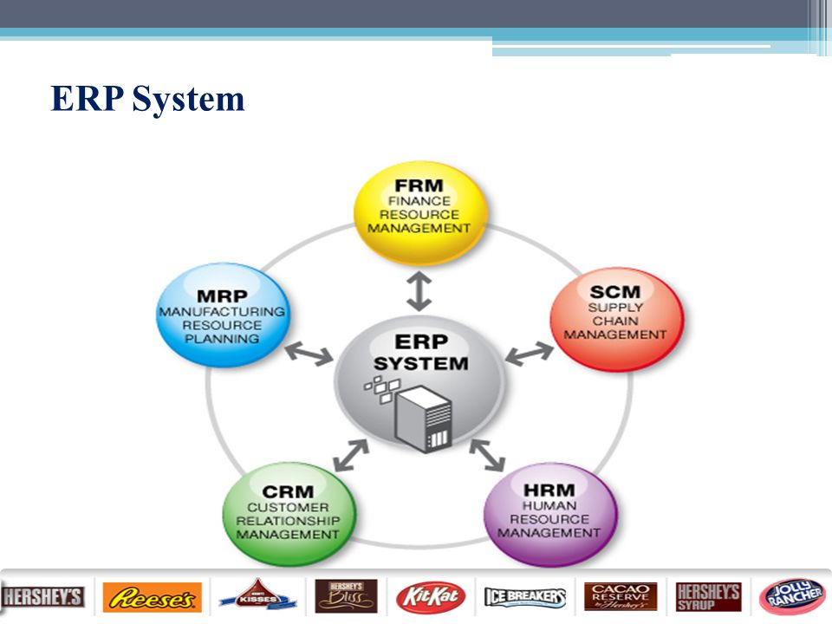
Figure 1 ERP System of Hershey Company
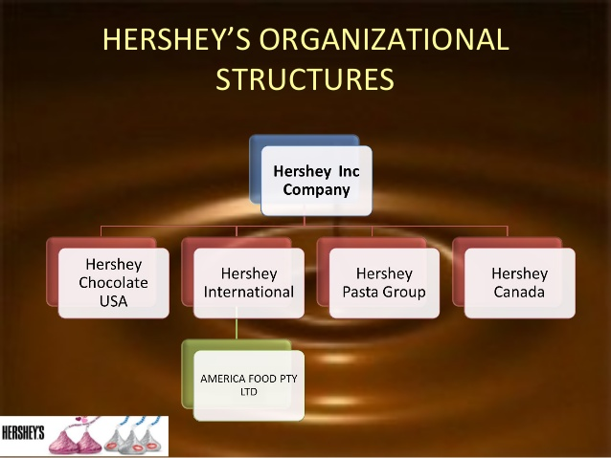
Figure 2 Organizational Structure of Hershey Company
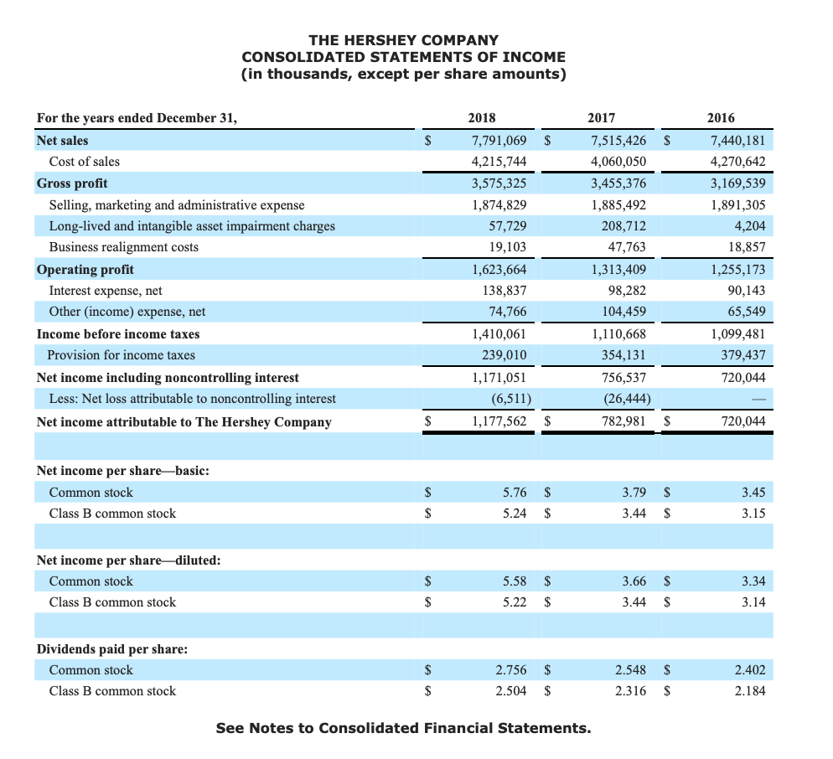
Figure 3 Financial Statement of Hershey Company

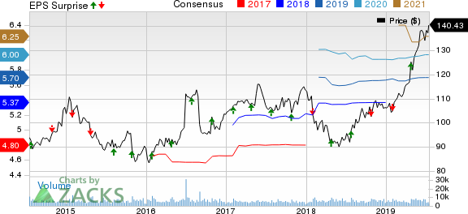
Figure 4 efficiency of IS of Hershey Company

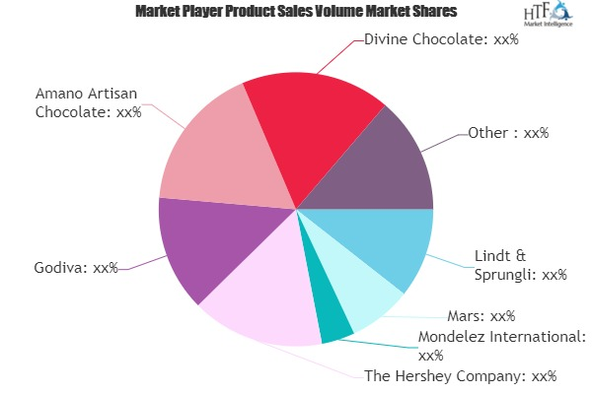
Figure 5 Marketing illustration of Hershey Company

