Tesla Analysis
Name of Student
Institutional affiliations

Tesla was founded in the year 2003 shortly after GM did not find the electric cars a viable option and threw away the prototypes of its electric cars. The CEO Elon Musk was able to provide ample capital support to the company to run it. The major idea was to make electric cars in bulk and sell them to masses. The first product was to be a sports car, then a $ 60000 sedan and then a $ 30000 sedan sold to masses. The company was not able to follow the timelines for introducing these products. In 2008, the roadster was introduced and was sold for four years and not manufactured since then. Company produced the model S as its next car which was originally released in 2012 with a lot of varying options available to the consumers. This was the first electric vehicle which was offered for the masses. The model is priced at a minimum of $ 74500. There are more experiments with these models including autopilot, super charging etc. The model X has a similar design but it is manufactured to satisfy the needs of SUV market. The company tries to improve the vehicles on the annual basis unlike other car manufacturers who bring out models with minimal changes every year. One aspect that is distinct to Tesla is that the cars can be charged at super charger stations placed all over the world. The current version of car is priced at $ 35000 which was originally promised to be $ 30000.
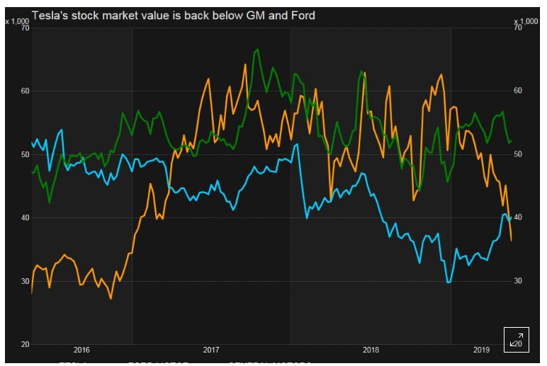
The above graph shows the 3 year performance of the company share prices and we do not see any considerable improvements in this graph. There is a negative change in share price where the prices have decreased. In the past, there have been drastic decrease in the prices of company shares due to two reasons, one is the crash involving a model X and the company was not able to produce model 3 in time. The company had to take the model X back and made it again with some improved quality features. The company has huge hopes with its model 3 and it has not started off very well. In the month of March in 2018, the stock prices of firm fell by 22.4% as compared to 2.69 % decline to S&P 500 during the same time period. The credit rating for company has improved with many rating agencies which is the reason why company has been able to get loans despite very poor performance on many major indicators. The company has recalled the model S because it had some issue with the power steering part. The company has fallen well behind the competitors GM and Ford.
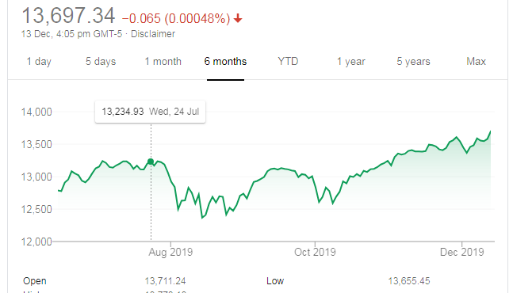
The above chart shows the 6-month values of the New York stock exchange and there is a changing trend in this graph. At some points in time, there is an increase and at some others, there is a decrease in the total values.
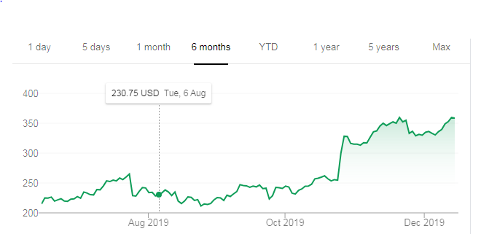
(YAHOO Finance, 2019)
The above chart shows 6-month performance of the share prices of TESLA company which also shows a mixed trend from the view point of a shareholder. There are some points of decrease and some points of increase in the above graph. There is a clear hike in the prices of shares around November of this year and then the trend of increase and decrease again followed. The company is again gaining some ground to revive itself.
The failure of Tesla is a company failure because it has not been able to produce quality products which can satisfy the needs of customers. The other competitors like GM and Ford have been able to grow the value of their shareholders and profitability of their companies. The macroeconomic factors would have affected all the companies equally so these factors have not played any part in the downfall of company. If we keep the electric cars and solar panels out of the analysis, the company is a complete failure on the basis of financial numbers. The CEO was able to generate some capital for the company but as the financial ratios have shown below, this capital has caused a decrease in leverage of the company. There has been no value created for the shareholders of company in terms of increase in share prices. The company has not been able to increase the number of shareholders but there has been a consistent increase in the number of creditors for the company. In 2014, the company saw a considerable decrease in share price as compared to the overall NASDAQ figures (Collins, 2014). The company has not been able to create any economic value as well as shareholder’s value and the company has not been able to maintain market share. A very similar trend has been shown by the prices of bonds issued by the company and these bonds were valued at 92.8 cents whereas the bonds issued for 2022 were valued at 96.46 cents and the junk bonds were trading at 84.25 cents on the dollar (Randewich, 2019).

Ratio analysis evolved out of Euclid’s rigorous analysis of properties of ratios in his book in the year 300 B.C. In last half of the nineteenth century, management from various industrial organizations turned from capitalists to real managers. At the same time, finance evolved as a powerful department and there was an increased need of analysing financial performance. The most important cause of evolution of financial analysis was increase in power of finance department. Different sets of ratios evolved over a period of time and there was considerable overlap between evolutions of different set of ratios. Credit analysis evaluated the ability of a business to pay off its debts whereas managers analysed the ability of a business to earn profit. There was a dominance of credit analysis approach on general development of ratio analysis. During the 1890’s there was an increase in flow of financial information between banks and concerned organizations. Current ratio is the most important among all financial ratios ever since financial statement analysis began. In the early years of the twentieth century, more ratios were developed, there was a need of analysis across firms to compare and contrast performance an there were absolute standards set up for benchmarking certain ratios. Current ratio was considered to be satisfactory if it was anywhere above 2 to 1. In his classic report in 1919, Alexander Wall compiled seven different ratios of 981 firms from different sectors of the economy. For around next 15 years, development in ratio analysis was based on report from Wall. At the same time, there were turnovers and margins used by managers in retail industry (O.Horrigan, 1968).

Current ratio is used to assess the liquidity of a company in terms of its ability to pay short term debts if they become due at the same time. This figure is calculated by dividing the current assets by current liabilities which means that company has enough current assets to pay off short term debts. A ratio of more than one will mean that the company will be left with some current assets even after paying the short-term debts. The current ratio is the first one to be calculated in a financial ratio analysis. It is a measure of liquidity for the firm and is represented as the amount of current assets left after paying all the short term debts. The normal standard of this ratio is 2;1 which means that a company has to keep $ 2 of current assets against each dollar of current liabilities. In the year 2017, the current ratio for Tesla was 0.85 which means that the company has only $ 0.85 of current assets against each dollar of current liabilities. This situation is dangerous because company will not be able to pay all the short-term loans if they become due all at the same time. In 2016, the same ratio was 1.07 which means that the company had just enough current assets to pay all short-term loans. The position has worsened in the year 2017 and the analysis shows that all current assets have increased except for cash and cash equivalents which have decreased from 2016 to 2016. The actual problem for the company lies in the increase in its current liabilities which have increased from the year 2016 to 2017. The accounts payable and accrued liabilities have been increased by considerable amounts. In fact, except for one or two of the current liabilities, all other items have increased. This will impact the ability of company to pay the short-term loans on time. The suppliers and related parties will suffer from this aspect because they will not get their payments on time. Another aspect is that the company will find it difficult to get some inventory on credit from any of its suppliers
Quick ratio is used to assess the extremely short-term ability of the company to pay off its debts. The quick assets do not include inventories from the current assets section. The nature of business for company is such that there have to be huge amount of inventories with the company at any given point in time so quick ratio will be lower than the standard that it should be. Generally, the quick ratio should be 1to 1 which means that company should have $1 of quick assets against each dollar of current liabilities. In the year 2017, the company has $ 0.56 of quick assets to each dollar of current liabilities. In the year 2016, the same ratio was 0.76 which means that the company had a little better position on liquidity in terms of quick assets in the year 2016 as compared to 2017 (TESLA, 2017). The major reason is that the company has increased the inventories over a period of one year and either it is not able to sell the products at pace or not able to produce them because the inventory section has to deal with these two options.
Cash ratio predicts the ability of a company to pay off short-term debts with the help of cash and cash equivalents only. This may not be possible for Tesla due to the nature of business and overall situation of the company. The ratio for 2017 was 0.43 which means that the company was able to pay only 43% of its short-term debts with the help of cash and cash equivalents. In 2016, the same ratio was 0.58 which meant that company could have paid 58% of its current liabilities from cash and cash equivalents. This difference has been caused by the increase in current liabilities for the company.
Profitability Ratios
Profitability ratios help companies to assess their situation regarding control on expenses and increase in revenues (Scranton.edu). Net and Gross profit margins are calculated to show profitability ratios of companies. These ratios show gross and net profits as percentage of sales. A higher percentage will mean that company is converting its sales more efficiently into profits. Controlling the expenses is another aspect of this analysis which means that company has effectively controlled the expenses to make sure that profits are higher. Profitability ratios are more important in those businesses which require huge investments to start and run over a period of time. If we talk about the gross profit margin, it is calculated by dividing the gross profit by sales and taking the percentage. In the year 2017, the gross profit margin was 18.9 percent whereas in 2016, the same figure was 22.84% which means that there has been a considerable decrease in this ratio. A detailed analysis shows that the company has not been able to control is expenses from the year 2016 to 2017 which has caused a decrease in percentage of gross profit to the sales. Another explanation of this aspect is that company has not been able to increase the amount of sales as much. The net profit margin is calculated to show the net profit as a percentage of sales. In the year 2017 and 2016, the company incurred huge losses so profitability ratios only included the gross profit margin.
Leverage Ratios
Leverage shows the extent to which a company has been financed with debt or equity. There are separate pros and cons of both forms of business financing and companies usually use a combination of both. Debt ratio is the first ratio which is calculated by dividing the total liabilities with total assets. The results show the percentage of company assets which have been financed from debt. In 2017, the ratio was 0.80 which meant that 80% of assets for the company have been financed through debt whereas the same figure in 2016 was 0.74 which meant that 74% of the company assets were financed by debt. The increase in this percentage means that the company has not been able toe generate funds from its business or from any shareholders so it had to buy the assets through debt. Another important ratio in this category is Debt to equity ratio which compares the total debt to total shareholder’s equity. This shows the percentage of financing done with the debt as compared to equity. In 2017, the ratio was 5.43 which means that company has $ 5.43 of debt against each dollar of equity which is a very high figure. In 2016, the same figure was 3.52 which means that the company had $ 3.52 of debt against each dollar of equity which is again not satisfactory but better than 2017.
Interest coverage ratio shows the ability of a firm to pay its interest obligations. The ratio is calculated by dividing the operation income by the interest expenses. In 2017, the company incurred a loss from its operations so this ratio cannot be calculated for 2017 and 2016. This will also mean that the company cannot pay the interest obligations without taking further loans.
Efficiency ratios
The efficiency ratios show the operational efficiency of the company. The first ratio calculated in this category is asset turnover ratio which shows the ability of company to generate sales from the available level of assets. In 2017, the ratio was at 41% where as the same ratio in 2016 was 30% which shows an increase in 2017 as compared to 2016. This increase is attributable to the increase in sales of the company.
The inventory turnover ratio is calculated as the ratio of cost of goods sold to the inventory held by the company. In 2017, the ratio was 4.21 which means that the company was able to sell the inventory 4 times in a year. In 2016 the same ratio was 2.61 which means that the company was able to convert inventory to sale only two times in one year. The improvement in this ratio is attributable to the increase in inventory. The company has managed to improve the efficiency ratios but other aspects have not been very positive.
Receivables turnover ratio allows us to see the ability of the company to receive timely payment from the debtors. The credit sales are divided by the accounts receivable to find out this figure. In 2017, the company was able to collect 10 times from the debtors over a period of one year whereas the same figure was 13 times in the year 2016. This means that the ability of company to collect from debtors has declined. This may be the result of a more relaxed policy of selling on credit which the company will have to change so that there is not much problem in collection from debtors.
The book value per share is calculated by dividing shareholder’s equity on the total shares outstanding. The company has already issued the shares equal to the maximum limit of authorized capital which means that there are no shares outstanding and this ratio cannot be calculated
Conclusion
The company started as a manufacturer of electric cars and was able to make various models related to them. The problem came when certain models made by the company showed several faults and there were many accidents involving cars of the company. The share price for company has been decreasing over a long period of time and it has fallen behind many of its competitors in terms of share and bond prices. The company has been the biggest culprit for itself because the CEO took on loan after loan to provide capital for the projects which were not feasible to be taken up. This action decreased the leverage and liquidity of the company. On the financial front, the company has been able to perform better only on the efficiency ratios which show the operations run by the company. The company has not been able to make any profits for the years 2017 and 2016. All the figures related to debt have been increased which shows that leverage has been reduced for company. In order to improve the situation, company has to focus more on equity financing. The expenses will have to be controlled by focusing on a single model in the start. The volume of sales can be set a bit higher but the company has to focus on single model and try to be a bit profitable as well. After a period of around 5 years, the company can think about launching a new model. Another improvement area will be the time at which these products will be launched. The company will have to make sure that models are launched at the promised time so that customer confidence is regained. The company will also have to think about all the stakeholders so that it can have long term success. In the scenario discussed, the most important stakeholder are the shareholders and they have been continuously suffering from this situation. In order to improve the situation as a whole, company ahs to focus on reducing the costs of production and making sure that there is some sort of profitability in the near future.

References
Collins, J. (2014, August 21). https://www.forbes.com/sites/jimcollins/2019/08/21/tesla-has-failed-massively-as-a-public-company/#3ce95bff1dc2. Retrieved from https://www.forbes.com: https://www.forbes.com/sites/jimcollins/2019/08/21/tesla-has-failed-massively-as-a-public-company/#3ce95bff1dc2
Randewich, N. (2019, May 20). https://www.reuters.com/article/us-usa-stocks-tesla/tesla-stock-and-bonds-tumble-as-investors-fret-about-costs-and-safety-idUSKCN1SQ1WY. Retrieved from https://www.reuters.com: https://www.reuters.com/article/us-usa-stocks-tesla/tesla-stock-and-bonds-tumble-as-investors-fret-about-costs-and-safety-idUSKCN1SQ1WY
Scranton.edu. (n.d.). https://www.scranton.edu/faculty/hussain/teaching/fin361_/Fin361C03.pdf. Retrieved from https://www.scranton.edu: https://www.scranton.edu/faculty/hussain/teaching/fin361_/Fin361C03.pdf
TESLA. (2017, December 31). http://www.annualreports.com/HostedData/AnnualReportArchive/t/NASDAQ_TSLA_2017.pdf. Retrieved from http://www.annualreports.com: http://www.annualreports.com/HostedData/AnnualReportArchive/t/NASDAQ_TSLA_2017.pdf
YAHOO Finance. (2019, December 14). https://finance.yahoo.com/quote/TSLA?p=TSLA&.tsrc=fin-srch. Retrieved from https://finance.yahoo.com: https://finance.yahoo.com/quote/TSLA?p=TSLA&.tsrc=fin-srch

