Technical Description Introductory Memo
[Name of the Writer]
[Name of the Institution]

Technical Description Introductory Memo

Computer Mouse
A computer mouse is an input pointing device attached to a computer used to control the cursor on the computer screen (Jillian, 2019). Although relatively small in comparison to the overall computer system, the mouse plays an important part in operating the computer system. The mouse enables the computer user to select any object displaying on the screen by moving and clicking on it.
Main features
There are three major parts of a computer mouse
Top part
The top part of the computer mouse is made up of plastic. This part has been built to fit the hand of a user perfectly. Additionally, this part protects the inner part of the mouse. The most important components of the top part of the mouse are a right-click, left-click, and a scroll wheel. A user can select any icon or option being displayed on the screen using the clicks. The scroll wheel is used to scroll up and down the computer screen.

Bottom part
The bottom part is also made up of plastic. The bottom part protects the inner part. There is a small trackball inside the bottom part of the computer mouse. The trackball is a small sphere ball made out of rubber. The motion of the trackball is detected when the computer mouse is moved by the user. This motion is translated into an electric signal which is reflected in the movement of the cursor on the computer screen.
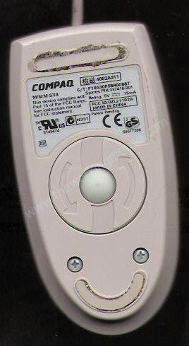

Internal circuit
The internal circuit of the computer mouse is an electronic component made out of copper. The internal circuit is placed inside the computer mouse and protected by the top and bottom parts.
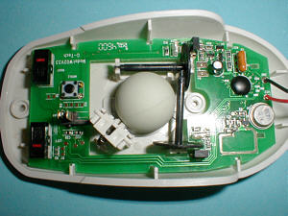

Primary Functions
A computer mouse is a simple yet useful input device that enables a user to interact and do useful work using it. When a user moves the mouse, the motion of the mouse in mirrored in the movement of the cursor at the display screen. Furthermore, a user can select any icon or option using the mouse.
The controls and working of a mouse are easy that anyone can learn.

References

Jillian, G. (2019). Functions of Computer Hardware Components. Retrieved 1 August 2019, from https://computerhardwarecomponentsandfunctions.wordpress.com/

