- Aerial photographs of both locations (Google Earth can provide jpg of locations)
WEVERSTOWN MALL CALIFORNIA
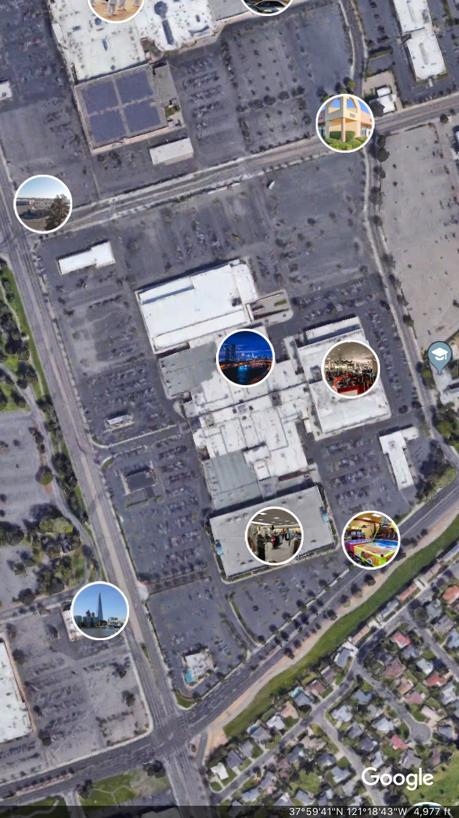
California elementary school
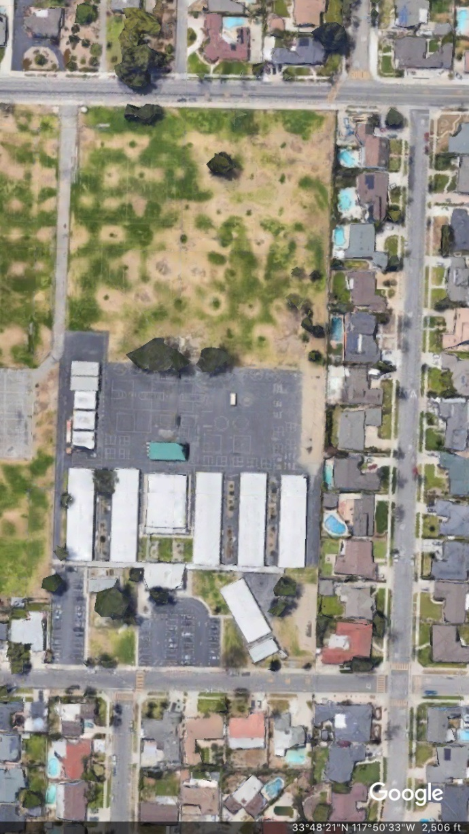

- Site photographs from both locations
WEVERSTOWN MALL CALIFORNIA
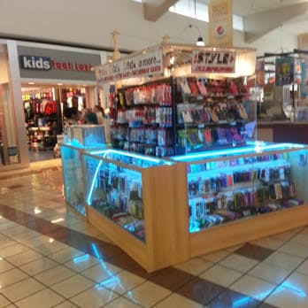
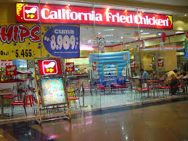
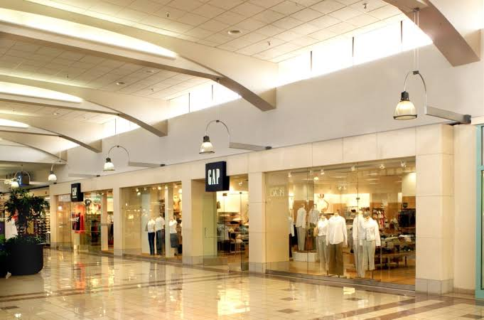
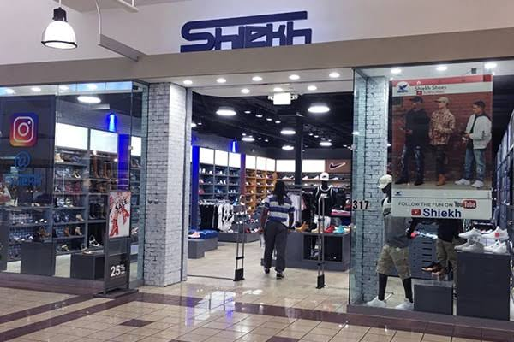

California elementary school
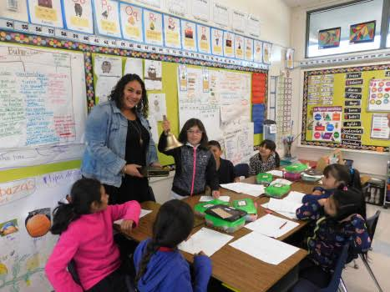
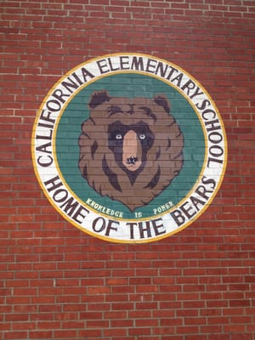
- Numerical values of all area calculations (Percentages)
WEVERSTOWN MALL CALIFORNIA

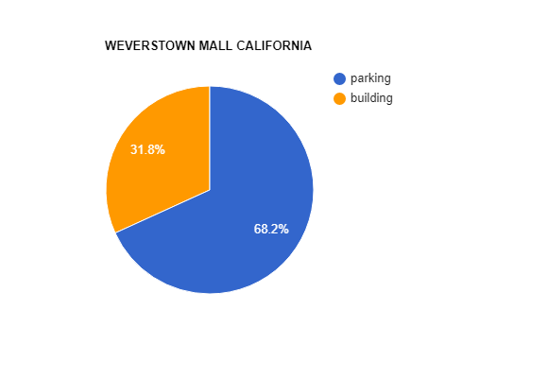
California elementary school
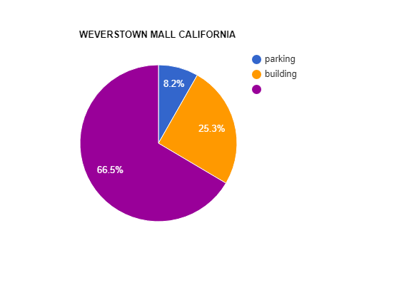

- Answers to the discussion questions in paragraph form
• What are the differences between land cover for each site?
Land covers are basically comprised of bare ground which is fertile and contain several vegetative and ornamental plants and trees which enhance lands beauty as well as provide refreshment to the people around. Land covers are also capable of controlling a person’s mood and reduce stress.
The land covers that I selected belong to the school and shopping centre. School land cover is well maintained and cover a large area as it keeps the health of teachers and students good. School infrastructure is built in a way to enhance ventilation so that students can enjoy the fresh air and there would be less sick days. Recent research revealed that land cover improves students brain functioning and physical activities are also promoted via this. Besides greenery being used as ornamental purpose grounds are also used by students for physical activities which helps in their growth. In the evening, numerous local people also came here for a walk and games to maintain health and to enjoy the company of each other. Such gatherings are usable as they listen to each other and help to solve each other's problems. Trees are also responsible for controlling the climate as it provides cooling and shade. They clean pollutants that outcomes in creating noise buffer.
Land covers can also help promote environmental literacy among students. Students interest in increased for plants and they are taught how to grow and take care of trees and vegetables.
Weverstown mall contained no land cover as it is situated in the heart of the city. Buildings are mostly constructed by cutting down trees. The buildings surely increase the beauty of the city but it diminishes the natural beauty as well rate of air and noise pollution also increases. Certain artificial plants were there in the mall but that was only for the ornamental purposes. They play no role in regulating the environment and human health. Several artificial machines were used for ventilation and atmosphere cleaning. It was a clear representation of a man-made world where artificial facilities were provided but they are no match of ground land grass.
• How is stormwater drainage handled at each location?
Rainwater drainage management is necessary especially in schools because standing water can result in an increase in the growth of germs and mosquitoes. The microbial growth is one of the causes of biological contamination which can affect people at large scale and Malaria is one of an example which took many lives like a storm and was spread due to human negligence but students life is important as they have to lead the future so precautions are taken to provide them with a better environment.
Trees and grass help in regulating rainwater. Grass increases the ability of water to seep more into the soil. it is thought that the first-inch rain mostly contains pollutants and soil act as a filtrate. Grass makes the rainwater runoff stable. In the school, rain barrels are placed to store water coming from the school building rooftop. Storm sewers are part of the infrastructure which collects rainwater and via savage pipes drained into channels that are emptied far away from the population in open land. These savage systems are helpful and drain runoff water only when there is high water pressure but still, some water is left behind and there is no proper way for complete drainage.
Shopping malls are better maintained to attract the customers and different new technologies are being introduced that help in regulating rainwater. the shopping centre was covered and there was a plastic pipe that carries water from the rooftop to the gutter. The downpipes were being checked and cleaned by the employees to avoid contamination. As there are no standing water chances in the shopping mall which reduces the chances of water pollution and contamination. rate of water bore diseases is also low and people are provided with a healthy time so they can enjoy their time. Food corner was covered and there was no window which eliminated the chances of rainwater contamination. Rainwater is pure and is being used for many purposes. There are several companies and shopping malls that collect this rainwater in a tank for future reuse. But acid rain effect infrastructure as well as human health badly. Stormwater deteriorates buildings so special material is used for construction. Acid rain if coming in contact with skin may cause skin burn, irritation, as well as skin cancer, can occur.
Nitrogen and sulphur oxide released into the atmosphere and when react with rainwater results in rainwater. When this acid rain falls on the land covers, it destroys the plants and grass. Even if the plants survive they still become less cold tolerant. There are also certain other adverse effects such as if the canals that carry stormwater from school and shopping mall contaminate empty into any fertile land or where vegetables are grown then it may affect the growth of crop plant as well as the quality of food and fruits. And when consumed by locals can cause health issues. If the canal drain into any lake or river can affect aquatic life.
• How is energy used at each location (e.g., lights, buildings, etc.)?
California elementary school was constructed in a way to increase ventilation. There were a lot of windows and students are provided with natural habitat. So the energy use is not much. Students enjoy the natural atmosphere which improves their brain functioning. Students work in day sunlight whereas in shopping mall there was a high consumption of light. The building was closed so there was continuous use of light during day and night. Besides this energy was being consumed by elevators, lifts and displays. There was an indoor play area for kids and adults to enjoy which are also rich consumers of light energy. Light energy is continuously required for a shopping mall to run so there were energy alternatives prepared in advance i.e. generator and solar cell.
• What are the sources for stormwater runoff contamination?
During heavy rain runoff water may carry a litter, dead leaves, chemicals, fertilizers and pesticides. Biological control management systems are there which are preferred and are eco-friendly because pesticides may accumulate into the soil as well as into plants and affect the greenery. If the rain water drain pesticide and land on any fertile land can effect crop plant.
Stormwater can cause air pollution as the germ and microbial growth increases where there is standing water, water pollution as the rainwater when reaches lakes and streams may contaminate them and in less amount is responsible for noise pollution as the pollution and contamination effects mood swings. The beauty and attractiveness of the landscape make the people healthy and calm.
• Summarize the difference between land-use practices.
Land becomes more susceptible to degradation when there is no land-use planning. Land use practices are designed after collecting necessary information about the land area and it helps to restore the natural habitat. Land management has a great impact on nutrients, plants and fertilizers. Via proper regulation future shifts in land can be prevented.
Schools are more concerned about land-use practices as they had to maintain the landscape and it is also related to children's health. Schools are people-oriented where students are being taught about how to save the ecosystem. Whereas shopping malls are object-oriented. They are more focused towards there sales and there are no proper land-use practices, they make use of land for building more shops to increase earning.

