Finance
Student’s Name
Institution

Section # 1
In the United States and worldwide, banks offer different interest return. The analysis of the financial sector established that Goldman Sachs Bank USA Marcus offers the best interest return of 1.90%. In order to have a saving of $10,000 saving for five years, the monthly saving will be $159 at an interest rate of 1.90% for a period of 5 years. The goal of saving $10,000 after 5 years would be met with the current saving of $159 at an interest rate of 1.9%.
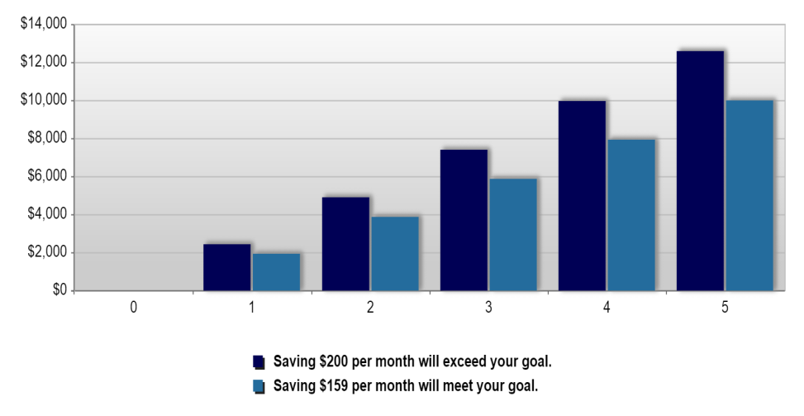
Graph 1: Saving plan by year
However, the Certificate of Deposit return after 5 years with an initial saving of $10,000 at an interest rate of 1.90% would be 9.866.79%. It is evident that after a period of 5 years, the total amount to be earned would be $10,986.79. In the diagram below, it is illustrated that the CD earn will increase years from $10,190 to 10,987 at the end of the 5 year period.
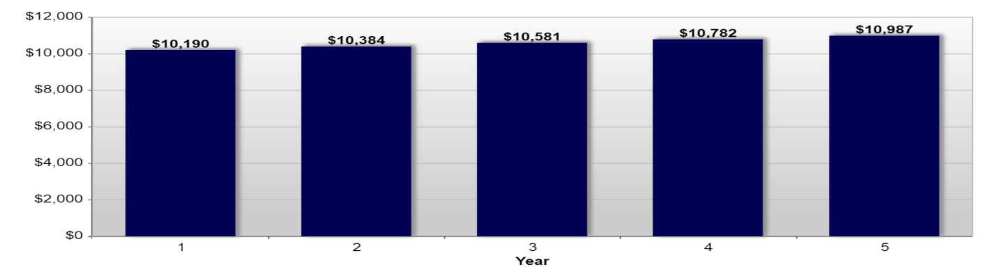
Diagram 2: CD Earning per year for a period of 5 years
Goldman Sachs Bank USA Marcus is the best company for investment because of the high-interest payment compared to other banks (Carlozo, 2019). Though it does not provide ATM, which most customers prefer, it provides high CD rate and interest return as well. It offers to check writing and also allows the opening of checking account which is connected for an easier transaction.
Section # 2
Chapter: 5
Page no: 143, Paragraph: 2
Interest rates tend to change over time, investors will demand different interest rates for different investment horizons based on their expectations.
The sentence is the most significant in the chapter because it helps companies’ business professional to be always aware of changes in interest rates because it changes over time while every investor demands varied interest rates as per their expectations (Berk, & DeMarzo, 2017). So, management and financial analyst shout take steps accordingly.
Page no: 161, Paragraph: 3
The cost of capital is clearly relevant for a firm seeking to raise capital from outside investors.
It is considered as the significant sentence because it clarifies the thoughts of firms that seek for raising capital that, according to (Berk, & DeMarzo, 2017), if a firm raises funds then they must and would have to bear the cost of capital for doing what you plan.

Chapter: 7
Page no: 220, Paragraph: Last
The payback investment rule states that you should only accept a project if its cash flows pay back its initial investment within a prespecified period.
It is the most significant sentence of the chapter because after reading this, I got clarified that being an investor or project analyst, I would accept only those projects which cash flows pay back their original investments during a pre-specified deadline. While I have to reject.
Page no: 225, Paragraph: 3
Even when projects have the same scale, the IRR may lead you to rank them incorrectly due to differences in the timing of the cash flows.
In chapter 7, the chosen sentence is significant because it helps that we or investors and analysts should not fully rely on the IRR. Because IRR could lead you to prioritize projects wrongly because of variances in cash flows timings (Berk, & DeMarzo, 2017). This can happen even the projects are of one or the same scale. Hence, it helps to be careful in such decisions.

References
Berk, J. B., & DeMarzo, P. M. (2017). Corporate Finance: The Core, 4/e. Boston: Pearson Education. ISBN 9780134083278.
Carlozo, L. (2019). Best Savings Accounts – September 2019.
https://money.usnews.com/banking/savings-accounts , 2-14.
Probasco, J. (2018). Banks That Pay the Highest Interest Rates on Savings Accounts.
https://www.investopedia.com/personal-finance/banks-pay-highest-interest-rates-savings-accounts/ , 2-15.

