Name
Course
Tutor
Date
Hazard Field Trip Pamphlet
This is a guide of a tour of the southern parts of the United States. It involves a visit to the areas widely known for a variety of natural hazards. This tour will provide deeper insights into understanding the causes of the hazards, ways to mitigate, and dangers they pose to human existence.
Stop 1: Track of huge tornadoes in Tennessee, Mississippi as far as Alabama
Places such as Tennessee, Alabama, and Mississippi are infamous for their violent tornadoes. They are nicknamed Tornado Alley. The reason for the frequent occurrence of tornadoes is attributed to warm and moist air from the Mexican Gulf, which collides with dry air from the Rocky Mountains in the east. The resulting force of this collision is thunderstorms and tornadoes. Geographers have found a long track in tornado alley in areas of Mississippi and Tennessee. Such long-track tornadoes are powerful and strong enough to stay in the ground for long. Tornadoes in the alley measure up to scale six in the Fujita Tornado Scale. At this scale, tornadoes have a high capacity of huge damage to property and even loss of lives.
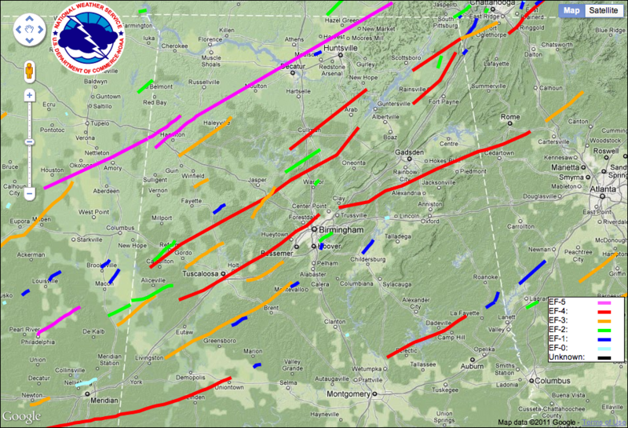
Long track tornadoes in Tennessee and Alabama
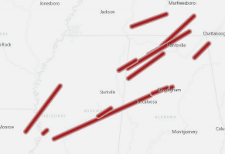
Long track tornadoes

Stop II: Loss of Flood regions and wetlands of coastal Louisiana
Over the years, there has been a loss of wetlands and flood especially in the coastal parts of Louisiana. This loss is caused by the uncensored human effect on the environment. The human activities such as increasing urbanization, extreme logging, and levees used to prevent flooding as well as canals for shipping has contributed to the loss. Besides, increased dredging for oil in the region has elevated the problem. Significantly, climate change has brought about adverse climate change and Rising Ocean levels which has further exasperated the problem. Degrading wetlands make people living in lower regions such as New Orleans highly susceptible to flooding, especially during storm surges.
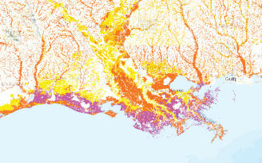
Land loss in Louisiana
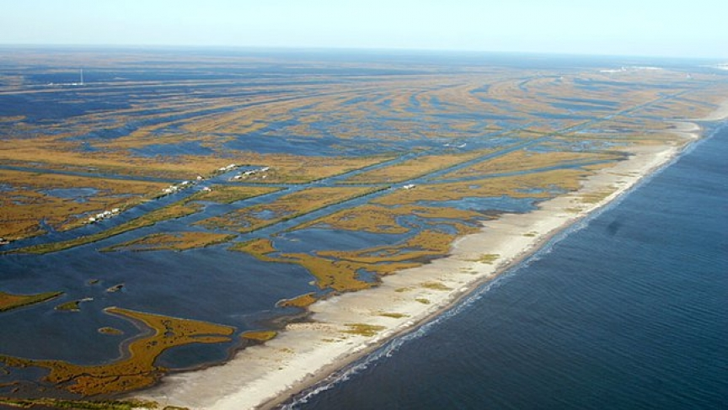
Disappearing Louisiana coastline by Adam Wernick

Stop III: Earthquake zones in New Madrid
Earthquakes rarely occur in southern regions such as Missouri, Kentucky, and Tennessee. However, according to United States Geological Survey (USGS) regions along the Mississippi River including Kentucky, Missouri, Arkansas, and other regions have a high potential of receiving an earthquake of a magnitude of more than six in years to come. USGS further predicts a good chance of occurrence of earthquake magnitude of over eight. The cause of earthquakes according to USGS is a weak spot just below the surface in the North American Plate. Geologists have identified the exact location of the weak spot as the New Madrid Seismic Zone (USGS, 3). Geologists forecast that the occurrence of earthquakes can be very dangerous since people in this region are ill-prepared in case of a major earthquake. In addition, some do not know how to react in the event of an occurrence. Earthquakes in this region can have a devastating impact because people living in major towns and population centers do not have proper building codes like those usually found in parts of the United States known for frequent seismic activities. Notably, city and town planning in areas such as Memphis and St. Louis are poorly choreographed. This could aggravate and heightened the effects of earthquakes leading to damage to the property and even death of people.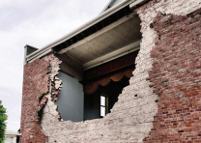
Effects of earthquakes in the regions include destruction of property
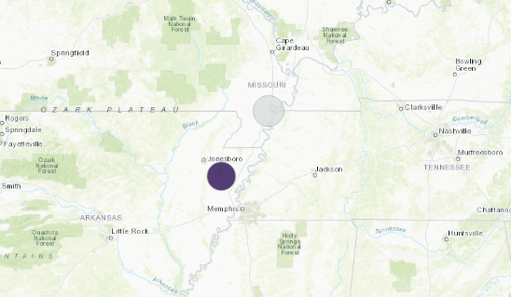
Seismic activity in New Madrid

References
United States Geological Survey (USGS). Summary of 1811-1812 New Madrid Earthquakes Sequence. US.Geological Survey. Accessed October 9, 2019 from <https://earthquake.usgs.gov/earthquakes/events/1811-1812newmadrid/summary.php>
Photograph of disappearing coastline in Louisiana. Adam Wernick. 23 September, 2014. <https://www.pri.org/stories/2014-09-23/louisianas-coastline-disappearing-rate-football-field-hour>

