Your Name
Instructor Name
Course Number
Date

Title: Math Homework:
Car 1 make: Mercedes-Benz-E-Class Model: 2017 Price: $53,500
Car 2 make: BMW 5 Series Model: 2017 Price: $ 53,400

Q1: What does it mean to be upside down in a loan? Look it up, the write the definition in your own words.
When the amount of loan borrowed using a collateral is more than the value of the item that you had bought, an upside loan situation occurs. In this collateral could be anything from car to home. Being Upside down in a loan happens when market value of the product bought has depreciated faster in respect to the decrease in loan balances.

Q2: Rate of depreciation of two new 2017 vehicles and their value in ten years.
Using the values of the cars listed above, their depreciation is calculated using reducing balance method.
Car 1  Depreciation for 1st year =$\frac{13375}{53500}*100=25\%$  Depreciation for 2nd year =$\frac{18190-13375}{53500-13375}*100=12\%$  Depreciation for 3rd year =$\frac{22427-18190}{53500-18190}*100=12\%$  Depreciation for 4rth year =$\frac{26777-22427}{53500-22427}*100=14\%$  Depreciation for 5th year =$\frac{30786-26777}{53500-26777}*100=15\%$  Depreciation for 6th year =$\frac{34193-30786}{53500-30786}*100=15\%$  Depreciation for 7th year =$\frac{36896-34193}{53500-34193}*100=14\%$  Depreciation for 8th year =$\frac{39054-36896}{53500-36896}*100=13\%$  Depreciation for 9thyear =$\frac{40392-39054}{53500-39054}*100=9\%$  Depreciation for 10th year =$\frac{42440-40392}{53500-40392}*100=16\%$ | Car 2:  Depreciation for 1st year =$\frac{13350}{53400}*100=25\%$  Depreciation for 2nd year =$\frac{18156-13350}{53400-13350}*100=12\%$  Depreciation for 3rd year =$\frac{22385-18156}{53400-18156}*100=12\%$  Depreciation for 4rth year =$\frac{26727-22385}{53400-22385}*100=14\%$  Depreciation for 5th year =$\frac{30728-26727}{53400-26727}*100=15\%$  Depreciation for 6th year =$\frac{34129-30728}{53400-30728}*100=15\%$  Depreciation for 7th year =$\frac{36827-34129}{53400-34129}*100=14\%$  Depreciation for 8th year =$\frac{38981-36827}{53400-36827}*100=13\%$  Depreciation for 9thyear =$\frac{40856-38981}{53400-38981}*100=13\%$  Depreciation for 10th year =$\frac{42361-40856}{53500-40856}*100=12\%$
Calculation:

Year | Depreciation rate for Car 1($) | Depreciation rate for Car 2 ($)
0 | 53500 | 53400
1 | 13375 | 13350
2 | 18190 | 18156
3 | 22427 | 22385
4 | 26777 | 26727
5 | 30786 | 30728
6 | 34193 | 34129
7 | 36896 | 36827
8 | 39054 | 38981
9 | 40392 | 40856
10 | 42440 | 42361

Q3: Graphs for the depreciation of each car
Graph for Cost of Depreciation for car 1
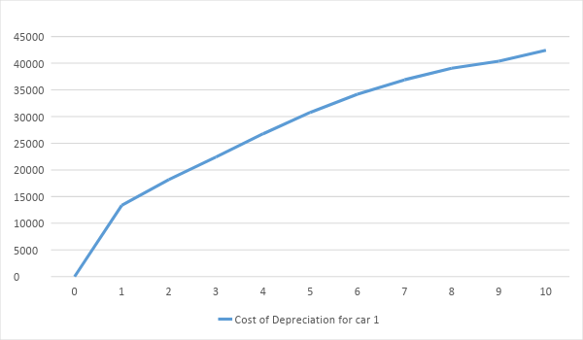

Graph for Cost of Depreciation for car 2

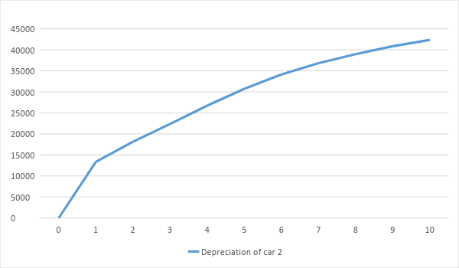

Q4: Using 5.25% as APR, calculate the total loan payments that you would have to make for year 3, 5, 7 and 10 years.

Year | Beginning Balance car 1 ($) | Total Loan Payment car 1 ($) | Year | Beginning Balance car 2 ($) | Total loan payment car 2 ($)
3 | 44917.28 | 4,640.58 | 3 | 44833.32 | 4631.93
5 | 35386.55 | 5153.14 | 5 | 35320.40 | 5143.55
7 | 24083.08 | 5722.36 | 7 | 24756.72 | 5711.68
10 | 6696.18 | 6696.16 | 10 | 6683.66 | 6683.71
Calculation:

Number of Loan Years | Total Payments for Car1 ($) | Total Payments for Car 2 ($)
3 | 4,640.58 | 4631.93
5 | 5153.14 | 5143.55
7 | 5722.36 | 5711.68
10 | 6696.16 | 6683.71

Compare these results, why some are higher than others from the same car
The table illustrates an increase in the value of loan payments for both cars in each of the 4 periods. This difference in values is because the interest paid lowers and the principle increases over till the loan’s maturity. This leads to increasing loan payments as the loan period increases further from 3 to 10 years for both cars.

Q5: Write the total amount of interest that you have to pay for each of the 4 situations described above
Number of Loan Years | Total amount of interest for car 1 ($) | Total amount of interest for car 2 ($)
3 | 2247.54 | 2243.35
5 | 1734.98 | 1731.73
7 | 1165.76 | 1163.60
10 | 191.96 | 191.57

year | Beginning Balance car 1 ($) | Interest car 1($) | Year | Beginning Balance car 2 ($) | Interest car 2 ($)
3 | 44917.28 | $$44917*5.25\%=2247.54$$ | 3 | 44833.32 | $$44833.32*5.25\%=2243.35$$
5 | 35386.55 | $$35386.55*5.25\%=1734.98$$ | 5 | 35320.40 | $$35230.40*5.25\%=5143.55$$
7 | 24083.08 | $$24083.08*5.25\%=165.76$$ | 7 | 24756.72 | $$24756.72*5.25\%=1163.60$$
10 | 6696.18 | $$6696.18*5.25\%=191.96$$ | 10 | 6683.66 | $$6683.66*5.25\%=191.57$$
Calculation:

Compare these results, why some are higher than others from the same car?
Total amount of interest paid over the years will decrease as the principal increases. At first year interest is high because principal paid on the loan is less. As more and more of the loan is paid off, the interest shrinks and keeps on decreasing till the loans maturity.

Q6: Assuming that you will take a 10 year long loan on your car, complete the following table with the amount of principal left after each year (look at the balance value).
Year | Principle left (Balance for ) Car 1($) | Principal left (Balance for) Car 2 ($)
0 | 53500 | 53400
1 | 53500-2709.13-4178.99 = 49321.02 | 53400-2704.08-4171.20= 49228.83
2 | 4931.02-2484.38-4403.75 = 44917.28 | 49228.83-2479.76-4395.52 = 44833.52
3 | 44917.28-2247.54-4640.58 = 40276.70 | 44833.32-2243.35-4631.93= 40201.42
4 | 40276.70-1997.96-4890.16 = 35386.55 | 40201.42-1994.23-4881.05= 35320.40
5 | 35386.55-1734.98-5153.14 = 30233.39 | 35320.40-1731.73-5143.55= 30176.88
6 | 30233.39-1457.82-5430.30 = 24803.08 | 30176.88-1455.08-5420.20= 24756.72
7 | 24803.08-116576-5722.36 = 19080.72 | 24756.72-1163.60-5711.68= 19045.06
8 | 19080.72-858.01-6030.11 = 13050.61 | 19045.06-856.41-6018.87= 13026.21
9 | 13050.61-533.69-6354.43 = 6696.18 | 13026.21-532.71-6342.57= 6683.66
10 | 6696.18-191.96-6696.16 = 0 | 6683.66-191.57-6683.71= 0
*To calculate the principle left after every year (not the principle paid every year) interest and principle paid within any given year will be subtracted from the beginning balance of every year. The remaining balance left would be the principle left after every year.
Q7: On the same graphs for Q2, graph the principal left to pay from Question 6 for both cars in RED. Connect the dots in a curve pattern.

In what years is the Red Line above the Blue Line for car 1?
Till year 3 the Red line line, denoting principle left (Balance for) car 1 has stayed above the Blue line, denoting depreciation for Car 1. This can be seen in the graph above.
In what years is the Red Line above the Blue Line for car 2?
The graph above illustrates that the Red line for principle left (Balance for) car 1 has stayed above the Blue line for depreciation of car 2 till 3 years.

Q8: What does it mean when the Red Line is above the Blue Line?
As, the period of the loan increases over time its principal amounts are going to decrease till its maturity. During this time the product bought using the loan, will have an increasing rate of depreciation and will continue to have a diminishing value even after the loan reaches maturity. In this case the value for the two cars bought using the loans will keep on decreasing due to their increase in depreciation value of the cars. In this time, their principal payments will get lower until the whole loan is paid off.

Q9: Based on these two graphs, which car do you think is the best option to purchase?
Explain why, please write your answer as a short paragraph
Based on these graphs, the recommendation would be to buy car 2 (BMW 5 series). This is based on the fact that firstly the price of car 2 ($53400) is bit lower than car 1 ($53500). This makes it a bit cheaper and has a high accessibility chance than car 1. Secondly, car 2 has a lower depreciating rate and depreciation cost than car 1. This will allow car 2 to retain more of its value over its lifetime and would be able to sold off at a higher price in comparison to car 1.Third, its interest payment is lower compared to car 1, so less amount of principle would have to be paid over the course of the loan period. Lastly, car 1 for total 10 years loan payment is $68881.27, whereas, for car 2 it is $68752.52. This gives the idea the it will be cheaper to pay off loan for car 2 than 1.

