Chevron Strategic Analysis
Name of Student
Name of Institution

Introduction & history
Chevron is one of the leading companies in the energy sector which was formed by a group of visitors on Sept.10, 1879 in San Francisco with the name of Pacific Coast Oil Company. The initial efforts to find the oil from the various areas was a failure. The company took over the company named California Star to continue the oil exploration in the California area. In the year 1895, the company launched the first marine carrier in the name of George Loomis. In the year 1878, there was a new company named Standard Oil Co. entered the scenario named Standard Oil company that later acquired the coastal oil company in the Iowa area. The name of the company was not changed and the Iowa standard gained a presence in all the aspects of the petroleum business. By 1902, the company completed the refinery named Richmond Refinery. In 1909, the company went on to find its own oil and the company had its first own well in 1910 in California. In 1911, a decision by the Supreme Court separated the Standard oil company from its parent company. This decision made it almost compulsory to look for some new sources of oil.
Marketing Mix (4P’s)
A marketing mix consists of all the decisions that a company takes regarding the product. The features of the product, the price, the way it will reach the customers and the way the company will create awareness for the product in the customers.
Product
The products provided by the company include oil, gas and all the underground energy resources. The major portion of the company products include the renewable resources of energy. The company has made segments for the individual customers and the business customers separately. It also caters the aviation businesses and marine fuels for marine businesses. The company can use any of the strategies named, product development, market penetration, market development or diversification as its product strategy. The product range of the company includes a wide range of petroleum varieties.
Price
The company should use the pricing strategy that keeps the price similar to the competitors. The reason behind this is that the products offered by the companies are not distinguished from one another so there cannot be much difference between the prices.
Placement
The company is working in various countries like South Africa, Australia, and South Korea. The company has own pipeline company to manage fuel transport as well as the marine option of transporting the fuel through a fleet of ships.
Promotion
The basic promotion of the company is the corporate social responsibility activities undertaken by the company. The company uses the activities regarding the corporate social responsibility to promote itself unlike the competitors like Exxon who does a comprehensive and intense advertising campaign. The promotion of the company is based upon the stance taken by it on the corporate social responsibility
The mission of the company
The foundation of the company is laid on the values, which make the company different from its competitors. The business of the company is conducted in a socially responsible way. All the stakeholders that are affected by our business are dear to us and we care for all the stakeholders.
This mission statement will affect organizational activities in many ways. The other companies focus on conventional aspects of advertising while Chevron only relies on the CSR aspects of operations and promotes itself on the basis of these activities. The company will also assess any of its activities on the basis of its impact on the various stakeholders including the society as a whole (Jawahar Alotaibi, 2015). The values include the higher performance that is expected from all the employees. There is a sense of inclusion in all the employees that means that they feel included in the overall operations of the company. This is very important because the motivation level of the employees will be much higher if they feel that their acts are benefitting the company.
Another value that the company possesses is to protect the people and the environment. The people aspect is related to the employees who have to be fit and healthy for the organization to operate properly and to achieve short and long term goals. The environment aspect is related to the corporate social responsibility aspects of the company. These aspects are important for the company as it operates in a field that is bound to affect the environment negatively if proper care is not taken. This also includes the effects of the exploration activities undertaken by the company.
Industry and Market Situation
The following graph will show the situation of the industry and the market related to the company.

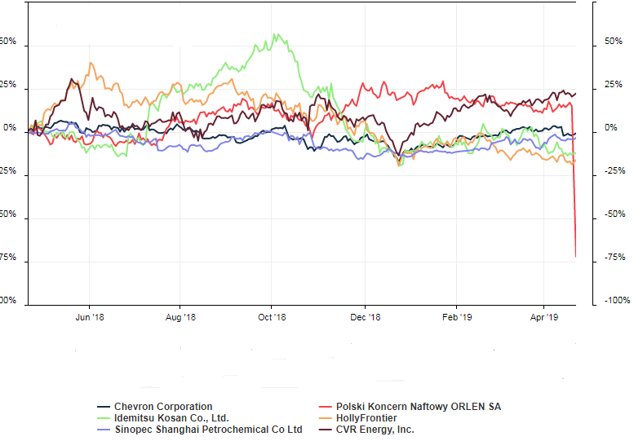
The above graph shows the share price fluctuations of various companies in the industry. This will help us to judge the performance of various companies who are competing with Chevron.
The overall environment analysis
The company is operating in more than one countries, thus it has to face different challenges that are posed by the different political systems working in the countries of operations. The instability in political terms prevailing in any country will affect the company directly as well as indirectly. The change of the system from democratic to dictatorship and changes in the relevant policies accordingly will also affect the company.
The economic aspects include the stage of the economic cycle which is prevailing in the country. This is especially important because this has some direct impacts on the spending capacity of the people. This will also have an important impact on the living standards of the people which in turn will affect the company that provides the energy for the various economic units. This will also affect people in terms of having cars or not. The monetary and fiscal policy prevailing in any country will also have an impact on the company. The monetary policy will decide how easy it will be for the company to obtain the loans in a particular country. The fiscal policy will decide the expenditures made by the government towards the investment with foreign companies like the one under consideration.
The social factors will include the makeup of the society as a whole, the structure of the society in terms of age and other related factors will affect the company. The major impact of the social aspect will be the tendency of the society towards the social responsibility aspects of the business. The company is already paying due attention to these aspects and will prefer such societies that value these activities more than others. However, if the society is off the view that the company must only consider the returns to shareholders while making decisions, then the company may not be required to spend more on the social aspects.
The technological aspects will include changes in the various technologies that will directly affect the company. This also includes the technological framework adopted by the competitors of the company. The advancement in the drilling equipment can be considered an important part of the technology span. The company Is involved in a process that needs heavy machinery if there is any change in the existing technology, the company will be affected definitely by it.
The environmental laws that are placed in a certain country will also affect the company. The amount of pollution in the environment caused by a company is allowed to certain extents in different countries. This percentage will decide what kind of operations can be undertaken by the company in a particular country (Ifedapo Adeleye, 2012). This is very important on the part of the company as its operations may create certain hazards to the environment. These hazards may be treated differently in different countries. Thus, the company must look closely into the environmental laws prevailing in the country.
The legal environment will also affect the company while working in any country. The major aspect that will affect the company is the employment law prevailing in the country. This will include the minimum wage and other job-related aspects for the company.
SWOT analysis

Strengths  Brand value  Complete Integration  The presence around the globe  Huge reserves of oil and Gas | Weaknesses  Lack of legal information  Poor Financials  Increase in debts
Opportunities  Rising Demand  Renewable energy market  Long term agreements | Threats  Changes in regulations  Economic Downturns  Natural Calamity

The first and foremost important factor regarding the SWOT analysis will be the brand image of the company. This aspect is specifically related to the long term or strategic aspects of the company. The stronger the brand image, the easier it will be for the company to enter a new market and to attract new customers. The brand image of the company is associated with the expenditures they make for the community in the name of Corporate Social Responsibility. This image is developed over a longer period of time and can create a sustainable competitive advantage for the company.
In terms of the weaknesses, the poor financials will hamper the ability of the company to finance the achievement of strategic goals and objectives. This can be improved by an in-depth analysis of the financial statements. This analysis can be done on an annual basis showing the various trends and these trends can be studied to see the directions of the company.
In terms of opportunities, the rising demand has the highest importance when strategic aspects are considered, this is because the higher demand will mean that the company will have the long and steady source of revenue at hand. This will also mean that in the countries with higher demand, the company will be able to have a positive cash flow. This opportunity has to be taken up with care. There are certain parts of the world that offer various opportunities but there are other problems attached to those areas as well so the company must assess the overall characteristics of the country before investing in it.
In terms of threats, the company may be the most vulnerable to natural calamity. The reason behind this is that the other points given in the list are controllable on the part of the organization to a certain extent. This aspect cannot be controlled by the company. In this regard, the company may opt for the insurance options before entering any country. The example can be taken for Japan where there are a large number of earthquakes every year.
Summary of Environmental Scan and Porter 5 forces model
The environmental scan has shown certain aspects of the internal as well as the external environment for the company. The company is a big name so overall it will not be affected very much from the external environment. If we talk of the internal aspects, the poor financials may affect the company the most.
Porter 5 forces model
This model includes the following:
The threat of New entry
In the industry in which Chevron is working, the costs of starting up a business are generally very high which will make the threat of the new entrants much lower in the industry. The new entrants will have to incur a good amount of investment to start the business. The operational costs will be even higher as there are chances that the site chosen for the exploration of the oil or gas will not prove to be successful.
Bargaining Power of Suppliers
The suppliers here are the countries where the company is working to extract oil and other minerals. The bargaining power of these suppliers is higher in the case of Chevron Company as any country can stop the company from working at any time. This will also include the changes in the various laws and the economic conditions prevailing in any of the countries. Some drastic change in the economic conditions may force the company to go out of a particular company.
Bargaining power of Buyers
The buyers are not in a position to affect the company because there are a large number of them. Each buyer buys a very small quantity of the product from the company and does not affect the company in any way. Thus the bargaining power of the buyers is low.
Threat of substitutes
The threat of substitutes is low as there are not many options available to the customers regarding the products offered by the company. However, in recent years, there has been raising concerns over the renewable resource usage. In the longer run, the company products can be replaced by solar and wind energy resources.
Competitive Rivalry
The competitive rivalry is high because all the competitors are offering similar products and any action undertaken by one company is quickly followed by the other competitors. In an industry where the formation costs are high and there are certain risks associated with the operations of the companies, the rivalry has to be high. This will mean that a single company is not able to affect the prices of the products that are sold in the market. In such a market, the formation of cartels is a common practice.
Cultural Barriers, Monetary exchange rate, and Political Instability:
The company has performed well on all these aspects especially the political instability aspect as it has been successfully working in South Korea.
Financial Performance and Condition of the company:
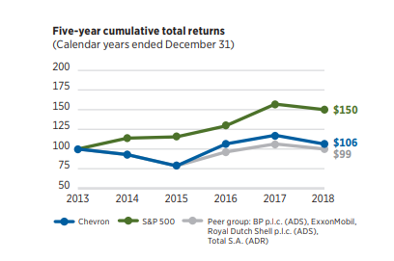

The above graph shows the annual returns for the last 5 years for the company.
Key Performance Indicators:
The below table shows some of the key performance indicators for the company for the last 3 years. The net income is a key component because this is left over after the deduction of all the expenses from the revenues. This figure is important for the shareholders and other parties who are interested in investing in the company. The debtors are interested in the liquidity aspects of the company which are shown in the cash provided by the operating activities. For the shareholders, the return on equity is also a key figure which has been improving over time.
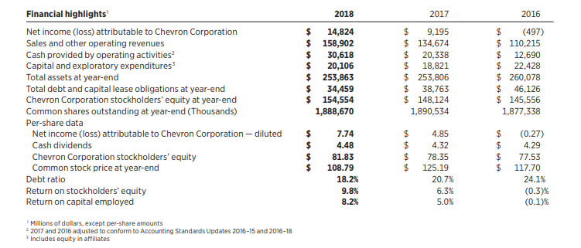

The above picture shows the financial condition of the company for the last 3 years. The things have improved at a very high level from 2016 to 2018. The key performance indicators are the net income of the company, cash provided by operating activities and the debt ratio. The performance has been improving when we consider these three indicators.
The debt to equity is 22.3% for the year 2018. This shows that the company is financing the 22.3% requirements from the loan and the rest from the equity.
The return on assets is 3.52% for the year 2018. This means that the company is generating 3.52% of its profits with the help of assets.
Operational budget:
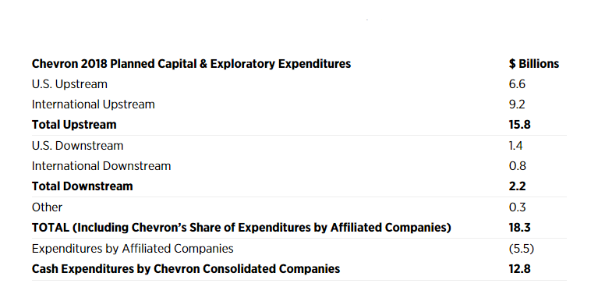
The overall financial performance of the company has been satisfactory as shown by the above figures. The net profit and other related aspects have been on an increasing trend. Almost all the critical figures have been on an increase in the time span under consideration.
The strategic plan for the next three years will be focused on the growth of the company, especially to the Asian Countries.
Recommendation of an Organizational Structure:
The company is operating in more than one country and these countries are apparently different from one another. This makes the situation for the country very complexed. Thus, the company should use the regional structure to perform satisfactorily. This will mean that the company operations will be managed from the country of operation or at least from the regional level.
Impact of Strategic plan on the organizational culture:
The strategic plan has set the strategic direction of the company to grow over the next three years. This will have a definite impact on the organizational culture. The actions of the people in the organization will be such that they will help the company improve in all the aspects of the business. This will also mean that the culture of quick decision making will be introduced in the company. This will also mean that the span of control will be kept shorter in the company because this will help in the quick decisions to be taken by the company.
Goals for the SWOT aspects
The company has been already working on the corporate social responsibility issues, however, the goal of the company will be the highest contributor towards the corporate social responsibility by the year 2020.
The company has set a goal of having an increasing trend on all the major financial aspects for the next five years.
The company has set a goal to take advantage of the increased demand by expanding to 5 more countries by the year 2025.
The company has set up a goal that it wants to minimize the loss due to the natural calamity by taking the insurance policies especially in those countries where the company operations have just started.
Corporate Social Responsibility
In achieving the goals, the company will make sure that most of the objectives of the stakeholders are addressed. The company will try to accommodate the needs of the stakeholders at large. The priority will be given to the stakeholders which are affected the most by the company operations. (Chevroninecuador) These may include society and the environment. Our acts in this regard will have a positive impact on the stakeholders.
Measuring Performance
Quarterly or biyearly reviews of the progress on the goals specified will be undertaken at all levels of the management. This will ensure that all the employees in the organization know what is expected of them and what steps they have to take in order to take the organization to the destination required. This will also require that the information about these goals has been communicated clearly and concisely all across the organization. The goals can be broken down into even smaller tasks so that their attainment becomes much easier. With the passage of time, there may be some revision regarding the goals. This may be necessary due to certain changes in the various aspects affecting the organization from both inside and outside environments.

References
Chevron in Ecuador. (n.d.). https://chevroninecuador.org/assets/docs/myths-facts-ecuador-disaster.pdf. Retrieved from https://chevroninecuador.org: https://chevroninecuador.org/assets/docs/myths-facts-ecuador-disaster.pdf
Ifedapo Adeleye, F. A.-N. (2012). Managing Diversity in Nigeria: “The Chevron Way”. Human Resource Management Journal, 1-13. Retrieved from https://www.researchgate.net: https://www.researchgate.net/publication/271837653_Managing_Diversity_in_Nigeria_The_Chevron_Way/download
Jawahar Alotaibi, T. B. (2015, June). https://www.researchgate.net/publication/309533241_A_Comparative_Analysis_of_ExxonMobil_Conoco-Phillips_BP_Chevron_and_Shell_Societal_and_Environmental_Sustainability_Strategies/download. Retrieved from https://www.researchgate.net: https://www.researchgate.net/publication/309533241_A_Comparative_Analysis_of_ExxonMobil_Conoco-Phillips_BP_Chevron_and_Shell_Societal_and_Environmental_Sustainability_Strategies/download
Nelson, J. (1992). Defining the Deal: Legislative Bargaining and the Chevron Decision. The Journal of Law, Economics, and Organization, 394-410.
Shank, J. K. (1998, January 1). https://www.strategy-business.com/article/9797?gko=342f6. Retrieved from https://www.strategy-business.com: https://www.strategy-business.com/article/9797?gko=342f6
Snierson, M. A. (2012). Chevron, Greenwashing and the myth of green oil companies. WASHINGTON AND LEE JOURNAL OF ENERGY, CLIMATE, AND THE ENVIRONMENT.

From Chevron Annual Report 2018

