Title page
International relations

Quiz 1.3
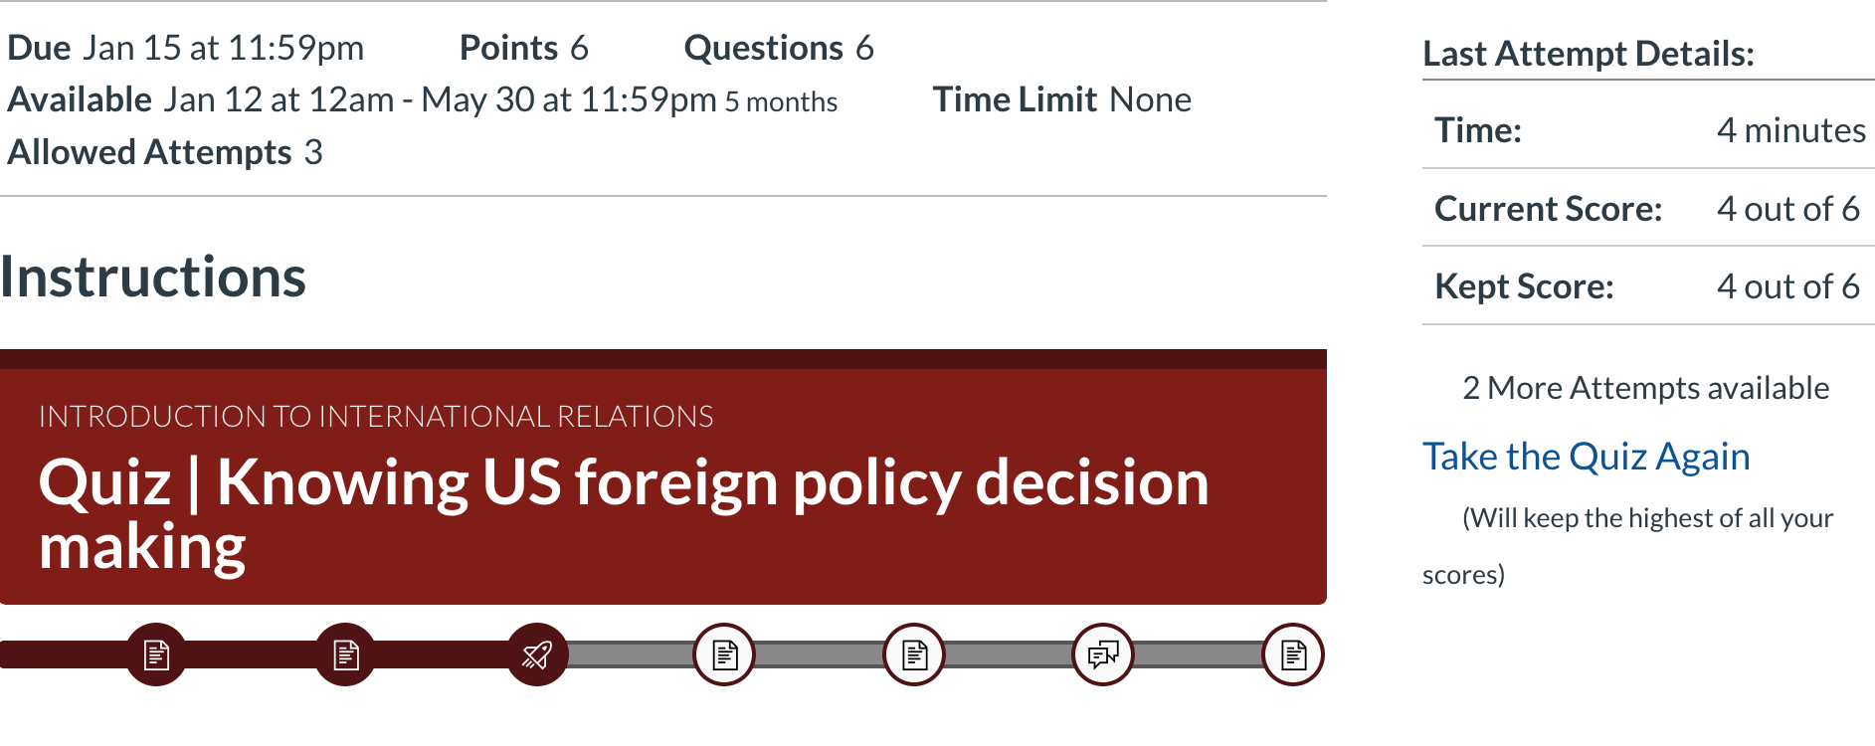
Assignment 1.6
Stages of war
- US strategic priority
US strategic priorities behind Iraq war was to protect its citizens, economic and political interests. America viewed government of Saddam Hussain as an international threat to peace and national security. United States promoted democratic regimes so it stood against the totalitarian government system of Iraq. America perceived Iraq as a threat to its national security which resulted in the launch of pre-emptive strike.
- Motivations behind Bush’s administration
Bush administration initiated war because it was motivated to maintain control over oil and for the preservation of dollars at the world’s currency level. Bush claimed that the purpose of war was to promote democracy and fight against the undemocratic states. His goal was to stop Iraqi leader Saddam Hussain from developing nuclear weapons which America perceived as a threat to international peace. Bush administration was motivated to invade in countries like Iraq for stopping nuclear expansion.
- Outline
US abandoned efforts to work through the UN in pursuits of Iraq and Saddam Hussain for making bolder assertions against Iraq. US government claimed that UN policy is based on humanitarian grounds, which is inappropriate for handling such threats. It emphasized “to use all means that he determines to be appropriate, including force” to deal with the Iraqi threat” (Harvard, 2018). The purpose of disconnecting from UN was to use all kind of strict measures and even force for removing terrorist groups (Chapman, 2004).
- Personal thoughts
I think if US waited for UN/ international approval the events in Iraq qould have unfolded differently. This is because US state adopted strict and harsh practices for fighting against the Saddam’s government and terrorists which caused deaths of many innocent people also (Harvard, 2018).
Response to classmate
I like the post of Amanda because she has managed to identify the causes behind the disturbed international relations among US and Iraq. I agree that the event of 9/11 changed the international situation as countries like US became more concerned for their national security. I also agree that the painting of Patio de Leones has some historic value.
Discussion
Part 1
After reading Lawson International Relations the concept that appealed me the most is “Globalizing the International”. This is because the concept stresses on changing the economic, social and political relations across the globe. I believe that this can be used for resolving tense international situations that arose among countries (Lawson, 2017). I think that the need for globalizing international relations became more evident since the historical event of 9/11. This incident changed the relations among countries specifically between the west and Muslim nations. This concept can be sued by countries for understanding how setting boundaries is affected their relationships adversely. Post cold-war period is identified as the major element that resulted in the success of capitalism. I think that globalization can improve relationship among countries and help them in overcoming their tensions. It is important to understand the benefits of globalization and how it can be an effective tool for attaining economic progress. International organizations like WTO is supporting globalization and encouraging countries to enter into free trade. I still believe that the best outcomes will be reached only when developing countries are given adequate opportunities for growth. Another concept that I found interesting in the topic of globalization is global governance. This is important for maintaining balance among countries that are entering in international trade. There must be a check an balance for assuring that all countries derive certain benefits. Global governance according to me is essential for eliminating exploitation. The topic has allowed me to realize the positive implications of globalization such as increased productivity and efficiency.
Part 2
The image of the place that I find meaningful is “Djinguereber mosque” located at Timbuktu, Mali. I like it because it has historical value and represents the African culture. This is linked to the tans-Saharan caravan route. This is an oldest mosque that was developed in the fourteenth century and commissioned by the emperor Musa. The mosque is of great significance for Africans and transmits the history of these people. This is a west African sculpture that portrays the past. The image has different themes such as it also demonstrated the hardships experienced by the black people. This was also associated with the political symbol and represents dignity of African people. The place still exists and makes me feel by bonding to the African culture. I am a Freshman at Boston College and studying Political Science. I have always been interested in politics and international relations.
Part 3
The post of Lavelle resonates with my post because he has also expressed his views on globalization. Lavelle has highlighted the positive aspects of globalization such as improved communication among nations. I think this is a practice way for building positive relations and removing tensions arising among countries. Globalization provides better opportunities of doing trade to both countries. I agree that globalization with shape political, social and economic conditions in a better way. This is also helpful for promoting international peace and discouraging war or aggressive situations that might arise among countries (Lawson, 2017). I believe that without globalization survival would be more difficult. This is because countries who have been involved in globalization gained many advantages such as reaching larger markets, getting high investments and improved GDPs. Without globalization it is not possible for the nations to attain efficiency. Although I believe that globalization offer many benefits but there is need for adopting global governance that will promote equality. This is an effective tool for controlling unfair global practices such as exploitation of labor. Lavelle’s post resonates with mine because he has also identified the need for globalization. I agree that without globalization lives of people would be less efficient.

References
Chapman, J. (2004). The real reasons Bush went to war. Retrieved 01 16, 2020, from https://www.theguardian.com/world/2004/jul/28/iraq.usa
Harvard. (2018). New Peril, Old Adversary: George W. Bush, 9/11, & Iraq(B)The Road to War, September 2002 to March 2003. Harvard Kennedy School.
Lawson, S. (2017). International Relations. Polity Press.

