Unit V Journal & Scholarly Activity
Student name
Affiliations

Unit V Journal
Consumer buying decisions are affected by a number of factors. One such factor is also group affiliations such as family and other cultural situations. Families have incredible control of consumer purchasing. There are decision makers in a family for purchases that contour individual behavior. A decision maker in a family can be a husband or a wife, or even a child. For example, while purchasing a grocery item mother is a decision maker in a family that has an effect over the decision. Children also have tremendous control over the decision making the process. If there are strong affiliations in a family, then these have a strong effect over the decision making the process and vice versa. Marketers are always interested in knowing which family member is mainly affecting the purchase of a particular product. They then try to target that family member for the sale of the product. Moreover; cultural situations also affect the decisions. Culture is a way in which people should live and this affects consumers purchasing decisions. For example, in Beirut, Lebanon, it is a common practice by women to purchase miniskirts as it is allowed in that culture. But this is not allowed in Asian countries such as Afghanistan, where women wear abaya.
Scholarly Activity
Consumer buying process:
The consumer buying process refers o the whole process of making a purchase. Marketers pay special attention to understand this process as it affects their marketing strategies. They study this process and devise different strategies accordingly (Hall, Towers, & Shaw, 2017). All marketing efforts will be wasted if marketers do not understand this process efficiently. The process consists of distinctive steps whether to make a purchase or not. Consumer spent his time at each stage and takes a buying decision for different products. Different factors affect this process and its length. Recently I purchased a car and before making this purchase I also went through all these six stages.
Problem Recognition:
It is the first step in the consumer buying process that starts with internal or external motivations. I was in need of a new car as I wanted to upgrade my car to a newer model and also wanted a larger vehicle. Moreover, I needed a fuel efficient car that requires less maintenance. It should be safe and comfortable.
Information Search:
This is the second stage of the consumer buying process that consists of getting information about the product. The consumer is likely to buy a product if it is near at hand. However, in case of need is in memory then the consumer will go for information search. Consumers can get this information both from external and internal sources (Gensler, Verhoef, & Böhm, 2012). Selection of sources is linked with personal distinctiveness, types of products as well as trustworthiness of sources. Each information source has a specific purpose and it affects the buying decision. From the information, the buyer gets enable to know about current products and brands in the market. Consumers mostly give more value to their internal information as compared to outside. I also used my memory and experience to search for information for a new car. I talked to my family and friends. I searched for information from magazines, from different companies and brands.
Evaluate Alternatives
After getting all the required information about the product, consumers then evaluate different alternatives to check about the satisfaction that they can get from the product. They evaluate alternatives depending upon different factors such as price, quality and time. I evaluated these alternatives Ford Figo, Toyota, Audi, Hyundai, and Mercedes.
Purchase decision
At this stage consumer not only has the required information but has also evaluated different alternatives. Now he is ready to make a purchase according to his need. At this stage, I also had information about different features of the car, its price and payment options. Moreover, there were also some external arguments that affected me at this stage; attitudes of the others and unexpected situational factors such as family and financial. I decided to purchase Audi as it has an excellent brand worth.
Purchase
At this stage consumer actually has to take a decision about making a purchase. Perceived risk played a role at this stage and its level varies with different factors such as research of information and warranties. I purchased Audi due to its brand and excellent features.
Post-Purchase Evaluation
The buying process does not end with the purchase and consumer evaluates his satisfaction regarding the product. It is the formal or informal evaluation of the product. The level of satisfaction or dissatisfaction is the result of the difference between customer’s expectations and the perceived performances.
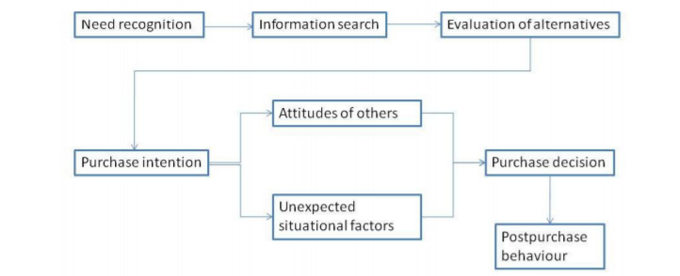
Consumers and marketing efforts:
Companies carry out marketing efforts to attract and change consumer’s behaviors. Consumers can interpret and evaluate information about products and services from these marketing efforts. Marketers use this ability of consumers to make them either spend or sway towards a specific brand or product. They use advertising and promotion to target consumers for products and services. They may compare their product with a celebrity or famous thing. In this way, they target the consumers and force them emotionally to make a purchase. They during their buying process evaluate the product and decide to try it. Moreover, they also use different rewards to make their consume1rs loyal to their brands. For example, they can use special pricing as an incentive to make a purchase.
Influence of situational factors:
Situational factors refer to provisional conditions that influence buyers. These can be physical, social and time factors. This also includes the reason for purchase. All these factors can affect at one time or another. For the purchase of a car, I also confronted with different situational factors. For example, there was a time factor. I was in need of a new car and wanted to purchase it as soon as possible. Moreover, my friends and family were also influencing my decision. I was in pressure to purchase a high-quality car that has an established brand worth. In addition, my financial capability also affected my decision and I had to set a standard for my purchase. The car was also an asset for me and it was a onetime decision. This was extending the length of my purchase process and I spent enough time at each step to make my purchase effective.
Influence of external groups or cultural beliefs:
Different external groups or cultural beliefs also have an effect on the purchase of different products (Seo, Buchanan-Oliver, & Cruz, 2015). I purchased Audi as my family was compelling me for this car. My peers were also expecting me to have a standard brand. Then there were also different cultural beliefs that were affecting my decision. I belonged to an upper class that required the use of an excellent brand. My social class requires the presence of a car as a necessity and not the luxury. Moreover, gender also affects this purchasing decision (Castro, 2014). As a male, I was thought to take a more wise decision. However, it is also believed in this class that only having a car is not only required by there must be an excellent brand of a car. This belief affected me much and I put greater efforts into gathering information about different brands and they're worth both for consumers and social class. Moreover, I also spent more time at the evaluation stage, as I wanted to fulfill the cultural expectations of my community.

References
Castro, B. G. A. (2014). Are Men More Rational than Women when Purchasing Cars? A Cross-cultural Comparison. Revista de Administração FACES Journal, 13(2).
Gensler, S., Verhoef, P. C., & Böhm, M. (2012). Understanding consumers’ multichannel choices across the different stages of the buying process. Marketing Letters, 23(4), 987–1003.
Hall, A., Towers, N., & Shaw, D. R. (2017). Understanding how millennial shoppers decide what to buy: Digitally connected unseen journeys. International Journal of Retail & Distribution Management, 45(5), 498–517.
Seo, Y., Buchanan-Oliver, M., & Cruz, A. G. B. (2015). Luxury brand markets as confluences of multiple cultural beliefs. International Marketing Review, 32(2), 141–159.

