Culture and Media
Your Name
[Institutional Affiliation(s)]

Author Note

Culture and Media
Identification of my Culture
Culture is the identity of a group of people who live in a specific area and have their own way of living. As a part of the United States, I follow the American culture. As every culture varies from society to society, the elements of my culture such as language, ways of eating, norms, customs, and dressing vary from all the other cultures of the world. material and non-material culture are the two main types of culture. Material culture includes a lot of things that are created by people and given meaning to, such as dressing, food, buildings, etc. Non-material culture includes the behavior patterns and thoughts that are learnt by people as a part of their values and customs such as language, religion, values, knowledge, etc. The diversity of American culture is reflected in the clothing of people. the American fashion is highly informal apart from the professional formal business dressing. Food in the American cuisine has a glimpse of the American history and is a blend of the various societies from all over the world such as the African-Americans, the indigenous American Indians, Latin Americans, the Europeans, and the Pacific Islanders. Various cooking methods are used by the Americans to create a classic and distinct taste that their food carries. A broad variety of architectural styles are demonstrated by the buildings in the United States. Many internal and external factors are responsible for the construction of these buildings that represent the American culture. The United States has no official language at the federal level. It has been observed that almost 97% of Americans can speak English very well and about 28 states have passed a legislation to make English the official language. among the well-develop countries of the world, U.S is one of the most religious where religion plays a very important and significant role in the lives of people. Freedom, equality, directness, informality, small talk, political correctness, and independence are the values that are most important to the American culture. The important days that are celebrated throughout the country as significant customs are the New Year’s Day, Christmas, Martin Luther King Jr. Day, Saint Patrick’s Day, Valentine’s Day, April Fool’s Day, Memorial Day, Labor Day, Columbus Day, Thanksgiving Day, and the President’s Day.

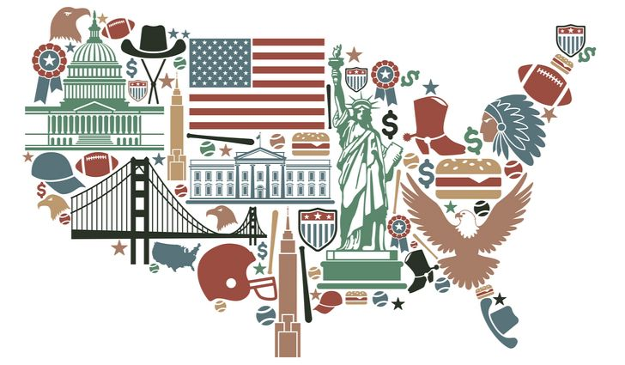
The United States is the third largest country in the world that has a population of about 325 million people. it is one of the most culturally diverse nations all over the world. sometimes considered as a ‘melting pot’ the American culture is a blend of multicultural ethos consisting of Africans, Asians, Latin Americans, Native Americans, and the Pacific Island people and their cultures. The American literature is much vast and diverse. There is a variety of artists and writers who have contributed and are still contributing to make the American culture popular and unique. The American music is also influencing people all over the world because of its diversity and popularity. Many modern innovations are also a gift of the technological advancements of the American culture that have provided strong international benefits across the globe. The Americans believe in thriving for competition, working hard and accomplishing the tasks. They are active and do not tend to wait for other people to succeed in any walk of life. The idea of being self-sufficient and independent is very much important to the American culture. Being a Western culture, the American culture has influenced people of the whole world who have adopted this culture as a part of their way of life.

