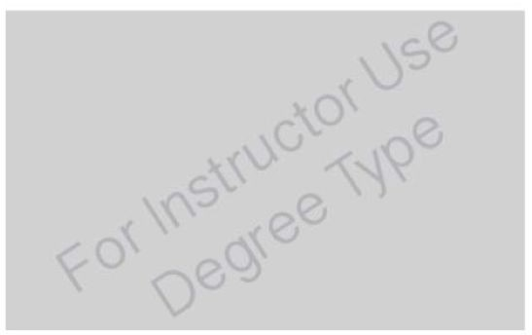
ARTWORK ANALYSIS ASSIGNMENT FORM STUDENT NAME:
PROMPT: Select an artwork from the options given by the instructor and analyze it using the terms and skills you’ve acquired thus far in the course by filling out this form.

DUE DATE: Monday, December 2 at the BEGINNING OF CLASS- 2 Copies Printed and Stapled

The answers to this worksheet should be typed and printed using this document.
PICTURE: Please include a picture of the artwork you selected and include/attach it with this document

DESCRIBE the ARTWORK:
IDENTIFY ARTWORK:

Artist Name: Juan Vallejo

Title of Artwork: Luisa

Medium: sculpting

Discipline: ceramics

Identify Style: Representational, Abstract, Non-Representational or a combination of these terms?
Representational

Identify SUBJECT MATTER (what is literally depicted?)

A truck mirror
DESCRIPTION: In your own words, describe the artwork. Your description should be broad enough, and thorough enough, that a family member or friend could accurately imagine the artwork. Don’t assume that the reader already knows what the artwork looks like – it’s your job to describe it well.
Please use complete sentences for this portion.
For printing purposes, when answering this question, do not allow your text to scroll down. Instead simply go to the next text box on the 2nd page to complete your answer.
A truck mirror, along with its complete frame, is shown in which the mirror is replaced with a grayscale picture of a man who is holding a piece of cloth.

FORMAL ELEMENTS: Identify 3 FORMAL ELEMENTS in your chosen artwork & DESCRIBE THEM:
(LINE (precise, gestural) SHAPE ( 2-D: geometric, organic) FORM (3-D: geometric, organic) SPACE: (positive, negative, DEPTH: foreground,
middle-ground, background, linear perspective, atmospheric perspective) TEXTURE (actual, implied) VALUE, COLOR (primary, secondary, intermediate)
1. LINE: Horizontal and vertical lines are used in combination to show stability and compactness of the truck mirror.

2. TEXTURE: The texture of the truck mirror seems to be smooth and hard at the same time. It seems to be made of iron and is thus robust in its texture.

3. FORM: It has an organic 3D form. The shadow and lighting gives it a 3 dimensional touch.

PRINCIPLES OF DESIGN: Identify 3 PRINCIPLES OF DESIGN that are being employed &

DESCRIBE HOW THEY’RE BEING USED:
(focal point / emphasis (contrast, detail, color, leading lines), scale, proportion, repetition & rhythm, unity & variety, overlapping, symmetry: asymmetrical, absolute, bilateral, or radial…)
`
1. Focal point: The image of the man, in the frame of the truck mirror, is the focal point of this picture.

2. Balance and alignment: The picture has an asymmetrical alignment as it represents an image of an imbalanced object.

3. Emphasis: All emphasis in this picture is on the accurate representation of a truck mirror
CONTENT: What role is the artist playing? Select one or more answers from the list below.
a Artists help us to see the world in new & innovative ways.
- Artists create a visual record of their time & place
- Artists makes functional objects & structures more pleasurable by imbuing them with beauty & meaning.
s Artists give form to immaterial ideas & feelings.

CONTENT: INTERPRETATION - What do you think the artist’s intentions were? What did they want to communicate? Please use complete sentences for this portion:
The artist wanted us to see the truck mirror to imagine the story of a man who was a truck driver and had a picture of himself embedded in the frame of the mirror. This artist wants us to feel empathy and a certain kind of sadness. The picture embedded in the frame is in grayscale, thus depicting that the person might have gotten older.

CONTEXT: What contextual clues do you notice in this artwork that help you decipher it’s meaning? These “clues” could be text, certain images, symbols, a contrast of images, etc… Using context as your supporting evidence, EXPLAIN how you interpreted the content of the artwork (evidence in this case would be a focused description of the context within the artwork that reinforces your opinion). Please use complete sentences for this portion:
The picture in this truck mirror is in grayscale, thus showing that the person in the image might be the owner of the truck and that he had gotten older and probably died. Hence, feelings of compassion and sympathy should be felt for the driver. The frame of the truck mirror is also very slim showing that at the time that this truck mirror was in use, technology regarding truck mirror was not very advanced i.e. the truck mirror is also very old.

CONTENT: DIFFERENT PERCEPTION/INTERPRETATION – How might someone else interpret this artwork differently than you do? Discuss another meaning that could be extracted from this artwork. Provide evidence that supports your conjecture (evidence in this case would be a focused description of the artwork that reinforces your conclusions) Please use complete sentences for this portion:
Nowadays, the bicycles used in developing countries have similar mirrors, thus one belonging to a developing country can interpret to say that this is a mirror of a bicycle which belonged to the man in the picture and that the picture is intentionally kept grayscale.

SUMMARY:
- In two or three complete sentences, describe what the artwork looks like, the medium used, and the name of the artist:
The artwork looks like a photograph of a truck mirror in 3-dimensional space. The medium used is ceramic. The name of the artist is Juan Vallejo.

- In two or three complete sentences, summarize the content of the artwork:
A very old truck mirror is shown. The frame of the truck mirror has a picture of a man holding a cloth embedded in place of the mirror. The image is in grayscale.

