Your Name
Instructor Name
Course Number
Date
Glaciers around the World

Glaciers are thickened ice masses that form from fallen snow trodden over many years. The world has nearly 198,000 glaciers that are covering 726,000 km2 and this is approximately 10 percent of the world's total land area. Glaciers are mostly situated in Polar Regions such as Antarctica, Greenland, and the Canadian Arctic. Moreover, glaciers are of four types; piedmont, valley, ice sheet, and ice cap. These also vary in their size and length as most of them are situated within mountain ranges. Glaciers have several advantages such as supplying water to people living downstream. These people use this freshwater for different purposes; agriculture, fishing, generation of hydropower as well as tourism.

Glaciers formation
Glaciers are formed due to the combined effect of different elements. Snow falls at the highest elevation of the glacier and increases glacier's mass. Snow when remains at one location for many years, transforms into ice and further increases weight (Sood). Excessive weight deforms ice and fall the glacier downhill. Thus, glaciers move as they have a weight of thick layers and force of gravity also affects the ice mass.

Technologies used to identify, monitor and track glaciers
Technology has enabled mankind to identify, monitor and track glaciers. Different techniques are being used for this purpose that helps in determining glacier mass loss and glacier-related hazards (Pandey et al.).

Remote Sensing
The mountain glaciers are mostly sited at distant and unreachable places. It is not possible to monitor these glaciers through the ground survey. In this case, remote sensing is a valuable tool for assembling information about distantly situated glaciers (Pandey et al.). Remote sensing allows information monitoring without touching an object. Cameras are put in space that can capture glacier behaviour easily. This has helped in inventory world's glaciers. Repeated images are taken over time to check the movement of glaciers by estimating their size and volume. The use of remote sensing has further improved with the advancement in number and quality of earth observing sensors and algorithms (Pandey et al.).

Benefits of glaciers
Glaciers affect natural systems in numerous ways and require noting glacier changes to predict their effect on the environment. For example, glaciers have a huge amount of freshwater in freezing form and in case of warm climate glaciers melt significantly causing global sea levels to rise. Glaciers in the Alps and Himalayas are supplying a large amount of freshwater to downstream population (Akmal et al.).
Moreover, precipitations at high elevations become part of glaciers and do not immediately get the way towards the sea. Instead, they become parts of a glacier. Eventually, the glacial ice melts into water and continues on its way into the sea. Furthermore, they also have a role in the rock cycle as they act as dynamic erosional agents that can collect, transfer, and pledge sediment.

Reasons for loss of glaciers
Greenhouse gases have been building up in the environment as the result of burning fossil fuels. As this burning activity traps enormous amount of heat in the atmosphere, the climate is influenced. This change in the temperature causes glaciers to melt and they expose the earth underneath it and cause rise in sea levels and result in floods.

Impacts of loss of glaciers
Galleries are decreasing to an alarming rate due to numerous factors. Firstly, there is the burning of fossil fuels that is accumulating greenhouse gases in the environment and turn to warm up the atmosphere. This rise in temperature causes more glaciers to melt and increase the sea level. Areas which have glacial ice on higher altitudes affect the environment. Moreover, there is sever disturbance in ecosystems and this is causing an imbalance in food chains. These losses have important socioeconomic concerns (Pandey et al.).

Efforts to reduce the loss of glaciers
The current and probable loss of glaciers in the future is of grave concern due to its severe implications on water reservoirs, sea level, natural disasters, and manmade recreational environment. As glaciers react to very sensitive climate changes and it is expected that they will recede drastically over the next few decades. So in the light of the current and predictable pattern of loss of glaciers, numerous studies are being projected to reduce this loss. Efforts to collect data for glaciers modeling and calibration is underway but global-scale model initialization of around 200,000 glaciers remains a global challenge. This is mainly due to data collection biases in climate change databases and complicated mountainous terrains.
In order to improve the stability and effectivity of the measurements taken to reduce the risks and hazards of the natural phenomenon, it is important to introduce integrated methodologies. The interdisciplinary coordination of natural, environmental, engineering and social sciences along with strategies, planning, and management can prove to be quite efficient. The foremost approach is to completely understand the risks and impacts of the loss of glaciers by using scientific analysis and gathering the biophysical response to the perilous stimuli in the environment. Next approach is to find out the measures to prevent the happening of natural events by the integrated use of risk management and technological strategies. Then it is also very important to reduce the vulnerability to destructive incidents by focusing on socioeconomic, cultural and political factors. Henceforth, it is critical to evaluate the probable hazards by examining the socio-cryospheric system using engineering, technological and social perceptions (Carey et al.).

Use of technologies to help reduce the loss of glaciers
Several techniques are underway for the prevention of glacier loss. Quantitative Methods for the estimation of glacier area, hypsometry and thickness are used via digital elevation and shuttle radar topography missions. The most reliable way to evaluate the exact mass and other characteristics of the glaciers which can help avert the anticipated disasters. It is important to calculate the data based on gravity recovery and climate experiment (GRACE), the ice, cloud, and land elevation satellite (ICESat) and thorough observations. For the validation of models and changes in the glaciers masses, it is imperative for seasonal and annual observations. The frontal ablation models are also estimated via satellite modeling for the derivation of surface flow speed at flux gates which are combined with ice thickness and control plans executed accordingly (Huss and Hock).
Glaciers are the largest freshwater source and their rapid melting means less water for mankind, irrigation, wildlife, and hydroelectric power generation. Global warming and greenhouse gases (GHG) emission has contributed drastically to the extreme rise in the global temperature. It is now needed for the sake of glaciers protection to focus on renewable energy resources to mitigate carbon dioxide emissions and securing the melting glaciers. Clean energy alternatives are being promoted by determining the standard baseline grid factors for GHG emissions. Technology is being used for the propagation and promotion of energy substitutes such as solar, wind, biogas, biofuels and integrated gasification combined cycle (IGCC) (Akmal et al.).

Geoengineering of glaciers is another plausible option if carried out on a global scale and can help delay the grounded ice of Greenland and Antarctica from melting and reaching the ocean for a couple of decades. This technology can be used as a distraction and meanwhile buying time to focus on global warming. Large and fast glaciers slide on the film of water and wet sediments, stemming those flows can help in thickening the ice, reducing its speed and even help in mitigating their contribution into the rise of sea level (Moore et al.).
Furtwangler Glacier, Mount Kilimanjaro, Tanzania
Furtwangler Glacier is situated close to the peak of Mount Kilimanjaro in Tanzania. It is the small remaining part of a huge ice cap that once covered the peaks of Mount Kilimanjaro. It reduced significantly from 1912 to 2000 left to only 18% of the total glacial ice. And by 2020 it is expected that the remaining glacier on mountain summit will also be melted down. Though seasonal snowfall covers the mountain tops for a few months the glaciers will be gone completely soon. It is said that deforestation activities at the lower slopes of the mountain are the main reason for the reduced flow of moisture towards the peak and thus glaciers are melting at a very fast pace (Pepin et al.).
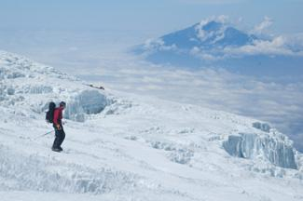
Furtwangler Glacier shrinking (Vastag)
Himalayan Glaciers
Himalayan glaciers are situated near Tropic of Cancer. Glaciers here are very sensitive to climate change as this region is hotter as compared to Arctic, Antarctic and Temperate zones. These are a source of freshwater in the sub-continent. Because of excess human-induced global warming, the Himalayan glaciers are adversely affected. This change in climate influences the retreat of glaciers responding according to their size, mass, altitude, and orientation. Though the debris from the climatic and topographic conditions may prove to be an influence for slowing down the speed of glacier melting by isolating the ice from solar radiations (Sood).
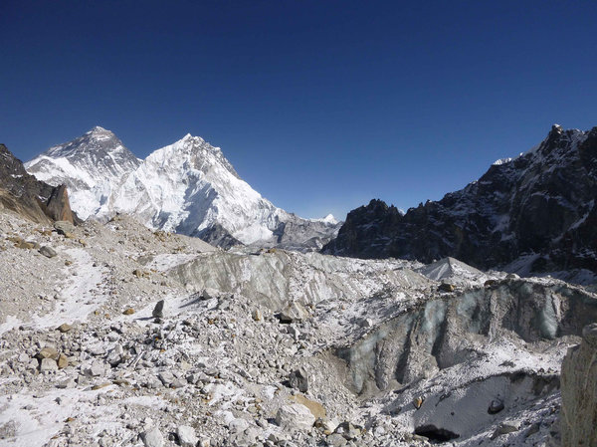
Himalayan Glacier view from Changri Nup (Huang)

Glaciers of Chile
Exploration of critical statistics of different glaciers is essential to identify their actual significance. The glaciers of Chile recognized as one of the greatest and prominent glaciers. These particular glaciers cover 2.7% (20, 188 km2) of the land area of the overall area of the country. It is critical to indicate that it has a great impact on the facets of landscape and water supply exist in the case of a country. Proper measurements indicate that 80% of the surface of South America's glaciers comprised in Chile. These particular glaciers developed in the domain of Andes of Chile which is 27˚S far from southwards. It is also crucial to mention that there is consideration of very few places in case of north and extreme north of the country. There is the existence of a clear gap between two edges due to the element of extreme dryness. The largest glaciers of Chile are recognized with the names of Northern and Southern Patagonian Ice Fields. The latitude for these glaciers recognized as 47° S from the sea level. It is noteworthy to indicate that the overall setting of Chilean glaciers also actively concerns the domain of precipitation patterns (Ayala et al.). This means, there is a clear existence of two different regions established in the forms of the Dry Andes and the Wet Andes. The most significant aspect of Chile Glacier dis that involves two huge ice-breaks in extreme forms.
Glaciers of Chile captured from NASA satellites (Grey Glacier, Chile)

Glaciers of Venezuela
Mountains of the Sierra Nevada de Mérida have glaciers of Venezuela that are covering nearly 2,500 acres. These are the highest part of the Andes Mountains in Venezuela. Venezuela is no doubt an uncommon homespun for a glacier. 95 percent of tropical glaciers are situated here but we are continuously losing these glaciers due to human activities. Conversely, these glaciers have shortened in length to nearly 700 acres in 1952, further to 200 acres in 1985. Now, there is less than one percent of that glaciated area leftover. Venezuela initially had five glaciers. Now there is the only one left and it seems soon the country could be glacier free. The last existing glacier is the Humboldt glacier. It has also reduced to nearly ten football pitches. This shrinking has several economic concerns as it is a source of supplying to Peru and Colombia for drinking agriculture, and hydropower. This will also bring changes in atmospheric patterns and temperatures leading to have an effect over food availability for humans and other species (Veettil et al.).

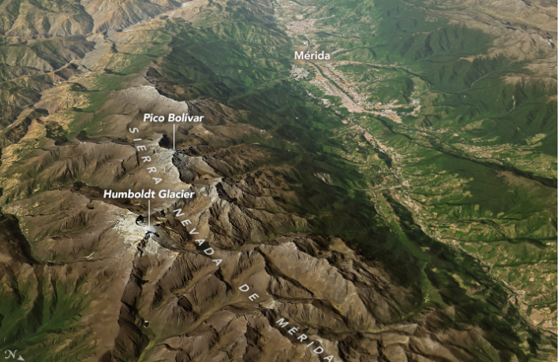
The glacier of Venezuela captured from NASA satellites (Hansen)
With climate, the other reason for the melting of the glacier is also the political difficulties in the country. Glaciers in this regain were the identity of the Venezuelan mountains and their people. Their vanishing will affect people both physically and spiritually. The glacier is predictable to disappear in ten to twenty years and if these difficulties persist in the long run, then it will be difficult for scientists to save these glaciers. Scientists are required to use different variables, such as ice coverage and the reflection of solar radiation to know about the current state of glaciers. These can only be determined by going into fields. Researchers in Venezuela are trying to protect and preserve scientific bequest.

It is argued by researchers that there is the existence of great frequency in case of occurrence of break-off in every side of these glaciers. There is a need for exploring more relevant information to make better inferences about stability. Changing climate is observed as one common concern appeared in the specific case of Patagonia. Increasing temperature is one sure sign of changing the reality of the atmosphere. The growing risk of abnormal trend eventually impacts the nature of glaciers significantly in the form of breaking points in the walls of glaciers. Downward spiral becomes the risk for the actual domain of glaciers in a drastic manner.

Works Cited
- Sood, SAHIL. Glacier Classification and Movement Estimation Using SAR Polarimetric and Interferometric Techniques. University of Twente Faculty of Geo-Information and Earth Observation (ITC), 2014.
- Pandey, A. C., M. S. Nathawat, and Swagata Ghosh. "Morphometric control on glacier area changes in the Great Himalayan Range, Jammu and Kashmir, India." Current Science (2012): 1188-1193.
- Akmal, Urva, et al. “Climate Change: Intimidating Remark To Glaciers And Its Extenuation Strategies In Pakistan-A Review.” Environmental Contaminants Reviews (ECR), vol. 1, no. 1, 2018, pp. 24–29.
- Carey, Mark, et al. “Integrated Approaches to Adaptation and Disaster Risk Reduction in Dynamic Socio-Cryospheric Systems.” Snow and Ice-Related Hazards, Risks and Disasters, Elsevier, 2015, pp. 219–61.
- Huss, Matthias, and Regine Hock. “A New Model for Global Glacier Change and Sea-Level Rise.” Frontiers in Earth Science, vol. 3, 2015, p. 54.
- Moore, John C., et al. Geoengineer Polar Glaciers to Slow Sea-Level Rise. Nature Publishing Group, 2018.
- Pepin, N. C., et al. “The Montane Circulation on Kilimanjaro, Tanzania and Its Relevance for the Summit Ice Fields: Comparison of Surface Mountain Climate with Equivalent Reanalysis Parameters.” Global and Planetary Change, vol. 74, no. 2, 2010, pp. 61–75.
- Vastag, Brian. The Melting Snows of Kilimanjaro. Nature Publishing Group, 2009.
- Huang, Pien. “I Spy, Via Spy Satellite: Melting Himalayan Glaciers.” NPR.Org, June 2019, https://www.npr.org/2019/06/19/733739909/i-spy-via-spy-satellite-melting-himalayan-glaciers.
- Ayala, Alvaro, et al. “Modelling the Hydrological Response of Debris‐free and Debris‐covered Glaciers to Present Climatic Conditions in the Semiarid Andes of Central Chile.” Hydrological Processes, vol. 30, no. 22, 2016, pp. 4036–58.
- Grey Glacier, Chile. 25 June 2007, https://earthobservatory.nasa.gov/images/7802/grey-glacier-chile.
- Veettil, Bijeesh Kozhikkodan, et al. “Decadal Evolution of Glaciers and Glacial Lakes in the Apolobamba–Carabaya Region, Tropical Andes (Bolivia–Peru).” Geografiska Annaler: Series A, Physical Geography, vol. 99, no. 3, 2017, pp. 193–206.
- Hansen, Kathryn. "The last Glacier Standing in Venezuela." Climate Change: Vital Signs of the Planet, https://climate.nasa.gov/news/2792/last-glacier-standing-in-venezuela. Accessed 13 Sept. 2019.

