Special Project
[Name of the Writer]
[Name of the Institution]

Special Project

Abstract
The objective of this paper is to discuss the causes of the Greek economic crisis from 2010 to 2017 using the macroeconomic theory of aggregate supply and aggregate demand. Also, it will evaluate the methods that are used by the Greek government in order to rectify the issues and how their policy implementation theoretically differs from the practical outlook.
The economic policy distortion is kept on spreading and reproducing usually because of the theoretical concept of disorientating sources. We will also discuss in this study about the implementation of Greek government exclusion policy of economy's program called as "dual deficit program" which is the amalgamation of internal devaluation and the austerity and we will see how this program failed. Greece is still facing creditworthiness high risk, lackluster growth in export and an uncertain macroeconomic situation. The failure’s root cause can be found arguably in the measures that are detrimental to austerity performance on the private sector and its repercussions in the ensuing aggregate economy. Finally, our aim in this paper is to look into the macroeconomic figures available and making the predictions about the recession approximation given by the international organizations, research centers of Greece, and the government of Greece. Suggesting finally that the decline prediction given by them in recent years in real GDP that was falsely optimistic.

Discussion
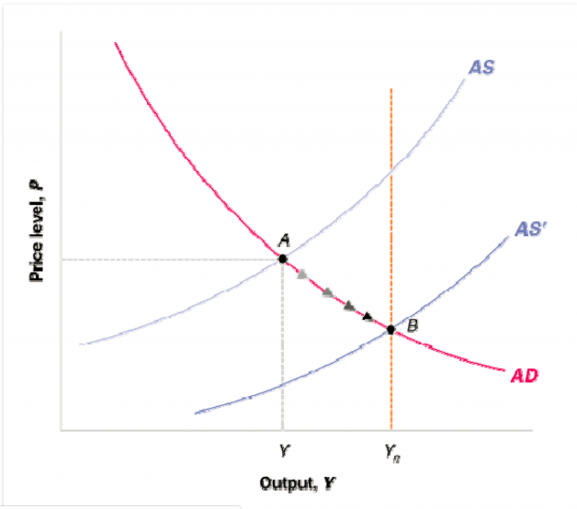
The graph highlights the fact that given prices drop (or unit costs of labor) can happen with a flat curve of AS with negative large gap of the output, or the steep curve of AS and negative small gap of output. We can say in other words that just because of the falling of price levels, it cannot be asserted that it is full employment approach. In May 2014, it is a fact that the IMF forecasted the gap output for Greece at -9.3% of GDP potential. It can be said in other words that deficiency in demand is the main factor in understanding the program perversity that is considered nowadays.
So the main point to notice is that in the first phase of the crises, the level of supply was increased in huge numbers in order to increase the level of the output. But due to the low level of demand, consequently, the level of the demand price decreases in the first phase.
In the second phase when the prices have been decreased, there has been no benefit in the production so investment by the people is low therefore it decreases the income which has a consequence of a decrease in the demand.
The goal principally in the application by the Economic Adjustment Programmes (EAPs) that is applied in Greece was to eliminate the so-called economy's "dual deficit problem" by the amalgam of internal devaluation and the austerity measures. This prescription of the policy was expected originally to get Greece out from the public debt and get it back on tracks of sustainability and boost the productive sector of Greece competitiveness, thereby enhancing growth that is export-led. Whereas the policy agenda implementation has a resulting unit labor costs and fiscal deficit sharp reduction, Greece is still facing a high risk of creditworthiness, export growth lackluster, and a macroeconomic uncertain outlook. In this paper, we will discuss the creditors' failure of policy agenda in profound transformations view that it has let loose upon the sectoral balances of the economy and implication of macroeconomic process.
The vital ingredient of the Greece reform program is three. Fiscal contraction to massive deficit budget reduction and eventually payment of the debt; wages and pension reduction, and other increase in the costs to make the Greek industry competitive. Also, reforms of structural nature are included to increase productivity and modernizing the Greek economy. The institutional lender's expectation was that the small negative multipliers by the fiscal contraction would have result in "internal devaluation" that eventually would result in unit labor cost reduction and would increase exports. Also, the expectation was to help domestic demand and increase in productivity through structural reform, wages and expectation improvement about the prospects in future, giving Greece access to cheaper and more finances for output growth and investment.
In practice, bigger negative multipliers that were led by fiscal austerity than IMF estimated (as was acknowledged itself by the IMF) and more output fall than was expected(Alogoskoufis, 2012). The efforts of internal devaluation did not help the right way to the exports but instead the reduction in the wages, combined with rising prices, further brought negative multipliers through domestic demand fall. With barriers to fall entry in unit labor costs and wages and sticky prices so far have contributed in recession instead of making it reverse. In circumstances as such, it instills more sense to first target the market product reforms, which would make an improvement in the flexibility of prices and competitiveness in the structural aspect of the Greek economy.
The simultaneous recession presence and price relative stability that is witnessed in the 2012 second half, ought to leftward shift attribution of the schedules of aggregate supply and aggregate demand.
The initiatives are thus suggested in order to end the recession could be in either front carried out (Ioannides & Pissarides, 2015). The distorted Greek economy's structure, especially its economic activity concentration in small group hands, inflexibility introduction in prices, so the wage cuts and fiscal austerity have a consequence in demand catastrophic fall. IMF features of fiscal multipliers underestimation; the demand fall is behind the recession depth and unemployment rise. The problem of Greece is both in supply and demand. The problems in supply are present in the country since its acceptance in 1981 in the EU; on the other hand problems in demand is caused by the wage cuts and austerity have added to the problems of supply, making the matter worse. Both the wage costs fall and productivity fall was as a result of investment and aggregate demand collapse. In 2014 euro area fixed capital formation was at GDP 19 percent, which is from pre-crisis slightly below levels, in Greece it slumped from larger than 20 percent in the years from pre-crisis to 16.3 and 8 percent in 2009 and 2014 respectively, with construction residential accounting for collapse in large proportions(Kiriakidis & Kargas, 2013).
In economies such as that of Greece, fall in prices is not easy and the aggregate demand decrease is brought about the decrease translation of wages into an aggregate activity contraction and unemployment. Greece wage reduction was reflected in large profit margin increase rather than price reductions.
Conclusion
After years of wide-ranging reforms from neoliberalism idea implementation and painstaking austerity, the economy of Greece is continuously encompassing in a situation of highly unfortunate protracting deflation, uproaring unemployment and instability in the finance sector, with quick and robust prospect recovery still is highly uncertain and remain in gloomy conditions (Lse.ac.uk., 2017). The duration and the depth of the Greek crisis highlight vividly that only the austerity as a measure to regain economic fortune has failed both on theoretical front and as well as a policy option to deliver the outcomes that were promised.

References
Alogoskoufis, G. (2012). Greece’s sovereign debt crisis: retrospect and prospect.
Kiriakidis, M., & Kargas, A. (2013). Greek GDP forecast estimates. Applied Economics Letters, 20(8), 767-772.
Ioannides, Y. M., & Pissarides, C. A. (2015). Is the Greek crisis one of supply or demand?. Brookings Papers on Economic Activity, 349-383.

(2019). Lse.ac.uk. Retrieved 31 May 2019, from http://www.lse.ac.uk/europeanInstitute/research/hellenicObservatory/CMS_20pdf/Publications/Greece-Macro-Monitor-Greece-2017-Economic-Outlook-1-March-2017.pdf

