Policy Analysis
[Author Name(s), First M. Last, Omit Titles and Degrees]
[Institutional Affiliation(s)]

Author Note
[Include any grant/funding information and a complete correspondence address.]

Policy Analysis

Introduction
This paper attempts to apprise the government of Western Australia regarding the appropriateness of utilizing micro-grids based on renewable energy sources in the pursuit of remote areas electrification. Australia, an industrialized country, rich with the technology of renewable energy and resources, did not fully realize its potential for decarbonizing the energy mix until recently.
Since the advent of industrialization and the age of mechanization, there has been a relentless rise in production and global carbon emission, which has dangerously used the natural resources of the earth to a nearly exhaustive level. The potential dangers of environmental degradation for future generations have led researchers and social activists across the globe to lessen the adverse effects of rapid industrialization and exhaustion of the earth's natural resources.

Executive Summary
The generation of conventional power from fossil fuels and coal has largely been substituted with the growing use of renewable energy. Across the world, and in Australia, a boom in renewable energy is accelerating, and the new policies of federal governments are evident in a steady transition from the traditional sources of energy generation to clean, renewable energy sources. This research paper analyses the existing sources of generating electricity for remote areas in Western Australia and attempts to enlighten the state's government about the potential significance of micro-grids based on renewable energy sources.
A prevalent global crisis faced by millions of households across countries is energy poverty. Having considerable access to affordable energy resources is considered an essential requisite for the attainment of a decent standard of living and ultimately, economic growth. This paper attempts to provide the readers with an insight into the difficulties faced by the communities in the remote areas of Western Australia who don't have adequate energy services, and there is a huge possibility that those areas will never be connected to national grids in the foreseeable future. Simultaneously, constructive policy analysis is also delineated by this research paper, providing a framework for the installation of microgrids based on renewable energy resources.

Literature Review
Western Australia shares an extended and proud history of partnerships with various Asian economies in a quest for supplying the latter’s energy demands. The world is gradually moving towards the deployment of energy sources which are cleaner and environment-friendly. Even though Australia and its states have experienced economic booms in recent year, households falling in the low-income brackets have not benefitted much from the rise in economic growth and still have no access to a wide range of facilities and amenities which are associated with a decent living in the contemporary societies (Cassells, 2014). Accounting to this fact, some households in the remote areas of Western Australia are bound to spend the lion's share of their disposable income to acquire electricity and during this action, fall below the poverty line which has its unwanted consequences (Cornwell, 2016).
Two different dimensions regarding deprivation of energy faced at an individual and collective levels have been developed in the existing literature. One accounts to “fuel poverty”, which is associated with a household needing to spend more than its purchasing power in keeping the house warm for its members and the other refers to “energy poverty” which is the subject of consideration in this research paper. In the international settings of energy sector discussions, energy poverty is frequently used and alludes to a conspicuous lack of access to modernized energy services.
As depicted by multiple reports and incidents, as of 2016, electricity through renewable energy sources amounted to 13% of the total consumption in Western Australia's main grid. However, this figure is still less if the state is aiming towards a lower carbon future in its true essence (Anda, 2016). Furthermore, the remote areas in Western Australia still lack energy supplies as a survey reported by taking into account a wide range of households (Falk, 2011). According to the report, if the members of a household allocate more than 10% of their income on achieving their energy requirements, then the household is categorized as “energy poor”, (Chester, 2011). Given the exhaustion of natural sources and the alarming levels of environmental degradation, there is no possibility of electricity generation from conventional sources in these remote areas of Western Australia (Byrnes L. B., 2016). The subsequent sections of this research paper attempt to present alternative policy options to the government of Western Australia and devise a framework for electrification through renewable energy sources in remote areas.

Evaluation Criteria
There are some indicators for evaluating proposed policy option for electrification based on micro-grids (Numminen, 2019), which need a multi-faceted criterion to be fulfilled. Following are some criteria mentioned which need to be evaluated for proposing a framework for microgrids based on renewable energy resources in remote areas of Western Australia:
- Economic indicators
- Investment cost
- Operational costs
- Maintenance costs
- Payback period
- Service life
- Technical indicators
- Capacity for energy production
- Reliability
- Feasibility of the framework
- Technological maturity
- Safety
- Environmental indicators
- Emission of Carbon Dioxide and other harmful gases
- Impact on air quality and ecosystem
- Social indicators (corporate social responsibility)
- Societal and communal benefits
- Acceptability in the remote areas of Western Australia

Alternative Policy Options
The existing energy policy in Western Australia is under the fiscal and regulatory ascendancy of the federal government. Energy policies from the federal government continually advocate the functioning of coal and natural gas industries for generating electricity as these also prove to be valuable sources of foreign exchange earnings contributing to economic growth. Australia is ranked in the list of the most coal-dependent countries in the world. In spite of the harsh truth that electricity generation through coal-mining accounts to more than 35% of the greenhouse emissions, thereby damaging the ecosystem. Due to these factors, Australia faces a relatively greater threat of climate change according to recent reports.
A rise in coal and gas prices has resulted in a significant lack of generational electricity capacity in rural areas, and the public is viewing the existing energy policy with doubt and uncertainty. These problems have led social activists and the public to persuade the researchers and policymakers to look at renewable energy resources for the future production of electricity.
This paper is also a step of the ladder in this cause. Alternate policy options are presented in this section which will potentially serve two purposes at the same time.
The requirements of the contemporary world ask for a reliable grid that can provide high-quality electricity to far-flung areas and heavily populated areas like hospitals and schools. Most of the renewable energy sources are out of human control, for instance, wind and solar energy, as they are only available when nature schedules. Solar panels and grids in the recent past have been established as alternate options to conventional sources of energy, but they lack the resilience factor which prevents their functioning as these sources are largely aligned with the weather. Therefore, micro-grids based on solar energy are proposed as an alternative policy option to generate electricity in remote areas of Western Australia.

Solar Micro-grids
A micro-grid refers to a smaller version of a utility power system which is comprised of power sources and users, wires to connect the whole circuit and a control system at the base to operate it. There are no strict rules regarding the size of a micro-grid, but they are relatively cheaper in contrast to the conventional sources of electricity. Recent use of solar panels was a hassle as the arrangement could not continue the generation of electricity when the power was out or if there was bad weather. When the power goes away, people primarily want efficient and reliable sources of energy and micro-grids greatly qualify in achieving this.

Working of micro-grids using solar energy as a renewable source
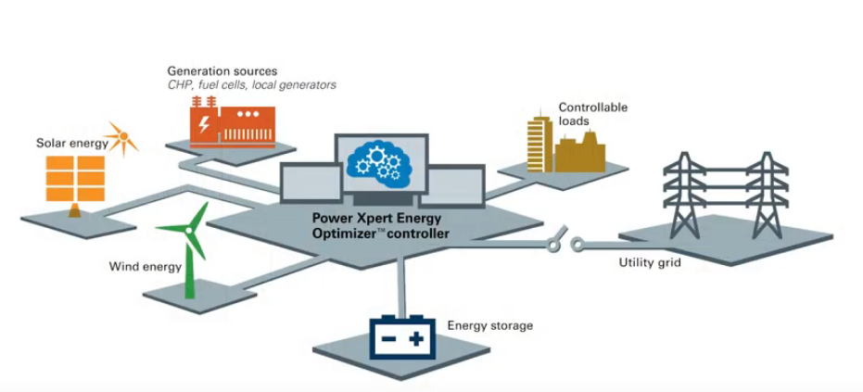
All the assets portrayed in the above figure, i.e. generators, batteries stored with solar and wind energy and the control systems can be combined for electrification. The existing assets can be designed into a system, and the controllers make a micro-grid work. Four different sources, generators, utility systems, solar and wind energy and batteries, can provide continuous power to remote areas through the installation of a micro-grid. The combination of different sources is so efficient and seamless that the end-user does not know about his power source.
The components of a solar micro-grid are as follows:
- A source of generation
- An element of energy storage
- Load control
- The interface of a utility interconnection
- Micro-grid control system
Many low-cost generators based on natural gas and a renewable energy source; in this case, solar energy results in the production of power. The owners of the micro-grids or the buildings where these micro-grids are installed can use these arrangements in two configurations.

Configuration 1
Owners who currently experience over-pricing from electricity generating companies can avail of the use of micro-grid arrangement as a dependable energy source. The owner of, in this case, remains connected to the primary grid of the local area and will utilize solar power as the renewable energy source in the pursuit of decreasing his consumption from the main grid. When there is a peak in demand, which is particularly the day time, natural gas generators work in alignment with the solar energy to lessen the level of consumption form the grids. As the peak hours pass and there is a decrease in utility costs of electricity, owners of the micro-grid switch their power source from solar energy to utility grids and there would not be any shortage of power.

Configuration 2
Sometimes, there are situations (socio-political, socio-economic) where the utility companies of the local communities are not in favour of renewable sources of energy because of potential loss in their profit-making abilities (Byrnes L. B., 2013). In the context of such a situation, owners of the solar micro-grids can fully disengage their power connection from the main utility grid of the local area and make use of the micro-grid. This configuration gives the owner and users complete freedom and autonomy in the utilization of their electric services.
Therefore, the installation of micro-grids is strongly recommended for electrification in Western Australia.

Wind turbine emulators in micro-grids

Working
The operation of this micro-grid will be based on the principles of aerodynamics (Neely, 2012).

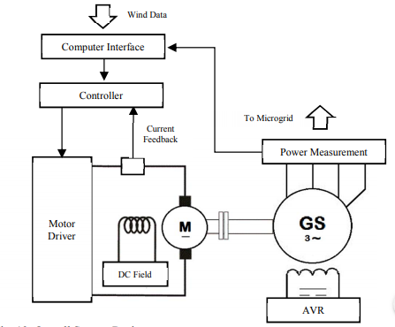
In the above arrangement, a wind turbine emulator attached to a micro-grid is shown which has already been tested in laboratory conditions to determine the production of electricity from wind as a renewable energy source. Real-time data about wind speed, air density, and other indicators will be collected for an improved and accurate monitoring of the system.

Bio-mass in stand-alone micro-grids

Working
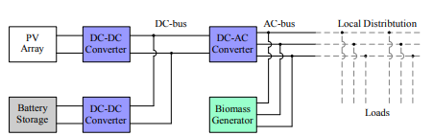
After investigating the potentials of manure and solid bio-mass for the production of electricity, it was found that solid bio-mass has the highest level of potential for this purpose (Løtveit, 2014). The above configuration portrays the working of a micro-grid utilizing biomass as a renewable energy resource.

Evaluation of the Proposed Policy Options

Solar micro-grids
This alternate policy option is expected to provide the remote areas with cleaner sources of power at a much lower cost than the conventional power generating sources. The biggest advantage which the households of Western Australia will experience is the practice of complete control over their energy requirement and its fulfilment.
The potential benefits of a solar micro-grid as discerned by a cost-benefit analysis are as follows:
- Net positive payback goals
- A stable and reliable source of energy
- Reduction in greenhouse emissions which are harmful to the environment
- Access of electric utilities for a huge number of population
- Lower costs of electrical utilities faced by consumer body

Wind turbine emulators in micro-grids
The provision of clean and low-cost energy is expected by installing wind turbines in micro-grids. Even though the initial infrastructure would require huge costs, but its critical nature will improve the resilience of the micro-grid. There are also potential decreases seen in line losses and fuel use.

Bio-mass in stand-alone micro-grids
The traditional usage of biomass in rural areas of developing countries for the sole purpose of cooking is seen as transitioning towards contemporary uses of this natural resource, paving the way for largely sustainable energy usage. Technical investigations regarding the potential of bio-mass have been highlighted in several published studies.

Summary of the alternative options
The installation of micro-grids using solar energy, wind energy, and biomass as renewable energy sources is suggested in this research paper, notifying the government of Western Australia about the significance and working of these micro-grids. The existing energy policy in Western Australia makes use of traditional energy sources which are posing high levels of threat for the global climate and the ecosystem in general.
Detailed workings of the micro-grids have been mentioned with the prospective merits the micro-grid owners will experience upon installation and usage of the system.

Monitoring and Evaluation
This section highlights the procedure and importance of monitoring and evaluating the social, economic and environmental impacts of micro-grids.
Published reports and evidence which is measured empirically can be rarely found in the extant literature about the use of renewable energy sources, even though these practices have widely gained recognition in many industrialized nations.
To ensure that harmonious decisions are developed and implemented by the energy policymakers, there is a need for an effective strategy of monitoring and evaluation. Improvement of existing services and achievement of maximum impact from the installation of solar micro-grids is only possible if monitoring the micro-grids and evaluating the community's perception about these changes are done at regular intervals.
There can be many approaches for M&E to assess the functioning of solar micro-grids:
- Institutionalizing monitoring and evaluation within the local energy department to elevate process efficiency
- Measuring levels of impact, outcome, activity, and output: These levels will entail desired changes, vital conditions to attain these developments, necessary outputs to produce direct outcomes, and all the activities that need to be commenced for these outputs
- Development of performance indicators in the remote areas regarding energy production and usage
- Installation and administration of efficient tools for timely collection of data: smart meters, surveys, and questionnaires addressed to the local community
- Setting up initial targets and regularly measuring the performance of micro-grids in contrast to electricity production by the national grid
- Focus group discussions and expert interviews

Conclusion and Recommendations
This paper attempts to illuminate the potential significance of micro-grids using solar energy, wind energy, and solid biomass as renewable energy sources. The government of Western Australia must take note of the consequential gravity of using conventional sources for electricity generation and must make use of inter-connected micro-grids for electrification in remote areas of Western Australia.

References
Anda, M. B. (2016). Transitions to a post-carbon society: Scenarios for Western Australia. Renewable Energy in the Service of Mankind Vol II, 147-162.
Byrnes, L. B. (2013). Australian renewable energy policy: Barriers and challenges. Renewable Energy, 711-721.
Byrnes, L. B. (2016). Reviewing the viability of renewable energy in community electrification: The case of remote Western Australian communities. Renewable and Sustainable Energy Reviews, 470-481.
Cassells, R. D. (2014). Housing affordability: The real costs of housing in WA.
Chester, L. &. (2011). A new form of energy poverty is the hallmark of liberalized electricity sectors. Australian Journal of Social Issues, 435-459.
Cornwell, A. H. (2016). Energy poverty in Western Australia: A comparative analysis of drivers and effects.
Falk, J. &. (2011). Australia: Approaching an energy crossroads. Energy Policy, 6804-6813.
Løtveit, M. S. (2014). A study of biomass in a hybrid stand-alone Micro-Grid for the rural village of Wawashang, Nicaragua. Ninth International Conference on Ecological Vehicles and Renewable Energies, 1-7.
Neely, J. G. (2012). Wind turbine emulation for intelligent microgrid development. IEEE International Conference on Cyber Technology in Automation, Control, and Intelligent Systems, 28-33.
Numminen, S. &. (2019). Evaluation of the reliability of solar micro-grids in emerging markets–Issues and solutions. Energy for sustainable development, 34-42.

Appendices
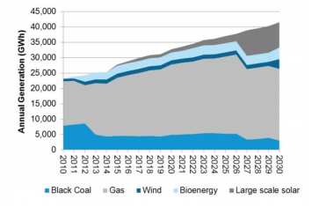
Figure 1. Projected large scale policies for lower carbon emissions by Western Australia
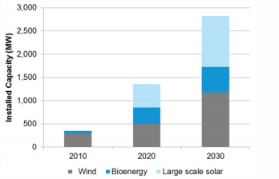
Figure 2. Projected growth

