CRM Report

Student’s Name:
University Affiliations:
Professor’s Name:
Course Title:

CRM Report
Customers are considered as a vital asset for any business and they can easily be managed through the utility of a CRM software (Gonzalez & Venturini, 2017, Pg.427). The delivery of top-notch quality products is enough reason to have your clients loyal and happy and this attainment is measured through sales made. To have consistent sales can be a challenge for e-business companies especially when one does not have the right means of carrying out the activities that contribute to high sales. Well, currently most organizations have discovered the secret to having more customers through the use of customer relationship management (Venturini & Benito, 2015. Pg. 873). The system can help an online entity increase its sales greatly without facing huge operation costs. In the past years, the term CRM has spread rapidly in the business world since it has helped in making profits through increased sales (Venturini & Benito, 2015. Pg. 871). This paper is driven towards developing an e-business application through a CRM software.
The chosen application will aid in managing; accounts, contacts, opportunities, meetings, leads, sales, procurements, workflow marketing, and activity streams. The CRM software used for this task is the SuiteCRM tool. The latter was chosen due to its diversity and efficiency. The name of the organization chosen for the task is – Zuntram food export. The online business is engaged in making supplies of varied dehydrated food products worldwide hence the need of having an established platform that one can organize and control customers and sales.
Manage Accounts
A CRM software application can do so much for a firm. It can assist in storing data collected from; meetings, forums or through other communication channels (Venturini & Benito, 2015. Pg. 871). However, one of the most relevant of its functions is account management. Through an account management software, the company will be empowered to keep track of any account information in an up to date and organized manner. In a CRM software, the function of account management is made up of varied key functions. The essence of account management is attaining motion whereby a firm can attain the next deal which requires the accounting department to collaborate with the sales team (Venturini & Benito, 2015. Pg. 873). Through account management, sales representatives can close more important deals through the access of deals made, contacts and other relevant data. A complete view of managed accounts helps in keeping track of any improvements or downfalls that need to be rectified. The accounts team is also able to configure sectors that need improvements.
Manage Contacts
The process of contact management in a business is the recording of clients' contacts to enhance monitoring of interactions (Venturini & Benito, 2015. Pg. 873). The systems of handling this function have slowly evolved into the aspects of most Customer Relationship Management Systems. Through such applications, companies can manage their contacts, which help in improving services and sales levels. It is eminent that customer relationship management evolved from contact management. Each interaction with any contact can aid in making a sale or a referral. Follow-ups are also made possible through the organization of customer's contacts. SuiteCRM has premium services which can be considered as the next evolution of management of contacts known as cloud-based CRM software. The function enables an organization's employees to update the CRM with the latest data concerning contacts from wherever they are situated. This can be carried out for as long as one has a web-enabled device. The feature is made possible by the fact that a company's data is collected in a single database, therefore, making it possible to input new or updated data, which instantly becomes visible to relevant parties in the company. Integration of customer information through a CRM enables a company to keep in touch with clients, which is important in promoting customer loyalty.
Manage Opportunities
Opportunity management when it comes to getting new clients or in making new sales is an important requirement for a firm that wants to succeed or to expound its selling efforts (Venturini & Benito, 2015. Pg. 875). When a lead shifts into the sales pipeline, it turns to be an opportunity. This ultimately means that there is a real chance for the sales force to be a closed sale. Qualifying to get a lead seems to be simple but when it comes to opportunity management things turn to be a bit complex. This is brought out by the fact that there are higher stakes hence more time and effort are required to maintain the opportunity.
Activities involved at this point include; the engagement of the right people from the export company, creating relevant presentations and making sales techniques that should be shown to the persons interested in making the imports (Venturini & Benito, 2015. Pg. 875). At this point, individuals from other departments are likely to get involved. Through Customer Relationship Management software, a company is given the platform to take control of its opportunities (Venturini & Benito, 2015. Pg. 873). Zuntram Food Export has the responsibility of making sure that there is consistency during all stages that portray some opportunity. Through the application, the company can identify relevant priorities that can purchase products and manage these leads accordingly by the use of the ‘manage opportunity' feature.

Manage Meetings
Customer Relationship Management software is dedicated to making sure that an organization can manage its activities, strategies, and plans (Lok & Dimantha, 2016. Pg.14). Meetings handled by the firm are vital in making primary decisions, strategies, and ventures that may lead to sales. It is therefore important to keep up with all meetings held that are linked with the company's business. Through proper management of meetings, Zuntram will manage to develop better relationships between workers and administrators or between the sales team and the customers. Being prompt in meetings can help in gaining customer loyalty and can be a means of retaining clients. The SuiteCRM acts as a great management strategy for both formal and informal meetings linked to the company. The tool has developed a simple user interface through which users can key in when they have meetings and the persons involved in the meetings making it easier for follow-ups. Reminders are also provided days before the meeting for adequate preparation. CRM software will help the business to optimize its clients' interactions before and after meetings. This is carried out by streamlining complex clients' interaction processes. Optimization of business meetings helps in improving customer satisfaction (Lok & Dimantha, 2016. Pg.10). One of the paramount benefits of lead management is that it offers updates about customer data, this means that firms do not have to wait for quarterly reports to make new sales strategies. With great access to clients' insights, firms can obtain the best from the CRM software. Zuntram team plans on paying close attention to customer data reports to get an insight into the best decisions to make while trying to convert leads into paying clients.

Manage Leads
It is one thing to obtain leads but it is another thing to turn best-qualified leads into bringing in profits (Ahmad et al, 2019. Pg. 125). This makes the management of leads to be a very important process in any company. By the use of CRM software, an organization can track conversations with clients making sure that the leads are converted into sales. Management of leads is crucial when a company's sales team is focused to increase revenue or sales. Having a better management of leads through CRM does not merely help the sales team to be on top when it comes to maintaining qualified leads, it also assists them in cultivating firm relationships with existing customers and leads. Through the continuous process of tracking customers' patterns and needs, the sales team becomes better equipped with proficient customer service (Kumar & Reinartz, 2018. Pg. 242). SuiteCRM is enabled to generate capable leads and those which are likely to be fruitless.
Manage Sales
One of the core objectives of companies; large, small or medium is to accelerate sales for a long period (Cruz & Vasconcelos, 2015. Pg, 27). Through the utility of SuiteCRM, the company has the ability to create a plan of action that can help to reach out to customers interested in our products and prompt them to make export purchases. Hereby are some of the several ways through which Zuntram Food Export will increase its sales through SuiteCRM.
Elimination of Inactive Activity; If a business attains unnecessary costs, this means that the business will be acquiring hidden costs. In a business sense, such costs should be avoided in all means possible. When the CRM application will be used by Zuntram Food Export online business, the sales team will manage to align activities depending on target customer prospects and data, this avoids approaching wrong customers. Through such an organization, the firm will manage to present relevant information to appropriate clients at the right time. Through the utility of the application, the sales team will manage to develop an accurate plan in keen consideration of profitable activities that can enhance sales for the business. Lastly, the firm will manage to easily handle day to day activities such as; lead follow-ups, sales history, call lists, call reminders and also manage data relating to loyal contacts. All of the latter are relevant in ensuring that an organization can plan its schedule in a manner that it can contribute to higher sales.
Increase the momentum: The CRM system will aid in the recording of fundamental activities according to customers and time(Ahmad et al, 2019. Pg. 124). Through the help of an automated system, the sales team will manage to accelerate touchpoints for clients. For instance, the firm can automate approvals related to sales such as; timelines, start dates, stock at hand and discount requests. Through the Suite CRM application, the firm will manage to maintain its workflows, which aids in attaining faster approvals. This by itself helps in having a fast turn-around and an improvement in customer service. Delays experienced in delivering orders will be eliminated. With an elaborate CRM, an online business can manage to attain target sales only with the right organization. With proper planning, workflow processes can be easily handled without involving too much labor which saves the company a lot.
Manage Procurements
Procurement executives in a firm can adapt CRM to help in establishing priorities, allocating resources and also in engaging relevant stakeholders (Hennekey et al, 2016. Pg 862). The customer relationship management software is enabled to support procurement and supply management in vast ways. In conventional means of managing procurement, e-mails are used often in making follow-ups and sales (Ahmad et al, 2019. Pg. 125). However, this has changed over time. CRM is developed in a manner through which suppliers and procurement communities can easily assess real-time data and utilize it in making profits. The software supports procurement activities due to the availability of corporate memory. CRM has a platform that is enabled for discussion groups and for transmission of knowledge which are important activities in procurement. Lastly, Zuntram will benefit from SuiteCRM since it is well integrated to ensure that suppliers can consistently communicate with clients concerning products they need supplied to their destinations.
Manage Workflow
Most companies find numerous advantages through the management of tasks and other workflow processes by the use of CRM software (Gonzalez & Venturini, 2017, Pg.425). The software is developed in a manner through which clients' contacts can be processed and saved in on orderly manner. For most companies, the CRM software ensures that the whole system tasks and workflow are adequately managed since most of the firms are centered on clients. It is a brilliant idea for Zuntram to use SUiteCRM considering the numerous tasks that should be handled on a daily basis. There are vast functions that are involved in the management of workflow. The CRM software helps in planning the company's sales funnel since it has the capability of comprehending clients' lifecycles (Venturini & Benito, 2015. Pg. 873). SuiteCRM is enabled to automate varied tasks that are quite time consuming. These automated tasks include; communication with clients, setting up a meeting, doing follow-ups and creation of orders as per the client's instructions. One prerequisite task in any company is communication which can be carried out through SuiteCRM. The CRM increases chances for communication in vast ways. To obtain the best workflow management, it is important to integrate the CRM application with other apps.
Manage Marketing (Campaigns, surveys)
A Customer Relationship Management system helps in generating extensive contact records as well as focused tracking reports (Cruz & Vasconcelos, 2015. Pg, 27). Through the software application, the business can manage to track which sales or marketing tactics are efficient with their clientele. The software is developed in a manner that important contacts that can help in marketing can be accessed.
A modern CRM such as SuiteCRM is integrated with marketing tools so that online businesses or rather companies can develop efficient email campaigns, create advertisements and keep up with trending prospects in one's funnel. Through the CRM application, Zuntram Food Export will keep track of relevant business prospects that can help in marketing such as; famous online searches, trending customer interests and elaborate marketing campaigns used by competitors. Through the utility of the organization's sales interactions, the company's marketing team can configure frequently asked questions in their marketing campaigns. Such data is also important in comprehending the concerns of the firm's relevant clients and how these concerns should be addressed during advertisements. Through a well developed CRM, the company can manage to create a cost-efficient marketing platform that targets the most important clients. The SuiteCRM has features that will aid in setting up relevant promotions for profitable groups and execute at the best time. Through this marketing optimization, the firm allows itself to grow and increase its revenue.

Manage Activity Stream
Through an integrated CRM, Zuntram will allow its employees to access an activities list that has been performed over a certain period. Records provided will have comments' interfaces through which the users can post or comment about the activities. The platform helps the workers to easily track current updates in the entire firm through records and from other users' posts. (Kumar & Reinartz, 2018. Pg. 242) SuiteCRM activity streams can be accessed through record views, a module list or through a dashboard. Activity streams help in making important follow-ups that are relevant in developing Zuntram establishment.

Sources
A Al-Homery, H., Asharai, H. and Ahmad, A., 2019. The Core Components and Types of CRM. Pakistan Journal of Humanities and Social Sciences, 7(1), pp.121-145.
Cruz, A. and Vasconcelos, A., 2015. A Reference Application Architecture for the CRM Domain: The Portuguese Citizen Space Case Study. International Journal of Enterprise Information Systems (IJEIS), 11(2), pp.24-49.
González-Benito, Ó., Venturini, W.T. and González-Benito, J., 2017. CRM technology: implementation project and consulting services as determinants of success. International Journal of Information Technology & Decision Making, 16(02), pp.421-441.
Kumar, V. and Reinartz, W., 2018. Impact of CRM on marketing channels. In Customer Relationship Management (pp. 237-264). Springer, Berlin, Heidelberg.
Lok, S.H. and Dimantha, R., PROTEL COMMUNICATIONS LIMITED, 2016. Unified integration management—contact center portal. U.S. Patent 9,521,207.
O'donnell, C., Pitre, A., Schnitt, M., Sit, E., Hennekey, T., Ball, M., Brown, G., Kaplow, Z.E., Sobin, Z., Williams, J. and Neuwirth, M., 2016. Method of enhancing customer relationship management content and workflow. U.S. Patent Application 14/854,591.
Venturini, W.T. and Benito, Ó.G., 2015. CRM software success: a proposed performance measurement scale. Journal of Knowledge Management, 19(4), pp.856-875.

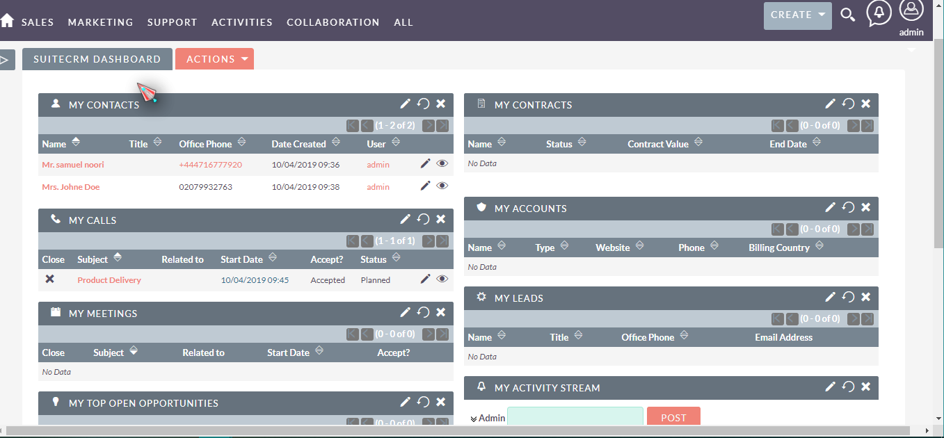
SUITE CRM APPLICATION SCREENSHOTS

