HELLO CLIENT, THERE IS NEED TO ADD SOME CONTENT AT THE FINDINGS AND RECOMMENDATION SECTION ACCORDING TO THE RESEARCH THAT YOU CARRIED OUT. THANK YOU

Research Project

Kathryn Campbell
MBA 5652
10/30/2019
James Schindler

Table of Contents
Executive Summary 2
Introduction 3
Statement of the Problems 3
Literature Review 5
Research Objectives 6
Research Questions and Hypotheses 7
Research Methodology, Design, and Methods 8
Research Methodology 8
Research Design 9
Research Methods 9
Data Collection Methods 9
Sampling Design 9
Data Analysis: Descriptive Statistics and Assumption Testing 10
Data Analysis Procedures 26
Independent Samples t-test 27
Hypothesis 27
Excel output and interpretation 27
Dependent Samples (Paired Samples) t Test 28
Hypothesis 28
Excel output and interpretation 29
One-way ANOVA 29
Hypothesis 30
Excel output and interpretation 30
Data Analysis: Hypothesis Testing 31
Findings 40
Recommendations 42
References 43

Executive Summary
The research project involves taking up the role of a Health and Safety Director who has left the firm to pursue other ventures. The research has to be conducted thoroughly to identify health and safety matters related to members of staff. Through the utility of some of the data provided by the former health and safety director, a comprehensive research is formulated. A quantitative research methodology is used to collect additional information, which is further analyzed using varied tests.

Introduction
Senior leadership at Sun Coast has identified several areas of concern that they believe could be solved using business research methods. The previous director was tasked with conducting research to help provide information to make decisions about these issues. Although data were collected, the project was never completed. Senior leadership is interested in seeing the project through to fruition. The following is the completion of that project and includes the statement of the problems, literature review, research objectives, research questions and hypotheses, research methodology, design, and methods, data analysis, findings, and recommendations.

Statement of the Problems
Six business problems were identified while undertaking the research project:
Particulate Matter (PM)
There is a concern that job-site particle pollution is adversely impacting employee health. Although respirators are required in certain environments, PM varies in size depending on the project and job site. PM that is between 10 and 2.5 microns can float in the air for minutes to hours (e.g., asbestos, mold spores, pollen, cement dust, fly ash), while PM that is less than 2.5 microns can float in the air for hours to weeks (e.g. bacteria, viruses, oil smoke, smog, soot). Due to the smaller size of PM that is less than 2.5 microns, it is potentially more harmful than PM that is between 10 and 2.5 since the conditions are more suitable for inhalation. PM that is less than 2.5 is also able to be inhaled into the deeper regions of the lungs, potentially causing more deleterious health effects. It would be helpful to understand if there is a relationship between PM size and employee health. PM air quality data have been collected from 103 job sites, which is recorded in microns. Data are also available for average annual sick days per employee per job-site.
Safety Training Effectiveness
Health and safety training is conducted for each new contract that is awarded to Sun Coast. Data for training expenditures and lost-time hours were collected from 223 contracts. It would be valuable to know if training has been successful in reducing lost-time hours and, if so, how to predict lost-time hours from training expenditures.
Sound-Level Exposure
Sun Coast’s contracts generally involve work in noisy environments due to a variety of heavy equipment being used for both remediation and the clients’ ongoing operations on the job sites. Standard ear-plugs are adequate to protect employee hearing if the decibel levels are less than 120 decibels (dB). For environments with noise levels exceeding 120 dB, more advanced and expensive hearing protection is required, such as earmuffs. Historical data have been collected from 1,503 contracts for several variables that are believed to contribute to excessive dB levels. It would be important if these data could be used to predict the dB levels of work environments before placing employees on-site for future contracts. This would help the safety department plan for procurement of appropriate ear protection for employees.
New Employee Training
All new Sun Coast employees participate in general health and safety training. The training program was revamped and implemented six months ago. Upon completion of the training programs, the employees are tested on their knowledge. Test data are available for two groups: Group A employees who participated in the prior training program and Group B employees who participated in the revised training program. It is necessary to know if the revised training program is more effective than the prior training program.
Lead Exposure
Employees working on job sites to remediate lead must be monitored. Lead levels in blood are measured as micrograms of lead per deciliter of blood (μg/dL). A baseline blood test is taken pre-exposure and postexposure at the conclusion of the remediation. Data are available for 49 employees who recently concluded a 2-year lead remediation project. It is necessary to determine if blood lead levels have increased.
Return on Investment
Sun Coast offers four lines of service to their customers, including air monitoring, soil remediation, water reclamation, and health and safety training. Sun Coast would like to know if each line of service offers the same return on investment. Return on investment data are available for air monitoring, soil remediation, water reclamation, and health and safety training projects. If return on investment is not the same for all lines of service, it would be helpful to know where differences exist.

Literature Review
The literature view pointed out some of the challenges faced by companies working in remote areas and coastal regions. It focused on the repair and maintenance industry and especially safety and health issues which should be observed by companies working in high risk areas. A study conducted by Denyer & Jaina (2017) concluded that Sun Coast like other stakeholders in the repair and maintenance industry has faced several problems related to the health of employees and wages. It is pointed out that the problems and other risk factors, facing employees of Sun Coast have made several employees to quit their work. The article was published in 2017, and authored Denyer and Jaina. The authors are professors from the universities in the AUnited States . They have a lot of experiment in matters related to health and safety of workers. The authors have also worked as consultants in matters related to health and safety for different companeis. It also illustrated some of the solution to the problems faced by workers in the remote areas where they are highly exposed to chemicals and other gases. It is concluded in the literature review that management of companies should take responsbilities to protect the health and safety of workers.

Research Objectives
Research objectives define the aims and main goals of the research and should be stated clearly before the start of the research (Farrugia, Petrisor, Farrokhyar, & Bhandari, 2010). The research objectives for this research are listed below:
RO₁: To determine if there is a relationship between the size of PM (particulate matter) size and employee health.
RO₂: To determine if the safety training has been successful to reduce the lost-time hours
RO₃: To determine if the frequency, chord length, velocity and displacement can be used to predict dB levels.
RO₄: To know if the revised training program is better than the prior training program.
RO₅; To determine if there is any difference in the level of lead in the blood of employees before and after the lead remediation program.
RO₆; To determine if the differences exist in return on investment for air monitoring, water reclamation, soil remediation, and health and safety training projects.

Research Questions and Hypotheses
The research question should be specific and broad enough to cover all the necessary aims of the research at the same time (Boland, Cherry, & Dickson, 2017). The research questions and hypotheses, based on the above objectives, are given below:
RQ₁: Is there any connection between PM (particulate matter) size and the number of sick leaves exist?
H0₁: There is no statistically important association between PM (particulate matter) size and the number of sick leaves.
HA₁: There is a statistically important association between PM (particulate matter) size and the number of sick leaves.
RQ₂: Have the safety training sessions been effective in reducing lost-time hours?
H0₂: Safety raining has not been successful in reducing number of lost-time hours
HA₂: Safety raining has been successful in reducing number of lost-time hours
RQ₃: Do the variables like frequency, angel, chord length, velocity and displacement can be related to noise (dB)?
H0₃: The frequency, angel, chord length, velocity and displacement are not related to noise (dB).
HA₃: The frequency, angel, chord length, velocity and displacement are related to noise (dB).
RQ₄: Is there any difference in the effectiveness of the revised and prior training programs?
H0₄: The revised training has been effective than the prior training program.
HA₄: The revised training has not been effective than the prior training program.
RQ₅: Did the lead amounts in the blood of workers increase after the lead remediation project?
H0₅: The lead amounts in the blood of workers increased after the lead remediation project.
HA₅: The lead amounts in the blood of workers did not increase after the lead remediation project.
RQ₆: Is there any difference in the return of investment by water reclamation, air monitoring, health and safety training and soil remediation projects?
H0₆: A difference exists in the return of investment by the four projects.
HA₆: No difference exists in the return of investment by the four projects.

Research Methodology, Design, and Methods

Research Methodology
The research methodology is quantitative research. Choosing quantitative research is to follow the scientific and systematic methods to justify and understand the questions of how and why people act and think in some specific ways (Nardi, 2018).

Research Design
Descriptive research design is suitable and appropriate. Reason for descriptive design is because of systematic and accurate study about the impacts of the work environment on the workers' health and safety. A descriptive research design aims to study the associations and relationships between or among the required variables (Dulock, 1993).

Research Methods
The study was completed using both primary and seconday data. In order to complete the study, quantitative research methods were used for collection of data. The decriptive resarch design was applied and the data was analyzed using SPSS application and microsoft excel. The quantitaive research method is described as a method of data collection where statistic, and mathermatic are applied in the analysis of the data. The quantitaive research emphasize on the objectives, statistical, mathematical and numerical analyze to manipulate the data. It is pointed out that 321 people 45% male and 55% female participated in the study. The participants were of 18 years to 55 years. It is also illustrated that 60% of participants were either former employees of Sun Coast or aworking for related company. The data was analyse using SPSS where hypothesis were derived and answered .

Data Collection Methods

Sampling Design
The sampling design for this research design would be non-probability (convenience sampling) because the participants are available. Convenience sampling is the one in which the targeted participants meet the criteria and available for participation (Etikan, Musa, & Alkassim, 2016). There was a total of 321 participants, including 45 percent of males and 55 percent of females. Among these participants, 60 percent of the participants were either workers or the employees of the Sun Coast Company.

Data Analysis: Descriptive Statistics and Assumption Testing
The analysis of the data established that health and safety matters are key issues for Sun Coast workers. It is also pointed that there are significant correlations between the lost time hours and safety training expenditure. The study also established that there is relationship between health and safety of workers and the performance of Sun Coast. The study also established that Sun Coast also works around the clock to offer a better working environment for all workers through elimination of substances which can hinder growth of workers. The data analysis is represented on the tables below.
Frequency distribution table
It is a chart, which provides the summary of values and their charts on the table.

Descriptive Statistics Analysis
The descriptive statistic is regarded as the basic feature of data in a study. It provides the mean, mode, median and standard deviation. The mean, mode, media and standard deviation is obtained as illustrated in the table below.
Column1 |  | Column2
Mean | 63.66290704 | Mean | 36.05781174
Standard Error | 1.29748924 | Standard Error | 0.547442611
Median | 68.224587 | Median | 36.089061
Mode | 79.43 | Mode | 31.92666
Standard Deviation | 15.78463787 | Standard Deviation | 6.659926806
Sample Variance | 249.1547926 | Sample Variance | 44.35462506
Kurtosis | -1.024398771 | Kurtosis | -1.325145342
Skewness | -0.246301829 | Skewness | 0.136789913
Range | 66.1409 | Range | 23.034936
Minimum | 26.75474 | Minimum | 24.407484
Maximum | 92.89564 | Maximum | 47.44242
Sum | 9422.110242 | Sum | 5336.556138
Count | 148 | Count | 148
Confidence Level (95.0%) | 2.564141412 | Confidence Level (95.0%) | 1.081874305

The study identified six problems as some of the major concerns for Sun Coast. The first major concern is job site particle pollution affecting the health of employees. It also reported that Sun Coast suffers from high job lose and this could be as a result of poor working condition. Though respirators are needed in certain environment, the particulate matter (PM) differs in size and mostly depends on the job site and project which are being undertaken. There are also other issues such as safety training effectiveness, sound level exposure, new employee training and lead exposure which senior management must address.
Regression analysis
SUMMARY OUTPUT
Regression Statistics
Multiple R | 0.057185425
R Square | 0.003270173
Adjusted R Square | -0.003556744
Standard Error | 6.67176012
Observations | 148
ANOVA
 | df | SS | MS | F | Significance F
Regression | 1 | 21.32195 | 21.32195 | 0.479012 | 0.48997
Residual | 146 | 6498.808 | 44.51238
Total | 147 | 6520.13
 | Coefficients | Standard Error | t Stat | P-value | Lower 95% | Upper 95% | Lower 95.0% | Upper 95.0%
Intercept | 34.52175714 | 2.286143 | 15.10044 | 1.26E-31 | 30.00355 | 39.03997 | 30.00355 | 39.03997
X Variable 1 | 0.024127937 | 0.034862 | 0.692107 | 0.48997 | -0.04477 | 0.093026 | -0.04477 | 0.093026

It is means that there a relationship between particulate matter size and employee sick days because of the p. value is 0.48997. It means that the hypothesis is accepted. It is also obtained that there a predictive relationship between safety training expenditure and lost time hours?

Cumulative Analysis
Bin | Frequency | Cumulative % | Bin | Frequency | Cumulative %
24.407 | 0 | 0.00% | More | 127 | 85.81%
24.407 | 0 | 0.00% | 42.519 | 5 | 89.19%
25.770 | 0 | 0.00% | 41.574 | 3 | 91.22%
25.770 | 0 | 0.00% | 34.771 | 2 | 92.57%
25.909 | 0 | 0.00% | 36.034 | 2 | 93.92%
25.909 | 0 | 0.00% | 26.854 | 1 | 94.59%
26.854 | 1 | 0.68% | 29.291 | 1 | 95.27%
26.854 | 0 | 0.68% | 29.689 | 1 | 95.95%
27.003 | 0 | 0.68% | 38.849 | 1 | 96.62%
27.003 | 0 | 0.68% | 42.947 | 1 | 97.30%
27.073 | 0 | 0.68% | 44.608 | 1 | 97.97%
27.073 | 0 | 0.68% | 45.473 | 1 | 98.65%
27.352 | 0 | 0.68% | 46.746 | 1 | 99.32%
27.352 | 0 | 0.68% | 47.442 | 1 | 100.00%
27.451 | 0 | 0.68% | 24.407 | 0 | 100.00%
27.451 | 0 | 0.68% | 24.407 | 0 | 100.00%
27.550 | 0 | 0.68% | 25.770 | 0 | 100.00%
27.550 | 0 | 0.68% | 25.770 | 0 | 100.00%
27.899 | 0 | 0.68% | 25.909 | 0 | 100.00%
27.899 | 0 | 0.68% | 25.909 | 0 | 100.00%
28.088 | 0 | 0.68% | 26.854 | 0 | 100.00%
28.088 | 0 | 0.68% | 27.003 | 0 | 100.00%
29.291 | 1 | 1.35% | 27.003 | 0 | 100.00%
29.291 | 0 | 1.35% | 27.073 | 0 | 100.00%
29.390 | 0 | 1.35% | 27.073 | 0 | 100.00%
29.390 | 0 | 1.35% | 27.352 | 0 | 100.00%
29.689 | 1 | 2.03% | 27.352 | 0 | 100.00%
29.689 | 0 | 2.03% | 27.451 | 0 | 100.00%
29.977 | 0 | 2.03% | 27.451 | 0 | 100.00%
29.977 | 0 | 2.03% | 27.550 | 0 | 100.00%
30.027 | 0 | 2.03% | 27.550 | 0 | 100.00%
30.027 | 0 | 2.03% | 27.899 | 0 | 100.00%
30.027 | 0 | 2.03% | 27.899 | 0 | 100.00%
30.037 | 0 | 2.03% | 28.088 | 0 | 100.00%
30.037 | 0 | 2.03% | 28.088 | 0 | 100.00%
30.037 | 0 | 2.03% | 29.291 | 0 | 100.00%
30.236 | 0 | 2.03% | 29.390 | 0 | 100.00%
30.236 | 0 | 2.03% | 29.390 | 0 | 100.00%
30.345 | 0 | 2.03% | 29.689 | 0 | 100.00%
30.345 | 0 | 2.03% | 29.977 | 0 | 100.00%
30.703 | 0 | 2.03% | 29.977 | 0 | 100.00%
30.703 | 0 | 2.03% | 30.027 | 0 | 100.00%
31.051 | 0 | 2.03% | 30.027 | 0 | 100.00%
31.051 | 0 | 2.03% | 30.027 | 0 | 100.00%
31.051 | 0 | 2.03% | 30.037 | 0 | 100.00%
31.081 | 0 | 2.03% | 30.037 | 0 | 100.00%
31.081 | 0 | 2.03% | 30.037 | 0 | 100.00%
31.240 | 0 | 2.03% | 30.236 | 0 | 100.00%
31.240 | 0 | 2.03% | 30.236 | 0 | 100.00%
31.240 | 0 | 2.03% | 30.345 | 0 | 100.00%
31.509 | 0 | 2.03% | 30.345 | 0 | 100.00%
31.509 | 0 | 2.03% | 30.703 | 0 | 100.00%
31.927 | 0 | 2.03% | 30.703 | 0 | 100.00%
31.927 | 0 | 2.03% | 31.051 | 0 | 100.00%
31.927 | 0 | 2.03% | 31.051 | 0 | 100.00%
31.927 | 0 | 2.03% | 31.051 | 0 | 100.00%
31.927 | 0 | 2.03% | 31.081 | 0 | 100.00%
31.927 | 0 | 2.03% | 31.081 | 0 | 100.00%
32.374 | 0 | 2.03% | 31.240 | 0 | 100.00%
32.374 | 0 | 2.03% | 31.240 | 0 | 100.00%
32.404 | 0 | 2.03% | 31.240 | 0 | 100.00%
32.404 | 0 | 2.03% | 31.509 | 0 | 100.00%
33.120 | 0 | 2.03% | 31.509 | 0 | 100.00%
33.120 | 0 | 2.03% | 31.927 | 0 | 100.00%
33.339 | 0 | 2.03% | 31.927 | 0 | 100.00%
33.339 | 0 | 2.03% | 31.927 | 0 | 100.00%
33.339 | 0 | 2.03% | 31.927 | 0 | 100.00%
34.771 | 2 | 3.38% | 31.927 | 0 | 100.00%
34.771 | 0 | 3.38% | 31.927 | 0 | 100.00%
34.771 | 0 | 3.38% | 32.374 | 0 | 100.00%
34.771 | 0 | 3.38% | 32.374 | 0 | 100.00%
36.034 | 2 | 4.73% | 32.404 | 0 | 100.00%
36.034 | 0 | 4.73% | 32.404 | 0 | 100.00%
36.034 | 0 | 4.73% | 33.120 | 0 | 100.00%
36.144 | 0 | 4.73% | 33.120 | 0 | 100.00%
36.144 | 0 | 4.73% | 33.339 | 0 | 100.00%
36.144 | 0 | 4.73% | 33.339 | 0 | 100.00%
36.144 | 0 | 4.73% | 33.339 | 0 | 100.00%
36.850 | 0 | 4.73% | 34.771 | 0 | 100.00%
36.850 | 0 | 4.73% | 34.771 | 0 | 100.00%
36.850 | 0 | 4.73% | 34.771 | 0 | 100.00%
36.850 | 0 | 4.73% | 36.034 | 0 | 100.00%
37.198 | 0 | 4.73% | 36.034 | 0 | 100.00%
37.198 | 0 | 4.73% | 36.144 | 0 | 100.00%
37.198 | 0 | 4.73% | 36.144 | 0 | 100.00%
37.198 | 0 | 4.73% | 36.144 | 0 | 100.00%
37.745 | 0 | 4.73% | 36.144 | 0 | 100.00%
37.745 | 0 | 4.73% | 36.850 | 0 | 100.00%
37.745 | 0 | 4.73% | 36.850 | 0 | 100.00%
37.745 | 0 | 4.73% | 36.850 | 0 | 100.00%
38.203 | 0 | 4.73% | 36.850 | 0 | 100.00%
38.203 | 0 | 4.73% | 37.198 | 0 | 100.00%
38.203 | 0 | 4.73% | 37.198 | 0 | 100.00%
38.203 | 0 | 4.73% | 37.198 | 0 | 100.00%
38.670 | 0 | 4.73% | 37.198 | 0 | 100.00%
38.670 | 0 | 4.73% | 37.745 | 0 | 100.00%
38.670 | 0 | 4.73% | 37.745 | 0 | 100.00%
38.670 | 0 | 4.73% | 37.745 | 0 | 100.00%
38.849 | 1 | 5.41% | 37.745 | 0 | 100.00%
38.849 | 0 | 5.41% | 38.203 | 0 | 100.00%
38.849 | 0 | 5.41% | 38.203 | 0 | 100.00%
38.849 | 0 | 5.41% | 38.203 | 0 | 100.00%
41.574 | 3 | 7.43% | 38.203 | 0 | 100.00%
41.574 | 0 | 7.43% | 38.670 | 0 | 100.00%
41.574 | 0 | 7.43% | 38.670 | 0 | 100.00%
41.574 | 0 | 7.43% | 38.670 | 0 | 100.00%
42.519 | 5 | 10.81% | 38.670 | 0 | 100.00%
42.519 | 0 | 10.81% | 38.849 | 0 | 100.00%
42.519 | 0 | 10.81% | 38.849 | 0 | 100.00%
42.519 | 0 | 10.81% | 38.849 | 0 | 100.00%
42.947 | 1 | 11.49% | 41.574 | 0 | 100.00%
42.947 | 0 | 11.49% | 41.574 | 0 | 100.00%
42.947 | 0 | 11.49% | 41.574 | 0 | 100.00%
42.947 | 0 | 11.49% | 42.519 | 0 | 100.00%
44.170 | 0 | 11.49% | 42.519 | 0 | 100.00%
44.170 | 0 | 11.49% | 42.519 | 0 | 100.00%
44.170 | 0 | 11.49% | 42.947 | 0 | 100.00%
44.170 | 0 | 11.49% | 42.947 | 0 | 100.00%
44.409 | 0 | 11.49% | 42.947 | 0 | 100.00%
44.409 | 0 | 11.49% | 44.170 | 0 | 100.00%
44.409 | 0 | 11.49% | 44.170 | 0 | 100.00%
44.409 | 0 | 11.49% | 44.170 | 0 | 100.00%
44.558 | 0 | 11.49% | 44.170 | 0 | 100.00%
44.558 | 0 | 11.49% | 44.409 | 0 | 100.00%
44.558 | 0 | 11.49% | 44.409 | 0 | 100.00%
44.558 | 0 | 11.49% | 44.409 | 0 | 100.00%
44.608 | 1 | 12.16% | 44.409 | 0 | 100.00%
44.608 | 0 | 12.16% | 44.558 | 0 | 100.00%
44.608 | 0 | 12.16% | 44.558 | 0 | 100.00%
44.608 | 0 | 12.16% | 44.558 | 0 | 100.00%
45.055 | 0 | 12.16% | 44.558 | 0 | 100.00%
45.055 | 0 | 12.16% | 44.608 | 0 | 100.00%
45.055 | 0 | 12.16% | 44.608 | 0 | 100.00%
45.055 | 0 | 12.16% | 44.608 | 0 | 100.00%
45.473 | 1 | 12.84% | 45.055 | 0 | 100.00%
45.473 | 0 | 12.84% | 45.055 | 0 | 100.00%
45.473 | 0 | 12.84% | 45.055 | 0 | 100.00%
45.473 | 0 | 12.84% | 45.055 | 0 | 100.00%
45.503 | 0 | 12.84% | 45.473 | 0 | 100.00%
45.503 | 0 | 12.84% | 45.473 | 0 | 100.00%
45.503 | 0 | 12.84% | 45.473 | 0 | 100.00%
45.503 | 0 | 12.84% | 45.503 | 0 | 100.00%
46.746 | 1 | 13.51% | 45.503 | 0 | 100.00%
46.746 | 0 | 13.51% | 45.503 | 0 | 100.00%
46.746 | 0 | 13.51% | 45.503 | 0 | 100.00%
46.746 | 0 | 13.51% | 46.746 | 0 | 100.00%
47.442 | 1 | 14.19% | 46.746 | 0 | 100.00%
47.442 | 0 | 14.19% | 46.746 | 0 | 100.00%
More | 127 | 100.00% | 47.442 | 0 | 100.00%

Data for the company:
 | Sun Coast Closing | Sun Coast Return
30-Jun-2019 | 82.780 | 47.442
31-May-2019 | 78.510 | 45.503
30-Apr-2019 | 74.520 | 45.473
31-Mar-2019 | 70.640 | 44.558
28-Feb-2019 | 73.950 | 44.170
31-Jan-2019 | 69.910 | 42.947
31-Dec-2018 | 72.390 | 46.746
30-Nov-2018 | 71.230 | 45.055
31-Oct-2018 | 69.230 | 44.608
30-Sep-2018 | 71.410 | 44.409
31-Aug-2018 | 71.240 | 42.519
31-Jul-2018 | 74.790 | 41.574
30-Jun-2018 | 72.870 | 38.670
31-May-2018 | 69.300 | 38.203
30-Apr-2018 | 71.820 | 37.198
31-Mar-2018 | 72.310 | 38.849
28-Feb-2018 | 76.390 | 37.745
31-Jan-2018 | 78.870 | 36.850
31-Dec-2017 | 80.340 | 36.144
30-Nov-2017 | 79.430 | 34.771
31-Oct-2017 | 77.630 | 36.034
30-Sep-2017 | 75.250 | 33.339
31-Aug-2017 | 75.800 | 31.927
31-Jul-2017 | 83.730 | 31.240
30-Jun-2017 | 82.810 | 31.927
31-May-2017 | 79.650 | 30.027
30-Apr-2017 | 87.400 | 30.037
31-Mar-2017 | 85.910 | 31.051
28-Feb-2017 | 82.320 | 32.404
31-Jan-2017 | 81.660 | 32.374
31-Dec-2016 | 82.410 | 31.081
30-Nov-2016 | 78.650 | 33.120
31-Oct-2016 | 73.390 | 31.509
30-Sep-2016 | 72.400 | 30.345
31-Aug-2016 | 71.810 | 29.291
31-Jul-2016 | 77.350 | 27.451
30-Jun-2016 | 74.370 | 27.352
31-May-2016 | 77.430 | 27.550
30-Apr-2016 | 73.890 | 27.899
31-Mar-2016 | 74.920 | 29.689
29-Feb-2016 | 70.140 | 29.390
31-Jan-2016 | 78.670 | 28.088
31-Dec-2015 | 85.530 | 27.073
30-Nov-2015 | 79.430 | 25.909
31-Oct-2015 | 76.730 | 24.407
30-Sep-2015 | 72.720 | 25.770
31-Aug-2015 | 75.080 | 26.854
31-Jul-2015 | 87.087 | 27.003
30-Jun-2015 | 84.670 | 30.236
31-May-2015 | 84.631 | 29.977
30-Apr-2015 | 88.390 | 30.703
31-Mar-2015 | 92.896 | 45.503
28-Feb-2015 | 91.424 | 45.473
31-Jan-2015 | 88.848 | 44.558
31-Dec-2014 | 85.187 | 44.170
30-Nov-2014 | 80.284 | 42.947
31-Oct-2014 | 80.045 | 46.746
30-Sep-2014 | 74.883 | 45.055
31-Aug-2014 | 80.881 | 44.608
31-Jul-2014 | 83.298 | 44.409
30-Jun-2014 | 80.443 | 42.519
31-May-2014 | 81.149 | 41.574
30-Apr-2014 | 78.474 | 38.670
31-Mar-2014 | 77.022 | 38.203
28-Feb-2014 | 74.257 | 37.198
31-Jan-2014 | 73.829 | 38.849
31-Dec-2013 | 77.380 | 37.745
30-Nov-2013 | 77.400 | 36.850
31-Oct-2013 | 75.669 | 36.144
30-Sep-2013 | 70.825 | 34.771
31-Aug-2013 | 72.447 | 36.034
31-Jul-2013 | 73.809 | 33.339
30-Jun-2013 | 68.806 | 31.927
31-May-2013 | 66.499 | 31.240
30-Apr-2013 | 73.053 | 31.927
31-Mar-2013 | 67.643 | 30.027
28-Feb-2013 | 66.907 | 30.037
31-Jan-2013 | 64.102 | 31.051
31-Dec-2012 | 61.844 | 47.442
30-Nov-2012 | 59.368 | 45.503
31-Oct-2012 | 57.438 | 45.473
30-Sep-2012 | 55.469 | 44.558
31-Aug-2012 | 54.444 | 44.170
31-Jul-2012 | 57.219 | 42.947
30-Jun-2012 | 52.813 | 46.746
31-May-2012 | 49.133 | 45.055
30-Apr-2012 | 51.689 | 44.608
31-Mar-2012 | 49.829 | 44.409
29-Feb-2012 | 49.163 | 42.519
31-Jan-2012 | 50.386 | 41.574
31-Dec-2011 | 48.954 | 38.670
30-Nov-2011 | 47.144 | 38.203
31-Oct-2011 | 49.004 | 37.198
30-Sep-2011 | 45.304 | 38.849
31-Aug-2011 | 47.960 | 37.745
31-Jul-2011 | 49.004 | 36.850
30-Jun-2011 | 52.018 | 36.144
31-May-2011 | 50.347 | 34.771
30-Apr-2011 | 53.420 | 36.034
31-Mar-2011 | 52.117 | 33.339
28-Feb-2011 | 52.823 | 31.927
31-Jan-2011 | 52.177 | 31.240
31-Dec-2010 | 50.496 | 31.927
30-Nov-2010 | 48.019 | 30.027
31-Oct-2010 | 48.636 | 30.037
30-Sep-2010 | 50.894 | 31.051
31-Aug-2010 | 50.028 | 32.404
31-Jul-2010 | 52.276 | 32.374
30-Jun-2010 | 48.377 | 31.081
31-May-2010 | 51.093 | 33.120
30-Apr-2010 | 58.194 | 31.509
31-Mar-2010 | 55.986 | 30.345
28-Feb-2010 | 53.629 | 29.291
31-Jan-2010 | 52.943 | 27.451
31-Dec-2009 | 54.554 | 27.352
30-Nov-2009 | 52.515 | 27.550
31-Oct-2009 | 51.968 | 27.899
30-Sep-2009 | 51.471 | 29.689
31-Aug-2009 | 45.752 | 29.390
31-Jul-2009 | 42.569 | 28.088
30-Jun-2009 | 38.789 | 27.073
31-May-2009 | 34.950 | 25.909
30-Apr-2009 | 34.920 | 24.407
31-Mar-2009 | 34.542 | 25.770
28-Feb-2009 | 29.639 | 26.854
31-Jan-2009 | 26.755 | 27.003
31-Dec-2008 | 28.744 | 30.236
30-Nov-2008 | 33.906 | 29.977
31-Oct-2008 | 40.082 | 30.703
30-Sep-2008 | 42.390 | 45.503
31-Aug-2008 | 42.171 | 45.473
31-Jul-2008 | 39.535 | 44.558
30-Jun-2008 | 39.953 | 44.170
31-May-2008 | 42.091 | 42.947
30-Apr-2008 | 44.608 | 46.746
31-Mar-2008 | 41.584 | 45.055
29-Feb-2008 | 41.902 | 44.608
31-Jan-2008 | 49.133 | 44.409
31-Dec-2007 | 58.781 | 42.519
30-Nov-2007 | 59.328 | 41.574
31-Oct-2007 | 61.168 | 38.670
30-Sep-2007 | 56.085 | 38.203
31-Aug-2007 | 54.852 | 37.198
31-Jul-2007 | 53.967 | 38.849
30-Jun-2007 | 54.952 | 37.745
31-May-2007 | 55.101 | 36.850
30-Apr-2007 | 52.475 | 36.144
31-Mar-2007 | 49.989 | 34.771

Data Analysis Procedures
Using Suncoast dataset, effectiveness of training program, effects of lead exposure and difference in return of investment has been evaluated using statistical data analysis techniques in Excel data analysis Toolpak. The document includes the hypothesis, Excel outputs and interpretation of results for independent sample t-test, paired sample t-test and one-way ANOVA.

Independent Samples t-test

Hypothesis
The null and experimental hypotheses of the research measuring the effectiveness of training program are stated below.
Null hypothesis H₀: The mean difference between two groups in the effectiveness of training program is equal to zero.
Experimental hypothesis H₁: The mean difference between two groups in the effectiveness of training program is greater than zero.

Excel output and interpretation
Independent T-test has been chosen to check the difference as it the most suitable test to know the mean difference among two groups from different populations (Field, 2009). Figure 1 shows the Excel output of independent sample t-test. The sample comes from the different populations, group A, who received prior training and the other group B, who received the revised training.
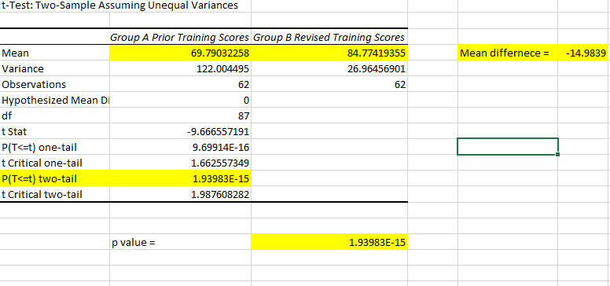
Fig. 1. Excel output for independent sample T test
It can be observed from the figure 1 that means for two groups are not equal. Mean difference observed is equal to 14.98. The value for the test 1.93983E-15 is significantly less than 0.05. Hence, we reject the null hypothesis that the mean difference between groups is equal to zero and accept the experimental hypothesis. It can be noted that the average is greater in group B which suggests that the revised training program is better than the previous one.

Dependent Samples (Paired Samples) t Test
Paired sample t-test will be used to know the amount of lead before and after exposure as the sample meets the assumptions of paired sample t-test. The test variable has been recorded twice in the same group or same population before and after exposure (Field, 2009; Creswell & Creswell, 2017).

Hypothesis
Null hypothesis H₀: The mean difference in the blood lead amounts is zero before and after the project.
Experimental hypothesis H₁: The mean difference in the blood lead amounts is higher than zero before and after the project.

Excel output and interpretation
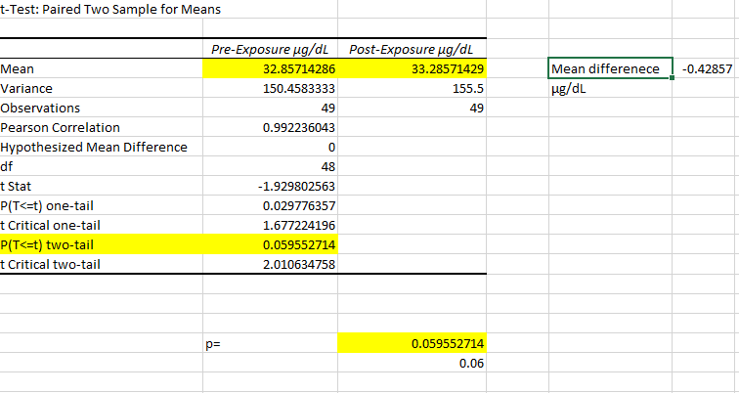
Fig. 2. Excel output for paired sample T test
It can be seen from the results that the mean difference, 0.428 microgram is closer to zero. The p value p = 0.056 suggests a slight increase after the exposure but the value rounded to two decimals, 0.06>0.05. We accept the null hypothesis that the mean difference before and after the exposure is zero. This suggests that the project does not contribute to higher level of lead in the blood of workers.

One-way ANOVA
One-way ANOVA test is used to know the differences in two or more groups for one variable Creswell & Creswell, 2017). The one-way ANOVA tells the difference in one variable measured in different groups from different samples. The variable in this study is return of investment measured for four different projects air, water, soil and training.

Hypothesis
Null hypothesis H₀: No difference exists in the return of investment by the four projects.
Experimental hypothesis H₁: A difference exists in the return of investment by the four projects.

Excel output and interpretation
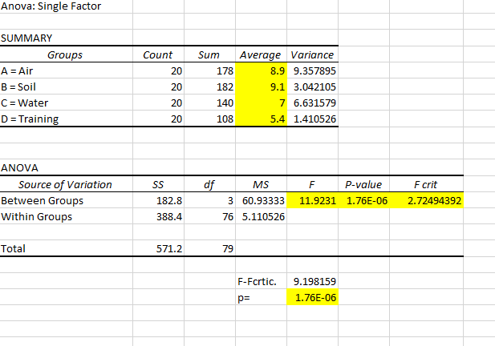
Fig. 3. Excel output for one-way ANOVA
The excel output provided above show p value, 1.76E-06 is significantly higher than 0.05, so we reject the null hypothesis. The greatest amount of return in investment has been received from soil project with average 9.1 and second highest was air project, average 8.9. water project generated an average 7 and the least amount of return from the investment was given by training project. Therefore, the Suncoast can keep investing in air and soil projects for higher revenues.

Data Analysis: Hypothesis Testing
With the help of SPSS the data analysis was carried out. SPSS is a software to analyze the quantitative data, which is not time-consuming, and it has benefits of modeling on multilevel (Heck, Thomas, & Tabata, 2011).
The Pearson correlation coefficient p value < .05 (alpha), therefore, the null hypothesis (H0₁) is rejected and the alternative hypothesis (HA₁) is accepted that there is a statistically significant relationship between particulate matter size and employee sick days.
The Pearson correlation coefficient r = - 0.715 indicates that particulate matter size, as measured in microns, is strongly and negatively correlated with mean annual sick days per employee. R² = .51 indicates that 51 percent of the variability in employee sick days is explained by particulate matter size.
Correlation: Hypothesis Testing
The correlation hypothesis testing involves testing the relationship between two variables A and B (Field, 2000). In this test, the relationship of health of employees and particulate matter (PM) will be tested using chi-square correlation test, and simple regression will show the percentage of relationship between the variables. The test results will predict if the higher level of air pollution measured in microns of particulate matter's size is associated with a higher number of leaves from the employees in different sites.
Hypotheses
Null hypothesis Ho₁: No statistically substantial relationship exists among particulate matter and number of sick leaves.
Experimental hypothesis Ha₁: A statistically substantial relationship exists among particulate matter and number of sick leaves.
Correlation output and interpretation
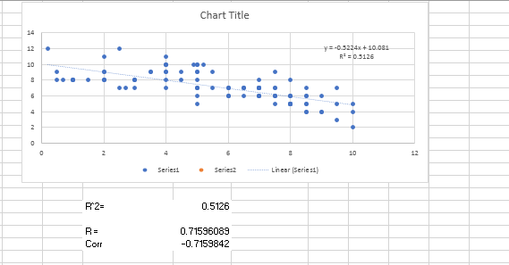
Fig. 1 Correlation output
It is evident from the table that the R-square is equal to 0.513, Pearson’s coefficient r is ‘-0.715’. Hence, the two variables are 71.5% related to each other. The negative sign indicates an inverse relationship between the two. Lower the particle size, higher the number of sick leaves. It is important to note that the results of correlation analysis only show the relationship, which means it does not predict cause and effect. For example, we cannot say that particle size is causing ill health. However, there is surely a strong relationship observed among the two variables.
Therefore, we reject the null hypothesis and accept the experimental or alternative hypothesis, which states that a relationship exists between particulate matter size and a number of sick leaves.
Simple Regression: Hypothesis Testing
The regression analysis in addition to proving the relationship between the variables, determines the percentage of relationship between them (Field, 2000). The simple regression in this case will predict to what extent the safety training is correlated to lost time hours. The training has been measured by amount of money spent on safety training.
Hypotheses
Null hypothesis Ho₁: Training has proven to be effective in reducing the lost-time hours.
Experimental hypothesis Ha₁: Training has proven to be effective in reducing the lost-time hours.
Simple/linear regression output and interpretation
Simple Regression: Hypothesis Testing
H0_{2.} There is no statistically significant relationship between safety training expenditure and lost-time hours.
HA_{2.} There is a statistically significant relationship between safety training expenditure and lost-time hours.
Regression Statistics
Multiple R | 0.939559324
R Square | 0.882771723
Adjusted R Square | 0.882241279
Standard Error | 24.61328875
Observations | 223
ANOVA
 | df | SS | MS | F | Significance F
Regression | 1 | 1008202.105 | 1008202.11 | 1664.210687 | 7.6586E-105
Residual | 221 | 133884.8903 | 605.813983
Total | 222 | 1142086.996
 | Coefficients | Standard Error | t Stat | p value | Lower 95% | Upper 95%
Intercept | 273.449419 | 2.665261963 | 102.597577 | 2.1412E-188 | 268.1968373 | 278.702001
Safety Training Expenditure | -0.143367741 | 0.003514368 | -40.7947385 | 7.6586E-105 | -0.150293705 | -0.13644178

The ANOVA F value < .05 (alpha) indicates that the simple regression model is statistically significant in its ability to predict the dependent variable. Therefore, the null hypothesis (H0₂) is rejected and the alternative hypothesis (HA₂) is accepted that there is a statistically significant predictive relationship between safety training expenditure and lost-time hours.

Linear regression outputs from the data provided have been presented below.
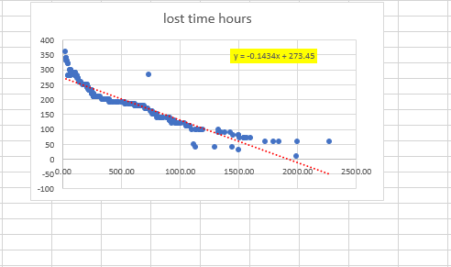
Fig.2 (a) Scatterplot showing correlation training expenses and lost time hours
The scatterplot above shows inverse relationship between the two variables. The rise in money spent on training is accompanied by the reduction of a number of lost hours. The plot shows the Pearson’s coefficient (r) 0.1434. Hence, the relationship between the two variables was 14.34%. It is important to note that the outlier exists, which was removed for better interpretation of results.
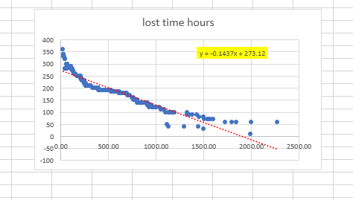
Fig.2 (b) Scatterplot showing correlation training expenses and lost time hours after removal of outliers
The scatterplot after removal of outlier is presented above. The relationship after removing outliers is 14.37% which is not statistically different from that obtained before removal of the outlier.

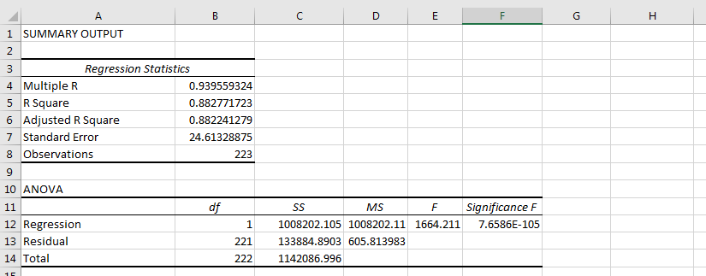
Fig.3 (a) Simple regression test result
It is evident from the table above that r square value is 0.883. Hence, the results show that the variables are 88% related to each other. The multiple R is 0.939, R square 0.883, ANOVA F value 1851.86 and alpha a value is 273.45.
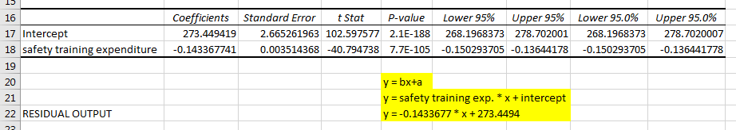
Fig.3 (b) Simple regression test result
Y = bx + a
Where b is safety training expenditure and a is intercept. Hence,
Y = -0.143 * x + 273.45
The regression equation shows that lost time hours can be obtained by multiplying x to -0.143 and adding 273.45. Considering the above results, we do reject the null hypothesis and accept the experimental hypothesis that safety training is effective in reducing the lost time hours.
Multiple Regression: Hypothesis Testing
The multiple regression is used to study a number of factors linked to a variable Creswell & Creswell, 2017). In this case, it is tested if the variables like angle, velocity, chord length, frequency and displacement are contributing to noise measured in decibels.
Hypotheses
Null hypothesis Ho₁: The variables frequency, angle, chord length, velocity and displacement do not contribute to noise (dB).
Experimental hypothesis Ha₁: The variables frequency, angle, chord length, velocity and displacement contribute to noise (dB).
Multiple regression output and interpretation
Multiple Regression: Hypothesis Testing
H0_{3.} There is no statistically significant relationship between frequency, angle in degrees, chord length, velocity, and displacement and decibel level.
HA_{3.} There is a statistically significant relationship between frequency, angle in degrees, chord length, velocity, and displacement and decibel level.
Regression Statistics
Multiple R | 0.601841822
R Square | 0.362213579
Adjusted R Square | 0.360083364
Standard Error | 5.51856585
Observations | 1503
ANOVA
 | df | SS | MS | F | Significance F
Regression | 5 | 25891.88784 | 5178.377569 | 170.0361467 | 2.1289E-143
Residual | 1497 | 45590.48986 | 30.45456904
Total | 1502 | 71482.3777
 | Coefficients | Standard Error | t Stat | p value | Lower 95% | Upper 95%
Intercept | 126.8224555 | 0.623820253 | 203.2996763 | 0 | 125.5988009 | 128.0461101
Frequency (Hz) | -0.0011169 | 4.7551E-05 | -23.48846042 | 4.0652E-104 | -0.001210174 | -0.001023627
Angle in Degrees | 0.047342353 | 0.037308069 | 1.268957462 | 0.204653501 | -0.025839288 | 0.120523993
Chord Length | -5.495318335 | 2.927962181 | -1.876840613 | 0.060734309 | -11.23866234 | 0.248025671
Velocity (Meters per Second) | 0.083239634 | 0.009300188 | 8.950317436 | 1.02398E-18 | 0.064996851 | 0.101482417
Displacement | -240.5059086 | 16.51902666 | -14.55932686 | 5.20583E-45 | -272.9088041 | -208.103013

The ANOVA F value < .05 (alpha) indicates that the multiple regression model is statistically significant in its ability to predict the dependent variable. Therefore, the null hypothesis (H0₃) is rejected and the alternative hypothesis (HA₃) is accepted that there is a statistically significant predictive relationship between the independent variables in the model and dependent variable of decibel level.
Further analysis determined that frequency, velocity, and displacement coefficient p values < .05 (alpha); therefore, these are the only variables that are statistically significant in their ability to predict decibels.
The correlation coefficient of r = 0.60 indicates that frequency, velocity, and displacement are moderately to strongly correlated with decibel level. R² = 0.36 indicates that 36% of the variability in decibel level is explained by frequency, velocity, and displacement.
Decibel level can be predicted by the following linear equation:
Y = a + b₁X₁ + b₂X₂ +…+ b_{n}X_{n}
dB = 126.8 + (-0.0011)(Frequency) + (.0.047)(Angle in Degrees) + (-5.49)(Chord Length) + (.083)(Velocity) + (-240.5)(Displacement)

The excel outputs of multiple regression analyses have been presented below.
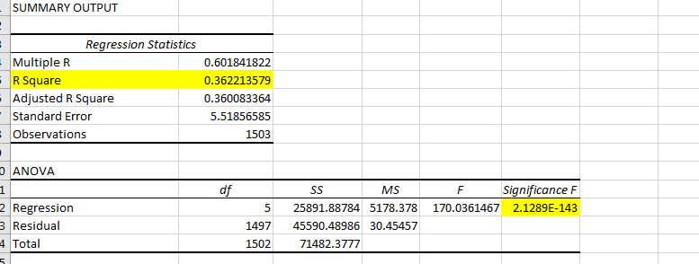
Fig.4 (a) Multiple regression output
The Multiple R value observed is 0.00, R square is 0.36 and ANOVA F value 170.03.
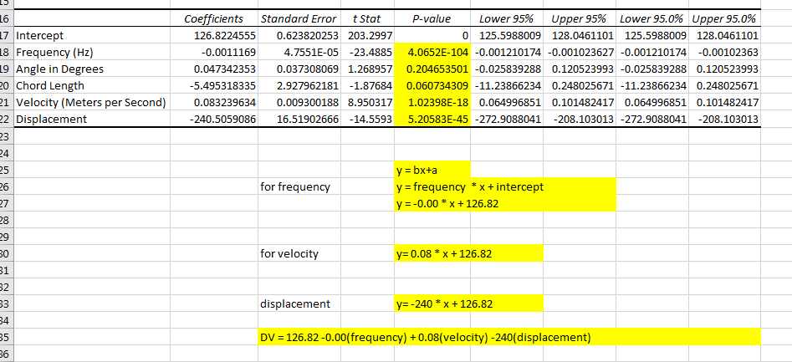
Fig.4 (b) Multiple regression output
As evident from the table above, the regression outputs display non-significant outputs for angle and chord length and significant values for frequency, velocity, and displacement. Therefore, the velocity, frequency, and displacement contribute to noise at workplace. The amount of noise can be predicted by following equation if the frequency, velocity and displacement are known.
Dependent variable (Noise) = 126.82 – 0.00 (frequency) + 0.08(velocity) – 240(displacement), where 126.82 is constant alpha value.

Findings
The study discovered that health and safety matters are key issues for Sun Coast workers. It is also pointed that there are significant correlations between the lost time hours and safety training expenditure. The study also established that there is relationship between health and safety of workers and the performance of Sun Coast. The study also established that Sun Coast also works around the clock to offer a better working environment for all workers through elimination of substances which can hinder growth of workers.
The study identified six problems as some of the major concerns for Sun Coast. The first major concern is job site particle pollution affecting the health of employees. It also reported that Sun Coast suffers from high job lose and this could be as a result of poor working condition. Though respirators are needed in certain environment, the particulate matter (PM) differs in size and mostly depends on the job site and project which are being undertaken. There are also other issues such as safety training effectiveness, sound level exposure, new employee training and lead exposure which senior management must address.
RO₁: To determine if there is a relationship between the size of PM (particulate matter) size and employee health.
RO₂: To determine if the safety training has been successful to reduce the lost-time hours
RO₃: To determine if the frequency, chord length, velocity and displacement can be used to predict dB levels.
RO₄: To know if the revised training program is better than the prior training program.
RO₅; To determine if there is any difference in the level of lead in the blood of employees before and after the lead remediation program.
RO₆; To determine if the differences exist in return on investment for air monitoring, water reclamation, soil remediation, and health and safety training projects.

Recommendations
Employees working at the job site to remediate must be efficiently monitored to ensure the company can be able to achieve its core objectives. Health and safety were highlighted as major issues which the company should address effectively.

References
Boland, A., Cherry, G., & Dickson, R. (2017). Doing a systematic review: A student’s guide. Sage.
Farrugia, P., Petrisor, B. A., Farrokhyar, F., & Bhandari, M. (2010). Research questions, hypotheses and objectives. Canadian Journal of Surgery, 53(4), 278.
Creswell, J. W., & Creswell, J. D. (2017). Research design: Qualitative, quantitative, and mixed methods approaches. Sage publications.
Denyer, B., & Jaina, ,. J. (2017). How do they manage? A qualitative study of the realities of
middle and front-line management work in health care. NIHR Journals Library , 2-15.

Dulock, H. L. (1993). Research Design: Descriptive Research. Journal of Pediatric Oncology Nursing, 10(4), 154–157. https://doi.org/10.1177/104345429301000406
Etikan, I., Musa, S. A., & Alkassim, R. S. (2016). Comparison of convenience sampling and purposive sampling. American Journal of Theoretical and Applied Statistics, 5(1), 1–4.
Field, A. (2000). Discovering statistics using SPSS:(and sex, drugs and rock'n'roll) (Vol. 497). Sage.
Heck, R. H., Thomas, S. L., & Tabata, L. N. (2011). Multilevel and Longitudinal Modeling with IBM SPSS. Routledge.
Nardi, P. M. (2018). Doing survey research: A guide to quantitative methods. Routledge.
Newman, I., Benz, C. R., & Ridenour, P. C. S. (1998). Qualitative-quantitative Research Methodology: Exploring the Interactive Continuum. SIU Press.
Offredy, M., & Vickers, P. (2010). Developing a Healthcare Research Proposal: An Interactive Student Guide. John Wiley & Sons.
P, M., Kumar, S., Lizarondo, L., & Baldock, K. (2015). Debriefing about the challenges of
working in a remote area: A qualitative study of Australian allied health professionals' perspectives on clinical supervision. Journal of health and safety issues , 2-15.

